Social Studies & CRE - Grade 5 of Term 1 Exams 2023
QUESTIONS
SOCIAL STUDIES
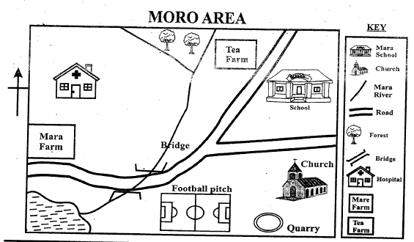
Study the map and answer the questions that follows
- Identify the title of the map above
- Name three items named on the map
- Name two crops grown in the map
- Which game is played in the Moro area?
- The religion practised in Moro is
- Name three elements of a map
- A compass has points
- Draw a compass and name the : cardinal points
- Our country is called
- Name the weather symbols
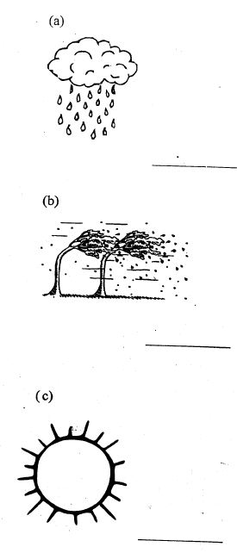
C.R.E
- ____has good plan for me.
- What is a gift?
- Which gift has God given you?
- From the parable of the talent. What lesson can you learn from it?
- Name three God's creation
- ____and_____were placed in the garden of
IRE
- Match the words with their meaning
Al-Kauthar To your Lord
Lirabbika One cut off
Al-Abtaru River in Paradise
- We should always be_____ to Allah (S.W.T.) for His continued blessings.
- Maun has_____ verses
- The verses of al-Quraysh are____
- Who fed and saved the Qurash from fear?
- Write the replies to the Salaamu
Assalam aleikum warahmatullahi?
- Allah has_____beautiful names
- Name one Allah creation

MARKING SCHEME
SOCIAL STUDIES
- Farming history

  - bridge
  - quarry (any other)

  - Maize
  - tea
- Football
- Christian

  - title
  - scale
  - compass
  - frame
- 4
- ..
- Kenya

  - rainy
  - windy
- sun
C.R.E
- God
- something given for free
- gift of life
- our talents will be taken if we don't use them well

  - star
  - moon
  - sun
- Adam, Eve
I.R.E
- Lirabbika - To your Lord
Al-Abtaru - One cut off
Al-Kauthar - Rive in Paradise
- Grateful/thankful
- 7
- 4
- Ala-Maududi
- Wa alaikum assalam
- 99
- The sun/ the moon/ the planets

