Science and Technology - Grade 5 Term 1 Exam 2023
- Plants can be classified into two. Flowering plant and non flowering plants. Which is a group does not produce flowers?______________________
- Mushrooms, yeast, bread moulds and puff balls are all examples of_____________________
- One similarity between a bird and a cat is that they are vertebrates which is a group of animals with_______________
- _________________is an example of a mammal that lay eggs.
- The body of a mammal is covered with ___________and____________
- During a science lesson, grade 5 learners were asked by their teacher to mention one difference between a chameleon and a sheep. Amina said that a chameleon is ___________ blooded unlike the sheep
- The diagram below show a fish
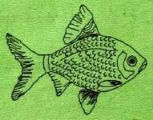
A fish ________________which hatch into young ones.
- One of similarity between a snake and a crocodile is that they take the temperature of their sorroundings. This is because they are________________
- Katana went to the river and saw an animal with the following characteristics
it has moist skin
partly lives in water and on land
it is a vertebrate
Which class of animals did Katana see?
________________________
- Your parent tells you that dinner is ready, You feel the cold water and soap as you wash your hands name the sense organ that you have used_____________________
- __________________are also known as voluntary muscles.
- Which function of the human skeleton will be affected when a person breaks his or her leg?
________________________
- _______________is a part of human skeleton that provides support to the body and helps the body to remain upright.
- Janice realized that she had the following symptoms
a cough that may produce mucus
sweating and shaking
shortness of breat
nausea, vomiting and diarrhea
fatigue
Which respiratory disease is she likely suffering from?
_____________________________
- The diagram below represents a model of the breathing system.
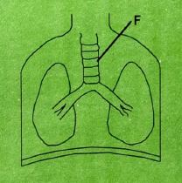
The part marked f is
- After sweeping the classroom, Kamau blew his nose and found dirt in the mucus. Which function did his nose perform?
_______________________
- ______________diseases are infections that are caused and spread through drinking or coming into contact with contaminated water.
- Which is the odd one out?
(stomach lungs trachea nose)
- A tomato fruit broke down and started to rot. Eventually it became part of the soil. This is called_____________________
- _____________means that you or someone else can use an item over and over again instead of throwing it away.
MARKING SCHEME
- Non-flowering plants
- fungi
- bones( internal skeletal structure)
- duck-billed platypus
- fur and hair
- cold
- egg
- cold blooded
- amphibian
- touch
- skeletal
- support
- spine
- pneumonia
- trachea
- trap dust and dirt in mucus and nose hairs
- water-borne
- stomach
- decomposition
- re-using

