Science & Agriculture - Grade 5 Term 1 Exams 2023
QUESTIONS
- Name the digestive system
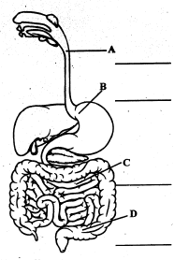
- Write three invertebrate animal
- Name two animals that give birth to young ones
- The digestion of food start in the____ and ends in the_____
- We use___ to brush our teeth
- Draw three personal items and name them
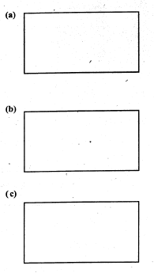

- Name two external parasites
AGRICULTURE
- What is soil conservation?
- Name three types of soil
- Write down three materials required to make compost manure
- List down three uses of water on a farm
- Write small animals that clothing crops
- Draw a scarecrow (2mks)
- Match the animal with its products
cow wool
goat egg
sheep mohair
hen milk
- We get water from?

MARKING SCHEME
SCIENCE

  - oesophagus
  - stomach
  - small intestine
  - large intestine

  - earth worm
  - files
  - cockroaches (any insect)

  - cow
  - dog

  - mouth
  - small intestine
- brush, water
- (any)

  - bedbugs
  - ticks (any other)
AGRICULTURE
- Soil conservation is practice of using water efficiently to reduce unnecessary water usage

  - loam
  - clay
  - sand

  - dry grass
  - ashes (any)
  - top soil

  - watering crops
  - washing tools
  - mixing chemicals

  - Monkey
  - Squirrel

- Cow - milk
goat - mobair
sheep - wool
hen - ege
- rain

