Science / Technology & Agriculture - Grade 4 of Term 1 Exams 2023

QUESTIONS
SCIENCE
- Name three living things
  - .......................................................
  - .......................................................
  - .......................................................
- List three characteristics of living things
  - .......................................................
  - .......................................................
  - .......................................................
- Animals with backbone are called
.......................................................
- Name four types of teeth
  - .......................................................
  - .......................................................
  - .......................................................
  - .......................................................
- Write living things or non living in the pictures (4mks)
  - .......................................................
  - 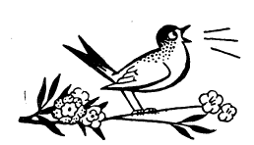
.......................................................
  - 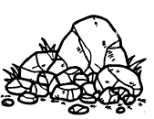
.......................................................
  - .......................................................
- Name two food crops you know
  - .......................................................
  - .......................................................
- Name three ways on how to care for animals
  - .......................................................
  - .......................................................
  - .......................................................
- We use ....................................................... and ....................................................... to clean our teeth
AGRICULTURE
- The best soil for cultivation is ....................................................... soil
- The compost manure is prepared using
  - .......................................................
  - .......................................................
  - .......................................................
- Name three uses of water at home?
  - .......................................................
  - .......................................................
  - .......................................................
- What is weeding?.......................................................
- Name three types of soil
  - .......................................................
  - .......................................................
  - .......................................................
- Write three small animals rised to destroy crops
  - .......................................................
  - .......................................................
  - .......................................................
- Draw the fruits we eat

- Name two animals that gives us milk
  - ......................................................
  - ......................................................

MARKING SCHEME
SCIENCE

  - cow
  - man
  - hen

  - They feed
  - They move
  - They reproduce

  - vertebrates

  - incisors
  - canines
  - molars
  - premolars

  - living thing
  - living thing
  - non-living
  - non-living

  - maize any other)
  - beans

  - watering them
  - feeding them
  - treating them

  - water, toothpaste
AGRICULTURE
- loam

  - kitchen refuse
  - dry grass any other)
  - ashes

  - washing
  - cooking
  - drinking
- Removal of unwanted plant

  - clay
  - loam
  - sand

  - birds
  - monkeys
  - mongoose
- any fruit

  - cow
  - goat

