SOCIAL STUDIES GRADE FIVE TERM 1 2023
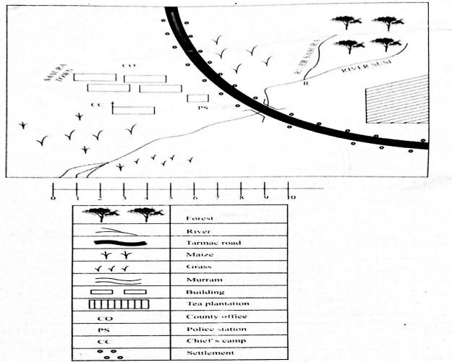
- The general flow of rivers in Mwakitu area is towards?___________________________________
- The settlement in Mwakitu area can be described as______________________________
- The plantation in Mwakitu grows?_______________________________
- What is the direction of the church from the plantation?________________________________
- The growing of tea in Mwakitu area indicates that the climate is_______________________________________
- River Susi has _______________ tributaries.
- Who is the head of Mwakitu area ______________________?
- State 3 elements of the map. ________________________________
- Name two countries found in East Africa. __________________________________
- Name three arms of the National Government of Kenya. ________________________,________________________,_____________________
- State three elements of weather
____________________
____________________
____________________
- The main language groups found in Kenya are:
____________________
____________________
____________________
____________________
____________________
- What is the longitude of Kenya _______E and _________E
- Name 4 lakes found in Kenya
____________________
____________________
____________________
____________________
- Name three roles of the school administration
____________________
____________________
____________________
- The way of life of a particular community is known as
____________________
- Name five rivers that drain into Lake Victoria
____________________
____________________
____________________
____________________
____________________
- Who were the traditional teachers?
____________________
- Traditional society youths were taught through the following ways except
  - Proverbs
  - Songs and dances
  - Riddles
  - Writing
- The largest lake in Kenya is ____________________
- The most Northerly point of Kenya is at ____________________
- The largest valley in Kenya is ____________________
- Name three main physical features in Kenya? _________________,___________________,__________________________
- What is the meaning of a climate?____________________________________________________

