SOCIAL STUDIES ACTIVITIES - CBC GRADE 4 TERM 2023

QUESTIONS
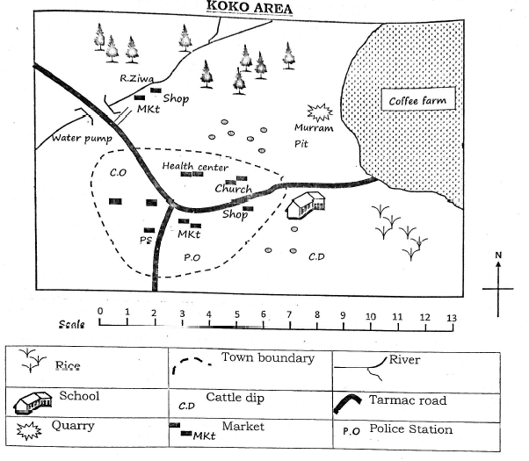
Answer the questions below
- The church is to the ...................................................................... of the coffee farm.
- Which crops are being grown in Koko area?
  - ......................................................................
  - ......................................................................
- The Health Centre is to the ...................................................................... of the police station.
- The mineral mined at Koko area is ......................................................................
- Give the directions of the area where the forests are located.
  - ......................................................................
  - ......................................................................
- Draw a compass showing the cardinal points
- West is to the......................................................................of North.
- ......................................................................is opposite South East.
- Compass points help us to tell the ......................................................................of the place.
- Kenya is made up of ...................................................................... counties.
- Identify the physical features described below:-
  - A large low-lying area of almost flat land ......................................................................
  - A large body of water that is salty ......................................................................
- Give three importance's of plains
  - ......................................................................
  - ......................................................................
  - ......................................................................
- Fill the table
Activities that can be done during the dry season | Activities that can be done during the wet season

- Draw a picture to show a rainy season
- Which season do we experience no rain for a long time? ......................................................................
- Fort Jesus was built by the ......................................................................
- Give three examples of historic built environments
  - ......................................................................
  - ......................................................................
  - ......................................................................
- Being dependent on each other for different things is called ......................................................................
- Why do people need these people?
  - Teachers ......................................................................
  - Police ......................................................................
- What is population distribution? ......................................................................
- Areas where houses are built very close together are said to be...................................................................... populated
- When people live far from each other the area is said to ......................................................................populated.
Write true or false
- Very steep areas attract many people ......................................................................
- Airports and game parks do not have people living there ......................................................................
- What is culture? ......................................................................
- ......................................................................are things that are made by people and have been kept well for cultural and historical reasons.
- The type of clothes worn depended on the ......................................................................
- In the past, who wore special clothes
  - ......................................................................
  - ......................................................................
- The Maasai house is called a ......................................................................
- Name two traditional games
  - ......................................................................
  - ......................................................................
- What are resources? ......................................................................
- Give three examples of soils in the county
  - ......................................................................
  - ......................................................................
  - ......................................................................
- Do you pay any fees to the county government to trade in the county? ................................................................................

