COMPETENCY BASED CURRICULUM GRADE 5 - TERM 1 EXAM 2023
SCIENCE AND TECHNOLOGY

- Farmers keeps cows for…………………….. and ( 2mks )
- The diagram below indicates …………………………. Days (1mk)

- We wear gumboots when the weather is (1mk)
- Animals with backbones are called (1mk)
- Name four characteristics of plants as a living thing (4mks} a) ………………………………………………………
b) ………………………………………………………
c) …………………………………………………………
d) ………………………………………………………...

6 we irrigate our crops during Seasons (1mk)

7 Name three uses of water at home (3mks)
a) …………………………………………………….
b) …………………………………………………….
c) ………………………………………………………

- We clean our hands with …………………………………………. And (2mks)
- The soil that has large particles is called ………………………………( loam ,
clay , sand ) (1mk)
- Where do plants grow (1mk)
- State six types of domestic and wild animals

(Eagle, Elephant, Dog, Hen, Donkey, Hare)

Domestic animals | Wild animals

- Loam soil is best suitable for …………………… (Modeling , Farming

,building ) (1mk)

- Name two cash crops grown at home ( 2mks ) a) ………………………………
b) ………………………………

- Name the four colours of the national flag (4mks) a) …………………………………..

b) ………………………………….

c) ……………………………………

d) …………………………………….

- Name four sources of water at home (4mks) a) …………………………………………..
b) ……………………………………………

c) …………………………………………….

d) …………………………………………….

- Name the type of area where cactus plant grows

…………………………(1mk)

- We use what to sweep the house at home (1mk)

- Moving air is called (1mk)

- How many common senses do human being (1mk)

- A person who treats human teeth is called (1mk)

- The tool below is called (1mk)

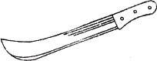

- . Which characteristic do this animal possess as a living

organism. (1mk)

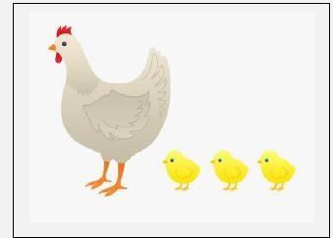

- . Define the term digestion

…………………………………………………………………………………………………………………………

………………………………………………………………………………(1mk)

- . When we breathe in, the chest moves (1mk)

- . Digestion begins in the And ends at

………………………….. (2mks)

- . Draw and label a digestive system (5mk)

