SCIENCE AND TECHNOLOGY ACTIVITIES - CBC GRADE 4 TERM 1 2023
- State two characteristics of plants as living things
  - .....................................................................
  - .....................................................................
- We should wear ..................................................................... to protect our feet when handling plants.
- Draw and colour the protective clothing that protects our eyes when handling plants
- Classify the following into living and nonliving things.
stone, dog, paper, earthworm, flag, frog, bottle, plant, cow, jembe
 | Living things | Non-living things
a)
b)
c)
d)

- Name two characteristics of animals
  - .....................................................................
  - .....................................................................
- Animals without a backbone are called .....................................................................
- Animals with a backbone are called .....................................................................

- Digestion of food starts in the ..................................................................... and ends in the .....................................................................
- The picture below shows the digestive system. Name the parts marked
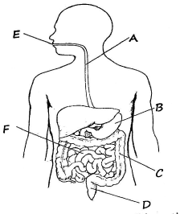
  - .....................................................................
  - .....................................................................
  - .....................................................................
  - .....................................................................
  - .....................................................................
  - .....................................................................
- Another name for small intestine is .....................................................................
- The juice found in the mouth is called .....................................................................
- How many incisors does a human being State two characteristics of canines
  - .....................................................................
  - .....................................................................
- The two types of teeth that are used for chewing and grinding food are ..................................................................... and .....................................................................
- What is the meaning of air pollution? .....................................................................
- Write two causes of air pollution
  - .....................................................................
  - .....................................................................
- Motor vehicle pollute air because they produce a lot of ..................................................................... (water, smoke)
- What is the air pollutant in the picture below?

- Write True or False
- Plants and animals need clean air for their growth .....................................................................
- Polluted air is the best for breathing .....................................................................
- Dusty roads cause air pollution .....................................................................
- Write the name of each of the digital devices shown below.
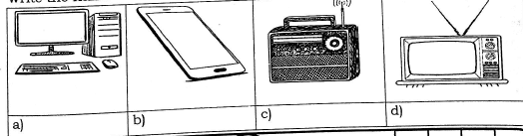
- Write the functions of the following parts of a computer
  - Monitor.....................................................................
  - Keyboard .....................................................................
  - Central processing unit .....................................................................

