SCIENCE AND TECHNOLOGY GRADE 4 TERM 1 2023
- Name four domestic animals that you know.
  - _______________________________
  - _______________________________
  - _______________________________
  - _______________________________
- Animals that feed on plants are called ____________________________
- The animals that feed on meat only are called _____________________
- Several young ones born at the same time to the same mother are known as ___________________
- Ducks reproduce by ______________________
- The solid wastes removed by animals is called ________________________________.
- A dog removes its tongue and pants when the weather is __________________________.
- The animals with a backbone are called ____________________________________.
- Fill the chart below
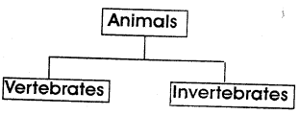
_________________ ___________________
_________________ ___________________
_________________ ___________________
(dog, hen, snail, butterfly, grasshoper, man)
- The breaking down of food into small particles that are absorbed by our bodies is called _____________________,
The figure below shows digestive system
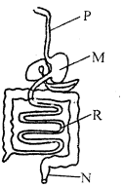
(small intestines, rectum, wind pipe or trachea, esophagus, stomach)
- Name the part marked
P __________________________
M __________________________
R __________________________
N __________________________
- Digestion of food starts in the ____________________ and ends in the ___________________
- The large intestines are also called _________________________
- Human being has ____________________ types of teeth (4, 32, 20)
- What part of a plant do we eat? (5mks)
  - Sugarcane ____________________
  - Spinach _________________________
  - Tomato ___________________________
  - Kales ____________________________
  - Yams ____________________________
- How many premolars does an adult have? (1 mark) ______________________________
- Which part of plants is used for feeding? (1 mark) _______________________________
- Name two examples of invertebrates. (2 marks)_________________________________
- State two characteristics of plants. (2 marks)____________________________________
- Your parent tells you that dinner is ready, You feel the cold water and soap as you wash your hands name the sense organ that you have used_____________________

