SCHOOL BASED ASSESSMENT MATHEMATICAL ACTIVITIES - GRADE 1 2023 EXAMS TERM 1

QUESTIONS
- How many balls are there?
- Count and write how many
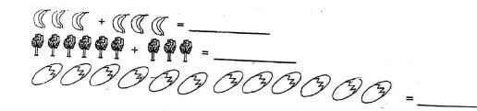
- Draw objects
  - 15 =
  - 9 =
  - 4 =
  - 3 =
- Put together
  - 1 + 3 + 4 =
  - 5 + 5 + 0 =
  - 2 + 2 + 3 =
  - 7 + 3 + 1 =
- Take away
  - 9 - 3 =
  - 11 - 3 =
  - 10 - 1 =
  - 8 - 4 =
- Match the shapes
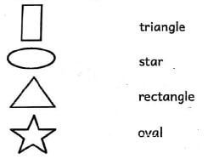
- Measuremnts:
Which one is shorter =
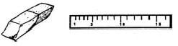
- Which is heavier?
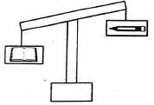
- Which one holds more water?
- The leaf is _____________________than the table.
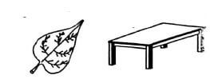
(lighter, heavier)
Geometry
- Join the dots and form shapes
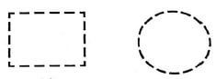
- This is a _____________ line.
(curved, straight)
- Draw the next shape in the pattern below.
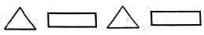
- Complete.
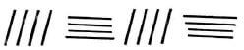

MARKING SCHEME
- 4
- 6 bananas
9 trees
12 eggs

  - 000000000000000
  - 000000000
  - 0000
  - 000

  - 8
  - 10
  - 7
  - 11

  - 6
  - 8
  - 9
  - 4

- the rubber
- the book
- A
- lighter

- curved

