SCHOOL BASED ASSESSMENT MATHEMATICAL ACTIVITIES - GRADE 3 2023 EXAMS TERM 1

QUESTIONS
Match the objects with equal group
- 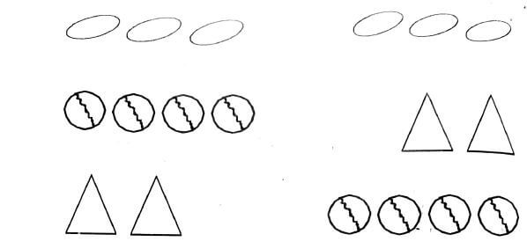
- Addition
6 + 5 = .................................
- 10 + 7 = .................................
- 33 + 5 = .................................
- 44 + 22 = .................................
- 39 + 11 = .................................
- 26 + 3 = .................................
- 50 + 40 = .................................
- Subtract
40 - 11 = .................................
- 50 - 40 = .................................
- 3 - 2 = .................................
- What is 12 take away 7?
- take away 19 - 4 = .................................
- Fill in the missing numbers: 2 + ......... = 9

- Match numbers with its name in words
7 | eleven
9 | nine
8 | ten
10 | eight
11 | seven
- Fill in the missing numbers
2, 4, 6, 8, ......, ........, ........ , .........
5, 10, 15, 20, ......, ........, ........ , .........
- Name the shapes

- Complete the statements
1547 = .............thousands.............hundreds.............tens.............ones
- 6 = .............hundreds.............tens.............ones
- Write the following numbers in words and symbols
40....................................................
- 100....................................................
- 250....................................................
- sixty eight....................................................
- Ninety nine....................................................
- 12....................................................
- Measurement and Geometry
Today is Thursday tomorrow will be ....................................................
(wednesday, Friday)

