447/2
POWER MECHANICS
Paper 2
(PRACTICALS)
November/December 2021

BUNAMFAN EXAMINATIONS
Kenya Certificate of Secondary Education
POWER MECHANICS
Paper 2
(PRACTICALS)

MARKING SCHEME

STATION 1

Draw an exploded view of a battery hydrometer and label the major parts.

(10 marks )

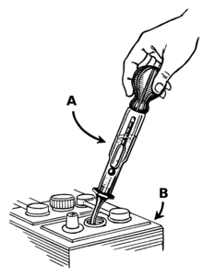

STATION 2
Use the tools, equipment and materials provided to make the template shown in the figure below.

(10 marks )

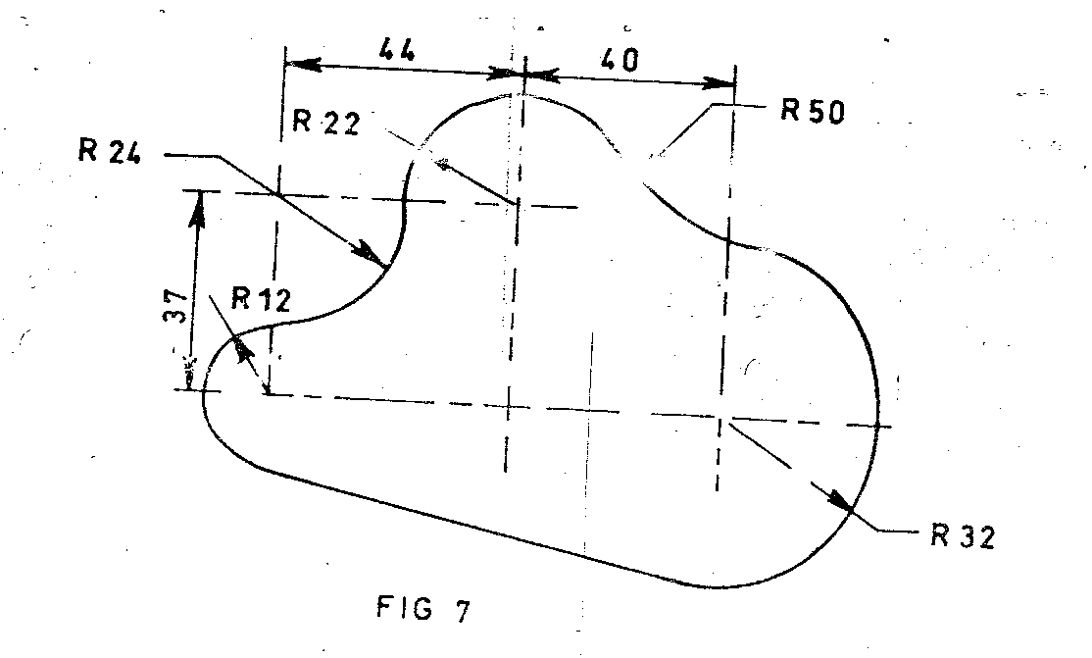
CORRECT CURVE OF R32…………………………………………………………………………1 ½ MKS
CORRECT CURVE OF R12…………………………………………………………………………1 ½ MKS
CORRECT CURVE OF R24…………………………………………………………………………..1 ½ MKS
CORRECT CURVE OF R22……………………………………………………………………………1 ½ MKS
CORRECT CURVE OF R50……………………………………………………………………………1 ½ MKS
FILING OFF SHARP EDGES………………………………………………………………………….1 ½ MKS
FINISHING IN TIME…………………………………………………………………………………….1 MK
STATION 3
State the name of the fluids provided labeled V, W, X, Y and Z and in each case state one use.

( 10 marks )

FLUID | NAME | USE
V | PETROL | FUEL FOR S.I. ENGINES
W | DIESEL | FUEL FOR C.I. ENGINES
X | KEROSENE | WASHING OILY ENGINE PARTS
Y | AIR | WHEEL TUBE INFLATION
Z | VASELINE | BATTERY TERMINALS

CORRECT IDENTIFICATION…………………………………………………………..1 MK EACH
CORRECT USE……………………………………………………………………………..1 MK EACH

STATION 4

- Using the tools and apparatus provided determine the taper and ovality on the big-end journal of the engine crankshaft provided. Show all your working.
A B
D
VERTICAL DIAMETERS
C

A B C
TAPER=DIA.AA- DIA. BB D
OVALITY= DIA. CC- DIA. DD
-SHOWING ALL THE WORKING………………………………..2 MKS
-CORRECT TAPER…………………………………………………….2 MKS
-CORRECT OVALITY…………………………………………………2 MKS

- Demonstrate to the examiner how to check the crankshaft for distortion. ( 4 marks )

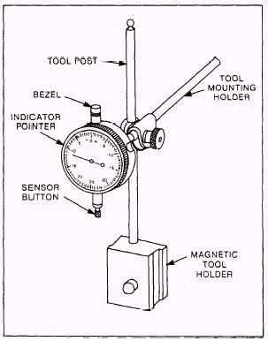

PLACING THE CRANSHAFT ON V-BLOCKS AND POSITIONING THE SENSOR
BUTTON ON THE MAIN CRANK JOURNAL AS IT IS ROTATED…………..4 MKS

STATION 5
Identify the locking devices labeled A to E and state a feature that makes each locking device unique in the class. ( 10 marks )

LOCKING DEVICE | NAME | UNIQUE FEATURE
A | SPRING WASHER | THE STEPPED UP ENDS THAT MAKE IT SPRINGY
B | TANG WASHER | THE INNER LOCKING PROTRUTION
C | SPLIT PIN | IT IS SPLIT AND MALLEABLE
D | WOODRUFF KEY | ITS HARDNESS AND HALF MOON SHAPE
E | SERRATED WASHER | THE SERRATIONS ON THE CIRCUMFERENCE

STATION 6
- Using the tools and equipment provided, carry out the following service checks on the battery given on the workbench. Record the following;
- Physical condition of the battery…………………………………………………………………
……………………………………………………………………………………………………..( 1 mark )
WHETHER DIRTY, CRACKED, CORRODED TERMINALS, ETC

- Specific gravity of each cell………………………………………………………………………..
…………………………………………………………………………………………………………………..
……………………………………………………………………………………………………( 3 marks )
AS PER THE DATA COLLECTED ON THE PARTICULAR BATTERY

- Battery voltage…………………………………………………………………………………………….
………………………………………………………………………………………………….…( 3 marks )
AS PER THE DATA COLLECTED ON THE PARTICULAR BATTERY

- Demonstrate to the examiner how to measure the individual cell voltage ( 3 marks )

(-) (+)

METER

BATTERY

STATION 7

- Use the tools and equipment provided and determine the coefficient of friction between the brake pad friction surface and the steel plate. Show all your working on the space provided below.
(10 marks)
AS PER THE DATA PROVIDED FROM THE STATION.

COEFFICIENT OF FRICTION = FORCE RECORDED AT THE SPRING WHEN PULLING THE PAD
WEIGHT OF THE BRAKE PAD

STATION 8
- Measure and record the resistance of each of the following given components;
- Secondary winding resistance………………………………………………………………
CORRECT METER READING OF SECONDARY RESISTANCE………………….2 MKS
- Primary winding resistance………………………………………………………………….
CORRECT METER READING OF PRIMARY RESISTANCE……………………..2 MKS

- Using the components and the wires provided, connect a horn circuit.

Let the examiner check your work. ( 6 marks )

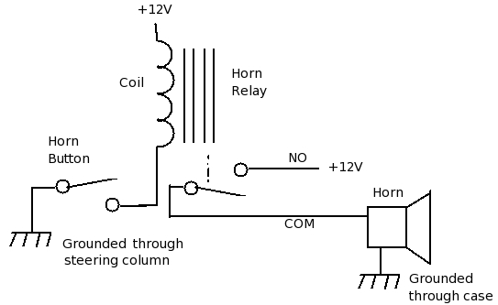

STATION 9

For the tyre provided;
- Identify and record the following;
- Maximum load…………………………………………………………………………………………
- Maximum inflation limit……………………………………………………………………………
- Tyre size…………………………………………………………………………………………………...
- Tyre costruction……………………………………………………………………………………….
- Rim size………………………………………………………………………………………………….
- Date of manufacture………………………………………………………………………………
( 3 marks )

- Identify the defect at the section marked X and state one possible cause of the defect.
DEFECT………………………………………………………………………………………………………………………
POSSIBLE CAUSE………………………………………………………………………………………………………..

AS PER THE DATA PROVIDED FROM THE STATION

( c ) Demonstrate to the examiner how to measure the following;
- Inside diameter
- Height
- Width
- Tread depth
- Tread width
( 5 marks )
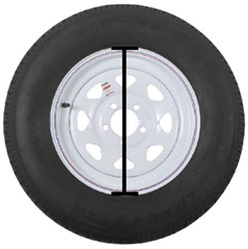INSIDE DIAMETER

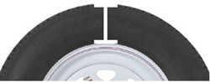 HEIGHT

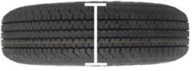 WIDTH

TREAD DEPTH
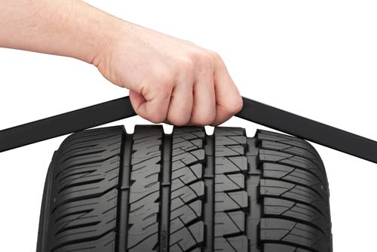

TREAD WIDTH

STATION 10

On the multi-cylinder engine block provided, demonstrate to the examiner how to determine the oil clearance in the main bearings using the tools and equipment provided.
( 10 marks )
It is recommended that surfaces be clean prior to use of Plastigauge
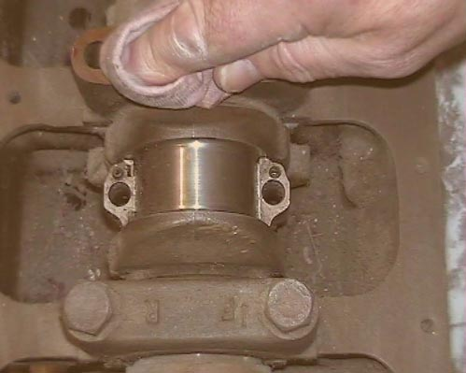

Plastigauge placed across the bearing surface

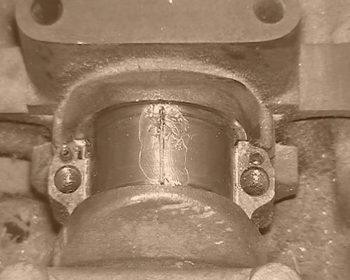

THE CAP IS PLACED AND TORQUED TO SPECIFICATION TO SPREAD THE PLASTIGAUGE, THEN REMOVED.

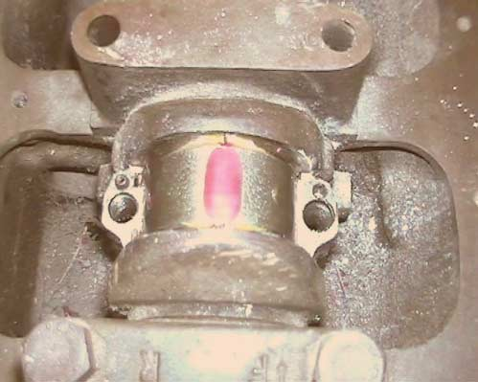

De-formed Plastigauge compared with calibrated scale.

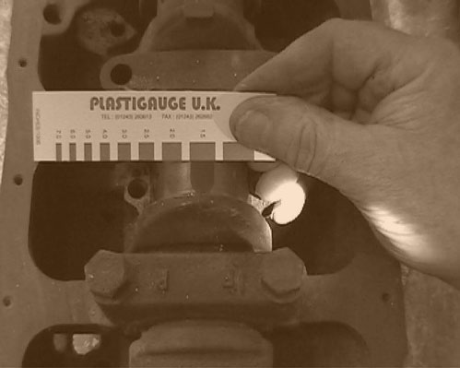
The actual clearance is shown alongside the mark which most nearly corresponds to the width. For greater accuracy the clearance may be interpolated between the two most nearly comparable scale marks.

EACH STEP…………………2 MKS
TOTAL………….10 MKS

