BUNAMFAN CLUSTER EXAMINATION – 2022
Kenya Certificate of Secondary Education
447/2 – POWER MECHANICS – Paper 2 (PRACTICAL)
June 2022 - 2 ½ hours
Name…………………………………Adm No……
Class…………… Date……………………………
Instructions to candidates
- This paper consiste of 10 questions named stations.
- Answer all questions.
- All the questions have equal marks.
- Do not spend more than 15 marks per station.
- Once you leave a station, you will not be allowed back to the same station.
- This paper consists of 8 printed pages. Ensure that all questions are present.

STATION 1

INSTRUCTIONS

Draw an assembled valve train system. (10mks)

STATION 2

INSTRUCTIONS

Using the tools, equipment and materials provided, make the handle as shown in the figure below.
(10mks)
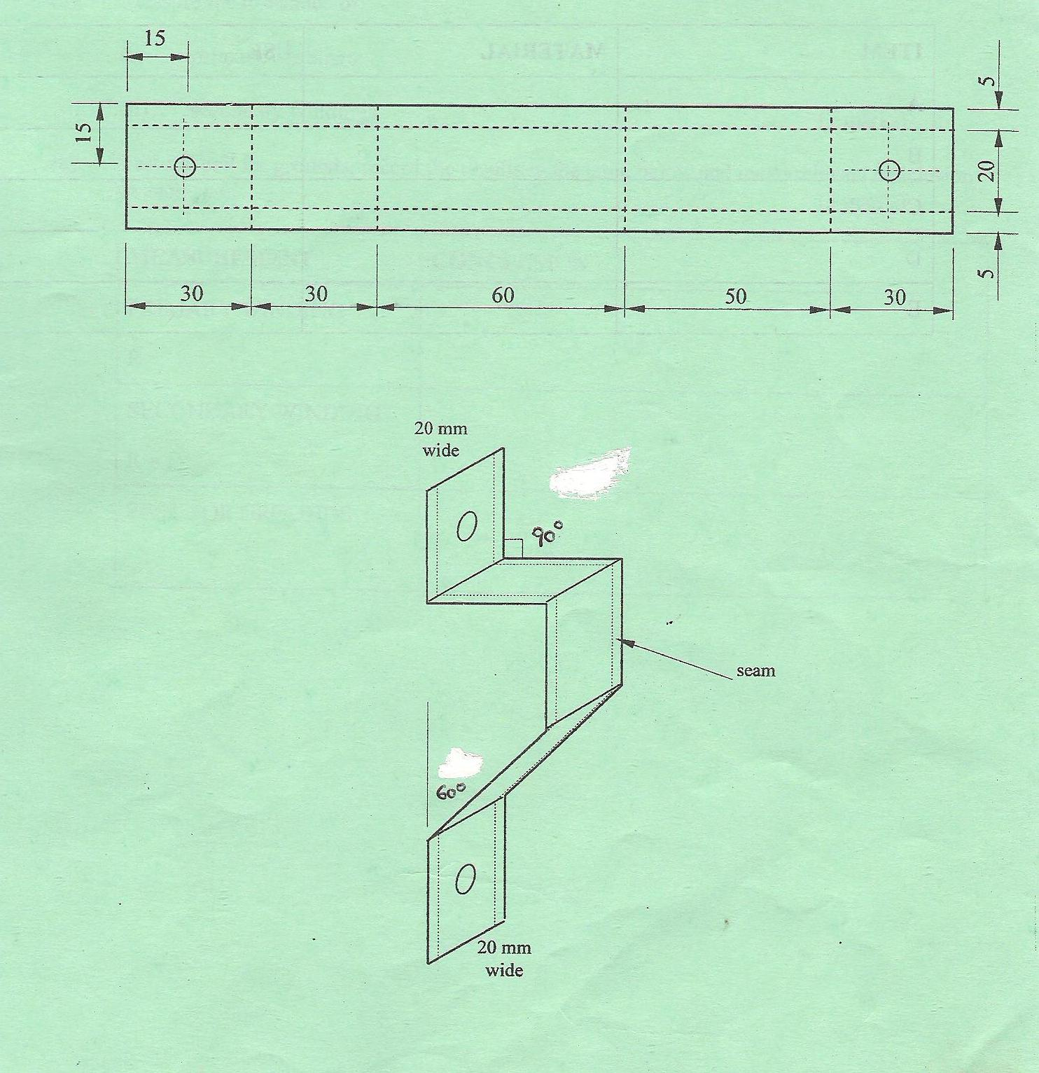

STATION 3

INSTRUCTIONS

Identify the items labeled A to E. State the material each is made of and one use of each part in a motor vehicle (10mks)

ITEM | MATERIAL | USE
A
B
C
D
E

STATION 4

INSTRUCTIONS

Provided on the bench are hand tools used in mechanics. Study them and fill the table below appropriately. (10mks)

TOOL | NAME | USE
A
B
C
D
E
F
G
H
I
J

STATION 5

INSTRUCTIONS

Using tols and gear oil pump provided, carrry out the following tasks;
- Dismantle the pump
- Perform neccessary service checks
- Assemble the pump (10mks)
Let the examiner check your work

STATION 6

INSTRUCTIONS

Identify the motor vehicle parts labelled J, K, L, M and N. Name each part, state the vehicle system it belongs to and state its main function in a motor vehicle. (10marks)

PART | NAME | VEHICLE SYSTEM | FUNCTION
J
K
L
M
N

STATION 7

INSTRUCTIONS

On the single engine provided;
- Remove the exhaust valve.

- Measure and record the exhaust valve diameter.

___________________________________________________________________mm

- Name the tool you have used to take the reading.

_____________________________________________________________________________

- Assemble back the engine.
Let the examiner check your work. (10mks)

STATION 8

INSTRUCTIONS

Study the welding equipment provided. Name and state the function of the parts labeled. (10mks)

PART | NAME | FUNCTION
P
Q
R
S
T

STATION 9
INSTRUCTIONS
- Take the following measurements of the marked parts of the camshaft provided. (7mks)
- Camlobe height using vernier calipers.
___________________________________________________________________________________
- Camlobe diameter using micrometer provided
______________________________________________________________________________
- Journal ovality using dial indicator.
_____________________________________________________________________________
- State the accuracy of each of the following tools. (3mks)
- Vernier calipers_________________________________________
- Micrometer_____________________________________________
- Dial indicator___________________________________________

STATION 10

INSTRUCTIONS

Connect correctly the battery ignition circuit, using the components of the ignition system laid on the bench. (10mks)
Let the examiner check your work.

