Name………………………………………………………Class…………………………………

447/2
POWER MECHANICS
Paper 2
DECEMBER 2021
2 ½ hours

BUNAMFAN CLUSTER EXAMINATION 2021
Kenya Certificate of Secondary Education
POWER MECHANICS
Paper 2
(PRACTICAL)
2 ½ hours

Instructions to candidates

(a) Write your name and index number in the spaces provided above.
(b) Sign and write the date of examination in the spaces provided above.
(c) There are TEN stations in this examination.
(d) Candidates are allowed 15 minutes at each station
(e) At each station, candidates are not allowed to either review the previous stations’ work or read instruction for other stations
(f) Attempt ALL exercises in each station
(g) All dimensions are in millimeters unless otherwise stated.

For examiner’s use only
Stations | 1 | 2 | 3 | 4 | 5 | 6 | 7 | 8 | 9 | 10 | Total
Marks

This paper consists of 7 printed pages. Candidates should check the question paper to
ascertain that all the pages are printed as indicated and that no questions are missing

STATION l

The figure below shows a truncated air cleaner assembly. On the drawing paper provided, sketch in good proportion the exploded view of the assembly and label four parts. (10 marks)

,;

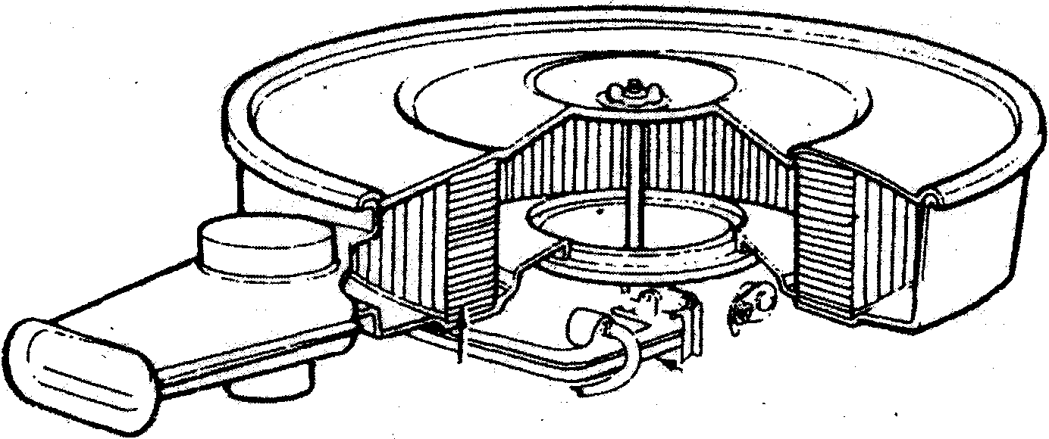

STATION 2

INSTRUCTIONS:

Use the tools, equipment and materials provided to make the
template shown in the figure below.

(10 marks) )

STATION 3

- Demonstrate to the examiner how to test the cylinder head provided for warpage.

- For the piston provided determine:

  - taper;

  - ovality . (6 marks)

(4 marks)

STATION 4

Change the wheel marked on the vehicle provided.
Let the examiner check your work

. STATION 5

Using the measuring tools provided, take and record each of the measurements
(a) | Valve: | (i) | length
 |  | (ii) | margin width
 |  | (iii)  (iv) | stem diameter  head diameter

listed below:
PART AND MEASUREMENT REQUIRED READING

(b) Valve spring free length

(c) Piston ring:
(i) free gap

    - width

    - working gap

(10 marks)

STATION 6
Using the tools provided, determine the compression ratio of the given engine. Take the clearance
volume to be 30 c.c.
(10 marks)

STATION 7

'From the vehicle parts labelled F, G, H, J and K. For each part, identify one defect, state two
Possible effects and complete the table below. ( 10 marks)

"
PART | NAME | DEFECT | EFFECTS
F
G
H
J
K

STATION 8

Using the tools, materials and components provided, connect the starting circuit of a vehicle.
(10 marks)

For the tyre provided:

  - Identify and record the following:

    - Maximum load
    - Maximum inflation limit
    - Type of construction

    - Tyre size
    - Rim size
    - Date of manufacture
STATION 9

  - Identify the defect at the section marked X and state one possible cause of the defect.

DEFECT......................................................................................................................................... .
I
POSSIBLE CAUSE ........................................................................................................................ .
(2 marks)
- Demonstrate to the examiner how to measure the following:

  - inside diameter
.............................................................................................................................................
  - height
.............................................................................................................................................
  - width
·············································································································································
  - tread depth

  - tread width

(5 marks)

STATION 10

- Using the multicylinder engine provided, demonstrate to the examiner how to identify the misfiring cylinder. (6 marks)

- State:

  - Two possible causes of the misfiring in (a) above. (2 marks)

(ii) How each cause in (b) (i) above is determined. (2 marks)

