BUNAMFAN CLUSTER EXAMINATION – 2022
Kenya Certificate of Secondary Education
447/1 – POWER MECHANICS – Paper 1
June 2022 - 2 ½ hours
Name…………………………………Adm No……
Class…………… Date……………………………
Instructions to candidates
- Write your name and admission number in the spaces provided above.
- Sign and write the date of examination in the spaces provided above.
- Candidates should have the following for this examination:
- Drawing instruments;
- Scientific calculator
- Drawing paper size A3.
- This paper consists of two sections; A and B.
- Answer all the questions in section A in the spaces provided.
- Answer question 11 on A3 paper and any other three questions from section B in the spaces provided.
- All dimensions are in millimeters unless otherwise stated.
- This paper consists of printed pages.
- Candidates should check the question paper to ascertain that all pages are printed as indicated and that no questions are missing.
- Candidates should answer the questions in English.
For Examiner’s Use Only
Section | Question | Maximum Score | Candidate’s Score
A | 1 – 10 | 40
 | 11 | 15
 |  | 15
 |  | 15
 |  | 15
 |  | Total Score

SECTION A(40 marks)
Answer all questions in this section in the spaces provided
- a) List four classes of body cuts. (4mks)
- ______________________________________________
- ______________________________________________
- ______________________________________________
- ______________________________________________
- State one safety measure that should be taken under the following circumstances.
- Acid spills in your eyes. (1mk)
________________________________________________________________________________________________________________________________________________
- Fire breaks in the workshop. (1mk)
________________________________________________________________________________________________________________________________________________
- Identify the following tools and state uses of each in power mechanics workshop. (4mks)

Tool | Name | Used for
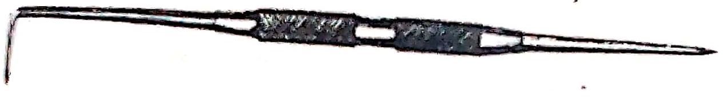
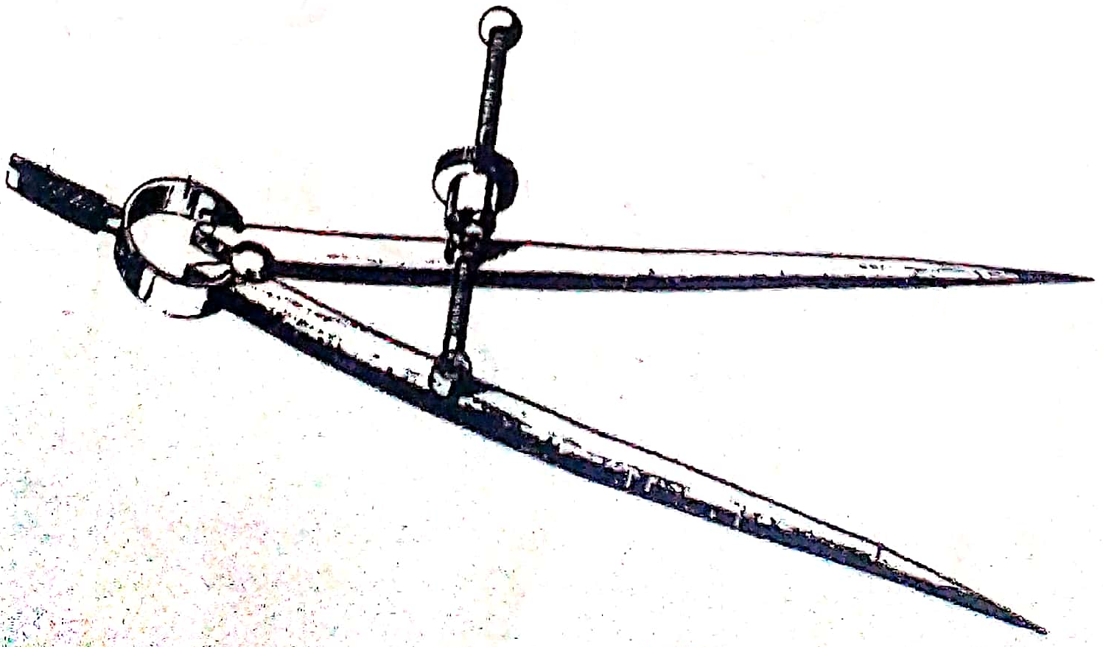

- Give three reasons why aluminium alloys are used in making of piston. (3mks)
- ______________________________________________________________________________________________________________________________________________________
- ______________________________________________________________________________________________________________________________________________________
- ______________________________________________________________________________________________________________________________________________________
- The diagram below shows an engine system. Use it to answer the questions that follows.
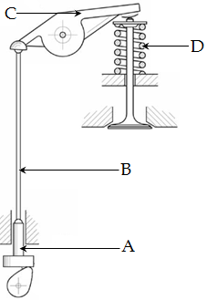
- Name the system. (1mk)
___________________________________________________________________________
- On the diagram, use an arrow to show where valve clearance is measured. (1mk)
- Name the components labeled A and B. (2mks)
- A ______________________________________________________________________
- B _______________________________________________________________________
- State the functions of components C and D. (2mks)
- C ______________________________________________________________________ ________________________________________________________________________
- D ______________________________________________________________________ ________________________________________________________________________
- Explain two reasons why choke valve should be opened immediately after the engine starts. (2mks)
- ______________________________________________________________________________________________________________________________________________________
- ______________________________________________________________________________________________________________________________________________________
- Use the diagram below to answer the questions that follows.
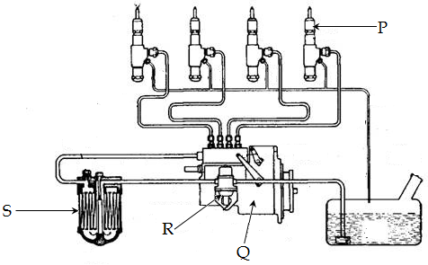
- On the diagram, indicate the direction of fuel flow. (2mks)
- Name the parts labeled P, Q, R and S. (4mks)
- P_______________________________________________________________________
- Q_______________________________________________________________________
- R_______________________________________________________________________
- S_______________________________________________________________________
- State three permanent metal joining processes. (3mks)
- ___________________________________________________________________________
- ___________________________________________________________________________
- ___________________________________________________________________________

- In the space provided below, draw a three phase diode rectification diagram. (3mks)

- Explain the following terms as used in spark plug. (3mks)
- Heat range_________________________________________________________________ ___________________________________________________________________________
- Spark plug reach____________________________________________________________ ___________________________________________________________________________
- Spark plug diameter_________________________________________________________ ___________________________________________________________________________
- Sketch in first angle orthographic views of the following pictorial drawing. (4mks)
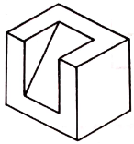

SECTION B (60 marks)
Answer question 11 on A3 paper provided and any other three questions from this section in the spaces provided. Candidates are advised to spend not more than 25 minutes on question 11.
- The following is a machine block drawn in isometric projection.
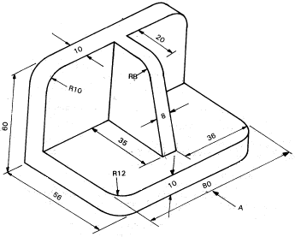
Draw the following views in first angle orthographic projections. (15mks)
- Plan
- Front viewed from direction A
- End view

- a) Explain the following activities in a diesel engine: (4mks)
- Induction stroke_____________________________________________________________ ___________________________________________________________________________
- Exhaust stroke______________________________________________________________ ___________________________________________________________________________
- Compression stroke _________________________________________________________ ___________________________________________________________________________
- Power stroke________________________________________________________________ ___________________________________________________________________________
- State three advantages of a rotary engine as compared to reciprocating engine.(3mks)
- ________________________________________________________________________________________________________________________________________________
- ________________________________________________________________________________________________________________________________________________
- ________________________________________________________________________________________________________________________________________________
- Explain the functions of the following engine parts; (4mks)
- Recoil starter_____________________________________________________________ ________________________________________________________________________
- Power take – off shaft_____________________________________________________ ________________________________________________________________________
- Automatic advance_______________________________________________________ ________________________________________________________________________
- Dip stick________________________________________________________________ ________________________________________________________________________

- Explain the meaning of the following terms; (4mks)
- Lean mixture_______________________________________________________________ ___________________________________________________________________________
- Rich mixture________________________________________________________________ ___________________________________________________________________________
- Over square engine__________________________________________________________ ___________________________________________________________________________
- Under square engine_________________________________________________________ ___________________________________________________________________________
- a) Identify two precautions to be observed when handling each of the following
equipment in a workshop. (6mks)
- Gas cylinders____________________________________________________________ ________________________________________________________________________________________________________________________________________________
- Hoses and connections____________________________________________________ ________________________________________________________________________________________________________________________________________________
- Torches_________________________________________________________________________________________________________________________________________________________________________________________________________________
- Define backfire in oxy-acetyline welding. (1mk)
______________________________________________________________________________________________________________________________________________________

- With the aid of diagrams differentiate between leftward and rightward welding techniques. (8mks)

- a) State four factors which are considered when selecting oil for use in a particular
engine. (4mks)
- _______________________________________________________________________
- _______________________________________________________________________
- _______________________________________________________________________
- _______________________________________________________________________
- List and explain four types of engine lubrication. (4mks)
- ______________________________________________________________________________________________________________________________________________
- ______________________________________________________________________________________________________________________________________________
- ______________________________________________________________________________________________________________________________________________
- ______________________________________________________________________________________________________________________________________________
- With aid of a sketch, explain how oil pressure indicator light operates. (7mks)

- Use a neat diagram to show the construction and explain operation of a voltage regulator. (15mks)

