FORM 4, BUNAMFAN EVALUATION TEST
Kenya Certificate of Secondary Education
447/1 – POWER MECHANICS – 447/1
Paper 1
(THEORY)
Jul. 2021 - 2½ hours
Name……………………………………….……….........………Adm. No……..…………
Candidate’s Signature………………….……….……………...Date……………….……
Instructions to candidates
- Write your name and admission number in the spaces provided above.
- Sign and write the date of examination in the spaces provided above.
- Candidates should have the following for this examination:
- Drawing instruments;
- Scientific calculator
- Drawing paper size A3.
- This paper consists of two sections; A and B.
- Answer all the questions in section A in the spaces provided.
- Answer question 11 on A3 paper and any other three questions from section B in the spaces provided.
- All dimensions are in millimeters unless otherwise stated.
- This paper consists of printed pages.
- Candidates should check the question paper to ascertain that all pages are printed as indicated and that no questions are missing.
- Candidates should answer the questions in English.
For Examiner’s Use Only
Section | Question | Maximum Score | Candidate’s Score
A | 1 – 10 | 40
 | 11 | 15
 |  | 15
 |  | 15
 |  | 15
 |  | Total Score

SECTION A(40 marks)
Answer all questions in this section in the spaces provided
- a) List four classes of body cuts. (4mks)
- ______________________________________________
- ______________________________________________
- ______________________________________________
- ______________________________________________
- State one safety measure that should be taken under the following circumstances.
- Acid spills in your eyes. (1mk)
________________________________________________________________________________________________________________________________________________
- Fire breaks in the workshop. (1mk)
________________________________________________________________________________________________________________________________________________
- Identify the following tools and state uses of each in power mechanics workshop. (4mks)

Tool | Name | Used for
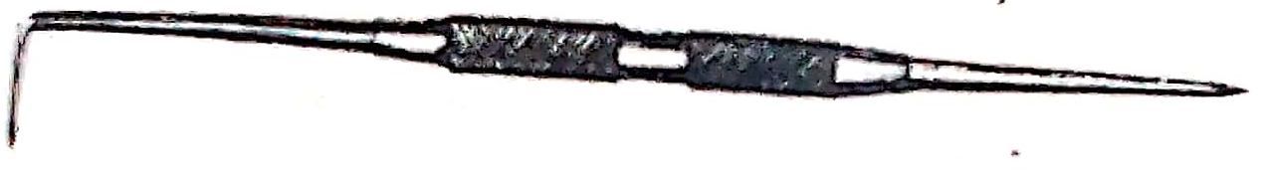
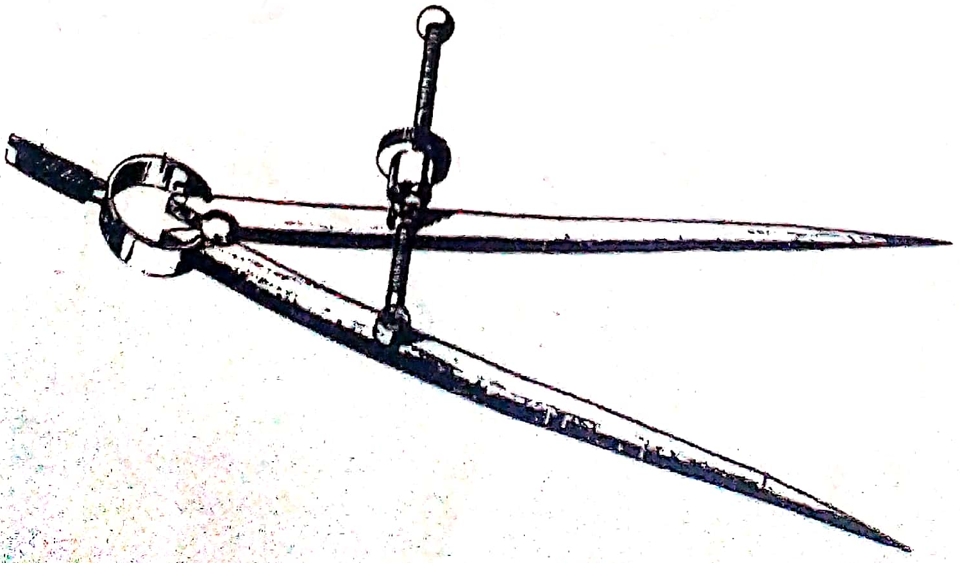

- List four properties that a bearing should have. (3mks)
- _________________________________________________________________________________
- _________________________________________________________________________________
- _________________________________________________________________________________
- The diagram below shows an engine system. Use it to answer the questions that follows.
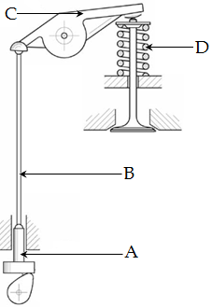
- Name the system. (1mk)
___________________________________________________________________________
- On the diagram, use an arrow to show where valve clearance is measured. (1mk)
- Name the components labeled A and B. (2mks)
- A ______________________________________________________________________
- B _______________________________________________________________________
- State the functions of components C and D. (2mks)
- C ______________________________________________________________________ ________________________________________________________________________
- D ______________________________________________________________________ ________________________________________________________________________

- Explain two reasons why choke valve should be opened immediately after the engine starts. (2mks)
- __________________________________________________________________________________________________________________________________________________________________
- __________________________________________________________________________________________________________________________________________________________________
- Use the diagram below to answer the questions that follows.
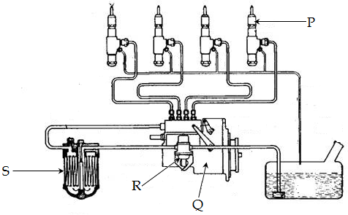
- On the diagram, indicate the direction of fuel flow. (2mks)
- Name the parts labeled P, Q, R and S. (4mks)
- P_______________________________________________________________________
- Q_______________________________________________________________________
- R_______________________________________________________________________
- S_______________________________________________________________________
- State three permanent metal joining processes. (3mks)
- ___________________________________________________________________________
- ___________________________________________________________________________
- ___________________________________________________________________________

- List two power transmitters in an engine and state specific place in an engine where each is applied. (4mks)
- _________________________________________________________________________________
- _________________________________________________________________________________
- _________________________________________________________________________________
- Explain the following terms as used in spark plug. (2mks)
- Heat range______________________________________________________________________ _________________________________________________________________________________
- Spark plug reach_________________________________________________________________ _________________________________________________________________________________
- Sketch in first angle orthographic views of the following pictorial drawing. (4mks)
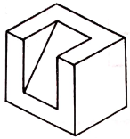

SECTION B (60 marks)
Answer question 11 on A3 paper provided and any other three questions from this section in the spaces provided. Candidates are advised to spend not more than 25 minutes on question 11.
- The following is a machine block drawn in isometric projection.
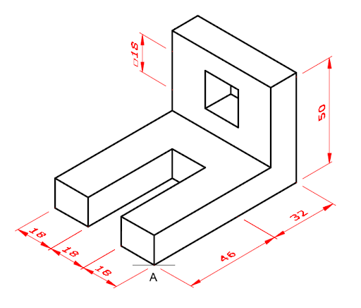
On the A3 plain paper provided, draw the block as it is in isometry. (15mks)

- The following is a three speed gear box. Use it to answer questions that follow.
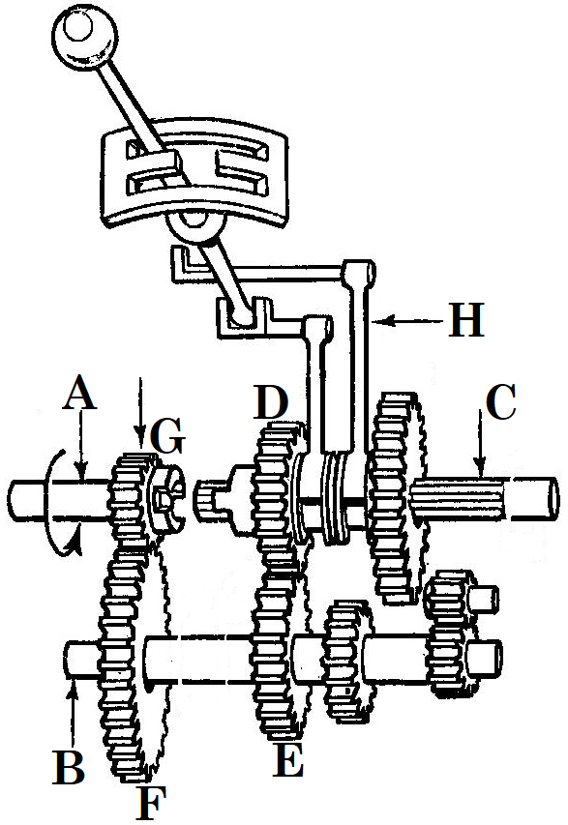
- Name the parts labeled the following; (4mks)
- A____________________________________________________
- B____________________________________________________
- C____________________________________________________
- H____________________________________________________
- Name the type of gear box. (1mk)
_________________________________________________________
- State one disadvantage of the gearbox shown above. (1mk)
__________________________________________________________________________________________________________________________________________________________________
- If shaft A rotates in the direction shown, show on the same diagram, the direction of rotation of shaft C. (1mk)
- Gears G, F, E and D have 20, 28, 20 and 25 teeth respectively. If the engagement is as shown, calculate;
- Torque multiplication at stage 1. (2mks)

- Torque multiplication at stage 2. (2mks)

- Torque multiplication factor. (2mks)

- Apart from the type of gearbox in the diagram, name two other types. (2mks)
- _______________________________________________________
- _______________________________________________________
- a) Identify two precautions to be observed when handling each of the following
equipment in a workshop. (6mks)
- Gas cylinders
- ______________________________________________________________________________________________________________________________________________________
- ______________________________________________________________________________________________________________________________________________________
- Hoses and connections
- ______________________________________________________________________________________________________________________________________________________
- ______________________________________________________________________________________________________________________________________________________
- Torches
- ______________________________________________________________________________________________________________________________________________________
- ______________________________________________________________________________________________________________________________________________________
- Define backfire in oxy- acetyline welding. (1mk)
______________________________________________________________________________________________________________________________________________________
- Draw a diagram showing rightward welding technique. (4mks)

- Apart from welding, state and explain two other metal joining processes. (4mks)
- ____________________________________________________________________________________________________________________________________________________________
- ____________________________________________________________________________________________________________________________________________________________

- a) State three quality requirement of a propeller shaft. (3mks)
engine.
- _______________________________________________________________________
- _______________________________________________________________________
- _______________________________________________________________________
- Explain the effect of the following to a propeller shaft. (4mks)
- Too long_____________________________________________________________________ _____________________________________________________________________________
- Too heavy ___________________________________________________________________ _____________________________________________________________________________
- Explain why the following is necessary in transmission; (4mks)
- Universal joint.
____________________________________________________________________________________________________________________________________________________________
- Slip joint.
____________________________________________________________________________________________________________________________________________________________
- Explain the difference between Hotchkiss drive shaft and torque tube. (2mks)
___________________________________________________________________________________________________________________________________________________________________________________________________________________________________________________
- List any two non – constant universal joints. (2mks)
- ______________________________________________________________________________
- ______________________________________________________________________________
- Study the diagram below and answer the questions that follow.
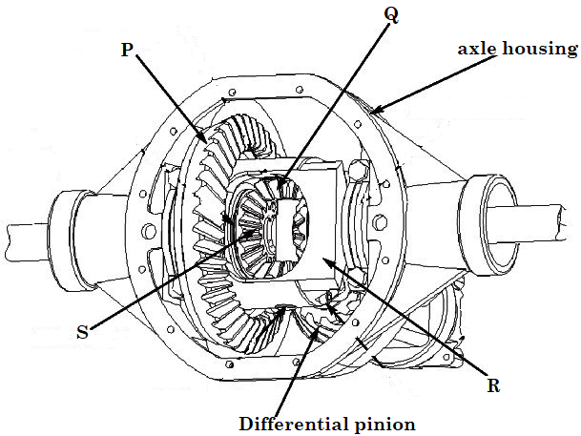
- Name the parts labeled; (4mks)
P ____________________________________________________
Q ____________________________________________________
R ____________________________________________________
S ____________________________________________________
- List two functions of a final drive. (2mks)
- ____________________________________________________________________________________________________________________________________________________________
- ____________________________________________________________________________________________________________________________________________________________
- State one function of a differential unit. (1mk)
__________________________________________________________________________________________________________________________________________________________________
- List one shortcoming of a differential unit. (1mk)
__________________________________________________________________________________________________________________________________________________________________
- Explain how the differential unit works when;
- The vehicle is moving in a straight forward motion. (3mks)
______________________________________________________________________________________________________________________________________________________________________________________________________________________________________________________________________________________________________________________________________________________________________________________________________
- The vehicle is cornering to the right. (3mks)
____________________________________________________________________________________________________________________________________________________________________________________________________________________________________________________________________________________________________________________________________________________________________________________________________________________________________________________________________________________
~ THE END ~

