NAME_______________________________________________ ADMNO ___________________________

SIGNATURE________________________DATE____________________CLASS____________________

ASUMBI GIRLS HIGH SCHOOL
TERM 2 – DECEMBER 2021
FORM 4 – PHYSICS PAPER 2

232/2
Physics
Paper 2
Time: 2 hours

Instructions
- Write your name, index number and name of your school in the spaces provided above.
- This paper consists of two sections, section I and II. Answer all the questions in both sections.
- Mathematical tables and silent non – programmable calculators may be used.
- This paper consist of 12 printed pages. Ensure all the pages are printed.

For examiners’ use only

section | Question | Maximum score | Candidate’s score
I | 1 – 11 | 25
II | 12 | 11
 | 13 | 11
 | 14 | 11
 | 15 | 12
 | 16 | 10
Total |  | 80

Section I (25 marks)
Answer all the questions in this section
- What is the reading shown by the pointer in the figure below, if the full scale range is;
2.0
1.5
1.0
3
2
1
4
2.5
0.5
0
5
0
mA

  - 0 - 2.5 (1 mark)
…………………………………………………………………………………………
  - 0 – 5 (1 mark)
…………………………………………………………………………………………
- The following diagram shows two mirrors inclined at an angle to each other. A ray of light is incident on one of the mirrors and finally reflected from the second mirror parallel to the first mirror find the angle between the mirrors. (2 marks)
30⁰
ɵ

- It is not possible to charge an electroscope by contact method using a metal rod. Explain
(2 marks)
………………………………………………………………………………………………………………………………………………………………………………………………………………………………………………………………………………………………………………………………………

- A car battery is rated 40 Ah and it is expected to supply a constant current for 120 minutes.
  - What is the strength of the current delivered? (2 marks)

………………………………………………………………………………………………………………………………………………………………………………………………………………………………………………………………………………………………………………………………
  - Explain why eight dry cells in series cannot be used to start a car engine even though they have the same e.m.f. (1 mark)

……………………………………………………………………………………………………………………………………………………………………………………………………………………
- A coil of insulated wire is wound around a u – shaped soft iron core X Y and connected to a battery as shown below.

Y
X

State the polarities of the ends X and Y. (2 marks)
X ……………………………………
Y……………………………………
- The figure below shows a coil carrying a current flowing in the direction shown in a magnetic field.
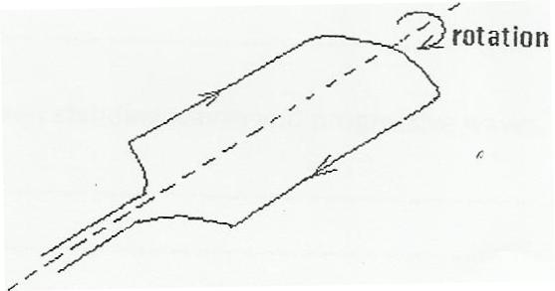

On the same diagram draw the magnetic field lines across the coil. (1 mark)

- An object of height 5 cm is placed 25 cm from a convex mirror of focal length 15 cm. determine the image distance and hence state the nature of the image formed. (3 marks)

……………………………………………………………………………………………………………………………………………………………………………………………………………………………………………………………………………………………………………………………………………………………………………………………………………………………………………………
- Loudspeaker placed between two wall A and B is sending out constant wave pulses. Determine how far the loudspeaker is from wall B if it is 100m from wall A, and the time between the two echoes received is o.2 seconds (speed of sound is 340m/s) (3 marks)

………………………………………………………………………………………………………………………………………………………………………………………………………………………………………………………………………………………………………………………………………………………………………………………………………………………………………………………………………………………………………………………………………………………………
- The following table shows part of the electromagnetic wave spectrum.

Ultraviolet rays
Microwaves
X-rays
Visible light

- On the right column of the table, arrange the waves in the order of decreasing energy. (1 marks)
- Give an application of each of the following electromagnetic waves. (2 marks)
    - Ultraviolet rays:
…………………………………………………………………………………………………………
    - Microwaves:
…………………………………………………………………………………………………………

- A 4 resistor is connected in series to a battery of e.m.f 6V and negligible internal resistance. Determine the power dissipated by the resistor. (2 marks)

………………………………………………………………………………………………………………………………………………………………………………………………................................................................................................................................................................................................................................................................................................................................................................................
- State any two laboratory safety rules that deal with electrical safety in the lab. (2 marks)

………………………………………………………………………………………………………………………………………………………………………………………………………………………………………………………………………………………………………………………………………

Section II (55 marks)
Answer all the questions in this section.
- a) Define term focal length as used in thin lenses (1 mark)
…………………………………………………………………………………………………………………………………………………………………………………………………………………………
- Give the functions of the following parts of a lens camera. (3 marks)

    - Shutter: …………………………………………………………………………………...
    - Film: ………………………………………………………………………………………
    - Diaphragm: …………………………………………………………………………………
- A compound microscope with objective lens L₁ of focal length 0.8cm and an eyepiece lens L₂ of focal length 2.5cm is shown in figure below. An object O is placed in front of the objective lens at a distance u₁ of 1.2cm. The system forms a final image I₂ at a distance of 10cm from L₂. Determine the distance of separation of lenses L₁ and L₂. (4 marks)

F_{o}
F_{o}
F_{e}
O
I₂
L₁
L₂
d

………………………………………………………………………………………………………………………………………………………………………………………………………………………………………………………………………………………………………………………………………………………………………………………………………………………………………………………………………………………………………………………………………………
- The figure below (figure 9) shows an object placed in front of a convex lens. Complete the ray diagram to show the position of the image. (3 marks)

- The figure below shows the features of an X-ray tube
Vacuum
Filament supply
Tungsten target

Copper anode
x-rays
Cathode
Filament
High p.d
-
+

oil

        - (i) What is the purpose of the oil going in and out of the anode (1mk)
……………………………………………………………………………………………………………………………………………………………………………………………………
(ii) State the property of tungsten that makes it suitable as a target (1mk)
……………………………………………………………………………………………………………………………………………………………………………………………………
(b)An X-ray tube operates with a potential difference of 100kv and filament current is 20mA. Calculate;
- The power transferred to the target of X-ray tube (2mks)
………………………………………………………………………………………………………………………………………………………………………………………………………………………………………………………………………………………

- The number of electrons hitting the target per second (2mks)
………………………………………………………………………………………………………………………………………………………………………………………………………………………………………………………………………………………
- The maximum kinetic energy of emitted electrons (Take charge of an electron=1.6x10⁻¹⁹C, mass of an electron =9.1x10⁻³¹kg) (2mks)
………………………………………………………………………………………………………………………………………………………………………………………………………………………………………………………………………………………
(c) The diagram shows monochromatic radiation falling on a photocell connected to a circuit
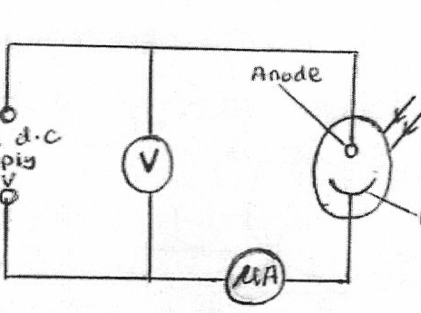

Variable d.c supply -6v to 6v
Anode
Incident monochromatic radiation
Photo cathode

The incident radiation has a wavelength of 2.15x10⁻⁷m. The metal surface of the photocell has a work function of 2.26 eV.
          - Calculate the energy in eV of a photon of the incident radiation (Take c=3.0x10⁸m/s, h=6.63x10⁻³⁴Js and e=1.6x10⁻¹⁹C) (3mks)

……………………………………………………………………………………………………………………………………………………………………………………………………………………………………………………………………………………………………………………………………………………………………………………………………………………
          - What is the maximum kinetic energy of the emitted electrons (2mks)
……………………………………………………………………………………………………………………………………………………………………………………………………………………………………………………………………………………………………………………………………………………………………………………………………………………
          - Write down the value of the stopping potential (1mk)
………………………………………………………………………………………………………
- a) State Snell’s law (1 mark)
…………………………………………………………………………………………………………………………………………………………………………………………………………………………
          - A student prepares to swim to the bottom of a pool to pick a coin on the bed. It is only while under the water that she realizes the presence of a sharp object beside the coin that she had not seen. Explain a possible reason why it was not visible in clear swimming pool water. (1 mark)
…………………………………………………………………………………………………………………………………………………………………………………………………………………
          - The figure below shows a ray of light travelling
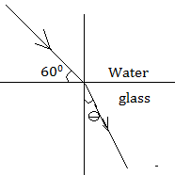

    - Calculate the refractive index of water with respect to glass given the refractive index of glass and water are ³/₂ and ⁴/₃ respectively. (2 marks)

……………………………………………………………………………………………………………………………………………………………………………………………………………………………………………………………………………………………………………………………………………………………………………………………………………………
    - Calculate the angle Ɵ (2 marks)
……………………………………………………………………………………………………………………………………………………………………………………………………………………………………………………………………………………………………………………………………………………………………………………………………………………
d) Using a well-labeled diagram, describe how optic fibers are used for communication. (3 marks)

- a) Define the term capacitance. (1 mark)
………………………………………………………………………………………………………………………………………………………………………………………………………………………
b) The figure below shows two charged plates close to each other
+ + + + + + + + + + + + + + + -
- - - - - - - - - - - - - - - - - - - - - - - -

    - Complete the diagram to show the electric field patterns between the plates (1 mark)

- Without changing the area of overlap, suggest any two ways of increasing the capacitance of a parallel plate capacitor. (2 marks)
…………………………………………………………………………………………………………………………………………………………………………………………………………
c) You have been provided with THREE identical capacitors each of capacitance 12F. State and show how you would combine them to get the following effective capacitance

          - 36µF (2marks)
………………………………………………………………………………………………………………………………………………………………………………………………………………………………………………………………………………………………………………………………………………………………………………………………………………………………………
          - 4µF (2marks)
…………………………………………………………………………………………………………………………………………………………………………………………………………………………………………………………………………………………………………………………………………………………………………………………………………………………………………
          - 8µF (2marks)
…………………………………………………………………………………………………………………………………………………………………………………………………………………………………………………………………………………………………………………………………………………………………………………………………………………………………………
- (a) (i) The following nuclear reaction is part of a radioactive series

            - Name the radiation represented by r and s (1mk)
r …………………………………………………………………………
s ………………………………………………………………………..
            - Determine the number represented by x and y (1mk)
x ………………………………………………………………………….
y …………………………………………………………………………….

(ii) The figure below shows the features of diffusion cloud chamber used for detecting radiations from radioactive sources

Felt soaked in alcohol
Base of chamber
Radioactive source
Solid CO₂
Form

Transparent glass
Lamp

- State the property of alcohol that makes it suitable for use in the chamber (1mk)
……………………………………………………………………………………………………
- What is the purpose of the solid CO₂? (1mk)
…………………………………………………………………………………………………
- Explain how the radiation from the radioactive source is detected in the chamber. (2mks)

IV. State one advantage of the cold chamber over a charged gold leaf electroscope when used as detectors of radiation (1mk)

(b) The graph below shows how the activity of a sample of the radioisotope technetium which is used extensively in medicine, varies with time

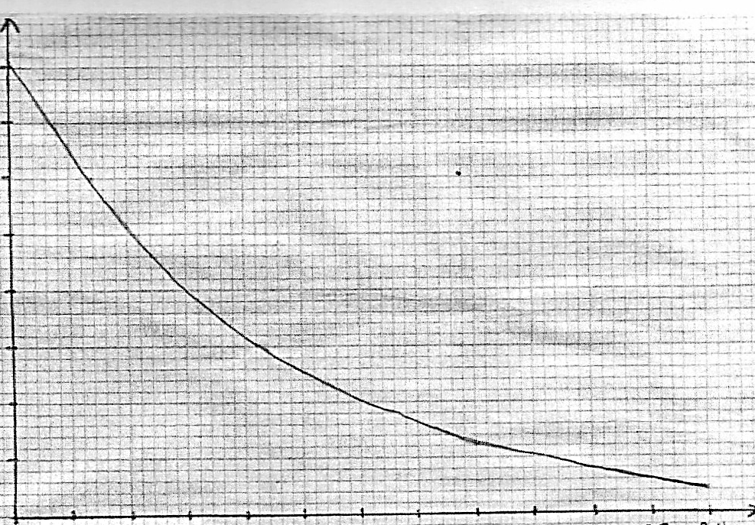
0
2
4
6
8
10
12
14
16
18
20
22
24
0
1
2
3
4
5
6
7
8
Activity x 10⁷(B₂)

Time (hours)

I. Use the graph to determine the half-life. T ½ of technetium (1mk)

II. Hence calculate the decay constant for technetium given that where λ is the decay constant. (1mk)

III. Determine the number of technetium atoms remaining in the sample after 24 hours (1mk)

