PHYSICS FORM 4 PP2

NAME…………………………………………………………………..CLASS…………………….ADM……………

- State the property of light suggested by the formation of shadows. (1 mark)

2. The figure below shows a sharp pin fixed on a cap of leaf electroscope. The electroscope is highly charged and then left for sometime.
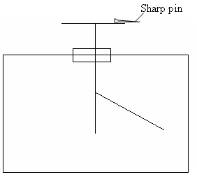

Explain why the leaf collapses. (2 marks)

The figure below shows an object O placed infront of a plane mirror.
Object O
•
(E)
eye

On the same diagram, draw rays to locate the position of the image I as seen from the eye E. (2 marks)

4. (a) State the basic law of magnetism. (1 mark)

- The figure below shows how magnets are stored in pairs with keepers at the ends.
S
N
N
S
Bar magnets
Keeper
Keeper

Explain how this method of storing helps in retaining magnetism longer. (2 marks)

5. Why is a convex mirror better than plane mirror when used as a driving mirror? (1 mark)

6.
The figure 2 shows a circuit diagram with cells in parallel. Each cell has e.m.f of 1.5V and internal resistance of 0.5Ω and the resistance of the bulb is 6Ω each. Determine the ammeter reading when the switch is closed. (3mks)

Bulb
A

Switch

Fig2
7. An appliance is rate 2.5KW, 240V a.c 50Hz. Explain the meaning of the rating(figures) on this appliance. (2mks)

- The following are electromagnetic waves. Arrange them according to their increasing frequency. Gamma rays, microwaves, ultra-violet, TV waves and blue light. (1mk)

- Distinguish between a transformer and induction coil. (2mks)

- Distinguish between a transverse and a longitudinal wave. (1 mark)

(b) Determine the frequency of the wave shown below. (2 marks)
0.5
1.0
1.5
2.0
Time(s)
Displacement (m)

- An electric heater rated 240V, 3000W is to be connected to a 240V mains supply, through a 10A fuse. Determine whether the fuse is suitable or not. (3 marks)

(c) State one reason why ultrasound is preferred to audible sound in echo-sounding. (1 mark)

- An electric heater rated 240V, 3000W is to be connected to a 240V mains supply, through a 10A fuse. Determine whether the fuse is suitable or not. (3 marks)

- Kiai noticed that any time he a light from his car and close the door holding the metallic hand he get a slight shock. Explain. (2mks)

SECTION B (55 MARKS)
Answer all the questions from this section in the spaces provided.

- A transformer with 2000 turns in the primary circuit and 150 turns in the secondary circuit
has its primary circuit connected to a 800Va.c. source. It is found that when a heater is
connected to the secondary circuit it produces heat at the rate of 1000W. Assuming 100%
efficiency, determine the:
(i) Voltage in the secondary circuit. (2 marks)
(iii) Current in the secondary circuit. (1 mark)

(iv) State the type of transformer represented above. (1 mark)

(b) (i) State the reason why long distance power transmission is done at a very high
voltage and using thick cables. (1 mark)

- Calculate the cost of using the following appliances in one month (30 days) of the company rate is Ksh.9.50 per unit.
I A 2000W water heater for 2 hours per day.
II A 75W bulb for 10 hours per day.
III An 1500W electric iron for 1 hour per day. (3 marks)
- Find the total monthly bill for the above household if in addition to the energy consumed, the power company charges each consumer.
I A standing charge of Ksh.200.
II Fuel cost levy at 70 cents per unit. (2 marks)

- (a) State two ways in which one can increase the strength of an electromagnet. (2 marks)

(b) The following figure shows a conductor placed in a magnetic field. Indicate on the diagram the direction of motion of part AB of the conductor. (2mks)

Magnetic field
A
B

- A cell drives a current of 5A through a 1.6Ω resistor. When connected to a 2.8Ω resistor,
the current that flows in 3.2A. Find E and r for the cell. (4 marks)

- Calculate the length of a nichrome resistance wire of cross-sectional area 7 ×10ˉ⁸m²
required to make a resistor of 10 ohms. (Take resistivity of nichrome = 1.10 × 10ˉ⁶Ωm).
(3 marks)

(e) In figure below, calculate the p.d across resistor R. (2 marks)
2A
3A
10Ω
R

(ii) Current in the primary circuit. (2 marks)

- The figure below shows rays of light entering a human eye which has a defect.

- Name the defect. (1mk)

- State 2 possible causes of the defect. (1mk)

b) Define the accommodation. (1mk)

c) A small bright object O lies at the bottom of a beaker containing water of depth h cm. A convex lens of focal length 15cm is held at the surface of water. The lens forms an image of O at 45cm from the surface of water.

Image

45cm

Lens

h

Object

Taking the refractive index of water to be 4/3, determine:
- the apparent depth of the object(2mks)

- the real depth h, of the object (2mks)

d. A ray of light is incident at right angles to the face AB, of a right angled isosceles prism of
Refractive index 1.6 as shown in the figure below.

Liquid
C

A
Liquid Liquid

If the prism is surrounded by a liquid of refractive index 1.40, determine:
- The angle of incidence on the face BC. (2mk)

- The angle of refraction on the face BC. (3mks)

- State two ways through which the rate of evaporation of a liquid may be increased. (2 marks)

- A metal of mass 10kg is heated to 120ºC and then dropped into 2kg of water. The final temperature of the mixture is found to be 50ºC. Calculate the initial temperature of the water. (Specific heat capacity of the metal and water is 450JKgˉ¹Kˉ¹ and 4200JKgˉ¹Kˉ¹ respectively). (3mks)

- Give the property of water which makes it suitable for use as a coolant in machines. (1 mark)

- Formation of ice on roads during winter in cold countries is known to hamper vehicles.
State two ways in which the melting point of ice may be lowered to solve this problem.
(2 marks)

(f) Some ether is put in a combustion tube and two glass tubes inserted into the tube through
a cork as shown in the figure below. The combustion tube is then put into a small beaker containing some water and a thermometer dipped in the water. When air is blown into the ether as shown, the reading in the thermometer lowers. Explain this observation. (2 marks)

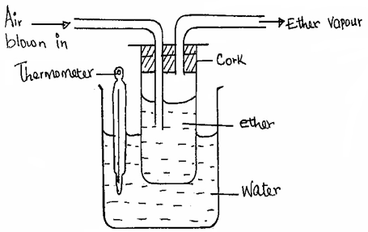

18. (a) An object is released to fall vertically from height of 100m. At the same time another object is projected vertically upward with velocity of 40m/s.
(i) Calculate the time taken before the objects meet (3mks)

(ii) At what height do the objects meet? (2mks)
(b) A string of negligible mass has a bucket tied at the end. The string is 60cm long and the bucket has a mass of 45g. The bucket is swung horizontally making 6 revolutions per second. Calculate
(i) The angular velocity (2mk)

(ii) The angular acceleration (2mks)

(iii) The tension on the string (2mks)

- The linear velocity (1mk)

