BUNAMFAN CLUSTER EXAMINATION – 2022
Kenya Certificate of Secondary Education
232/3 – PHYSICS – Paper 3
June 2022 - 2 ½ hours
Name…………………………………Adm No……
Class…………… Date……………………………

INSTRUCTIONS TO CANDIDATES
1. Write your name, index number, class, date and signature in the spaces provided above.
2. This paper consists of two questions 1 and 2.
3. Answer all questions in the spaces provided.
4. Non-programmable calculators and mathematical tables may be used.
5. Show all your workings.

QUESTION 1 | a | d | e | f | g | h | k | TOTAL
Maximum score | ½ | 1½ | 1 | 3½ | 2 | 6½ | 5 | 20
Candidates score

QUESTION 2 | c | d | e | f | i | j | k | l | TOTAL
Maximum score | 2 | 2 | 1 | 2 | 4 | 5 | 2 | 2 | 20
Candidates score

This paper consists of 10 printed pages. Candidates should check the question paper to ensure that all pages are printed as indicated and no questions are missing

QUESTION 1
PART A
You are provided with the following:
-A watch glass
-A piece of plasticine
-A marble
-A Stopwatch
-An electronic balance (to be shared)
- Vernier calipers (to be shared)
- Geometrical set
Proceed as follows:
(a) Measure the mass, m of the marble.
m = …………………………g (¹/₂mark)
b) Place the watch glass on the table. Cut the plasticine into two pieces and use them to hold the watch glass firmly on the table as shown in Figure 1.
c). Release the marble from one end of the watch glass and time 5 complete oscillation with the stopwatch. Repeat this one more time.
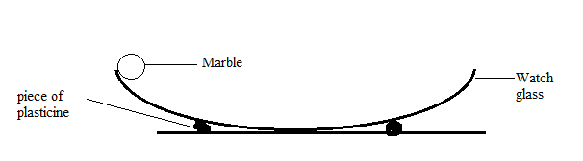
Figure 1

d) Record your values in the Table 1 (1¹/₂ marks)
Attempt | Time for 5 oscillations (seconds) | Periodic time, T(s)
1st
2nd
Table 1
e) Find the average periodic time T (1mark)

f) (i)Measure the diameter of the marble with the Vernier calipers, hence find its radius
Diameter, d = ………………… (1mark)
Radius, r = …………………….m (¹/₂mark)
(ii)Determine the volume of the marble given that V=$\frac{4}{3}$πr³ where π=3.142 (1mark)

(iii)Calculate the radius of the curvature of the watch glass R from the formula R - r =$\frac{5gT^{2}}{7{(2π)}^{2}}$
Where g=10m/s² and π=3.142 (1mark)

PART B
You are provided with the following:
• A glass prism
• A plain sheet of paper
• A soft board
• 4 optical pins
• 2 Thumb tacks

Proceed as follows:
g) (i)Firmly fix the plain sheet of paper on the soft board using the thumb tacks and place the prism at the centre of the paper. Trace the outline of the prism using a pencil.
(ii)Remove the prism from the outline and label the vertices of the outline L, M and N as shown in Figure 2
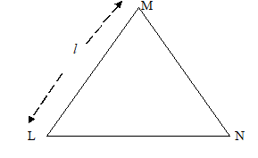
Figure 2

Measure Angle LMN and length, Ɩ using a ruler
Angle LMN = ……………………… (1mark)
Length, Ɩ = ………………………… (1mark)
iii) On the side ML mark a point and draw the normal at that point. Measure an angle T, 60° from the line LM and draw a line along this angle as shown in Figure 3.

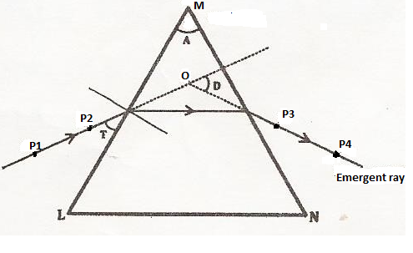
Figure 3

iv). Replace the prism on the outline and fix pins P₁ and P₂ on the 60° line at a distance of 3cm from each other. View the images of the pins P₁ and P₂ through side MN and fix P₃ and P₄ so that they appear to be on straight line with the images of P₁ and P₂.
v). Remove the prism and the pins and draw a line to pass through the holes made by pins P₃ and P_{4.} Extend the line into the outline as shown in figure 3 above. Also extend the 60° line so that the two lines cross each other at point O. Determine angle D and record it in the Table 2
h). (i)Repeat the procedure and complete the Table 2 (2 ¹/₂marks)

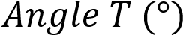 | 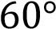 | 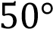
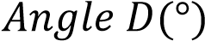
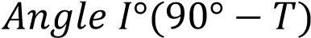
Table 2
(ii) Determine the average value D_{m} of D (1mark)

iii) Determine the constant k for the glass prism from the formula (2marks)
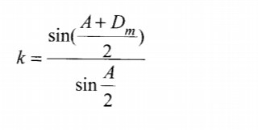

iv) State the significance of k (1mark)

PART C
You are provided with the following:
• A lens holder
• Convex lens
• A candle
• A white screen
• A metre rule
Proceed as follows:
i) Set up the apparatus as shown in Figure 4
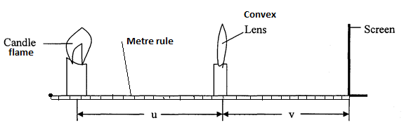
Figure 4

(j) Starting with u = 30 cm, adjust the position of the screen to obtain a sharp image of the candle flame. Record the value of v in Table 3.

(k)(i) Repeat the procedure in (i) for u = 30 cm. Complete Table 3 (3marks)

u (cm) | v (cm) | m =$\frac{v}{u}$
30
50

Table 3
(ii) Given that the focal length f of the lens satisfies the equation f$= \frac{v}{m+1}$, determine the average value of the focal length, f. (2 marks)

QUESTION 2
You are provided with the following:
- An ammeter (0 – 1 A)
- A voltmeter (0 – 3 V or 0 – 5 V)
- A variable resistor
- A 10Ω carbon resistor
- A piece of resistance wire
- Two new dry cells
- A cell holder
- A switch
- Seven connecting wires

Proceed as follows:
a) Take the resistant wire and coil it around the biro pen to make a coil.
b) Set up the apparatus as shown Figure 5 below such that the 10Ω carbon resistor and the coil are in parallel connection.
Coil
A
V
Figure 5

c) Close the switch and the adjust the variable resistor such that the ammeter read a current of I₁=0.08A and record the corresponding voltmeter reading V₁
i) V₁ =………………… (1mark)
ii) Calculate resistance (1mark)

d) Repeat (c) above for current of I₂ = 0.16A and record the corresponding voltmeter reading V₂
i) V₂ =………………… (1mark)
ii) Calculate resistance (1mark)

e) Find the average value of resistance R (1mark)

f) Determine the resistance, C of the coil (2marks)

g) Now set up the apparatus as shown in Figure 6 below such that the voltmeter is connected across the cells, 10Ω carbon resistor and the coil are in parallel connection.
Coil
A
V
Figure 6

h) Close the switch and the adjust the variable resistor such that the ammeter reads a current of 0.04A and note the corresponding voltmeter reading. Record the value in the Table 4 below.

i) Repeat (h) above for other values of current and voltage and complete the Table 4 below
Current, I (A) | 0.04 | 0.08 | 0.12 | 0.16 | 0.20 | 0.24
Voltage, V(V)
(4marks) Table 4
j) On the grid provided plot a graph of Voltage, V (V) against Current, I (A) (5marks)

k) Determine the slope of the of the graph (2marks)

l) Given that graph is related to equation where E and r are the emf and internal resistance of the cells respectively, use your graph to determine the value of:
E =…………………… (1mark)
r =……….…………. (1mark)

THIS IS THE LAST PRINTED PAGE

