Name:..................................................................................Adm no...............................................
Date....................................................................................Signature.............................................
232/2
PHYSICS PAPER 2
(THEORY)
DECEMBER 2021
TIME: 2 HRS.

BUNAMFAN CLUSTER EXAMINATION 2021
Kenya Certificate of Secondary Education
PHYSICS (Theory)
PAPER 2
Time: 2 hours
INSTRUCTIONS:
- Write your name and admission number in the spaces provided above.
- Sign and write the date of examination in the spaces provided above.
- This paper consists of TWO Sections: A and B.
- Answer all questions in section A and B in the spaces provided.
- All working MUST be clearly shown.
- Nonprogrammable silent electronic calculators and KNEC mathematical tables may be used.
- Candidate should check the question paper to ascertain that all the pages are printed as indicated and that no questions are missing.

FOR EXAMINER’S USE ONLY.
SECTION | QUESTION | MAX SCORE | CANDIDATE’S SCORE
A | 1-14 | 25
B | 15 | 12
 | 16 | 10
 | 17 | 11
 | 18 | 12
 | 19 | 10
TOTAL SCORE |  | 80

The paper consists of 12 printed pages.

SECTION A (25 MARKS)
Answer All the questions in this section in the spaces provided.
- Figure 1 shows a ray of light XY striking the mirror CD held at an angle of 108◦ to mirror DE.
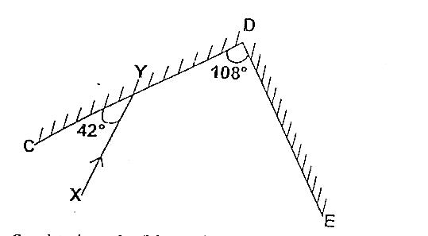
Complete the path of the ray XY and state the final angle of reflection. (3 marks)
…………………………………………………………………………………………………
…………………………………………………………………………………………………
…………………………………………………………………………………………………
- When storing a pair of bar magnets, it is advisable to put a keeper at each end.
- Draw a diagram in the space below to show the above arrangement and label the poles of each magnet (1 mark)

- Explain briefly how the above arrangement can minimize the loss of magnetism in the bar magnets (1 mark)
…………………………………………………………………………………………………
…………………………………………………………………………………………………
…………………………………………………………………………………………………
…………………………………………………………………………………………………
- Figure 2 below shows plane waves incident on a plane reflector inclined at 60◦C to the horizontal
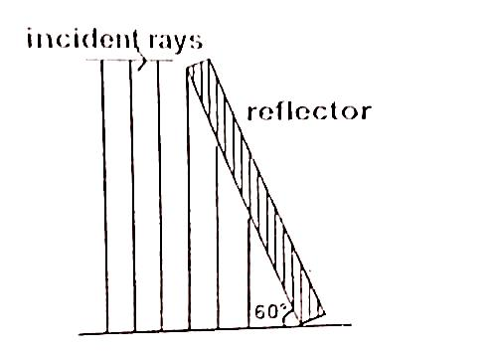
Complete the diagram to show reflected waves (1 mark)

- A student while investigating the focal length of a certain concave mirror, measured object and image distances and drew a graph 0f ¹/_{u} against ¹/_{v} shown below.
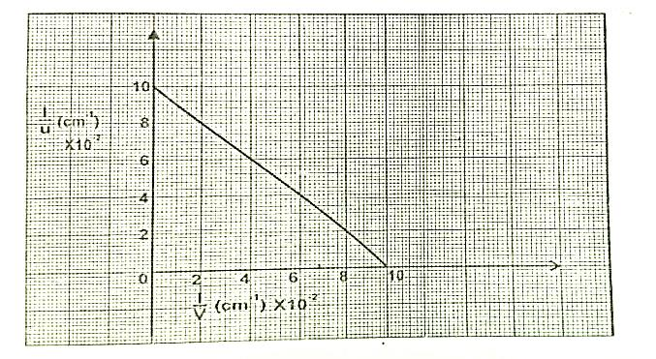
From the graph, determine the focal length (2 marks)

- It is advisable to top up acid level of an accumulator with distilled water and not acid. Give a reason for this (1 mark
……………………………………………………………………………………………….
………………………………………………………………………………………………
……………………………………………………………………………………………….

- Find the combined capacitance between A and B of the arrangement shown in the figure below. (2 marks)
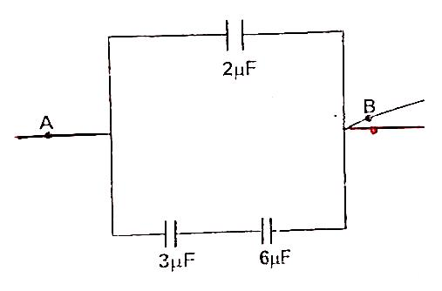

- Figure 3 shows a simple circuit breaker.
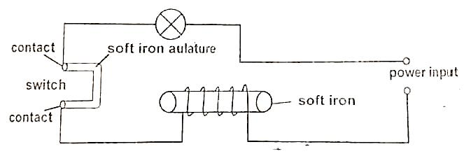
Explain briefly how it works (3 marks)
…………………………………………………………………………………………………
…………………………………………………………………………………………………
…………………………………………………………………………………………………
…………………………………………………………………………………………………
…………………………………………………………………………………………………
…………………………………………………………………………………………………

- Figure 4 shows a transverse wave.
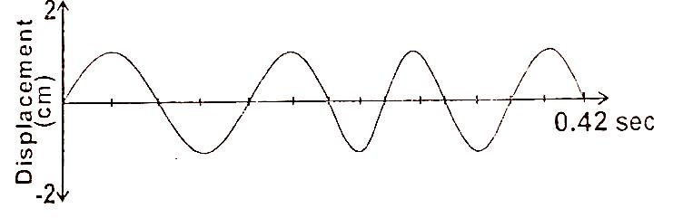
- Calculate the frequency of the wave (2 marks)

- Sketch another wave on the diagram that has double the frequency and half the amplitude (1 mark)

- For an echo to be heard, the minimum distance between the obstacle and the observer must be 17m.If the minimum time for hearing an echo is 0.1 seconds, Determine the speed of sound in air (2 marks
…………………………………………………………………………………………………
…………………………………………………………………………………………………
…………………………………………………………………………………………………
…………………………………………………………………………………………………
…………………………………………………………………………………………………
- Figure 5 shows a bar magnet FG being pushed into a coil connected to a Centre zero galvanometer. The current induced in the coil is shown.
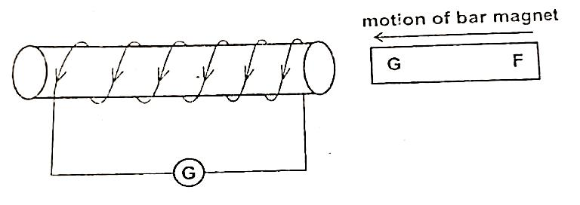
State the polarity of F (1 mark)
…………………………………………………………………………………………………
…………………………………………………………………………………………………

- Name one electromagnetic wave whose energy is higher than that of visible light. (1 mark)
…………………………………………………………………………………………………
…………………………………………………………………………………………………
…………………………………………………………………………………………………
- Below is part of radioactive decay series of uranium 238.
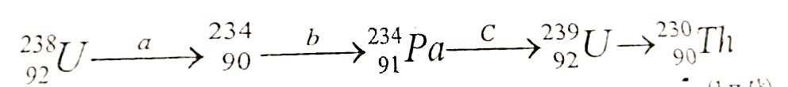
Identify isotopes from the series above. (1 mark)
…………………………………………………………………………………………………
…………………………………………………………………………………………………
- State how polarization is reduces in a simple cell (1 mark)
…………………………………………………………………………………………………
…………………………………………………………………………………………………
- Explain why it is not advisable to use a 10A fuse for hair drier rated 2.5Kw, 240V. (2 marks)
…………………………………………………………………………………………………
…………………………………………………………………………………………………
…………………………………………………………………………………………………

SECTION B (55 MARKS)

- What is meant by the term “A.C rectification” (1 mark)
…………………………………………………………………………………………………
…………………………………………………………………………………………………
…………………………………………………………………………………………………
- Figure 6 shows one method of A.C rectification using four diodes A,B,C,D.
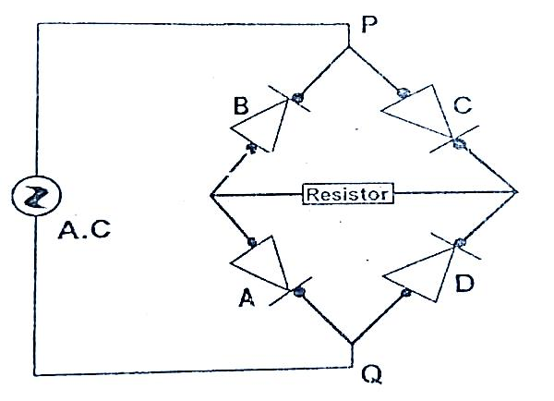

Explain how the A.C rectification is achieved in the above circuit (2 marks)
………………………………………………………………………………………
…………………………………………………………………………………………
…………………………………………………………………………………………
- In a transformer, a voltage of 240V is to be stepped down to 24V. The primary current is found to be 1.5 A while the secondary current is 14A. Calculate:
- Power input (1 mark)

- Power output (1 mark)

- Power wasted (1 mark)

- Efficiency of the transformer (3 marks)

- State two ways in which the power in a transformer is wasted (2 marks)
…………………………………………………………………………………………………
…………………………………………………………………………………………………
…………………………………………………………………………………………………

- Figure 7 below shows the circuits close to each other
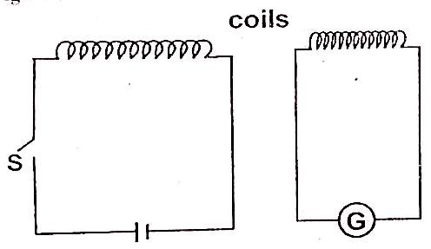

When the switch is closed, the galvanometer shows a reading and then returns to zero.
- Explain the observation (2 marks)
………………………………………………………………………………………….
………………………………………………………………………………………….
…………………………………………………………………………………………

- Give one adjustment that can be done to the arrangement so that:
- The galvanometer gives a bigger deflection in the same direction (1 mark)

- The galvanometer deflects in opposite direction when the switch is closed (1 mark)

- In an X-ray tube, the electrons are accelerated by a p.d of 24000V. Assuming that 2% of energy produced is converted to X-rays. Determine the:
- Energy of the X-rays produced (3 marks)

- Frequency of X-rays reduced (Take planks constant h= 6.6× 10⁻³⁴Js and charge on an electron e= 1.6× 10⁻¹⁹C). (3 marks)

- State the function of the grid of a cathode ray oscilloscope (CRO) (2 marks)
……………………………………………………………………………………………….
……………………………………………………………………………………………….
………………………………………………………………………………………………..
- State what is observed on the screen of a CRO when:
- Low voltage alternating current is connected to the time base and the y-gain switched off. (1 mark)
………………………………………………………………………………………….
………………………………………………………………………………………….
…………………………………………………………………………………………
- A high voltage ac is connected to the y-gain and the time base is switched off (1 mark)
………………………………………………………………………………………….
………………………………………………………………………………………….
…………………………………………………………………………………………

- The graph shows the activity versus tie for a sample of radioactive material.

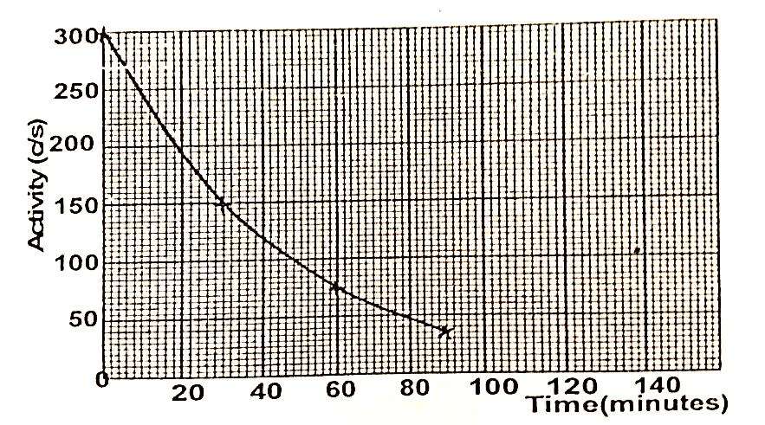

Use the graph to determine:
- The half life of the sample (3 marks)
………………………………………………………………………………………….
………………………………………………………………………………………….
…………………………………………………………………………………………
- The number of half-life’s needed for the activity to reduce from 300C/S to 37.5CS⁻¹ (3 marks)
………………………………………………………………………………………….
………………………………………………………………………………………….
…………………………………………………………………………………………
………………………………………………………………………………………….
………………………………………………………………………………………….
…………………………………………………………………………………………

- The figure 8 below shows the construction and circuit of the modern physics X-ray tube.
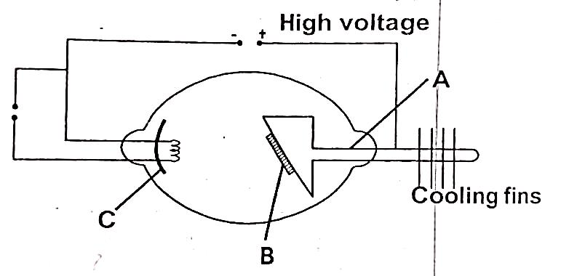

- Indicate on the diagram the path of the X-ray beam (1 mark)
……………………………………………………………………………………………….
………………………………………………………………………………………………
……………………………………………………………………………………………….
- Name the part marked C and state its function (2 marks)
……………………………………………………………………………………………….
………………………………………………………………………………………………
………………………………………………………………………………………………
- Name the metal used in parts A and B and state why they are suitable for use in the tube (4 marks)
……………………………………………………………………………………………….
………………………………………………………………………………………………
……………………………………………………………………………………………….
……………………………………………………………………………………………….
………………………………………………………………………………………………
……………………………………………………………………………………………….

- Why are cooling fins necessary? (1 mark)
……………………………………………………………………………………………….
………………………………………………………………………………………………
……………………………………………………………………………………………….

- Form four students performed an experiment in photoelectric effect and drew the graph below from the data collected
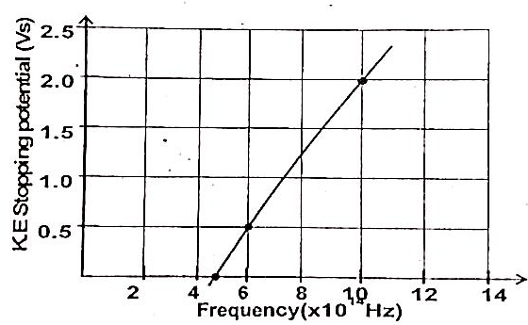
From the graph determine:

- Threshold frequency (1 mark)

- Planks constant (take charge on an electron, e= 1.6 × 10⁻¹⁹C) (3 marks)

- A person standing behind a wall hers a bell ringing although he cannot see the bell. What property of sound enables him hear the sound (1 mark)
……………………………………………………………………………………………….
………………………………………………………………………………………………

- The figure 9.0 below is a sketch of ripples caused by a vibrator in a ripple tank whose frequency is 50Hz.
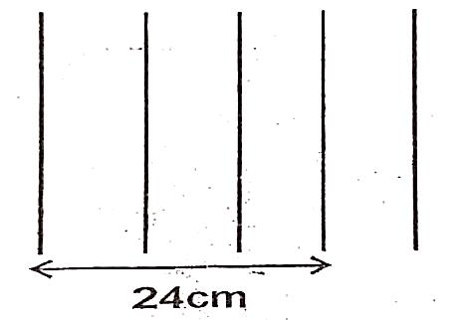
Using the above information, determine the speed of the wave motion (3 marks)

- The speed of sound in air determined o a warm day is 330m/s. Explain any difference you would expect in the results if the measurement is done on a cold day. (2 marks)
……………………………………………………………………………………………….
………………………………………………………………………………………………
……………………………………………………………………………………………….
……………………………………………………………………………………………….
- In an experiment to determine the speed of sound, an observer stood in front of a high wall at a distance of 80m. he clapped two boards together at such a rate that each clap coincided with the echo from the wall. A second observer noted a time of 9.5seconds starting with the first clap and ending with the 21st clap.

- Calculate the speed of sound under these conditions (3 marks)

- Describe one probable source of error in this experiment (1 mark)
……………………………………………………………………………………….
………………………………………………………………………………………
……………………………………………………………………………………….
- State two ways in which sound wave differ from light waves (2 marks)
……………………………………………………………………………………….
………………………………………………………………………………………
……………………………………………………………………………………….

