**FORM 4 PHYSICS PAPER 3**

**NAME………………………………………….. ADM NO:……………………….**

**CLASS:………………………….**

1. You are provided with the following

* **Liquid L in 500ml beaker**
* **Two identical cylindrical 100g masses**
* **Two pieces of thread (about 15cm long)**
* **A metre rule**
* **A knife edge**
* **A vernier callipers.**

**Procedure:**

1. Determine the volume of one of the masses using the apparatus provided.

Diameter = ___________________cm

Weight = ____________________ cm

Volume = (2mks)

1. (i) Determine the centre of gravity, G of the metre rule and record it.

G=_____________________________ cm (1mk)

(ii) Arrange the apparatus as shown in figure 1 below, such that x=5cm from the pivot with the 100g mass completely immersed in liquid L. Hang the other 100g mass from the metre rule and adjust its position until the system is in equilibrium.

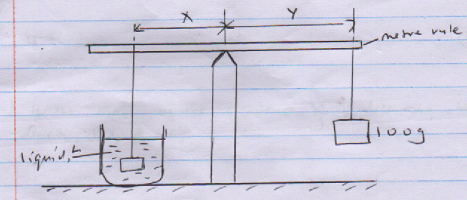

Repeat the procedure above for the values of x shown in the table below. (3mks)

|  |  |  |  |  |  |  |
| --- | --- | --- | --- | --- | --- | --- |
| X (cm) | 5.0 | 10.0 | 15.0 | 20.0 | 25.0 | 30.0 |
| Y (cm) |  |  |  |  |  |  |

(iii) Plot a graph of Y against X (5mks)

(iv) Determine the slope, S of the graph. (2mks)

(v) The slope, S of the graph is given by the equation  where wx is the apparent weight of the mass in liquid L and wy is the actual weight. Determine the value of wx and upthrust U

Wx = _________________________________N (1mk)

U = ___________________________________N (1mk)

(vi) If the mass of the liquid = , determine the density, s of liquid L. (3mks)

1. You are provided with the following:

* **Biconvex lens labelled A.**
* **A candle**
* **A lens holder**
* **A metre rule**
* **A piece of Plasticine.**

**Procedure:**

1. Arrange the candle, lens, screen and metre rule as shown below. Ensure the flame is at the same level as the centre of the lens, L. This maybe done by raising the candle with a piece of Plasticine as it gets shorter.

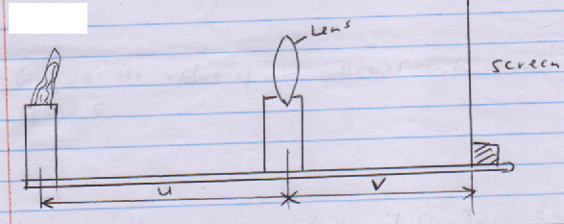

1. With the lens placed 20 cm from the candle, adjust the position of the screen till a sharp image of the candle is formed on the screen. Read and record the value of V.
2. Increase U in steps of 5cm and obtain the corresponding value of v. complete the table.

|  |  |  |  |  |  |  |  |
| --- | --- | --- | --- | --- | --- | --- | --- |
| U (cm | 30.0 | 35.0 | 40.0 | 45.0 | 50.0 | 55.0 | 60.0 |
| V (cm) |  |  |  |  |  |  |  |
|  |  |  |  |  |  |  |  |

1. Plot a graph of object distance, u (y=axis) against the ratio  (5mks)
2. Determine the slope, s of the graph. (2mks)
3. Find the value of u intercept (2mks)
4. Compare the value of u intercept with that of the slope, s. (2mks)
5. Move the screen till it is 80.0 cm from the candle.
6. Starting from very near the screen, move the lens slowly towards the candle and note the two positions P and R where sharp images of the candle are obtained on the screen.
7. Determine, d the distance between P and R.

d= _____________________cm (1mk)

1. Calculate the quantity Z from

Z=  (2mks)