**Name……………………………………………………… Index No………………...........**

Candidate’s signature...................

Date..............................................

**232/3**

**PHYSICS PRACTICAL**

**Paper 3**

**JUNE-2022**

**2 $\frac{1}{2}$ hours**

**MUMIAS WEST SUB-COUNTY EXAM**

***Kenya Certificate of Secondary Education (K.C.S.E)***

PHYSICS

(PRACTICAL)

Paper 3

**Instructions to Candidates**

1. *Write your name and index number in the spaces provided above.*
2. *Sign and write the date of examination in the space provided above.*
3. *Answer* ***all*** *questions on the question paper.*
4. *You are supposed to spend the first 15 minutes allowed for this paper reading the whole paper carefully before commencing your work and confirming your apparatus.*
5. *Marks are given for a clear record of the observations actually made, their suitability, accuracy and for the use made of them.)*
6. *Candidates are advised to record observations as soon as they are made*
7. *Mathematical tables and Electronic calculators may be used*
8. ***Candidates should answer the questions in English***

**For Examiner’s Use Only**

|  |  |  |
| --- | --- | --- |
| Question | Maximum | Candidates Score |
| 1 | 20 |  |
| 2 | 20 |  |
| Total | |  |

**Question 1**

You are provided with the following:

- a voltmeter

- two new dry cells and a cell holder

- a switch

- a resistor labeled R (4Ω)

- a wire mounted on a mm scale and labeled G.

- a micrometer screw gauge (to be shared)

- six connecting wires with six crocodile clips

**Proceed as follows**

a. i) Record the length L0 of the wire labeled G

L0  = ……………………………………………………… (1 mk)

ii) Use the micrometer screw gauge provided to measure the diameter of the wire labeled G at two different points and determine the average diameter, d.

The diameter d1 = ……………………mm, d2 = …………………………mm (1mk)

Average diameter d = ………………………….. mm (1mk)

iii) Determine the radius r of the wire in metres.

Radius r = ………………………………………………. m (1mk)

b. Set up the apparatus as shown in the circuit diagram in the figure below.

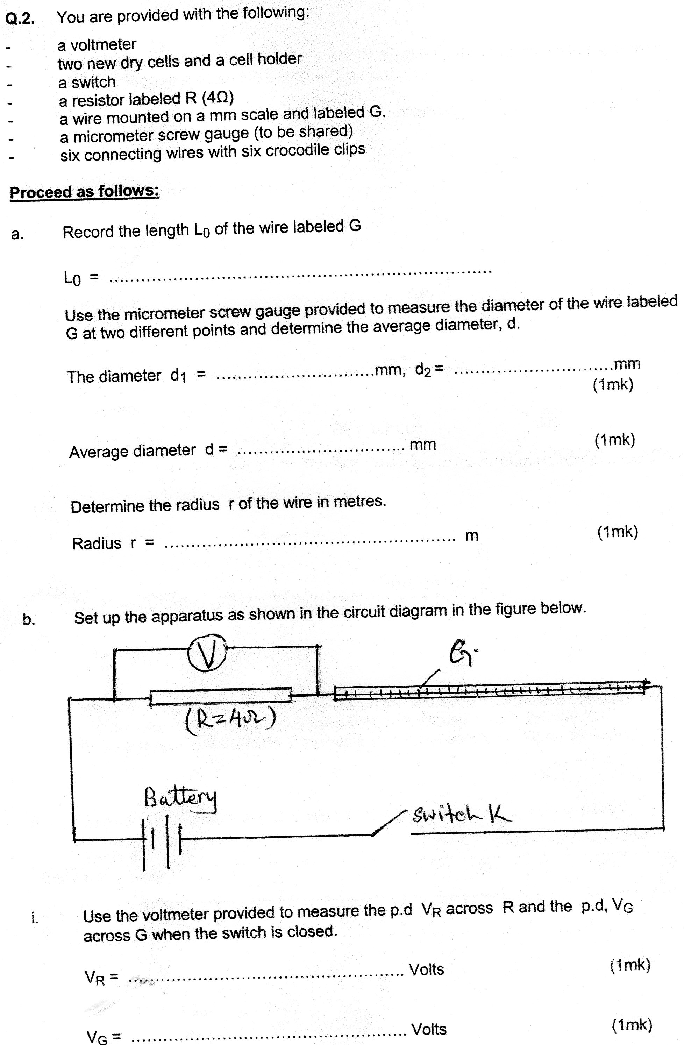

i. Use the voltmeter provided to measure the p.d VR across R and the p.d, VG

across G when the switch is closed.

VR = ……………………………………………. Volts (1/2 mk)

VG = ……………………………………………. Volts (1/2 mk)

**Open the switch**

ii. Use the value of R provided and the value of VR in b (i) above to determine the current

I flowing through R when the switch was closed.

I = ………………………………………………….Amperes (1mk)

iii. Determine the constant H given that

H = 100VG

IxL0

H = ………………………………………………… Ωm-1 (1mk)

c. Connect the voltmeter across R as shown in the figure below.

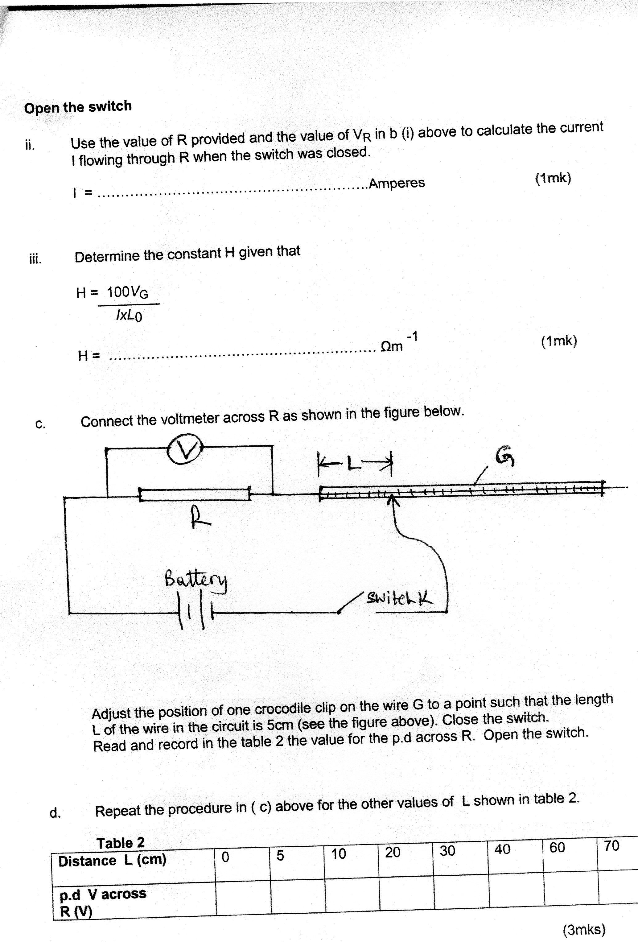

Adjust the position of one crocodile clip on the wire G to a point such that the length

L of the wire in the circuit is 5cm (see the figure above). Close the switch.

Read and record in the table 2 the value for the p.d across R. Open the switch.

d. Repeat the procedure in (c) above for the other values of L shown in table 2. (3mks)

**Table 2**

|  |  |  |  |  |  |  |  |  |
| --- | --- | --- | --- | --- | --- | --- | --- | --- |
| **Distance L (cm)** | 0 | 5 | 10 | 20 | 30 | 40 | 60 | 70 |
| **p.d V across**  **R (V)** |  |  |  |  |  |  |  |  |

e i. On the grid provided plot the graph of V (y-axis) against L (5mks)

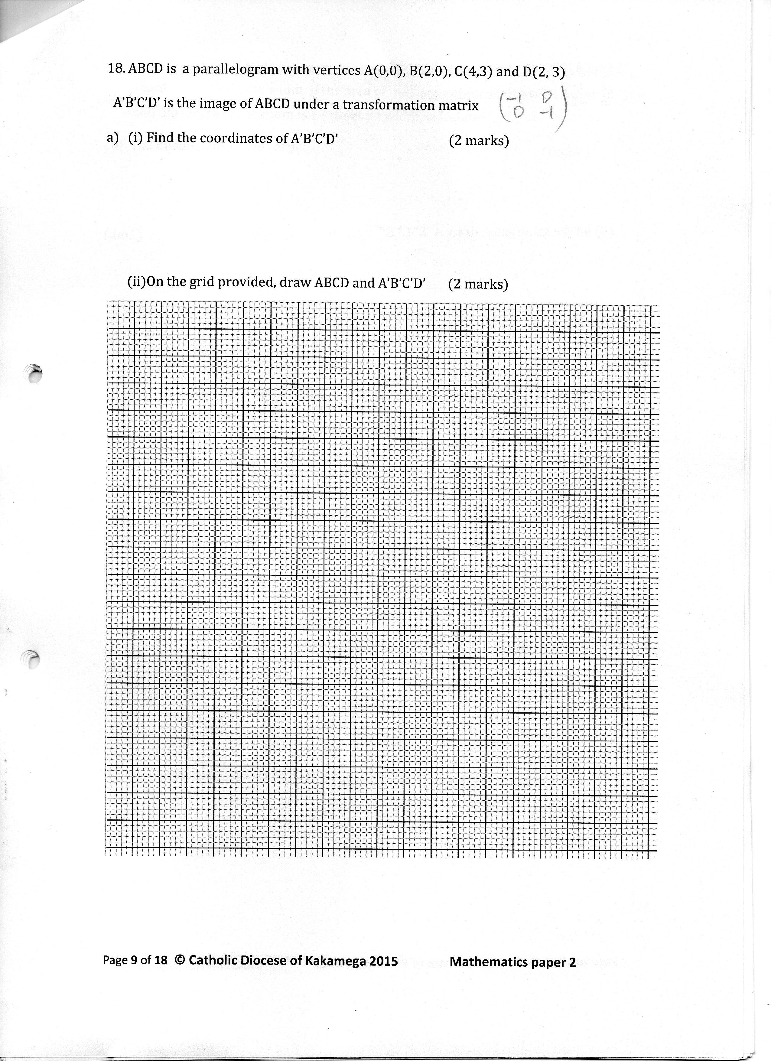

(ii) From the graph determine L1, the value of L when V = V0 where V0 is the p.d

2

when L = 0 (1mk)

f. Determine the constant D for the wire given that (2mks)

D = R X 300

L1 V0

g. Determine the constant p given that

p = *πr*2 (D + H) where **r** is the radius of the wire in metres. (2 mks)

2

**QUESTION 2**

You are provided with the following apparatus:

* clamp
* boss
* stand
* optical pin
* copper wire (15 cm long)
* protractor
* two pieces of plasticine of about 0.5cm diameter
* cork

1. Set up the apparatus as shown in the diagram below

Clamp

Cork

Plasticine

Ө

pin

stand

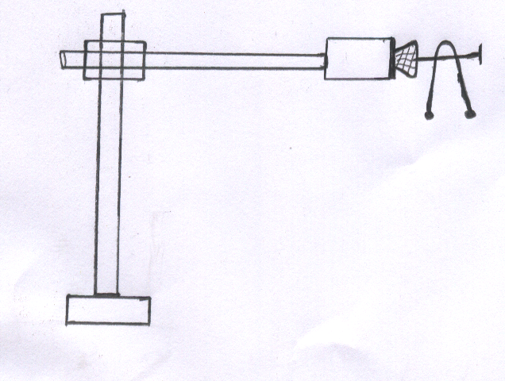

Angle

1. Bend the wire in the middle so as to make an angle of 500. Attach the two small pieces of plasticine at both ends of the bent wire as shown in the diagram.
2. Place the bent wire on the optical pin and give a small horizontal displacement. Take the time for 10 complete oscillations and record in the table below.
3. Repeat the procedure above for other values of  and complete the table below. (9mks)

|  |  |  |  |  |  |
| --- | --- | --- | --- | --- | --- |
| Angle | Time’t’for10oscillations (s) | Period T (s) | Frequency f (Hz) | f2 (Hz)2 | Cos |
| 50 |  |  |  |  |  |
| 60 |  |  |  |  |  |
| 70 |  |  |  |  |  |
| 80 |  |  |  |  |  |
| 90 |  |  |  |  |  |
| 100 |  |  |  |  |  |

1. On the graph paper provided, pot a graph of f2 (y-axis) against cos  (5mks)



Determine the gradient ‘S’ of the graph (3 mks)

1. The equation for the oscillation of the wire is given by the formula:



Given that L = 0.15m, use the gradient of the graph to determine the value of Z. (3mks)