Term 1- 2023 OPENER EXAM
PHYSICS (232/1)
FORM TFOUR (4)
Time: 2 Hours

Name: …………………………………………………………. Adm No: ……………….
School: ……………………………………………………….. Class: …………………..
Signature: …………………………………………………….. Date: …………………...

Instructions to candidates

- This paper consists of two sections A and B.
- Answer all the questions in the two sections in the spaces provided after each question
- All working must be clearly shown.
- Electronic calculators, mathematical tables may be used.
- All numerical answers should be expressed in the decimal notations.
- You may use ‘gravitational acceleration, g, as 10m/s²

For Examiner use only
SECTION | QUESTION | MAX MARKS | CANDIDATE’S SCORE
A | 1 – 13 | 25
B | 14 | 12
 | 15 | 11
 | 16 | 10
 | 17 | 10
 | 18 | 12
 | TOTAL | 80

This paper consists of 11 printed pages. Candidates should check to ascertain that all pages are printed as indicated and that no questions are missing.

SECTION A (25 MARKS)
- The scale of the micrometer screw gauge below has a zero error of +0.05mm.
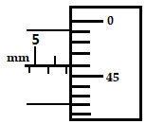Figure 1
What is the actual reading of the micrometer screw gauge? (2 marks)

- In a ball and ring experiment, the ball goes through the rings at room temperature. When it is heated it does not go through the ring, but when left on the ring for some time, it goes through. Explain this observation (2 marks)

- The set up shown below, figure 2, was used to study behavior of water when heated from room temperature at 20⁰C.
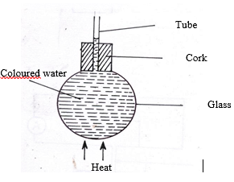

Figure 2
When heat was introduced, it was observed that the level of the water initially drops before starting to rise. Explain this observation (2marks)

- Figure 3 shows some air trapped by mercury in a glass tube. The tube is inverted in a dish containing mercury.
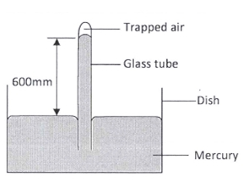
Figure 3
Given that the atmospheric pressure is 760 mmHg and the height of mercury column in the tube is 600 mm, determine the pressure of the air trapped in the tube in mmHg. (3 marks)

- State two measurements you would take in an experiment to determine the upthrust of an object which is immersed in a fluid. (2 marks)

- State how the measurements in question (5) are used to determine the upthrust of the object. (1 mark)

- It is easier to bend an iron rod than a glass rod of the same dimensions at room temperature. Give a reason for this (1 mark)

- An experiment was performed to find out how the length L of a spiral spring varies with the compression force, F. The figure, 4 shows the variation.

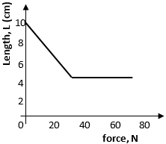Figure 4

- Draw a diagram of a possible set up of the apparatus (3 marks)

- Determine the length of the spring when it is not being used (1 marks)

- Why is it that boiling water is not used for sterilization of clinical thermometer? (1 mark)

- Figure 5 shows two identical balloons A and B. The balloons were filled with equal amounts of the same type of gas. The balloons are suspended at equal distances X1 and X2 from a metal cube filled with boiling water and placed on an insulating material. One side of the metal cube is shiny while the other side is dull (use this information to answer question 10 and 11).

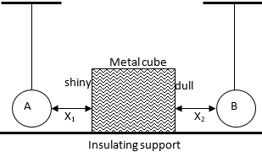Figure 5

State the mode by which heat travels from the cube to the balloons (1 mark)

- Compare the size of the balloons after some time. Give reason for your comment (2 marks)

- A pupil blows a current of air over the surface of a sheet of paper held close to its mouth. State and explain what happens to the paper. (2 marks)

- An object is projected horizontally at a velocity of 40m/s from a cliff 20m high. Calculate the time taken to hit the ground (2 marks)

SECTION B (55 MARKS)

- Define the following terms:
- Mechanical advantage (1 mark)

- Efficiency (1 mark)

- Velocity ratio (1 mark)

- A crane lifts a load of 200 kg through a vertical distance of 3.0m in 6 seconds. Determine the;
- Work done (3 marks)

- Power developed by the crane (3 marks)

- Efficiency of the crane given that it is operated by an electric motor rated 2.5kW
(3 marks)

- Distinguish between speed and velocity (1 mark)

- The diagram shows a tall measuring cylinder containing a viscous liquid. A very small steel ball is released from rest at the surface of the liquid as shown.

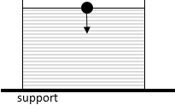
Figure 6

On the space alongside, sketch the velocity- time graph for the motion of the ball from the time it is released to the time just before it reaches the bottom of the cylinder. (1 mark)

- A body is initially in motion. If no external force acts on the body, describe the subsequent motion. (1 mark)

- Two trolleys of masses 2 kg and 1.5 kg are traveling towards each other at 0.25m/s and 0.40 m/s respectively. The two trolleys combine on collision.
- Calculate the velocity of the combined trolleys. (3 marks)

- In what direction do the trolleys move after collision? (1 mark)

- The graph bellows shows how the velocity varies with time for a body thrown vertically upwards.

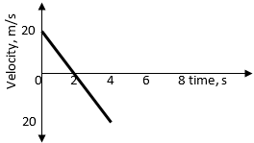
Figure 7
Determine:
- Time taken to reach maximum height (1 mark)

- The total distance moved by the body. (3 marks)

- Define pressure and state its SI unit (2 marks)

- State Pascal’s principle (1 mark)

- The figure below shows a hydraulic lift system. The radius of the small piston is 3cm while that of the larger piston is 9 cm. A force of 90N is applied to the smaller piston.
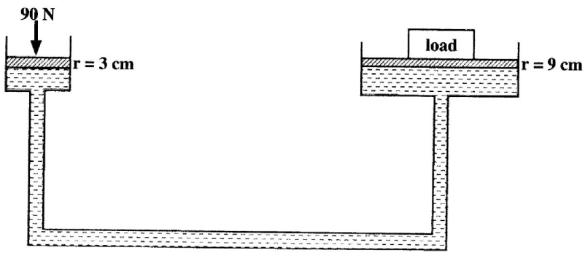
Figure 8

Determine the maximum load it can lift (3 marks)

- State two factors that affect pressure at a point in a liquid (2 marks)

- The figure 9 below shows two cylinders of different cross-sectional areas connected with a tube. The cylinders contain an incompressible fluid and are fitted with pistons of cross-sectional areas 4 cm² and 24 cm².
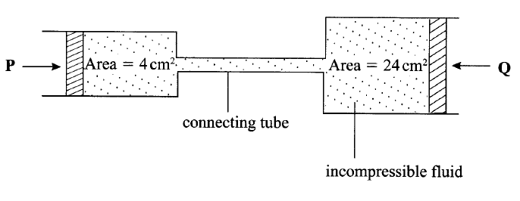
Figure 9
Opposing forces P and Q are applied to the pistons such that the pistons do not move. If the pressure on the smaller piston is 5N/cm², determine the force, Q. (2 marks)

- A student is provided with five 20g masses, a metre-rule, a spring with pointer, a stand, boss and clamp. In the space provided, sketch a labelled diagram of the set-up that may be used to verify the hookes’ law using this apparatus (3 marks)

- State two measurements that should be recorded in order to plot a suitable graph so as to verify hooke’s law (2 marks)

- Describe how the measurements made in b, above can be used to determine the spring constant (2 marks)

- A helical spring stretches by 0.6 cm when supporting a weight of 40g. determine the extension when the same spring supports a weight of 65g. (3 marks)

- State the principle of moments (1 mark)

- The figure10 shows two identical trolleys with loads A and B. The loads are identical in shape and size.

Figure 10
Given that the density of A is greater than that of B, explain why the trolley in (ii) is more stable. (2 marks)

- The figure below shows beaker containing water at 0⁰ C. The beaker is placed on a bench.
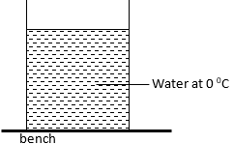

Figure 11
State and explain the changes in stability of beaker when water freezes (2 marks)

- A uniform half- metre rod is balanced by a weight of 38N at one end. If the pivot is placed 10cm from the same end, calculate the weight of the rod. (3 marks)

- Distinguish between streamline flow and turbulent flow (1 mark)

- Water flows along a horizontal pipe of cross sectional area 30cm². The speed of the water is 4m/s but it reaches 7.5m/s in a constriction in the pipe. Calculate the area of the constriction. (3 marks)

This is the last printed page.

