232/3

NAME…………………………………………….……. INDEX NO………..…………………..
SIGNATURE……………………………….………………DATE……………………………..
ASUMBI GIRLS HIGH SCHOOL
POST -MOCK 1
AUGUST/SEPTEMBER
2022
AUGUST / SEPTEMBER - 2022

PHYSICS
(PRACTICAL)
PAPER 3
TIME: 2 ½ HOURS

INSTRUCTIONS TO CANDIDATES

- Write your name, admission number and date in the spaces provided above,
- Answer ALL the questions in the spaces provided in the question paper.
- You are supposed to spend the first 15 minutes of the 2 ½ hours allowed for this paper reading the whole paper carefully before commencing your work.
- This paper consists of 9 printed pages. Check the question paper to ascertain that all the pages are printed as indicated and that no questions are missing.

FOR EXAMINER’S USE ONLY
Question 1 | d | e | f | g | i | j | k | TOTAL
Maximum score | 5 | 5 | 3 | 2 | 3 | 1 | 1
Candidate’s score

TOTAL
Question 2 | a | d | e | f | g | h(i) | h(ii) | h(iii)
Maximum score | 1 | 4 | 5 | 3 | 3 | 1 | 1 | 2
Candidate’s
score

GRAND

This paper consists of 8 printed pages. Candidates should check to ascertain that all pages are printed as indicated and that no questions are missing.

QUESTION ONE
This question consists of two parts A and B; attempt both parts.

PART A

You are provided with the following:
  - Two metre-rules.
  - A stopwatch.
  - A half metre rule.
  - Two retort stands, two bosses and two clamps.
  - Some sewing thread.
  - A pendulum ball.

Proceed as follows:
- Clamp one metre rule horizontally on the two stands so that it is on a vertical plane. Suspend the second metre rule so that it balances on one point as shown in figure 1 below. Note the balance point as the centre of gravity of the metre rule. Let this be point A.

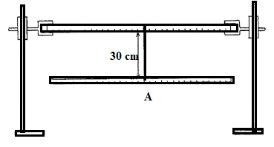

Fig.1

- Set the length of the string on which the metre rule is suspended to be 30cm. Tie a second support to the metre rule a distance D from the string. Let the point of support be point B
- Suspend the pendulum ball with a string a distance L from B and set the length of the string to 20cm. See figure 2 below.

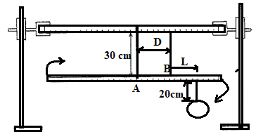

Fig.2

Starting with a distance D = 15cm, and distance L = 25 cm. displace the hanging metre rule on a horizontal plane and record the time taken for it to make 20 complete oscillations on table 1.
- Repeat part (c) above for other values of D and complete the table 1 below. (5mks)

Table 1
D (cm) | Time for 20  oscillations (s) | Periodic time (T)  (s) | T² (s²)
15
20
25
30
35
40
e) On the grid provided, plot a graph of D (cm) against T² (S²). (5mks)

- Determine the slope of the graph at D= 25cm. (3mks)
……………………………………………………………………………………………………………………………………………………………………………………………………………………………………………………………………………………………………………………………………………………………………………………………………………………………………………………
- Use your graph to determine the periodic time when the length of distance D is 33cm. (2mks)
…………………………………………………………………………………………………………………………………………………………………………………………………………………………
PART B
You are provided with the following:
  - A metre rule (use one used in part A).
  - A piece of knitting thread.
  - A rectangular stiff paper labelled M.
  - One l00g mass.
  - A funnel.
  - A pendulum ball (use one used in Part A).
  - A stopwatch (use one used in Part A).

Proceed as follows:
- Tie the pendulum ball tightly with the knitting thread and after passing the other end of the thread through the funnel and the marker (marked M) as shown in figure 3 below, tie it to a l00g mass. Push the marker to be about 1cm from the funnel after adjusting the length of the thread from the funnel to the pendulum ball to be 30cm.
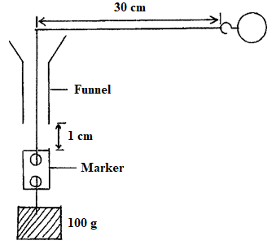
Fig. 3
- Hold the funnel vertically. Swing the pendulum ball around so that it moves in a constant horizontal circle with a uniform circular motion. The marker should be just below the funnel but not touching it. Measure the time taken by the Pendulum ball to make 10 complete revolutions and repeat this 3 times and complete the table below. (3mks)

Table 2
Trial | Time for 10 revolutions  (S) | Periodic time T (S)
1.
2.
3.

- Find average T.
T= (1mk)

- Given that W = $2π/T$ where W is the angular velocity of the pendulum ball, determine W. (1mk)
……………………………………………………………………………………………………………………………………………………………………………………………………………………………………………………………………………………………………………………………
- PART A
You are provided with the following apparatus
- A metre rule
- A log of plasticine
- Bi convex lens
- A candle
- A lens holder
- Across wire mounted on a cardboard
- A white screen

- Determine the average focal length, f of the lens using a distance object.

f=… ……………………………………………………………………………………….(1mk)
b) Set up the apparatus as shown.
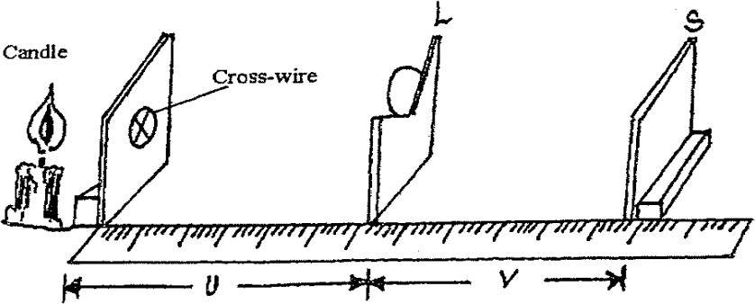

Fig. 4

- Starting with u=30cm, vary the position of the screen S until a sharp image of the cross wire is observed on the screen. Measure and record the value of the image distance v.
- Repeat the experiment above for other values of u35cm, 40cm, 50cm, and 55cm and fill the table below (4mks)

U (cm) | 30 | 35 | 40 | 45 | 50 | 55
V(cm)
$$m=v/u$$
- Plot a graph of M against v. (4mks)

- Determine the slope of the graph. (3mks)

………………………………………………………………………………………………………………………………………………………………………………………………………………………………………………………………………………………………………………………………………
- The equation of the graph is given by $m= \frac{v}{f}-1 .$ Use the graph to obtain the value of f. (3mk)
………………………………………………………………………………………………………………………………………………………………………………………………………………………………………………………………………………………………………………………………………

PART B
You are provided with the following apparatus.
-2 new dry cells size D
-A cell holder.
- One 100cm resistance wire mounted on millimeter scale.
- 1 switch
-1 Voltmeter 0 - 3V.
- 1 Ammeter 0— 1A,
- 8 connecting wires (4 with at least 1 crocodile clip).
- Resistor wire mounted on cardboard.

(h) Connect the circuit as shown below in figure 5
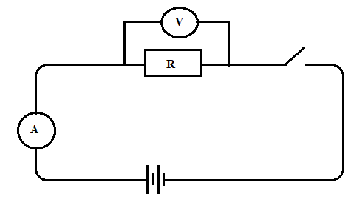

Fig 5
Record the reading of
(i) Ammeter, I=………………………………..A (1mk)
(ii) Voltmeter, V=……………………………….V (1mk)
(iii) Given that $K=V/I$, find K (3mks)
………………………………………………………………………………………………………………………………………………………………………………………………………………………………………………………………………………………………………………………………………………………………………

