Term 1 - 2023
PHYSICS PAPER 3 (PRACTICAL) -232/3
FORM FOUR
2.5 Hours
Name: …………………………………………………………. Adm No: ……………….
School: ……………………………………………………….. Class: …………………..
Signature: …………………………………………………….. Date: …………………...

INSTRUCTIONS
- Answer all the questions in this paper
- You are supposed to spend the first 15 minutes of the $2\frac{1}{2}$ hours allowed for this paper reading the whole paper carefully before starting your work.
- Marks are given for clear record of the observations made, their suitability and accuracy and the use made of them.
- Candidates are advised to record observations as soon as they are made
- Mathematical table and electronic calculators may be used.

For Examiner’s use only:

QUESTION | TOTAL MARKS | CANDIDATE’S SCORE
1 | 20
2 | 20
GRAND TOTAL | 40

This paper consists of 5 printed pages

QUESTION ONE

You are provided with the following apparatus:

• Two dry cells
• A cell holder
• A bulb
• A volt-meter
• An ammeter
• A switch
• Amounted resistance wire labelled AB

- Set up the apparatus as shown in the circuit below.
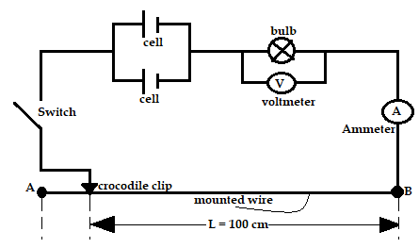
Figure 1

- With the crocodile clip at A (i.e. L = 100cm) take the voltmeter reading (V) and the ammeter reading (I). Record V and I in the table 1 below.

Table 1
Length l(cm) | 100 | 80 | 60 | 40 | 20 | 0
Voltage (V)

Current I (A)

Length, L (m)

(7 marks)

- Repeat the procedure in (b) above for the lengths shown and complete the table above.

- Explain the changes you observe on the bulb as L decrease from A. (2 marks)

- Plot a graph of voltage against current (5 marks)

- Determine the slope of the graph when L = 0.60 m (3 marks)

- State the significance of the gradient (1 mark)

QUESTION TWO

PART A
You are provided with the following
- A candle
- A lens and a lens holder
- A screen
- A metre-rule
- Some plasticine

- Set up the apparatus as shown in figure 2 below (ensure that the candle flame and the lens are approximately the same height above the bench)

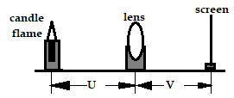
Figure 2

- Set the position of the lens so that it is 40cm from the candle (U = 40 cm). Adjust the position of the screen until a sharp image of the candle flame is obtained. Measure the distance, V between the lens and the screen. Record the value of V

V = ………… cm (1mark)

- Repeat the procedures in b) above for other values of U in the table b below. (4 marks)

Table 2
U(cm) | 45 | 50 | 55
V(cm)
Magnification (m) $=\frac{v}{u}$

- Given that f = $\frac{v}{m+1,}$ where f is the focal length of the lens, use the results in table above to determine the average values of ‘f’ (4 marks)

PART B.
You are provided with the following:
- rubber bung.
- Vernier calipers.
- beam balance. (or electric balance)

Proceed as follows:
- Using a Vernier caliper, measure the lengths D, d, and h as shown in figure 2.
d
h
D
Figure 2

D = ....................................................... m (1 mark)
d = ........................................................ m (1 mark)
h = ........................................................ m (1 mark)

- Measure the mass, M of the rubber bung using the electric balance.

M = …………………. g M = ............................................... kg (2 marks)

- Given that $Q= \frac{d+D}{4}$ determine the value of Q. (2 marks)

- Determine the value of r given that: $πrQ^{2}= \frac{M}{h}$ (3 mark)

- State the significance of r (1 mark)

This is the last printed page

