Term 1 – 2023 OPENER EXAM
PHYSICS (232/3)
FORM FOUR (4)
Time: $2\frac{1}{2} hours$

Name: …………………………………………………………. Adm No: ……………….
School: ……………………………………………………….. Class: …………………..
Signature: …………………………………………………….. Date: …………………...
INSTRUCTIONS:
- Answer all the questions in this paper
- You are supposed to spend the first 15 minutes of the $2\frac{1}{2}$ hours allowed for this paper reading the whole paper carefully before starting your work.
- Marks are given for clear record of the observations made, their suitability and accuracy and the use made of them.
- Candidates are advised to record observations as soon as they are made
- Mathematical table and electronic calculators may be used.
- The earth’s gravitational pull, $g=10N{kg}^{-1}$

For Examiner’s use only:
QUESTION | TOTAL MARKS | CANDIDATE’S SCORE
1 | 20
2 | 20
GRAND TOTAL | 40

This paper consists of 7 printed pages. Candidates should check the question paper to ensure that all the pages are printed as indicated and no questions are missing.

QUESTION 1

You are provided with the following apparatus:

• A cell holder
• A volt-meter (0-3V)
• An ammeter (0-1A)
• A switch
• Amounted resistance wire labelled AB

- Set up the apparatus as shown in the circuit below, figure 1
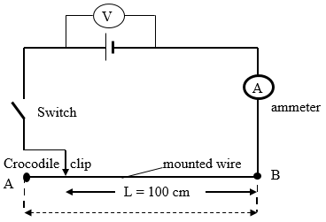Figure 1
- While the switch is open, record the voltmeter reading, V₀

$V_{0}=$ ........................... (1mark)

- Put on the switch. While the crocodile clip is at A (i.e. L = 100 cm) take the volt-meter reading (V) and the ammeter reading (I). Record V and I in the table 1 below.

Table 1
Length, $L$ (cm) | 100 | 80 | 60 | 40 | 20 | 0
Voltage (V)
Current, I (A)
(8marks)
- Repeat the procedure in (c) above for the lengths shown and complete the table 1 above.

- Plot a graph of voltage (Y-axis) against current (X-axis) (5marks)

- Determine the slope of the graph (3marks)

- The voltage and current are related by the equation: $V=V_{0}-b.I.$ Determine the value of b (2marks)

- What physical quantity does the slope of the graph represent? (1mark)

QUESTION TWO

You are provided with the following:
- a metre rule
- 3 optical pins
- 2 small wooden blocks
- a stop watch
- a stand, a boss and clamp
- a piece of sello-tape

Proceed as follows:

- Using the two wooden blocks, clamp two optical pins about 4 cm apart in the stand so that they project out of the blocks in a horizontal plane.
- Using a piece of sellotape, attach the third optical pin across the metre rule at a distance x = 10 cm from the 50 cm mark. Now suspend the metre rule on the two clamped pins so that it can swing freely in a vertical plan with the third pin as the axis. (See figure 2)

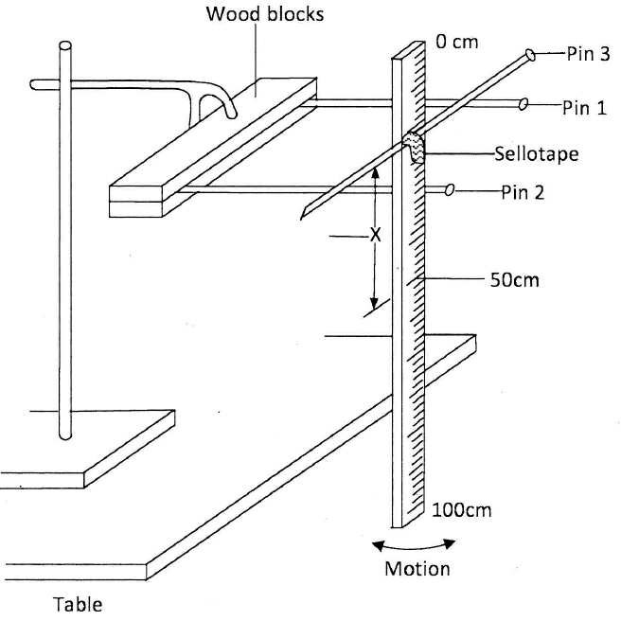
Figure 2
- Displace the lower end of the metre rule slightly and let it oscillate as shown in the figure 2. Measure and record in table 2 the time t (s) for 20 oscillations.
- Repeat the procedure in (b) and (c) for the values of x shown in table 2.
- For each value of x shown in the table, determine the period T(s), and complete the table. (The period T is the time for one complete oscillation).

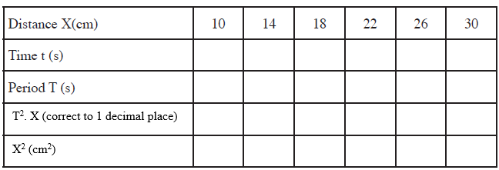
(9 marks)
- On the grid provided, plot a graph of T². X (y-axis) against X² (5marks)

- From the graph, determine:
- the slope S of the graph. (3marks)

- The value of constant r given that: $rS=39.5$ (3marks)

This is the last printed page

