**PHYSICS PP3 MARKING SCHEME**

(b) $\frac{ 0.37+0.38+0.36}{3}$



$$= 0.37mm$$

$$D = 0.00037 m$$

(c) Area $=\frac{22}{7}×{\left(\frac{3.7}{2}×{10}^{-4}\right)}^{2}= 1.076×{10}^{-7}m^{2}$



(e) $E = 3.0 ±0.2 V$



(f)



|  |  |  |  |  |  |  |
| --- | --- | --- | --- | --- | --- | --- |
| **Length, (m)** | 0.2 | 0.3 | 0.4 | 0.5 | 0.6 | 0.7 |
| **Current, I (A)** | 0.50 | 0.42 | 0.34 | 0.29 | 0.26 | 0.22 |
|  | 2.000 | 2.381 | 2.9412 | 3.448 | 3.846 | 4.545 |

(h)



$$1/I(A^{-1})$$

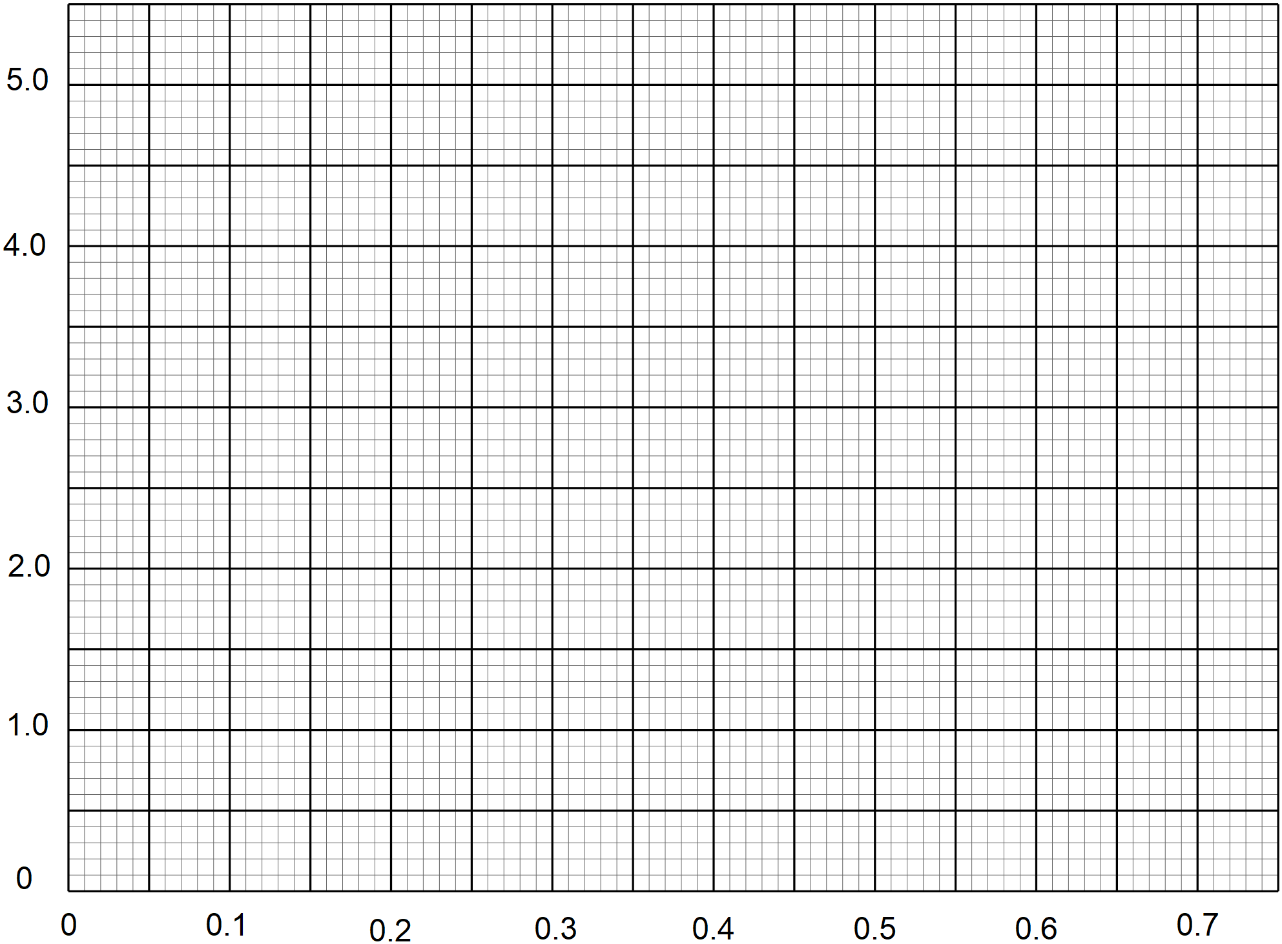



Length (m)



*A1 -award for correctly labelled axis and unit of the quantity given*



*S1- award if the scale is uniform, simple and accommodative*



*P2- Award 2 marks if all the points in the table are correctly plotted. Denie one mark for between 3 and 5 points plotted correctly. Otherwise give a give zero.*



*L1- Award one mark for line of best fit. (MUST pass through at least three points)*

(j $) Slope= \frac{∆\frac{1}{I}\left(A^{-1}\right)}{∆l\left(m\right)}=\frac{4.2-2.4}{0.65-0.30}$



$$=5.143A^{-1}m^{-1}$$

**(**k) $Slope=\frac{δ}{EA}$



$$δ=5.143×3.0×1.076×{10}^{-7}$$

$$=1.6602×{10}^{-6}Ωm$$

$\frac{1}{I} intercept=\frac{r}{E}$

$$r=3.0×0.8=2.4Ω$$

**QUESTION 2**

**PART A**

(a) $Balance point=50.0 cm$ $±1 cm$



(d) $X=14.0 cm$



(e) $F1d1=F2d2$



$$1×14=F2×30$$

$$F2=0.4667 N$$

$$U_{W}=0.5-0.4667$$

$$=0.0333N$$

(g) $X=$ 14.2cm



(h)(i)



(ii) $UL=0.5-0.4733$



$= 0.02667 N$

(iii) RD of L= $\frac{0.02667}{0.03333}= 0.8001$

PART B

(h)

|  |  |  |  |  |
| --- | --- | --- | --- | --- |
| Angle of incidence | 30° | 50° | 70° |  |
| Angle of deviation | 45o | 40o | 46o | *, denie if no units.* |

*Each value within the range a mark*



(g) (i) $θ-={27}^{0}$ (1 mark)

$E=90-27={53}^{0}$ (1 mark)



*marks students’ value*

(ii) $K=2\sin\left(30+\frac{F_{o}}{2}\right)$



= $2\sin\left(30+\frac{38}{2}\right)$ (1 mark)

= $2\sin\left(30+19\right)$



= $2\sin{49}$



= 1.509 (1 mark)

*marks students’ value*