Term 1- 2023 OPENER EXAM
PHYSICS PAPER 3 (232/3)
CONFIDENTIAL
FORM FOUR (4)
Time: $2\frac{1}{2} hours$

INSTRUCTION TO THE PHYSICS TEACHER:

The physics teacher should plan with school management to ensure availability of the following apparatus for the learner to carry-out this practical examination.

QUESTION ONE:

Each candidate to be provided with the following apparatus:
• One dry cell (size ‘D’)
• A cell holder
• A volt-meter (0-3V)
• An ammeter (0-1A)
• A switch
• Amounted resistance ‘nichrome’ wire labelled AB (diameter of 0.28mm)

QUESTION TWO

Each candidate to be provided with the following apparatus:
- a metre rule
- 3 optical pins
- 2 small wooden blocks (for holding the pins as shown in the figure 1 below)

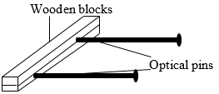
Figure 1
- a stop watch
- a stand, a boss and clamp
- a piece of sello-tape (about 30 cm long)

