ASUMBI GIRLS HIGH SCHOOL
POST -MOCK 1
AUGUST/SEPTEMBER
2022

232/3

PHYSICS PP3 MS QUESTION 1
PART A

d)
D (cm) | Time for 20  oscillations (S) | Periodic time (T)  (S) | T² (S²)
15 | 94.00 | 4.70 | 22.09
20 | 70.91 | 3.65 | 12.60
25 | 60.60 | 3.03 | 9.18
30 | 53.43 | 2.67 | 7.13
35 | 47.87 | 2.40 | 5.76
40 | 44.62 | 2.23 | 4.87
½ each 1mk for all ct 1mk for all correct

e) See graph attached.
P2
L1 A1 S1

f)
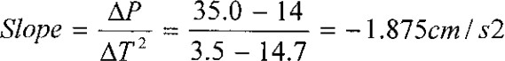

g) 33cm→6.25 (S²) T = 6.25
= 2.5 S

PART B

 | Time for 10 rev | T
1. | 5.92 | 0.592
2. | 6.10 | 0.610
3. | 5.87 | 0.587

T Ave = 0.596S
W = 2π = 10.543 rad S⁻¹
T

- F = 20 ± 0.1.
e)

U (cm) | 30 | 35 | 40 | 45 | 50 | 55
V(cm) | 58 | 47.0 | 42.0 | 46 | 34.5 | 32.5
M = v  u | 1.93 | 1.34 | 1.05 | 1.02 | 0.69 | 0.59

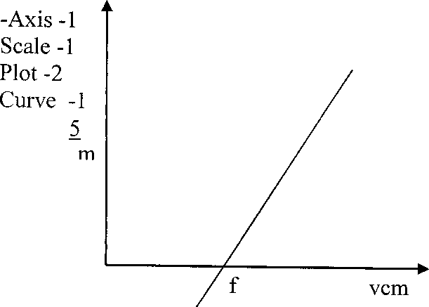
  - Slope = l
f

  - Use the x intercept When M = 0, v = f.
Or reciprocal of slope =f.

PART B
- (i) Ammeter, I = 0.25 A
  - Voltmeter, V = 1.35 V

  - K =
v ⇒ K = 1.35 5.4Ω

l 0.25

d)
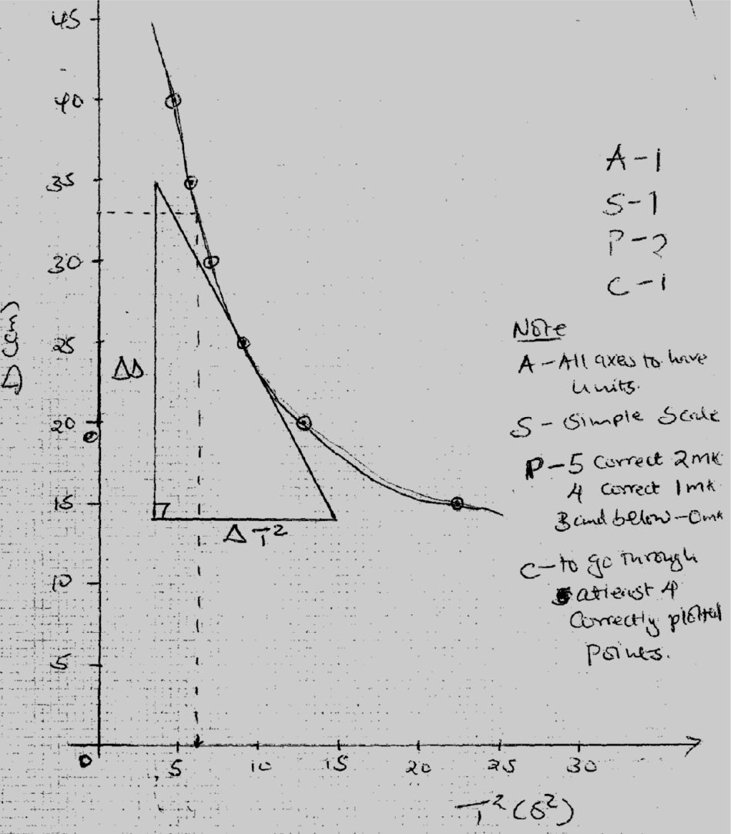

e)

