**Term 1 – 2023 OPENER**

**PHYSICS (232/2)**

**FORM FOUR (4)**

**Time: $2 Hours$**

**Name**: …………………………………………………………. **Adm** **No**: ……………….

**School**: ……………………………………………………….. **Class**: …………………..

**Signature**: …………………………………………………….. **Date**: …………………...

Instructions

* *Write your name, admission number, class, signature and date of examination in the spaces provided at the top of the page.*
* *This paper consists of two sections A and B.*
* *Answer all the questions in the two sections in the spaces provided after each question.*
* *Electronic calculators and mathematical tables may be used.*
* *All numerical answers should be expressed in decimal notations.*

FOR EXAMINER’S USE ONLY

|  |  |  |  |
| --- | --- | --- | --- |
| SECTION | QUESTION | MAXIMUM  MARKS | CANDIDATE’S SCORE |
| A | 1 – 11 | 25 |  |
| B | 12 | 10 |  |
| 13 | 10 |  |
| 14 | 13 |  |
| 15 | 10 |  |
| 16 | 12 |  |
|  | TOTAL | 80 |  |

SECTION A (45 MARKS)

This paper consists of **11** printed pages. Candidates are advised to check and to make sure all pages are printed.

SECTION A 25 MARKS

*Answer all the questions in this section in the spaces provided*

1. A pin hole camera forms on the screen an image which appears upside down and magnified with the aid of a ray diagram, explain how this happens. (2 marks)

…………………………………………………………………………………………………………………………………………………………………………………………………………………………………………………………………………………………………………………………………………………………………………

2. A form one student has the following apparatus two cells, a switch, connecting wires and two bulbs. Draw a possible circuit diagram for the arrangement that will allow the two bulbs to light simultaneously (2 marks)

3. An object is placed 30cm from a concave mirror of focal length 20cm. Calculate the magnification (3 marks)

…………………………………………………………………………………………………………………………………………………………………………………………………………………………………………………………………………………………………………………………………………………………………………

4. You are given three bars. One is magnetized with opposite poles at its ends. Another is magnetized with consequent poles. The third is not magnetized. Describe an experiment which you would perform to identify each. (2 marks)

…………………………………………………………………………………………………………………………………………………………………………………………………………………………………………………………………………………………………………………………………………………………………………..

5. The diagram below shows a ray of light XY traveling through a glass block of critical 420 to point A

Figure 1

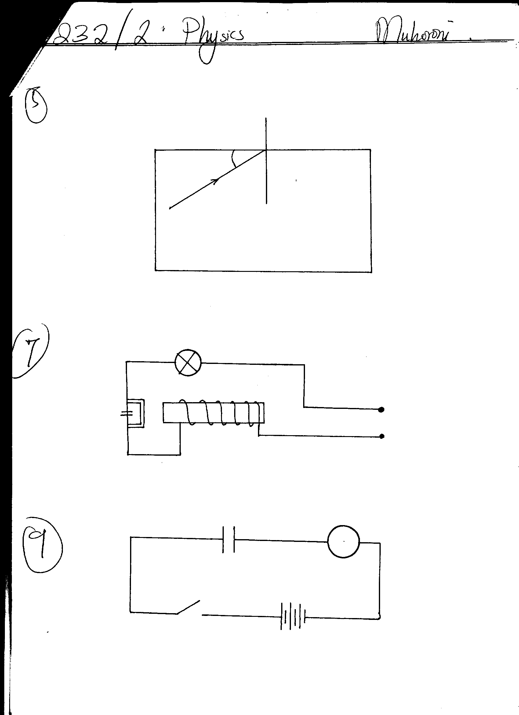

**430**

**A**

**Y**

**X**

On the same diagram, draw the path of the ray as it travels past point A.

(2 marks)

6. Sketch a displacement time graph of a wave of frequency 4HZ and amplitude 3.0cm over a time interval of 1.5 seconds (3 marks)

7. The figure 2 below shows a diagram of circuit breaker .

Figure 2



**Switch**

**Input**

Explain how it operates (3 marks)

…………………………………………………………………………………………..…………..…………………………………………………………………………………………………………..…………………………………………………………………………………………………………………………………………………………..

8. Differentiate between longitudinal wave and transverse wave (1mark)

……………………………………………………………………………………………………………………………………………………………………………………

9. A man standing between two walls claps his hands once and two echoes are heard; one after 1.0 seconds and another 1.8 seconds later. If the nearer wall is 170 m away from the man, calculate the distance between the two walls (3 marks)

………………………………………………………………………………………………………………………………………………………………………………………………………………………………………………………………………………………………………………………………………………………………………………………………………………………………………………………………………………………………

10. A positively charged rod is brought close to two neutral spheres A and B held by insulating handles as shown below.



Figure 3

Identify the charge(s) on A and B, in figure 3 above. (2mks)

………………………………………………………………………………………………………………………………………………………………………………………………………………………………………………………………………………………………………………………

11. Water waves from a given source move from a deep to a shallow end. What effect would this have on the;

(i) Speed (1mk)

……………………………………………………………………………………………………….……………………………………………………………………………………

(ii) Wavelength (1mk)

……………………………………………………………………………………………………….…………………………………………………………………………………….

SECTION B (55 MARKS)

*Answer all the questions in this section in the spaced provided*

12. Figure 4 below shows an electromagnetic relay being used to switch an electric motor on and off. The electromagnet consists of a coil of wire wrapped around a core. The motor in figure is switched off.

Motor

Springy metal strips

Contacts

Soft iron armature

Core

**S**

A

B

Pivot

Insulator

Figure 4

1. Suggest suitable material for the core. (1mark)

……………….………………………………………………………………………………………………………….……………………………………………

1. What happens to the core when switch S is closed? (2marks)

……………….………………………………………………………………………………………………………….………………………………………………………………………………………………………….…………………

1. Why do the contacts A and B close when the switch S is closed. (2marks)

……………….………………………………………………………………………………………………………….………………………………………………………………………………………………………….…………………

1. When the switch S is opened, what will happen to;
2. The core (1mark)

……………….………………………………………………………………………………………………………….…………………………

1. Soft iron armature. (1mark)

……………….………………………………………………………………………………………………………….…………………………

1. Give one other application of an electromagnet. (1mark)

……………….………………………………………………………………………………………………………….………………………………………………………………………………………………………….…………………

1. State two ways in which an electromagnet could be made more powerful. (2marks)

……………….………………………………………………………………………………………………………….………………………………………………………………………………………………………….…………………

13. (a) The figure 5 below shows a displacement-time graph of a wave. The velocity of the wave is 100m/s.

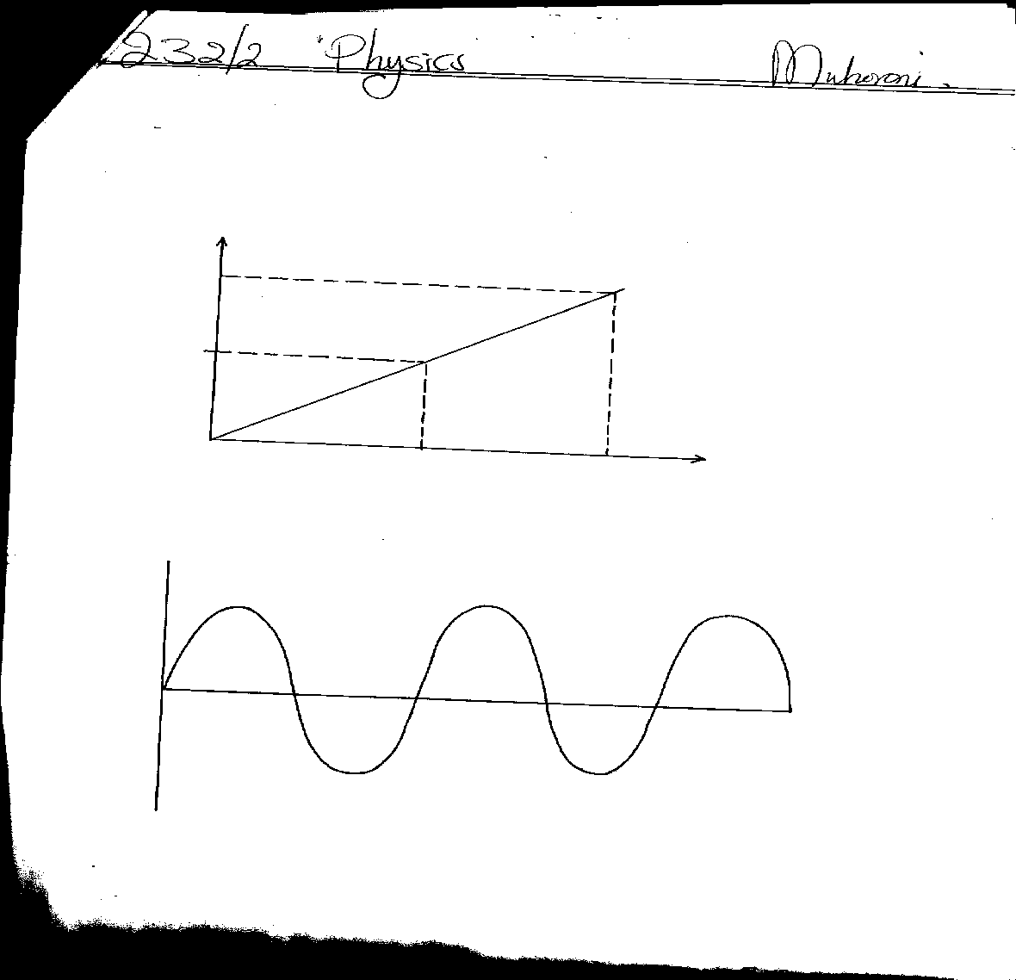

**Displacement, m**

**Metal (cm)**

**8**

Figure 5

**4**

**2**

**4**

**-8**

**-4**

**Time (Sec)**

**5**

**3**

**1**

Determine;

(i) Amplitude (1mark)

………………………………………………………………………………………………………………………………………………………………………………………………………………………………

(ii) Period (1mark)

………………………………………………………………………………………………………………………………………………………………………………………………………………………………

(iii) Frequency (3 marks)

…………………………………………………………………………………………………………………………………………………………………………………………………………………………………………

(iv) Wavelength (2 marks)

…………………………………………………………………………………………………………………………………………………………………………………………………………………………………………………………………………………………………………

(b.) Figure 6 below represents crests of water waves approaching a wide opening.

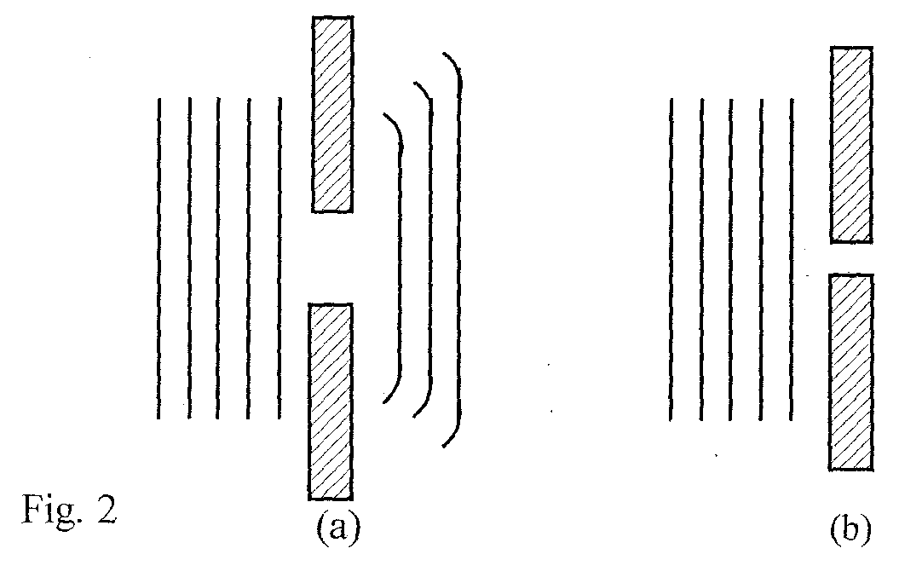

Figure 6

Crests of the same water waves are now approaching a narrow opening. Sketch the crests after passing through the opening. (2 marks)

(c.) In the figure 7 below, a wave is approaching a reflector. Complete the diagram, indicating at least 3 wave fronts after reflection (1 mark)

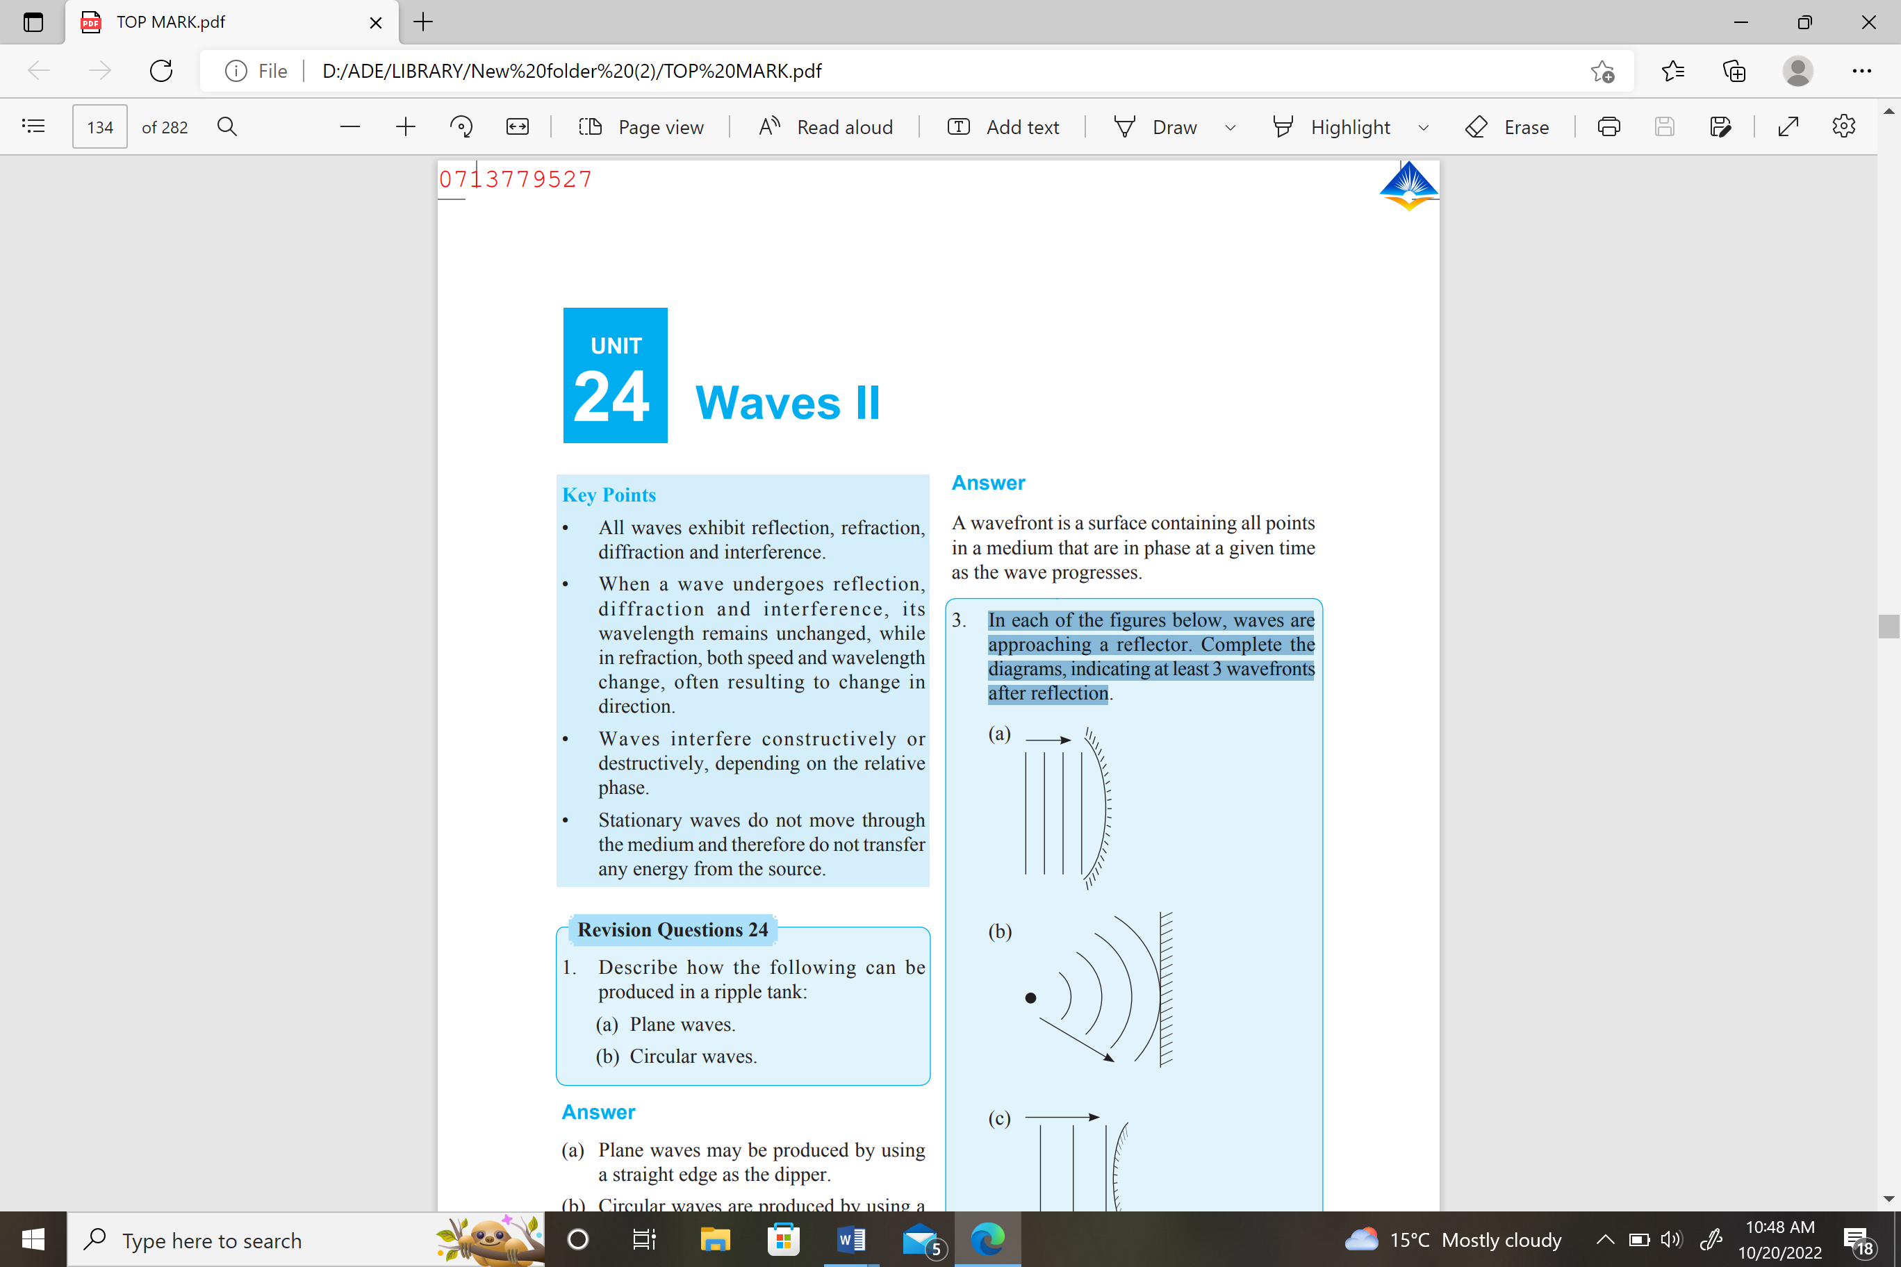

Figure 7

14. A student is provided with two resistors of value 2 Ω and 6 Ω

(a) (i) Draw a circuit diagram showing the resistors in series with each other

and with a battery (1 mark)

(ii) Calculate the total resistance of the circuit (assume negligible internal resistance) (2 marks)

………………………………………………………………………………………………….…………………………………………………………………………………………………………………………………………………………………….…………………………………

(b) Given that battery has an e.m.f of 3V and internal resistance 1.2Ω. Calculate the current through.

(i) The 6 Ω resistor (3 marks)

………………………………………………………………………………………………….…………………………………………………………………………………………………………………………………………………………………….…………………………………

(ii) The 2 Ω resistor when the two are in parallel. (3 marks)

………………………………………………………………………………………………….……………………………………………………………………………………………………………………………………

(c )The graph below shows the variation of potential difference V with current I for a certain cell.

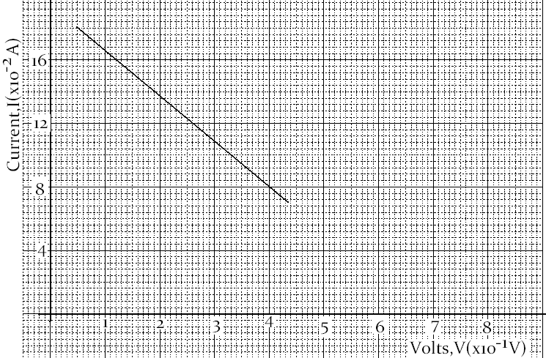

Figur

From the graph determine

1. The internal resistance of the cell (3 marks)
2. The e.m.f of the cell (1 mark)

15. (a) State Snell’s law (1mark)

…………………………………………………………………………………………………………………………………………………………………………………………………………………………………………………………………………………………………………………………………………

1. A ray of light travelling from water to glass makes an angle of incident of 300.

Find the angle of refraction in the glass. Refractive index of water =4/3. Refractive index of glass =3/2 (3 marks)

……………………………………………………………………………………………………………………………………………………………………………………………………………………………………………………………………………………………………………………………………………………………………………………………………………………………

1. State the necessary and sufficient conditions for total internal reflection to

occur. (2 marks)

……………………………………………………………………………………………………………………………………………………………………………………………………………………………………………………………………………………………………………………………………………………………………………………………………………………………

1. You are provided with a glass block, a soft board, white sheet of paper and

three optical pins. With the help of a diagram explain how you would use these apparatus to determine the refractive index of the glass block using real and apparent depth method. (4marks)

……………………………………………………………………………………………………………………………………………………………………………………………………………………………………………………………………………………………………………………………………………………………………………………………………………………………………………………..

16. Figure 9 shows three capacitors connected between two points M and N



Figure 8

1. Find the effective capacitance between M and N (3 marks)
2. Determine the charge in the circuit if 3 V is applied across MN (3 marks)

c. One of the factors which affect the capacitance of a parallel plate capacitor is the area of overlap of the plates. Name **two** other factors. (2mks)

……………………………………………………………………………………………………………………………………………………………………………………………………………….……………………………………………………………………………...

d. The figure below shows a thin wire connected to a charge generator and placed close to a candle flame.

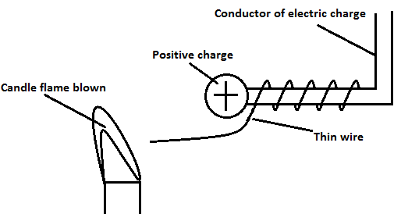

Explain why the candle flame is deflected as shown (2 marks)

…………………………………………………………………………………………………………………………………………………………………………………………………………………………………………………………………………………………………………………………………………………………………………………………………………………………………………………………

e.) Sketch the electric field patterns in the following situations: (2 marks)

