**NAME: ………………………………………………………….INDEX NO. …………………………**

**STREAM………………. CANDIDATE’S SIGN…………………..DATE: ……………….**

**232/2**

**PHYSICS PAPER 2**

**THEORY**

**JUNE 2022**

**TIME: 2 HOURS**

***MUMIAS WEST JOINT EVALUATION ASSESMENT TEST***

***KENYA CERTIFICATE OF SECONDARY EDUCATION (K.C.S.E.)***

**INSTRUCTIONS TO THE CANDIDATES:**

* Write your **name,index number and stream** in the spaces provided above
* Sign and write the date of the examination in the spaces provided.
* This paper consists of ***two*** sections: **A** and **B.**
* Answer ***all*** questions in section **A** and **B** in the spaces provided.
* All working ***must*** be clearly shown in the spaces provided in this booklet.
* Scientific calculators and KNEC mathematical tables may be used except where stated otherwise.

. For Examiner's Use Only

|  |  |  |  |
| --- | --- | --- | --- |
| **Section** | **Question** | **Maximum Score** | **Candidate's Score** |
| A | 1 - 13 | 25 |  |
| B | 14 | 11 |  |
| 15 | 11 |  |
| 16 | 13 |  |
| 17 | 10 |  |
| 18 | 10 |  |
| **Total Score** | **80** |  |

*This paper consists of 12 printed pages*

*Candidates should check the question paper to ensure that all the pages are printed as indicated and no questions are missing.*

**SECTION A (25 MKS)**

***Answer all the questions in this section in the spaces provided below each question***

1. **Figure 1** shows a ray of light XY striking the mirror CD held at an angle of 1080 to mirror DE.



**Fig 1**

Complete the path of the ray XY and state the final angle of reflection. (2 mks)

1. Figure 6 below shows a progressive wave incident from a shallow end to a deep end.

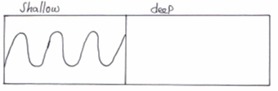

(a) Sketch the appearance of the wave in the deep region. (1mk)

(b) State the property of waves demonstrated in the figure above. (1mk)

1. State a device where a variable air capacitor could be used. (1 mk)
2. Figure 2 below shows a metre rule in equilibrium balanced by the magnet and weight. The iron core fixed to the bench.

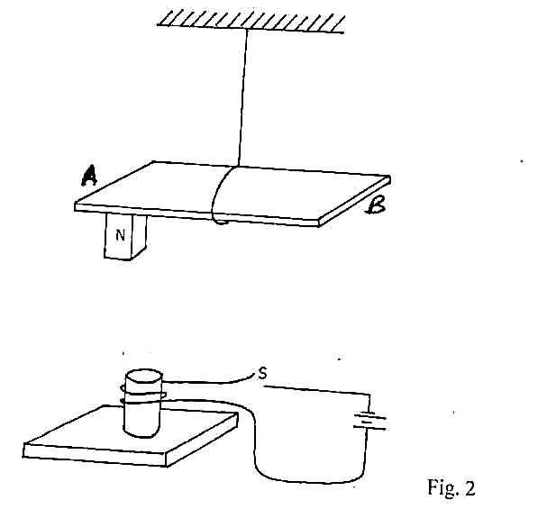

**Fig. 2**

State and explain the effect on the metre rule when the switch S is closed. (2 mks)

1. An electric kettle is rated at 1.8 kW, 240 V. Explain the choice of the safest fuse for the kettle. (the available fuses are 5 A, 10 A, and 20 A). (3mks)

…

1. The chart below shows an arrangement of electromagnetic spectrum.

|  |  |  |  |  |  |  |
| --- | --- | --- | --- | --- | --- | --- |
| radio waves | A | infra-red | visible  light | B | x-rays | gamma rays |

A) Name the radiation represented by A (1mk)

B) Name the device that can be used to detect radiation B (1mk)

1. An uncharged metal rod brought close but not touching the cap of a charged electroscope causes a decrease in the divergence of the leaf. Explain. (1 mk)
2. Figure 10 below shows capacitors connected to 3v supply.

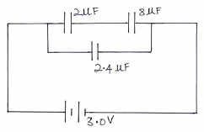

Calculate:

The total charge in the circuit. (3mks)

1. Explain how polarization affects the working of a simple cell. (2mks)
2. A siren has 200 holes and makes 30 revolutions per minute. If the speed of sound waves produced is 340m/s, determine the wavelength of sound produced. (2 marks)
3. Write ***one*** difference between a virtual and a real image. (1mk)

1. The figure1. Shows an object, O placed in front of a concave lens. By drawing appropriate rays, locate the image formed. (3mk)

Fig .1

F

F

O

**13.** Mention one factor that determines the current carrying capacity of lead acid accumulator (1mk)

**SECTION B (55 MKS)**

14. The figure below shows an X-ray tube.

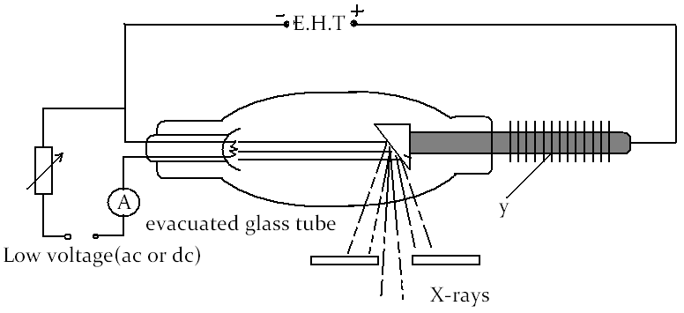

1. Label the part marked Y. (1 mk)
2. How would one increase
3. The intensity of the X –rays. (1 mk)
4. Penetrating power of the X –rays. (1 mk)
5. Explain why the tube is highly evacuated. (2 mk)
6. An X –ray tube operating with an anode potential of 10 kV and current of 15mA.
7. Calculate the number of electrons hitting the anode per second. (3 mk)
8. Determine the speed with which the electrons hit the target (3 mk)

(charge of an electron, q=1.6x10-19C, mass of an electron Me=9.1x10-31 kg.)

15. a) State what is meant by electromotive force (e.m.f) of battery. (1mk)

b) Three identical bulbs are connected in series with a battery of dry cells. At first the bulbs shine brightly but gradually become dimmer. Using the same cells, explain how you would increase the brilliance of the bulbs. (2mks)

c) The graph in **figure 8** shows the terminal voltage, V, of a certain battery varies with the current, I, being drawn from the battery.



**Fig. 8**

(i) Write an expression relating the e.m.f. E, terminal voltage, V, current, I and the internal resistance, r, of the battery for the circuit drawn in (i) above. (1mk)

(iii) From the graph determine the;

I. internal resistance, r, of the battery. (3mks)

II. e.m.f., E of the battery (2mks)

d) On the axes provided, sketch a graph to show how current, I varies with potential difference, V, across a metallic conductor that is being heated at the same time. Explain your answer (2mks)

**p.d (V)**

**I (A)**

16. a) What is meant by

i) Radioactive decay? (1mk)

ii) Background radiation. (1mk)

b) State one possible source of background radiation. (1mk)

c) Radiation from a radioactive source enters a G.M tube.

i) State the effect of the radiation on the gas inside the tube. (1mk)

ii) Explain how the large discharge current is created. (2mk)

d) The diagram in the figure below shows paths taken by three radiations K, J and L

from a radioactive through an electric field.

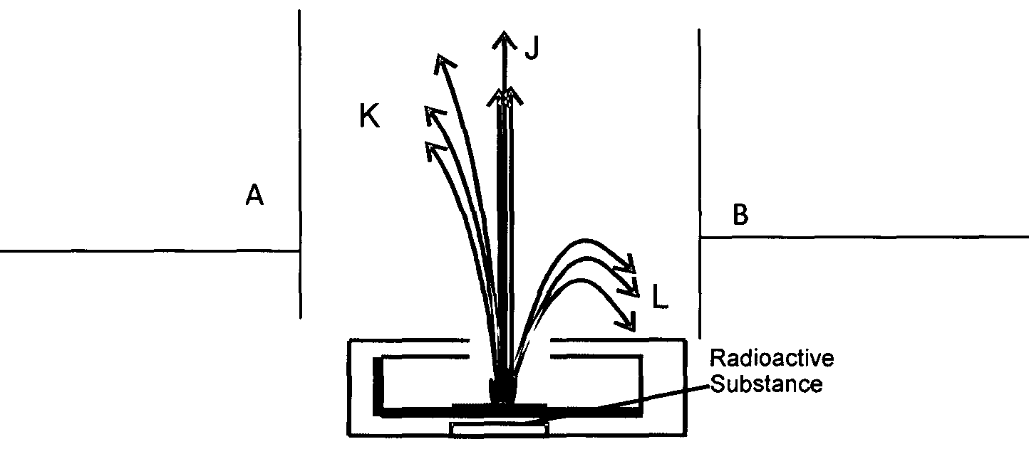

i) State the charge on plate A (1mk)

ii) Identify the radiations K and L. (2mks)

iii) Give a reason why L deviates more than K (1mk)

e) For a certain radioactive material, the average count-rate is found to be 82 counts per second. After 210 seconds, the count rate had dropped by 63 counts per second. The average background count-rate remained constant at 10 counts per second. What is the half-life of the material? (3mks)

17. (a) An optical fibre provides an efficient way of transmitting light energy. State

and explain the property of light behind its functioning. (2mks)

(b) State **one** condition under which the above property occurs. (1mk)

(c) Figure 6 shows a slab of glass of uniform thickness lying horizontally. Above it is a layer of water. A ray of light PQ is incident upwards on the lower surface of the glass and is refracted successively at A,B and C, the points where it crosses the interfaces.

*( Refractive index of glass = 3/2 , refractive index of water = 4/3)*

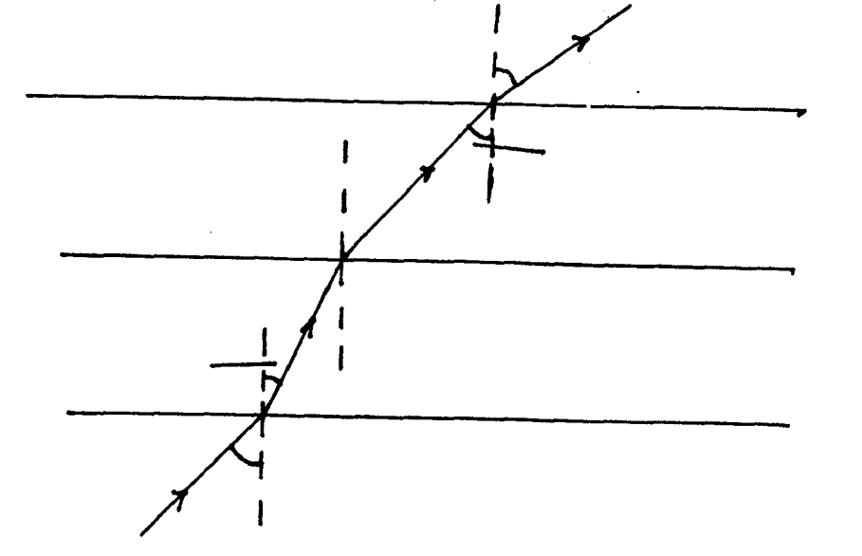

**Q**

**Water**

**yo**

**60o**

**B**

**xo**

**A**

**60o**

**P**

C

Calculate

(i) Angle x (3mks)

(ii) The refractive index for light passing from the glass to water. (2mks)

(iii) Angle y (2mks)

**18. a)** State the main difference between an induction coil and a transformer. (1mk)

**b)** The figure below is a simple microphone in which sound waves from a speaker cause the cardboard diaphragm to vibrate.

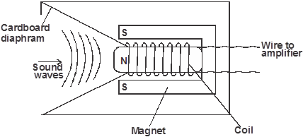

1. Explain how a varying current is induced in the coil when the diaphragm vibrates to and fro. (3mks)

  ii) State two ways in which the induced current in 18b(i) above can be increased. (2mks)

**C)**

I) i) Define flux leakage as used in transformers. (1mk)

ii) How is it minimized? (1mk)

II ) i) In the design of a transformer in a (i) above which coil would be made with thick conductors if the transformer is a step-up. (1mk)

ii) Explain your answer in b (i). (1mk)