Term 1 – 2023 MID TERM 1
PHYSICS PAPER 1 (232/1)
QUESTION PAPER
FORM FOUR
2 HOURS

Name: …………………………………………………………. Adm No: ……………….
School: ……………………………………………………….. Class: …………………..
Signature: …………………………………………………….. Date: …………………...

Instructions to candidates

- This paper consists of two sections A and B.
- Answer all the questions in the two sections in the spaces provided after each question
- All working must be clearly shown.
- Electronic calculators, mathematical tables may be used.
- All numerical answers should be expressed in the decimal notations.
- You may use ‘g’ as 10m/s²

For Examiner use only
SECTION | QUESTION | MAX MARKS | CANDIDATE’S SCORE
A | 1 – 14 | 25
B | 15 | 13
 | 16 | 13
 | 17 | 13
 | 18 | 09
 | 19 | 07
 | TOTAL | 80

This paper consists of 10 printed pages. Candidates should check to ascertain that all pages are printed as indicated and that no questions are missing.

SECTION A (25 Marks)
- The figure 1, below shows a section of a tape measure used for measuring the circumference of a cylindrical water tank.
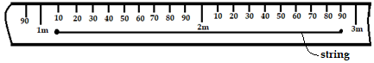

Figure 1
- State the accuracy of the tape (1 mark)

- Determine the diameter of the tank (2 marks)

- Figure 2, shows a metal bolt which is threaded. Explain how a metre-rule may be used to measure the pitch (distance between adjacent peaks) of the threading (2 marks)
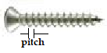

Figure 2

- State the advantage of fitting wide tyres on a vehicle that move on earth roads (1 mark)

- It may not be possible to suck liquid into your mouth using drinking straw on the surface of the moon. Explain (2 marks)

- A drop of blue ink is introduced at the bottom of a beaker containing water. It is observed that after sometime, all the water in the beaker turns blue. Name the process that takes place. (1 mark)

- In the set-up shown below, water near the top of the boiling tube boils while at the bottom it remains cold. Give a reason for this. (2 marks)
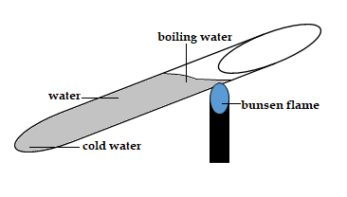

Figure 3

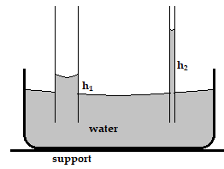
- The diagram below shows two glass-tubes of different diameters dipped in water. Explain why h₂ is greater than h₁ (3 marks)
Figure 4

- A solid copper sphere will sink in water while a hollow copper sphere of the same mass may float. Explain (2 marks)

- Name the instrument that would be most suitable for measuring the thickness of one sheet of this question paper (1 mark)

- State how pressure of a moving fluid varies with the speed of the fluid (1 mark)

- State Bernoulli’s principle (1 mark)

- The solid marble shown below is in a stable equilibrium. On the space provided, sketch the same marble in a neutral state of equilibrium (1 mark)

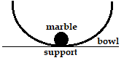
Figure 5

- The figure below shows how pressure and volume of a fixed mass of a gas vary at constant temperature. Sketch on the same axes, a graph for the same mass of gas at temperature,T₂ such that $T_{2}<T_{1}$ (1 mark)
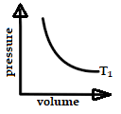

Figure 6

- The figure below shows a ball being whirled in a vertical plane. Sketch on the same figure the path followed by the ball if the string cuts when the ball is in the same position shown. (1 mark)
ball
String $ω$

Figure 7
- A spring extends by 6cm when supporting a mass of 0.06kg on earth. When the spring is used to support the same mass on moon, it extends by 1 cm. determine the moon’s gravitational strength (3 marks)

SECTION B (55 MARKS)

- Define the following terms:
- Angular velocity (1 mark)

- Centripetal acceleration (1 mark)

- State two ways in which the centripetal force on a body of mass m can be increased (2 marks)

- Figure 8 shows an object at the end of a light spring balance connected to a peg using a string. The object is moving in a circular path on a smooth horizontal table with a
constant speed.

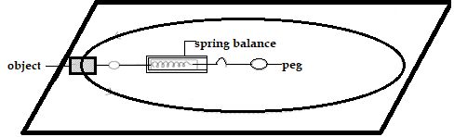
Figure 8
- State what provides the centripetal force (1 mark)

- On the same diagram Indicate with an arrow the direction of the centripetal force
(1 mark)

- State a reason why the object is accelerating while its speed remains constant
(1 mark)

- The mass of the object is 0.5kg and it is moving at a speed of 8m/s at a radius of 2m. determine the reading on the spring balance (3 marks)

- A body moving with uniform angular velocity found to have covered an angular distance 170 radians in t seconds. Thirteen seconds later it is found to have covered a total angular distance of 300 radians. Determine t (3 marks)

- State the pressure law for an ideal gas (1mark)

- The set up shows an arrangement to determine the relationship between temperature and pressure of a gas constant volume.
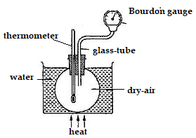

Figure 9

- Describe how measurements are obtained in the experiment. (3marks)

- Explain how the result form the experiment can be used to determine the relationship between temperature and pressure. (2marks)

- A bicycle tire is pumped to a pressure of 2.2 × 10⁵pa at23⁰C. After a race the pressure is found to be 2.6 × 10⁵ pa. Assuming the volume of the tyre did not change, what is the temperature of the air in the tyre. (3marks)

- Air is trapped inside a glass tube by a thread of mercury 240 mm long. When the tube is held horizontally the length of the air column is 240mm.
750 mmHg

240mm
L₁ = 240 mm
Figure 10

Assuming that the atmospheric pressure is 750mm Hg and the temperature is constant; calculate the length of the air column when the tube is vertical with open end down. (3marks)

- What is an ‘ideal gas?’ (1 mark)

- Define the following terms:
- Mechanical advantage (1 mark)

- Velocity ratio (1 mark)

- Sketch a labeled diagram to show how an arrangement of a single pulley may be used to provide a mechanical advantage of 2. (3 marks)

- The figure 11, below shows a loaded wheelbarrow.
- Indicate and label on the diagram three forces acting on the wheelbarrow when a worker is just about to lift the handle. (3 marks)

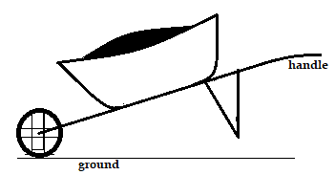

Figure 11
- Suppose the handle-bars of the wheelbarrow were extended, which force(s) would change? Explain (2 marks)

- A ball rolls on a table in a straight line. A part from the transitional kinetic energy, state the other form of kinetic energy possessed by the ball. (1 mark)

- The figure 12, below shows how the potential Energy (P.E) of a ball thrown vertically upwards.

2 4 6 8 height, m
2 4 6 8 (J)
P.E
Figure 12
On the same axes, plot a graph of kinetic energy of the ball. (2 marks)

- State the law of floatation (1 mark)

- When a piece of metal is placed on water, it sinks. But when the same piece of metal is placed on a block of wood, both are found to float. Explain this observation. (2 marks)

- Figure 13 shows a cork floating on water and held to the bottom of the beaker by a thin thread
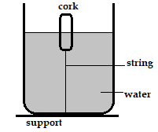

Figure 13
- Name the force acting on the cork. (3marks)

- Describe how each of the forces mentioned in (i) above changes when water is added into the beaker until it fills up. (3marks)

- Water flows in a horizontal smooth pipe. State the changes that would be observed in the nature of flow if the speed of water is steadily increased from low to high value (2 marks)

- A pipe of radius 6mm is connected to another pipe of radius 9mm. if water flows in the wider pipe at a speed of 2m/s, what is the speed in the narrower pipe? (3 marks)

- State the reason why it may not be possible to suck liquid into your mouth using drinking straw on the surface of the moon (1 mark)

- A can with a hole on the side is filled with water to a certain height. Water jets out as shown below (figure 14, a). A second identical can is filled with water to the same height and a block of wood floated on the water as shown (figure 14, b). give a reason why the water jet in (b) is longer than that in (a). (1 mark)

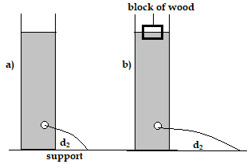

Figure 14

