ZERAKI ACHIEVERS’ EXAMINATIONS
MID TERM SERIES-TERM 1-2023
PHYSICS PAPER 1 (232/1)
MARKING SCHEME
FORM FOUR

SECTION A (25 Marks)
- The figure 1, below shows a section of a tape measure used for measuring the circumference of a cylindrical water tank.
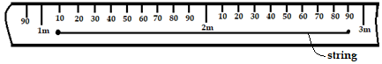

Figure 1
- State the accuracy of the tape (1 mark)
$\frac{10}{100}=0.1m$ ;
- Determine the diameter of the tank (2 marks)
$circumference=2.9-1.1=1.8m$ ;
$D=\frac{c}{π}=\frac{1.8}{3.142}=0.5729m$ ;

- Figure 2, shows a metal bolt which is threaded. Explain how a metre-rule may be used to measure the pitch (distance between adjacent peaks) of the threading (2 marks)
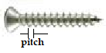

Figure 2
Count the number, n of peaks and measure the length, l of the n peaks ;
Pitch, P is given by: $P=\frac{l}{n-1}$ ;
- State the advantage of fitting wide tyres on a vehicle that move on earth roads (1 mark)
Wide tyres exert low pressure on the ground so that the vehicle would sink less into the ground ;

- It may not be possible to suck liquid into your mouth using drinking straw on the surface of the moon. Explain (2 marks)
No air pressure on moon; the lack of pressure difference does not provide the needed force to suck the liquid;

- A drop of blue ink is introduced at the bottom of a beaker containing water. It is observed that after sometime, all the water in the beaker turns blue. Name the process that takes place. (1 mark)
Diffusion ;

- In the set-up shown below, water near the top of the boiling tube boils while at the bottom it remains cold. Give a reason for this. (2 marks)
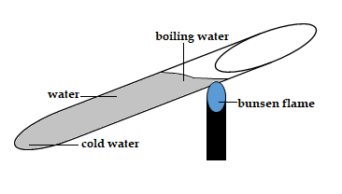
Water and glass are poor conductors of heat; no convectional currents because hot water at the top is less dense so it stays at the top hence no heat is transmitted down;

Figure 3

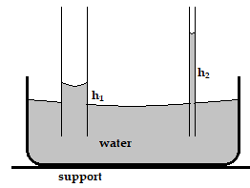
- The diagram below shows two glass-tubes of different diameters dipped in water. Explain why h₂ is greater than h₁ (3 marks)
Figure 4
Adhesive force experienced in h2 is greater than in h1; since the weight of water in the both tubes is the same, the narrower tube (h2) must have a longer column to equal the weight in the wider tube;

- A solid copper sphere will sink in water while a hollow copper sphere of the same mass may float. Explain (2 marks)
Solid copper sphere is denser than water so it sinks; weight of the hollow copper sphere is less than the up-thrust it experiences so it floats;

- Name the instrument that would be most suitable for measuring the thickness of one sheet of this question paper (1 mark)
Micrometer screw-gauge;

- State how pressure of a moving fluid varies with the speed of the fluid (1 mark)
Pressure is inversely proportional to the speed

- State Bernoulli’s principle (1 mark)
Provided a fluid is streamline, incompressible and non-viscous the sum of pressure, kinetic energy per unit volume and potential energy per unit volume is a constant;

- The solid marble shown below is in a stable equilibrium. On the space provided, sketch the same marble in a neutral state of equilibrium (1 mark)
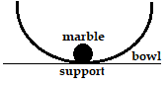
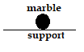
Figure 5

- The figure below shows how pressure and volume of a fixed mass of a gas vary at constant temperature. Sketch on the same axes, a graph for the same mass of gas at temperature,T₂ such that $T_{2}<T_{1}$ (1 mark)
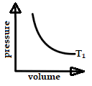
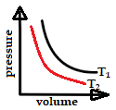
Figure 6

- The figure below shows a ball being whirled in a vertical plane. Sketch on the same figure the path followed by the ball if the string cuts when the ball is in the same position shown. (1 mark)
ball
String $ω$

Figure 7

- A spring extends by 6cm when supporting a mass of 0.06kg on earth. When the spring is used to support the same mass on moon, it extends by 1 cm. determine the moon’s gravitational strength (3 marks)
$k=\frac{F}{e}=\frac{0.6}{0.06}=10N/m$ ;
On moon: $k=\frac{W}{0.01}≡10=\frac{W}{0.01} therefore W=0.1 N$;
$g=\frac{W}{m}=\frac{0.1}{0.06}=1.667N/{kg}$;

SECTION B (55 MARKS)

- Define the following terms:
- Angular velocity (1 mark)
Rate of change of angular dispalcement with time;

- Centripetal acceleration (1 mark)
Rate of change of angular velocity with time;

- State two ways in which the centripetal force on a body of mass m can be increased (2 marks)
- Increasing the angular velocity of the body;
- Reducing the radius of the circular track;

- Figure 8 shows an object at the end of a light spring balance connected to a peg using a string. The object is moving in a circular path on a smooth horizontal table with a
constant speed.

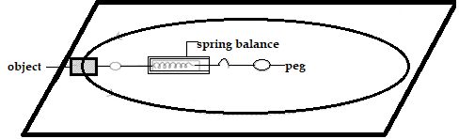
Figure 8

- State what provides the centripetal force (1 mark)
Friction between the object and table surface;

- On the same diagram Indicate with an arrow the direction of the centripetal force
(1 mark)
; Shown on diagram

- State a reason why the object is accelerating while its speed remains constant
(1 mark)
The change in direction of the instantaneous velocity constitute the acceleration.
- The mass of the object is 0.5kg and it is moving at a speed of 8m/s at a radius of 2m. determine the reading on the spring balance (3 marks)
$F=\frac{mV^{2}}{r};$
$\frac{0.5×8^{2}}{2};=16N;$
- A body moving with uniform angular velocity found to have covered an angular distance 170 radians in t seconds. Thirteen seconds later it is found to have covered a total angular distance of 300 radians. Determine t (3 marks)

$ω=\frac{170}{t} also ω=\frac{300}{t+13};$

$ω=ω, therefore \frac{170}{t}=\frac{300}{t+13}$ ;

Hence, t = 17 seconds;

- State the pressure law for an ideal gas (1mark)
Pressure of fixed mass on gas is directly proportional to the absolute temperature provided volume is kept constant;

- The set up shows an arrangement to determine the relationship between temperature and pressure of a gas constant volume.
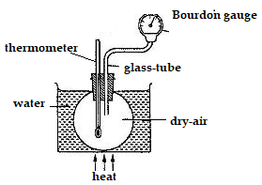

Figure 9

- Describe how measurements are obtained in the experiment. (3marks)

- Initial pressure and temperature is noted and recorded. ;
- The bath is heated, this in turn heats the air inside the flask, ;
- The values of Temperature and Pressure are taken at given intervals;
- Explain how the result form the experiment can be used to determine the relationship between temperature and pressure. (2marks)

The results obtained are tabulated and a graph of pressure against absolute temperature is plotted; A straight line graph through the origin is obtained hence verifying the relationship between pressure and temperature;

- A bicycle tire is pumped to a pressure of 2.2 × 10⁵pa at23⁰C. After a race the pressure is found to be 2.6 × 10⁵ pa. Assuming the volume of the tyre did not change, what is the temperature of the air in the tyre. (3marks)

$\frac{2.2×{10}^{5}}{296}=\frac{2.6×{10}^{5}}{T}$;;

= 349.8K;

- Air is trapped inside a glass tube by a thread of mercury 240 mm long. When the tube is held horizontally the length of the air column is 240mm.
750 mmHg

240mm
L₁ = 240 mm
Figure 10

Assuming that the atmospheric pressure is 750mm Hg and the temperature is constant; calculate the length of the air column when the tube is vertical with open end down. (3marks)

$P_{1}V_{1}=P_{2}V_{2}$ $750×240=(750-240)V_{2}$;;

V₂= 352.9 mm;

- What is an ‘ideal gas?’ (1 mark)
A gas that obeys all the gas laws;

- Define the following terms:
- Mechanical advantage (1 mark)
Ratio of load to effort;

- Velocity ratio (1 mark)
Ratio of effort distance to load distance;

- Sketch a labeled diagram to show how an arrangement of a single pulley may be used to provide a mechanical advantage of 2. (3 marks)
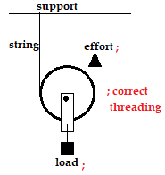

- The figure 11, below shows a loaded wheelbarrow.
- Indicate and label on the diagram three forces acting on the wheelbarrow when a worker is just about to lift the handle. (3 marks)
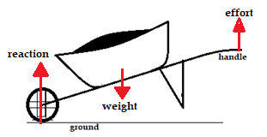

Figure 11
- Suppose the handle-bars of the wheelbarrow were extended, which force(s) would change? Explain (2 marks)

Effort; it would reduce because the longer handle would need less force for the same turning effect;
- A ball rolls on a table in a straight line. A part from the transitional kinetic energy, state the other form of kinetic energy possessed by the ball. (1 mark)

Gravitational potential energy ;

- The figure 12, below shows how the potential Energy (P.E) of a ball thrown vertically upwards.

2 4 6 8 height, m
2 4 6 8 (J)
P.E
K.E
Figure 12
On the same axes, plot a graph of kinetic energy of the ball. (2 marks)
;;

- State the law of floatation (1 mark)
A floating object displaces its own weight of the fluid in which it floats;

- When a piece of metal is placed on water, it sinks. But when the same piece of metal is placed on a block of wood, both are found to float. Explain this observation. (2 marks)

Metal sinks because it is denser than water (weight of metal is greater than upthrust); when placed on a block of wood, the up-thrust experienced equals the weight of wood and metal so the both metal and wood will float;

- Figure 13 shows a cork floating on water and held to the bottom of the beaker by a thin thread
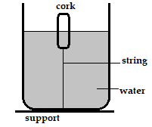

Figure 13
- Name the force acting on the cork. (3marks)
- Up-thrust ;
- Tension ;
- Weight ;
- Describe how each of the forces mentioned in (i) above changes when water is added into the beaker until it fills up. (3marks)
- Up-thrust increases ;
- Tension increases ;
- Weight remains constant ;

- Water flows in a horizontal smooth pipe. State the changes that would be observed in the nature of flow if the speed of water is steadily increased from low to high value (2 marks)
At low speed the flow is streamline; at higher speed the flow changes to turbulent;

- A pipe of radius 6mm is connected to another pipe of radius 9mm. if water flows in the wider pipe at a speed of 2m/s, what is the speed in the narrower pipe? (3 marks)
R₁= 0.006 m
R₂= 0.009m
$a_{1}V_{1}=a_{2}V_{2}$
${0.006}^{2}V_{1}={0.009}^{2}(2)$
V₁= 4.5 m
- State the reason why it may not be possible to suck liquid into your mouth using drinking straw on the surface of the moon (1 mark)
Absence of air on moon so pressure difference (which produces force) cannot be achieved;

- A can with a hole on the side is filled with water to a certain height. Water jets out as shown below (figure 14, a). A second identical can is filled with water to the same height and a block of wood floated on the water as shown (figure 14, b). give a reason why the water jet in (b) is longer than that in (a). (1 mark)

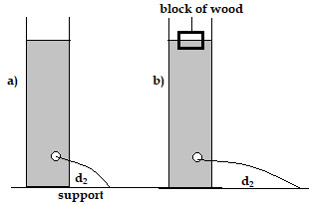
The weight of the block of wood exerts extra pressure so the jet in (b) is longer;

Figure 14

