Term 1 – 2023 OPENER EXAM
PHYSICS (232/1)
FORM FOUR (4)
Time: 2 Hours

Marking Scheme

Instructions to the teacher
This marking scheme may not be the final draft. The author acknowledges that there could be various perspectives of facts to the questions. It is therefore encouraged that the teacher concerned should adapt this marking scheme in order to capture all the relevant alternative facts.

SECTION A (25 MARKS)
- The scale of the micrometer screw gauge below has a zero error of +0.05mm.
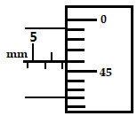Figure 1
Reading = 6.5 + 0.46 = 6.96 mm ;
Actual reading = (6.96 – 0.05) = 6.91 mm ;
What is the actual reading of the micrometer screw gauge? (2 marks)

- In a ball and ring experiment, the ball goes through the rings at room temperature. When it is heated it does not go through the ring, but when left on the ring for some time, it goes through. Explain this observation (2 marks)
On heating, the ball expands so it does not go through the ring; when left on the ring, the ball loses heat and contracts while the ring gains heat and expands allowing the ball to pass through;

- The set up shown below, figure 2, was used to study behavior of water when heated from room temperature at 20⁰C.
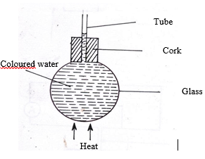

Figure 2
When heat was introduced, it was observed that the level of the water initially drops before starting to rise. Explain this observation (2marks)
Glass flask receives heat first and expands causing the level of water to drop; water expands more than glass so it rises up the tube ;

- Figure 3 shows some air trapped by mercury in a glass tube. The tube is inverted in a dish containing mercury.
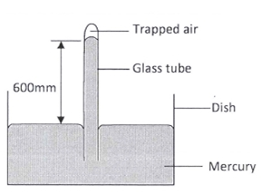
Figure 3
Given that the atmospheric pressure is 760 mmHg and the height of mercury column in the tube is 600 mm, determine the pressure of the air trapped in the tube in mmHg. (3 marks)
$atm.pressure=mercury pressure+air pressure$ ;
$760=600+air pressure$ ;
Therefore, air pressure = $760-600=160mmHg$ ;
The answer may also be expressed in Pascal or N/m². Check for correct conversion.

- State two measurements you would take in an experiment to determine the upthrust of an object which is immersed in a fluid. (2 marks)
- Weight of object in air ;
- Weight of object in fluid ;

- State how the measurements in question (5) are used to determine the upthrust of the object. (1 mark)

$upthrust=weight of object in air-weight of object in fluid$ ;

- It is easier to bend an iron rod than a glass rod of the same dimensions at room temperature. Give a reason for this (1 mark)
Iron is ductile so it can bend while glass is brittle so it easily breaks without bending ;

- An experiment was performed to find out how the length L of a spiral spring varies with the compression force, F. The figure, 4 shows the variation.

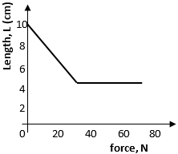Figure 4

- Draw a diagram of a possible set up of the apparatus (3 marks)
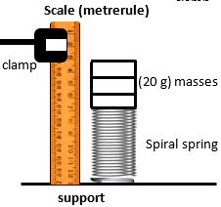

Measurement scale ;

Masses (weight) resting on spring ; ;

- Determine the length of the spring when it is not being used (1 marks)
10 cm ;

- Why is it that boiling water is not used for sterilization of clinical thermometer? (1 mark)
Clinical thermometer is designed for thermometric liquid to expand and contract between 35⁰C and 43⁰C. The higher temperature of boiling water will cause the thermometric liquid to expand and crack the bore of the thermometer.

- Figure 5 shows two identical balloons A and B. The balloons were filled with equal amounts of the same type of gas. The balloons are suspended at equal distances X1 and X2 from a metal cube filled with boiling water and placed on an insulating material. One side of the metal cube is shiny while the other side is dull (use this information to answer question 10 and 11).
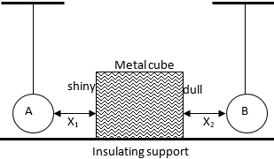Figure 5

State the mode by which heat travels from the cube to the balloons (1 mark)
Radiation ;

- Compare the size of the balloons after some time. Give reason for your comment (2 marks)
Balloon B is bigger; dull surface emits more heat than the shiny surface causing the air in balloon B to expand more than air in balloon A ;

- A pupil blows a current of air over the surface of a sheet of paper held close to its mouth. State and explain what happens to the paper. (2 marks)
The paper rises; fast moving air above the paper reduces pressure there. Higher pressure from below the paper creates a force which pushes the paper upwards;

- An object is projected horizontally at a velocity of 40m/s from a cliff 20m high. Calculate the time taken to hit the ground (2 marks)
$h=\frac{1}{2}gt^{2}$
$20=0.5×10t^{2}$ ;
Therefore, t = 2 seconds ;

SECTION B (55 MARKS)

- Define the following terms:
- Mechanical advantage (1 mark)
Ratio of load to effort ;

- Efficiency (1 mark)
Ratio of work output to work input ;
Accept: Ratio of work done on load to work done by effort

- Velocity ratio (1 mark)
Ratio of effort distance to load distance ;

- A crane lifts a load of 200 kg through a vertical distance of 3.0m in 6 seconds. Determine the;
- Work done (3 marks)
$workdone=load×load distance$ ;
$→workdone=2000×3.0 ;=6000$J ;

- Power developed by the crane (3 marks)
$power=\frac{workdone}{time}$ ;
$=\frac{6000}{6}$ ;
$=1000W$ ;

- Efficiency of the crane given that it is operated by an electric motor rated 2.5kW
(3 marks)
Work input = $power×time$
= $2500×6=15,000$J ;
Efficiency = $\frac{work output}{work input}×100$ $→\frac{6000}{15000}×100$ ;
Therefore, efficiency = 40 % ;

- Distinguish between speed and velocity (1 mark)
Speed is the rate of change of distance with time while velocity is the rate of change of displacement with time ;

- The diagram shows a tall measuring cylinder containing a viscous liquid. A very small steel ball is released from rest at the surface of the liquid as shown.
Time, s
Velocity, m/s
1 mark for labelling and correct shape of curve
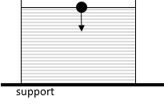
Figure 6

On the space alongside, sketch the velocity- time graph for the motion of the ball from the time it is released to the time just before it reaches the bottom of the cylinder. (1 mark)

- A body is initially in motion. If no external force acts on the body, describe the subsequent motion. (1 mark)
The body continues to move with the same motion in a straight-line ;

- Two trolleys of masses 2 kg and 1.5 kg are traveling towards each other at 0.25m/s and 0.40 m/s respectively. The two trolleys combine on collision.
- Calculate the velocity of the combined trolleys. (3 marks)
Momentum before collision = momentum after collision
$\left(2×0.25\right)+\left(1.5×\left(-0.4\right)\right)=(3.5×V)$ ;
$0.5-0.6=3.5V$
$-\frac{0.1}{3.5}=V$
therefore, V = -0.02857m/s ;;

- In what direction do the trolleys move after collision? (1 mark)
along the original direction of the 1.5kg mass

- The graph bellows shows how the velocity varies with time for a body thrown vertically upwards.

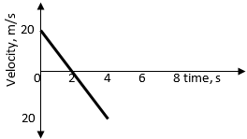
Figure 7
Determine:
- Time taken to reach maximum height (1 mark)

2 seconds ;

- The total distance moved by the body. (3 marks)
$distance=area under the graph$
$A=\left(\frac{1}{2}×2×20\right)+\left(\frac{1}{2}×20×\left(4-2\right)\right);;=20+20=40m$ ;

- Define pressure and state its SI unit (2 marks)
Force acting normally per unit area ; SI unit is pascal or newton per square metre

- State Pascal’s principle (1 mark)
Pressure applied at one part of an enclosed liquid is equally transmitted to other parts of the enclosed liquid ;

- The figure below shows a hydraulic lift system. The radius of the small piston is 3cm while that of the larger piston is 9 cm. A force of 90N is applied to the smaller piston.
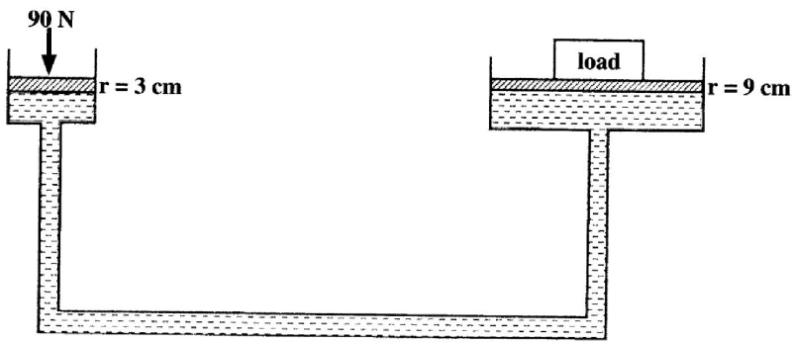
Figure 8

Determine the maximum load it can lift (3 marks)
$area of smaller piston= πr^{2}=3.142×3×3=28.278$cm²
$pressure at smaller piston=\frac{force}{area}=\frac{90}{0.0028278}=31826.86$ Pa ;

Maximum load = $pressure×area=31826.86×3.142×0.09×0.09$ ;
= 809.99N ;

- State two factors that affect pressure at a point in a liquid (2 marks)
- Depth ;
- Density of the liquid ;

- The figure 9 below shows two cylinders of different cross-sectional areas connected with a tube. The cylinders contain an incompressible fluid and are fitted with pistons of cross-sectional areas 4 cm² and 24 cm².
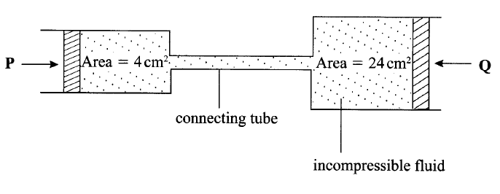
Figure 9
Opposing forces P and Q are applied to the pistons such that the pistons do not move. If the pressure on the smaller piston is 5N/cm², determine the force, Q. (2 marks)
Force = $pressure×area$ ;
$=5×24=120N$ ;

- A student is provided with five 20g masses, a metre-rule, a spring with pointer, a stand, boss and clamp. In the space provided, sketch a labelled diagram of the set-up that may be used to verify the hookes’ law using this apparatus (3 marks)
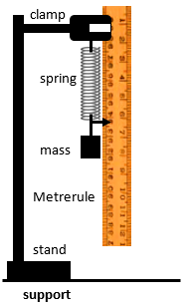

Spring attached to the clamp ;

Metre-rule alongside the spring with pointer ;

Mass hanging on the spring ;

- State two measurements that should be recorded in order to plot a suitable graph so as to verify hooke’s law (2 marks)
- Weight of the hanging masses ;
- Extension (on spring) ;

- Describe how the measurements made in b, above can be used to determine the spring constant (2 marks)
Plot a graph of force (weight) against extension ;
The gradient of the graph is the spring constant i.e. slope or spring constant = $\frac{∆force}{∆ extension}$);

- A helical spring stretches by 0.6 cm when supporting a weight of 40g. determine the extension when the same spring supports a weight of 65g. (3 marks)
$spring constank, k=\frac{0.4}{0.006}=66.67Nm^{-1}$ ;
$extension, e=\frac{F}{k}=\frac{0.65}{66.67};=0.00974951$
= 0.009749 m ;
Accept 0.9749 cm or 9.749 mm

- State the principle of moments (1 mark)
For a system in equilibrium, the sum of clockwise moments about a point is equal to the sum of anti-clockwise moments about the same point ;

- The figure10 shows two identical trolleys with loads A and B. The loads are identical in shape and size.
Figure 10
Given that the density of A is greater than that of B, explain why the trolley in (ii) is more stable. (2 marks)
Load B has less weight than load A; less weight at the top of trolley (ii) compared to trolley (i) makes it more stable than trolley (i) ;

- The figure below shows beaker containing water at 0⁰ C. The beaker is placed on a bench.
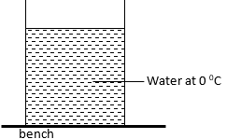

Figure 11
State and explain the changes in stability of beaker when water freezes (2 marks)
Less stable; water freezes while expanding. Some weight of the freezing water will therefore be spread toward the top of the beaker making it less stable;

- A uniform half- metre rod is balanced by a weight of 38N at one end. If the pivot is placed 10cm from the same end, calculate the weight of the rod. (3 marks)
W
38N
10 cm
25
$w×0.15=38×0.1$ ;;

$w=25.33N$ ;

- Distinguish between streamline flow and turbulent flow (1 mark)

Streamline flow | Turbulent flow
- All particles move in the same direction at the same speed i.e. a smooth kind of flow | - Particles move in different directions at various speeds i.e. it is a rough kind of flow characterized by eddies

- Water flows along a horizontal pipe of cross sectional area 30cm². The speed of the water is 4m/s but it reaches 7.5m/s in a constriction in the pipe. Calculate the area of the constriction. (3 marks)
$A_{1}V_{1}=A_{2}V_{2}$ ;
$4×0.0030=A×7.5$ ; award double mark for correct sub if no formula
Therefore, A = 0.0016 m² ;
Accept 16 cm²

This is the last printed page.

