Name ………………………..………………………` Index No. ………………..……
Candidates Sign: ……....…..…
Date: …………………………..
232/1
PHYSICS
Paper 1
Time: 2 Hours

@West practice papers-2021

Kenya Certificate of Secondary Education (K.C.S.E)

PHYSICS
Paper 1
Time: 2 Hours

Instruction to Candidates
- Write your name, index number in the spaces provided above.
- Sign and write the date of examination in the spaces provided above.
- This paper consists of two sections: A and B.
- Answer all the questions in sections A and B in the spaces provided.
- All working must be clearly shown.
- Silent non-programmable electronic calculators may be used.
- Candidates should answer the questions in English.

For Examiners Use Only
Section | Question | Maximum  Score | Candidate’s  Score
A | 1 – 12 | 25
B | 13 | 5
 | 14 | 11
 | 15 | 14
 | 16 | 13
 | 17 | 12
Total Score |  | 80

This paper consists of 11 printed pages, candidate should check the questions to ascertain that all pages are printed as indicated and that no questions are missing
SECTION A (25 marks)
Answer all the Questions in this section in the spaces provided.
- Sketch the scale of a vernier caliper showing a reading a 3.00 cm. (2 marks)

- The figure below shows two drums A and B. Drum A is empty while drum B has a cylindrical rod.

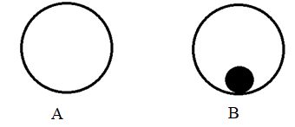
If the two drum are given the same rolling force, state and explain which drum stops first. (2 marks)
………………………………………………………………………………………………………………………………………………………………………………………………………………………………………………………………………………………………………

- An astronaut weighs 500 N on earth and 80N on the surface of another planet. Given that the gravitational field strength of the earth is 10 N/kg, calculate the gravitational field strength of the planet. (2 marks)
…………………………………………………………………………………………………………………………………………………………………………………………………………………………………………………………………………………………………………………………………………………………………………………………………………

- In order to estimate the height of a tree, a student measured the length of its shadow and found it to be 3.2 metres. A metre rule that she had produced a shadow of length 240 centimetres. What is the estimation of the tree height? (3 marks)

………………………………………………………………………………………………………………………………………………………………………………………………………………………………………………………………………………………………………………………………………………………………………………………………………………………………………………………………………………………………………………………………………………………………………………………………………………
- The figure below shows two identical containers A and B containing equal amounts of water and an identical ice block.
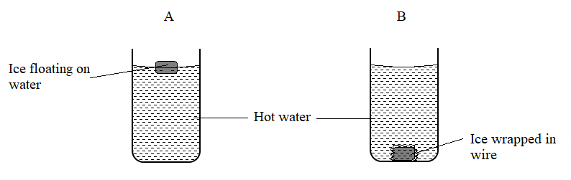
State with reason, which water cools faster, assuming the gauze absorbs negligible heat (2 marks)
…………………………………………………………………………………………………………………………………………………………………………………………………………………………………………………………………………………………………………………………………………………………………………………………………………
- On the axes provided below,

- Sketch a graph of pressure $(P)$ against reciprocal of volume $(1/V)$ of a fixed mass of an ideal gas at a constant temperature. (1 mark)

- State the physical quantity represented by the gradient. (1 mark)
…………………………………………………………………………………………………………………………………………………………………………………………
- The figure below shows two pipes A and B of different expansivities tightly fitted onto each other at the junction. When some ice was placed at the junction, it became easy to separate the conductors.
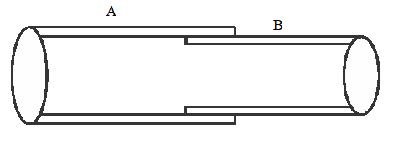
Explain which of the two was a better conductor of heat. (2 marks)
……….………………………………………………………………………………………………………………………………………………………………………………………………………………………………………………………………………………………………

- The figure below shows a Bunsen burner.
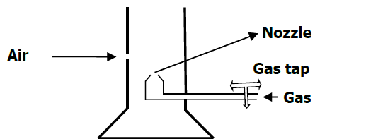

Explain how air is drawn into the burner when the gas tap is open. (2 marks)
…………………………………………………………………………………………………………………………………………………………………………………………………………………………………………………………………………………………………………………………………………………………………………………………………………
- (a) Define Brownian motion (1 mark)
………………………………………………………………………………………………………………………………………………………………………………………………………………………………………………………………………………………………………

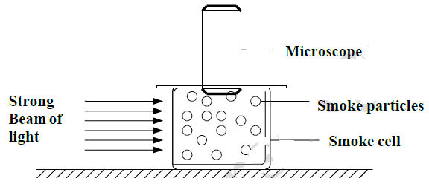
(b) The figure below shows apparatus used to observe the behaviour of smoke particles in a smoke cell

State one reason why smoke is used in the experiment. (1 mark)
………………………………………………………………………………………………………………………………………………………………………………………………………………………………………………………………………………………………………

- Three identical springs each of spring constant 10N/m and weight 0.5N are used to support a load as shown.

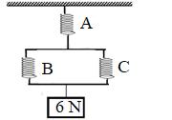
Determine the total extension of the system (2 marks)

………………………………………………………………………………………………………………………………………………………………………………………………………………………………………………………………………………………………………
……………………………………………………………………………………………………………………………………………………………………………………………………
- Other than the friction in a screw jack, state the reason it why it can’t be 100% efficient. (1 mark)
………………………………………………………………………………………………………………………………………………………………………………………………………………………………………………………………………………………………………
- A U-tube containing mercury is used as a manometer to measure the pressure of a gas in a container. When the manometer has been connected and the tap opened, the mercury in the U-tube settles as shown in the diagram below.
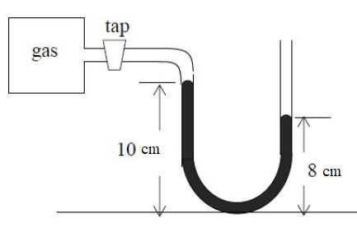

If the atmospheric pressure is 760 mmHg and the density of mercury is 13 600 kg/m³,
calculate the pressure of the gas in Pascals. (3 marks)
…………………………………………………………………………………………………………………………………………………………………………………………………………………………………………………………………………………………………………………………………………………………………………………………………………

SECTION B (55 marks)
Answer all the Questions in this section in the spaces provided.
- (a) State two ways of increasing the stability of a body (2 marks)
…………………………………………………………………………………………………………………………………………………………………………………………………….
(b) The figure below shows a solid cone which has a uniform density in equilibrium under action of force F.
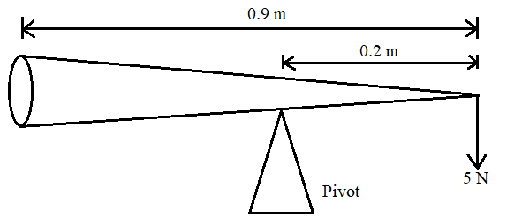
Determine the weight of the cone. (3 marks)
……………………………………………………………………………………………………………………………………………………………………………………………………………………………………………………………………………………………………………………………………………………………………………………………………………………………………………………………………………………………………………
- (a) State the law of floatation. (1 mark)
………………………………………………………………………………………………………………………………………………………………………………………………………………………………………………………………………………………………………
(b) The system in the figure below is at equilibrium.
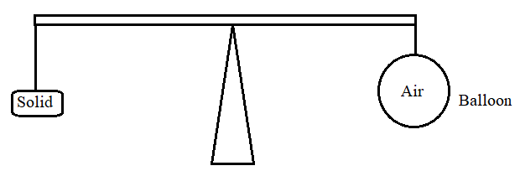
State and explain what may be observed as temperature of surrounding is increased. (2 marks)
………………………………………………………………………………………………………………………………………………………………………………………………………………………………………………………………………………………………………
…………………………………………………………………………………………………
(c) A hot air balloon is tethered to the ground on a windless day. The envelop of the balloon contains 1200 m³ of hot air of density 0.8kg/m³. The mass of the balloon (not including the hot air) is 400kg. The density of the surrounding air is 1.3 kg/m³.
- Explain why the balloon would rise if it were not tethered. (2 marks)
………………………………………………………………………………………………………………………………………………………………………………………………………………………………………………………………………………

- Calculate the tension in the rope holding the balloon to the ground. (3 marks)

……………………………………………………………………………………………………………………………………………………………………………………………………………………………………………………………………………………………………………………………………………………………………………………………………………………………………………………………………

- Calculate the acceleration with which the balloon begins to rise when
released. (3 marks)

………………………………………………………………………………………………………………………………………………………………………………………………………………………………………………………………………………………………………………………………………………………………………………………………………………………………………………………………………………………………………………………………………………………………
- A string of negligible mass has a metal ball tied at the end of the string 100cm long and the ball has a mass of 0.04kg. The ball is swinging horizontally, making 4 revolutions per second.
Determine;
- the angular velocity. (3 marks)
………………………………………………………………………………………………………………………………………………………………………………………………………………………………………………………………………………………………………………………………………………………………………………………………
- the angular acceleration (2 marks)

………………………………………………………………………………………………………………………………………………………………………………………………………………………………………………………………………………………………
- The tension on the string (2 marks)

………………………………………………………………………………………………………………………………………………………………………………………………………………………………………………………………………………………………
- The linear velocity (2 marks)

………………………………………………………………………………………………………………………………………………………………………………………………………………………………………………………………………………………………………………………………………………………………………………………………
- A muddy water was put in a container and whirled at a high speed in a horizontal circle. Explain how the high speed causes the separation of mud from water (2 marks)
………………………………………………………………………………………………………………………………………………………………………………………………………………………………………………………………………………………………………………………………………………………………………………………………
- What provides for the centripetal force the following cases of circular motion? (3 marks)
  - The moon moving around the earth.
……………………………………………………………………………………………………………………………………………………………………………………
  - A cyclist negotiating a curve.
……………………………………………………………………………………………………………………………………………………………………………………
  - Aeroplane taking a bend.
……………………………………………………………………………………………………………………………………………………………………………………
- (a) Define specific latent heat of vaporization (1 mark)
………………………………………………………………………………………………………………………………………………………………………………………………………………………………………………………………………………
- A jet of dry steam at 1000C is sprayed on to the surface of 100g of dried ice at 0⁰C contained in a well-lagged copper calorimeter, until all the ice has melted and the
temperature begin to rise. The mass of water in the calorimeter when the temperature reaches 40⁰C is found to be 120 g. Assuming that the specific latent heat of fusion of ice is 336000JKg⁻¹, specific heat capacity of water is 4200J/Kg/K, heat capacity of the calorimeter is 300J/K. Determine the:

- Heat gained by ice to melt (2 marks)
………………………………………………………………………………………………………………………………………………………………………………………………………………………………………………………………………………………………………………………………………………………………………………………………………………………………………………………

- Heat gained by the calorimeter and the melted ice (3 marks)

………………………………………………………………………………………………………………………………………………………………………………………………………………………………………………………………………………………………………………………………………………………………………………………………………………………………………………………………………………………………………………………………………………

- The specific latent heat of vaporization of water. (3 marks)

………………………………………………………………………………………………………………………………………………………………………………………………………………………………………………………………………………………………………………………………………………………………………………………………………………………………………………………

- Figure below shows a block of ice with two heavy weights hanging such that the copper wire connecting them passes over the block of ice.
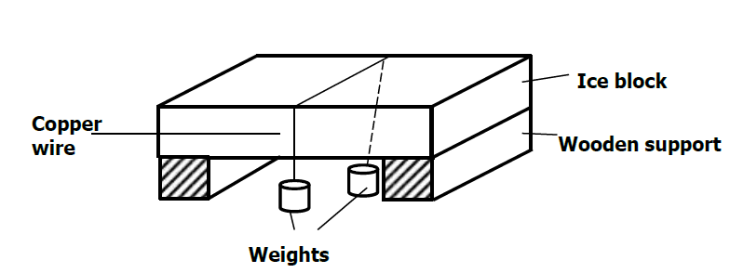

- It is observed that the wire gradually cuts its way through the ice block, but leaves it as one piece. Explain. (2 marks)

………………………………………………………………………………………………………………………………………………………………………………………………………………………………………………………………
- What change would be observed if the copper wire used in the experiment was replaced an iron wire. Explain your answer. (2 marks)
………………………………………………………………………………………………………………………………………………………………………………………………………………………………………………………………

- (a) The figure below shows the pattern formed on a tape in an experiment to determine the acceleration of a trolley. The frequency of the ticker tape used was 50Hz.
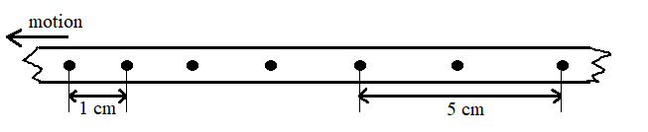

Calculate
- The initial velocity of the trolley (2 marks)
………………………………………………………………………………………………………………………………………………………………………………………………………………………………………………………………………………………………………………………………………………………………..

- The final velocity of the trolley (2 marks)

………………………………………………………………………………………………………………………………………………………………………………………………………………………………………………………………………………………………………………………………………………………………..

- The acceleration of the trolley (3 marks)

………………………………………………………………………………………………………………………………………………………………………………………………………………………………………………………………………………………………………………………………………………………………..

(b) Define the terms;
- Inelastic collision. (1 mark)
………………………………………………………………………………………………………………………………………………………………………………………………………………………………………………………………………………

- Inertia (1 mark)
………………………………………………………………………………………………………………………………………………………………………………………………………………………………………………………………………………
(c) A bullet of mass 20g leaves the muzzle of a gun at a speed of 250m/s. If the mass of the gun is 3.5kg, calculate the recoil velocity of the gun. (3 marks)
………………………………………………………………………………………………………………………………………………………………………………………………………………………………………………………………………………………………………………………………………………………………………………………………………………………………………………………………………………………………

