NAME: …………………………………………………….. SCHOOL……………............

ADM NO:………………………… DATE:……………….. SIGNATURE………….……

232/3
PHYSICS
(PRACTICAL)
PAPER 3
FORM FOUR
TIME: 2 ½ Hours

CATHOLIC DIOCESE OF KAKAMEGA EVALUATION TEST.
AUG/SEPT EXAM 2022.

Instructions to candidates
- Write your name, index number, school and stream in the spaces provided above.
- Sign and write the date of examination in the spaces provided above.
- Answer ALL the questions in the spaces provided in the question paper
- You are supposed to spend the first 15 minutes of 2 ½ hours allowed for this paper reading the whole paper carefully before commencing the work.
- Marks are given for clear record of the observations actually made, their suitability, accuracy and the use made of them.
- Candidates are advised to record their observations as soon as they are made
- Silent non-programmable electronic calculators may be used.

For Examiners use only

Question 1 | (b) | (c) | (d) | (e) | (f) | (h) | (i) | (j) | (k) | Total marks
Max score | 6 | 2 | 1 | 1 | 1 | 3 | 2 | 2 | 2 | 20
Candidate’s score

Question 2 | (a) | (c) | (d) | (e) | (g) | (h) | (i) | (j) | (k) | (l) | Total marks
Max score | 1 | 1 | 2 | 1 | 1 | 5 | 5 | 1 | 1 | 2 | 20
Candidate’s score
Grand Total

This paper consists of 7 printed pages. Candidates should check the question paper to ensure that all the pages are printed as indicates and no questions are missing.
Question 1

PART A

You are provided with the following:
- Metre rule.
- Vernier Callipers.
- 300g mass
- Two knife edges.
- Thread

Proceed as follows:

(a) Place the metre rule on the knife edges such that each is 5cm from the end.
Ensure the mm scale is facing upwards. Set the distance between the knife edges,
L= 900mm.

(b) Place the vernier callipers vertically against the metre rule at 50cm mark with the
depth gauge lowered to touch the bench.

(i) Record the height h_{o} of the upper edge of the metre rule at the 50cm mark

h_{o} = _______cm _______mm (1mark)

(ii) Using the thread provided hang the 300g mass at 50cm mark of the metre rule ensuring it does not touch the bench. Measure and record the height h of the upper edge of the metre rule from the bench at the 50cm mark.

h = _______cm _______mm (1mark)

(iii) With the 300g mass hanging at the 50cm mark, adjust the position of the knife edges so that the distance L is 600mm with the knife edges equidistant from the 50cm mark i.e. at 20cm from each end.
Measure and record the height h of the upper edge of the metre rule at 50cm mark.

h = _______cm _______mm (1mark)

Table
Length L(mm) | 900 | 600
Height h(mm)
Depression, d = (h_{o}-h) (mm)
Log L
Log d
(3marks)
(c) Determine the value of $s=\frac{log 900 - log600}{logd_{900 }-log d_{600}}$ (2marks)

(d) Evaluate $y=\frac{1}{s}$ (1mark)

(e) Given that $G=\frac{log K}{y} where G=2.75$, determine the value of K. (1mark)

PART B
You are provided with the following:
- A white screen with crosswires
- A Mounted lens
- A White screen
- A Candle
- A Metre rule

Proceed as follows:

(f) Estimate the focal length of the lens by focusing the image of a distant object on
the screen provided e.g. distant window.

f_{o} = ___________cm (1mark)

(g) Arrange the apparatus as shown.
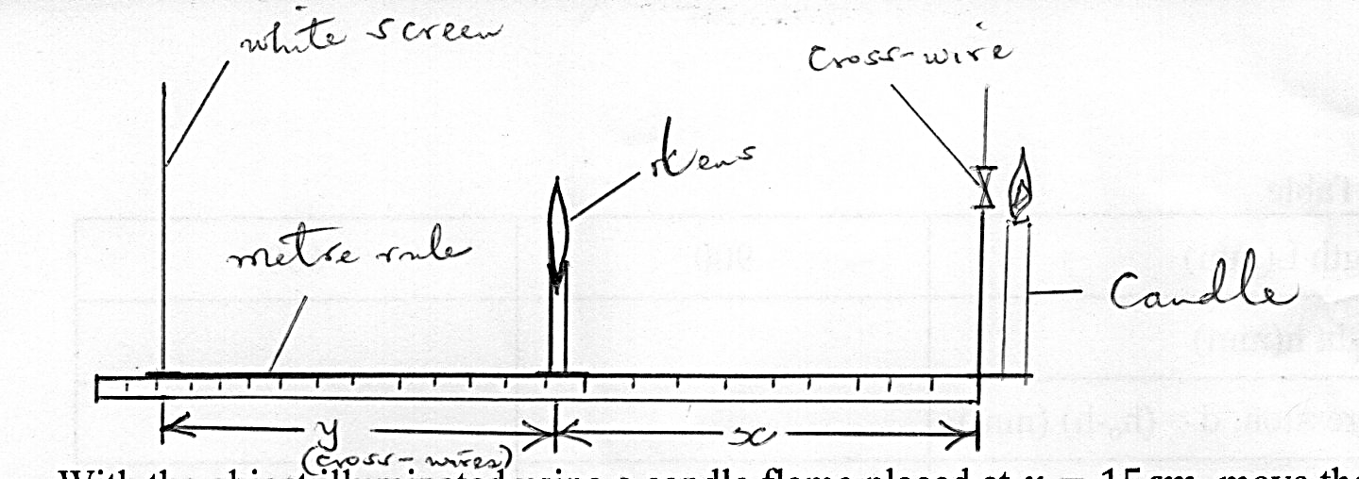

With the object (cross-wires) illuminated using a candle flame placed at $x=15cm$, move the screen until a sharp magnified image of the object is formed on the screen.
Measure and record the corresponding value of y in the table.

(h) Repeat step (g) for the value of $x=18 cm$

Table (3 marks)

$$x (cm)$$ | 15 | 18
$y (cm$)
$\frac{x+y}{xy}$(cm⁻¹)

(i) Determine the average of $\frac{x+y}{xy}$ (2marks)

(j) Compare the average $\frac{x+y}{xy}$ and $\frac{1}{{fo}_{}}$ (2marks)

(k) Given that $\frac{1}{fo}=\frac{y}{(\frac{y}{x})+1} and x=25 cm. Determine the value of y.$ (2marks)

Question 2
PART A

You are provided with the following:
- A voltmeter
- A resistance wire labelled R mounted on a metre rule.
- A metre rule.
- A resistance wire labelled T mounted on a small piece of carton.
- Two dry cells and a cell holder.
- Six connecting wires, each with a crocodile clip at one end.
- A switch.
Proceed as follows:
        - Measure and record the e.m.f. E₀ of the cells connected in series, E₀ = ____ V.
(1mark)
        - Connect the circuit as shown below. Point O on the resistance wire R is at 50cm mark of the metre rule. A and B are points on resistance wire R such that AO = OB = x = 30cm.

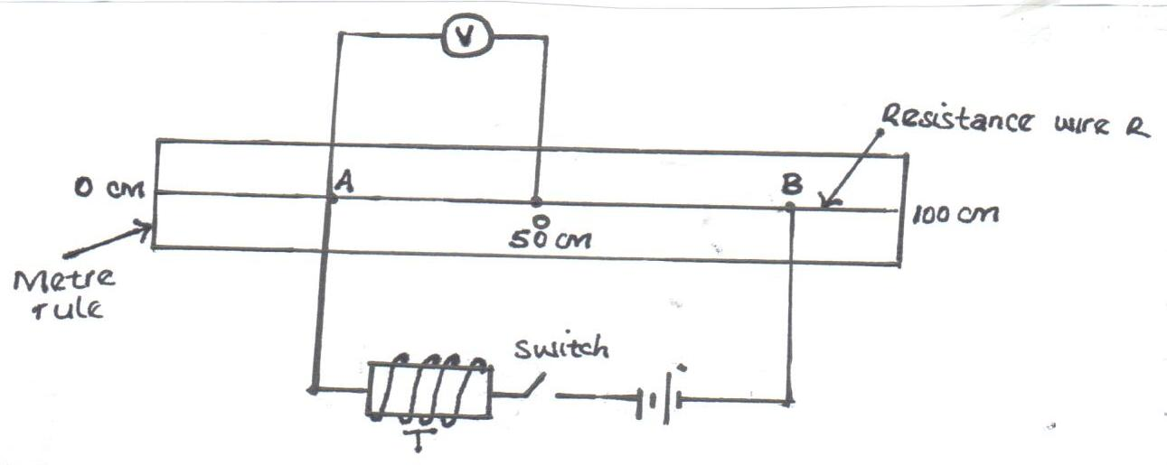

(c) Close the switch. Read and record the potential difference V across AO
V = …………………………………………. Volts. (1mark)

(d) The relationship between V and x is given by:
1 = 35 + 1
V x y
Determine the value of y. (2marks)

(e) Use the e.m.f. E₀ to determine the constant k, given that:
k = 8 (1mark)
35E₀

PART B
You are provided with the following:-
- A glass beaker
- A Bunsen burner
- A Thermometer
- A Stop watch
- A Tripod stand and a Wire gauze
- A measuring cylinder
- Water in a container
Proceed as follows:
(f) Set the apparatus as shown in the figure.
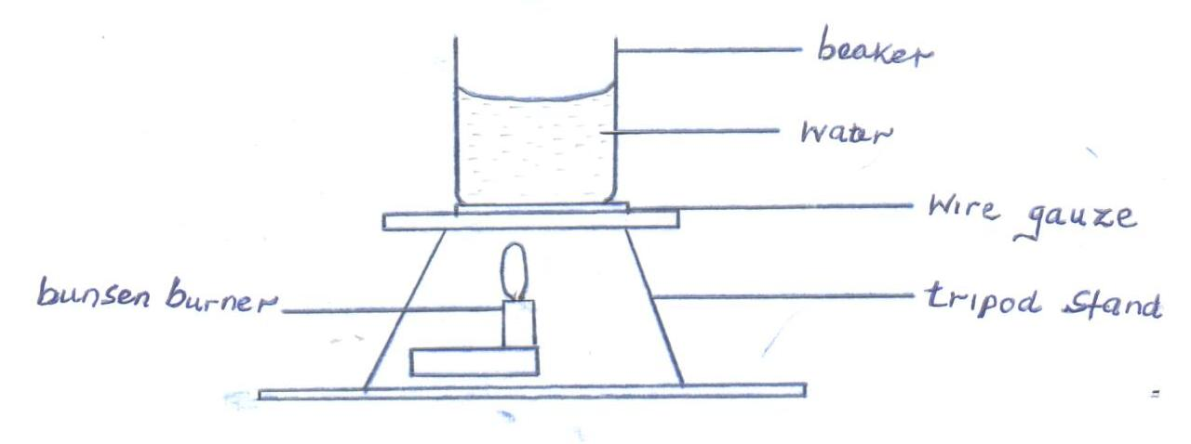
(g) Measure 100cm³ of water and pour it into the beaker. Take the initial temperature of the water.
T₀ = …………………………………………….⁰C (1mark)
(h) Now heat the water to a temperature of 80⁰C. Switch off the gas tap and place a thermometer into the beaker and start the stop watch when the temperature is 65⁰C. Take the temperature T (⁰C) of water after every two minutes. Record your results in the table

Table (5marks)
Time, t(min) | 2 | 4 | 6 | 8 | 10 | 12 | 14
Temperature , T ( ⁰C)
(T - T₀) (⁰C)
Log (T - T₀)

(i) Plot a graph of Log (T - T₀) against Time (t). (5marks)

(j) Determine the value of P (log (T - T₀)) when t = 0. (1mark)

(k) Determine N, where N is the antilog of P. (1mark)

(l) Determine the temperature of the surrounding T_{R} using the expression
N = 65–T_{R} (2marks)

