**Name: …………………………………………………………………….Class:………… Adm.No. ……………**

**232/3 Candidate’s Signature: …………………...**

**PHYSICS**

**PRACTICAL**

**DECEMBER 2021**

**Time: 2.5 hours**

**M O K A S A II J O I N T E X A M I N A T I O N**

**DECEMBER 2021**

**Kenya Certificate of Secondary Education**

**PHYSICS**

**PAPER 3**

Instructions to Candidates

* *Write your name, admission number, class and signature in the spaces provided at the top of the page. This paper consists of two questions* ***1*** *and* ***2.***
* *Answer* ***ALL*** *the questions in the spaces provided.*
* *Mathematical tables and electronic calculator may be used.*
* *This paper consists of 7 printed pages.*
* *Candidates should answer the questions in English.*

FOR EXAMINER’S USE ONLY

|  |  |  |  |  |  |  |  |  |  |
| --- | --- | --- | --- | --- | --- | --- | --- | --- | --- |
| **QUESTION 1** | **b** | **c** | **d** | **e** | **f** | **g** | **TOTAL SCORE** | **CANDIDATE’S SCORE** | |
|  | **2** | **1** | **7** | **5** | **3** | **2** | **20** |  | |
|  |  |  |  |  |  |  |  |  | |
| **QUESTION 2**  **PART A** | a | b | c | d | e |  | | | |
| **Marks** | 1 | 5 | 3 | 2 | 2 | **13** | | | |
|  |  |  |  |  |  |  | | | |
| **PART B** | a | g | 1 | 2 | 3 |  | | | |
| **Marks** | 1 | 1 | 3 | 1 | 1 | **7** | | | |
|  |  |  |  |  |  | **TOTAL SCORE** | | |  |

QUESTION 1

You are provided with the following apparatus

* Two dry cells
* Nichrome wire mounted on the meter rule
* An ammeter
* Cell holder
* Voltmeter
* 8 connecting wires
* Switch
* A jockey
* Proceed as follows.

1. Determine the electromotive force of the dry cells.

E =…………………………………….. (1 mark)

1. Draw a diagram to show how the e.m.f,E of the dry cells is measured. ( 1 mark)

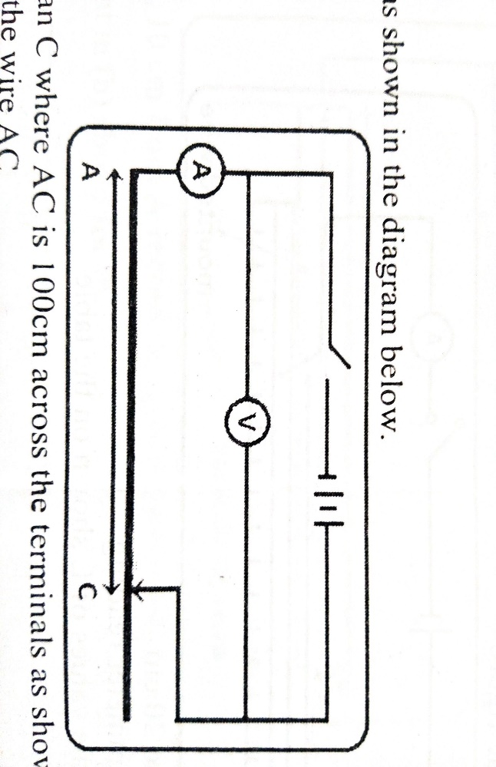

c. Connect the circuit as shown below.



Jockey

**A**

1. Connect the ends of A and C where AC is 100 cm across the terminals as shown above. Close the switch and record both ammeter reading and the voltmeter reading.

Current I = …………………………… ( 1 mark)

P.d (V) =………………………………. ( 1 mark)

1. Proceed for the lengths shown in the table and record the corresponding values of current,I and voltage,V( 6marks)

|  |  |  |  |  |  |  |
| --- | --- | --- | --- | --- | --- | --- |
| Length L(cm) | 100 | 70 | 60 | 50 | 40 | 20 |
| I(A) |  |  |  |  |  |  |
| P.d(V) |  |  |  |  |  |  |

1. Plot a graph of p.d,V(V) against current,I(A) (5 marks)
2. Determine the slope of the graph. (3 marks)

………………………………………………………………………………………………………………………………………………………………………………………………………………………………………………………………………………………………………………………………………………………………………………………………

1. Given thatE = $V+Ir$,determine thefollowing using the graph above.

**i)** Internal resistance **r** (1mk)

**………………………………………………………………………………………………………………………………………………………………………………………………………………**

**ii)** The e.m.f E of the dry cells (1mk)

**……………………………………………………………………………………………………………………………………………………………………………………………………………**

Question 2

PART A

You are provided with the following:

* A metre rule
* A knife edge
* One 50g mass and a 100 g mass
* Two pieces of threads each 30 cm long
* Some water in a beaker
* Liquid L in a beaker
* Tissue paper

Procced as follows

1. Balance the metre rule on the knife edge and record the reading at this point

Balance point =……………………………………cm mark (1 mark)

For the rest of this experiment the knife edge must be maintained at this position.

1. Set up the apparatus as shown in the figure below

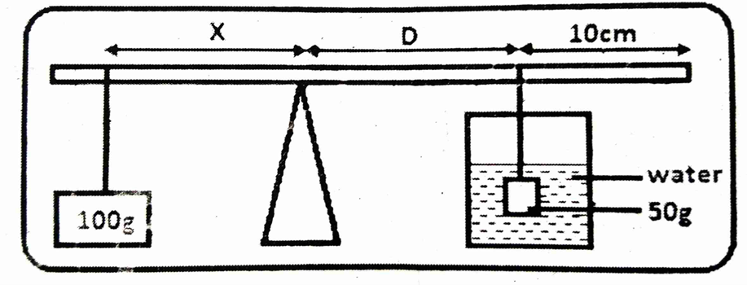

Thread

Thread

The balance is obtained by adjusting the position of 100g mass when 50 g mass is fully immersed in water. Record the values of X and D.

X=…………………………………………………… ( 1 mark)

D=…………………………………………………… ( 1 mark)

1. Using the principle of moments;
2. determine the weight W1of the 50g mass in water (2 marks)

**………………………………………………………………………………………………………………………………………………………………………………………………………………………………………………………………………………………………………………………………………………………………………………………………………………………………**

1. determine the Upthrust UW in water (1 mark)

**……………………………………………………………………………………………………………………………………………………………………………………………………………**

1. Remove the 50 g mass from the water and dry it using a tissue paper.

Keeping D constant, adjust the position of 100g mass until the metre rule is balanced and record the value of distance X.

X =…………………………………………………….. (1 mark)

1. Determine the weight W2 of the 50g mass in liquid L. ( 2 marks)

……………………………………………………………………………………………………………………………………………………………………………………………………………………………………………………………………………………………………………………..

1. Determine the Uphtrust UL in the liquid. ( 1 mark)

………………………………………………………………………………………………………………………………………………………………………………………………………………

1. Determine the relative density R.D of the liquid L, given that

$R.D=\frac{U_{L}}{U_{W}}$ (2marks)

………………………………………………………………………………………………………………………………………………………………………………………………………………………………………………………………………………………………

1. Find the density of liquid X in S.I unit (2marks)

………………………………………………………………………………………………………………………………………………………………………………………………………………………………………………………………………………………………………………………………………………………………………………………………

PART B

You are provided with the following:

* A semi-circular glass block
* Soft board
* White paper
* Four Optical pins
* Two Thumb pins
* Vernier calipers

Procedure

a) Measure the thickness of the glass block using the Vernier calipers provided

**t** = ________cm __________m (1mk)

**Eye**

**A**

**P4**

**P1**

**P2**

**P3**

**O**

**B**

**480**

b) Fix the plain paper to the soft board using drawing/thumb pins

c) Place the semi-circular glass block on the paper and trace its outline. Remove the block and label A and B as shown in figure above.

d) Identify the centre O of the plane and draw the normal at that point as shown in the figure above.

e) Measure incident angle ***i*** as **480** then draw the incident ray

d) Place two pins P1and P2 on the incident ray as shown.

e) Move your eyes at curved face and locate the images of pins P1 and P2, place pins P3 and P4such that the four pins are aligned in a straight line.

f) Remove the glass block and join points P3 and P4 to meet the interface AB.

g) Measure the angle Y between incident ray and the reflected ray.

Y= ___________ (2 marks)

………………………………………………………………………………………………………………………………………………………………………………………………………………………………………………………………………………………………………………………

1. Find the value of **M** given that (3marks)

M ${= \left(\frac{tY}{2}\right)}^{-1}$

………………………………………………………………………………………………………………………………………………………………………………………………………………………………………………………………………………………………………………………………………………………………………………………………………………………………

1. Hand in the white paper used (1mark)