PHYSICS PAPER 3 MARKING SCHEME
DECEMBER EXAM 2021
FORM FOUR
QUESTION 1
(a) W = 4.00cm (3.90-4.10) 2dp ( ½ mark)
T= 4.00cm (3.90-4.10) 2dp ( ½ mark)
(e) L_{o} = 43.5 (43.0 –44.0) cm 1dp ( ½ mark)
X = 40.5 (40.0 –41.0) cm 1dp ( ½ mark)
Determining the weight of the wooden block, W by using the formula
W = Lo ½ Substitution
2X ½ Correct evaluation
(g) Table
Mark | 1 | 2 | 3 | 4 | 5 | 6
Depth immersed, d (cm) | 0.5 | 1.0 | 1.5 | 2.0 | 2.5 | 3.0
L (cm) + 0.5 1dp | 92.0 | 87.0 | 81.5 | 78.5 | 73.0 | 67.5
1 mark each for correct reading up to the 5th entry (d =2.5)
(h) Graph of L (y-axis) against d
– Both axes labelled with appropriate units; 1
- Simple and uniform scale; 1
- Correctly plotted point ½ mark each maximum of 4 points2
-straight line with negative gradient passing through at least 3 correctly plotted points, shape extrapolated y-axis; 1
(i) No line no slope (3)
1 interval
1 Substitution
1 Correct evaluation
(j) A=WT (2)
1 Correct Substitution
1 Correct evaluation
(k) -20 ρ A = slope 1 Correct Substitution
1 Correct evaluation

QUESTION 2
PART A
PART I
(d) d = 0.2 ± 0.01 m Attempt to average
PART II Correct answer
(h) mark v in the table when u = 60cm. 1mk
(j)
±1 1dp
u(cm) | 30 | 35 | 40 | 50 | 60 | 70
v(cm) | 60.0 | 46.7 | 40.0 | 33.3 | 30.0 | 28.0
u +v (cm) | 90.0 | 81.7 | 80.0 | 83.3 | 90.0 | 98.0
uv(cm²) | 1800.0 | 1.634 | 1600 | 1665 | 1800 | 1960
½ mark each for correct reading of v to 1d.p. up to a maximum of 2mks ignoring v when u=60cm.
1 mark exact for ALL the candidate’s own correct conversion of u+v.
1 mark exact for ALL the candidate’s own correct conversion of uv.

(l) NO LINE NO GRADIENT
Gradient = 1800 – 0 1mk
90-0
= 20cm 1mk
Power of lens = 1 = 1
Gradient 20 x 10⁻²
= 5 Diopters ans 1mk
(m) d = focal length
d = 1
power of lens
PART B
(o) L₁ = 70.0 ± 2cm 1dp
L₂ = 30.0 ± 2cm 1dp
(p) L₁ = L₂
R₁ R₂
70 = 30
C 4
C = 70 x 4 = 9.333 Ω ( 8.50 – 10.29) 4sf or exact within range.
30
(k) – Both axes labelled with appropriate units; 1
- Simple and uniform scale; 1
- Correctly plotted point ½ mark each maximum of 4 points2
-straight line with positive gradient passing through at least 3 correctly plotted points; 1
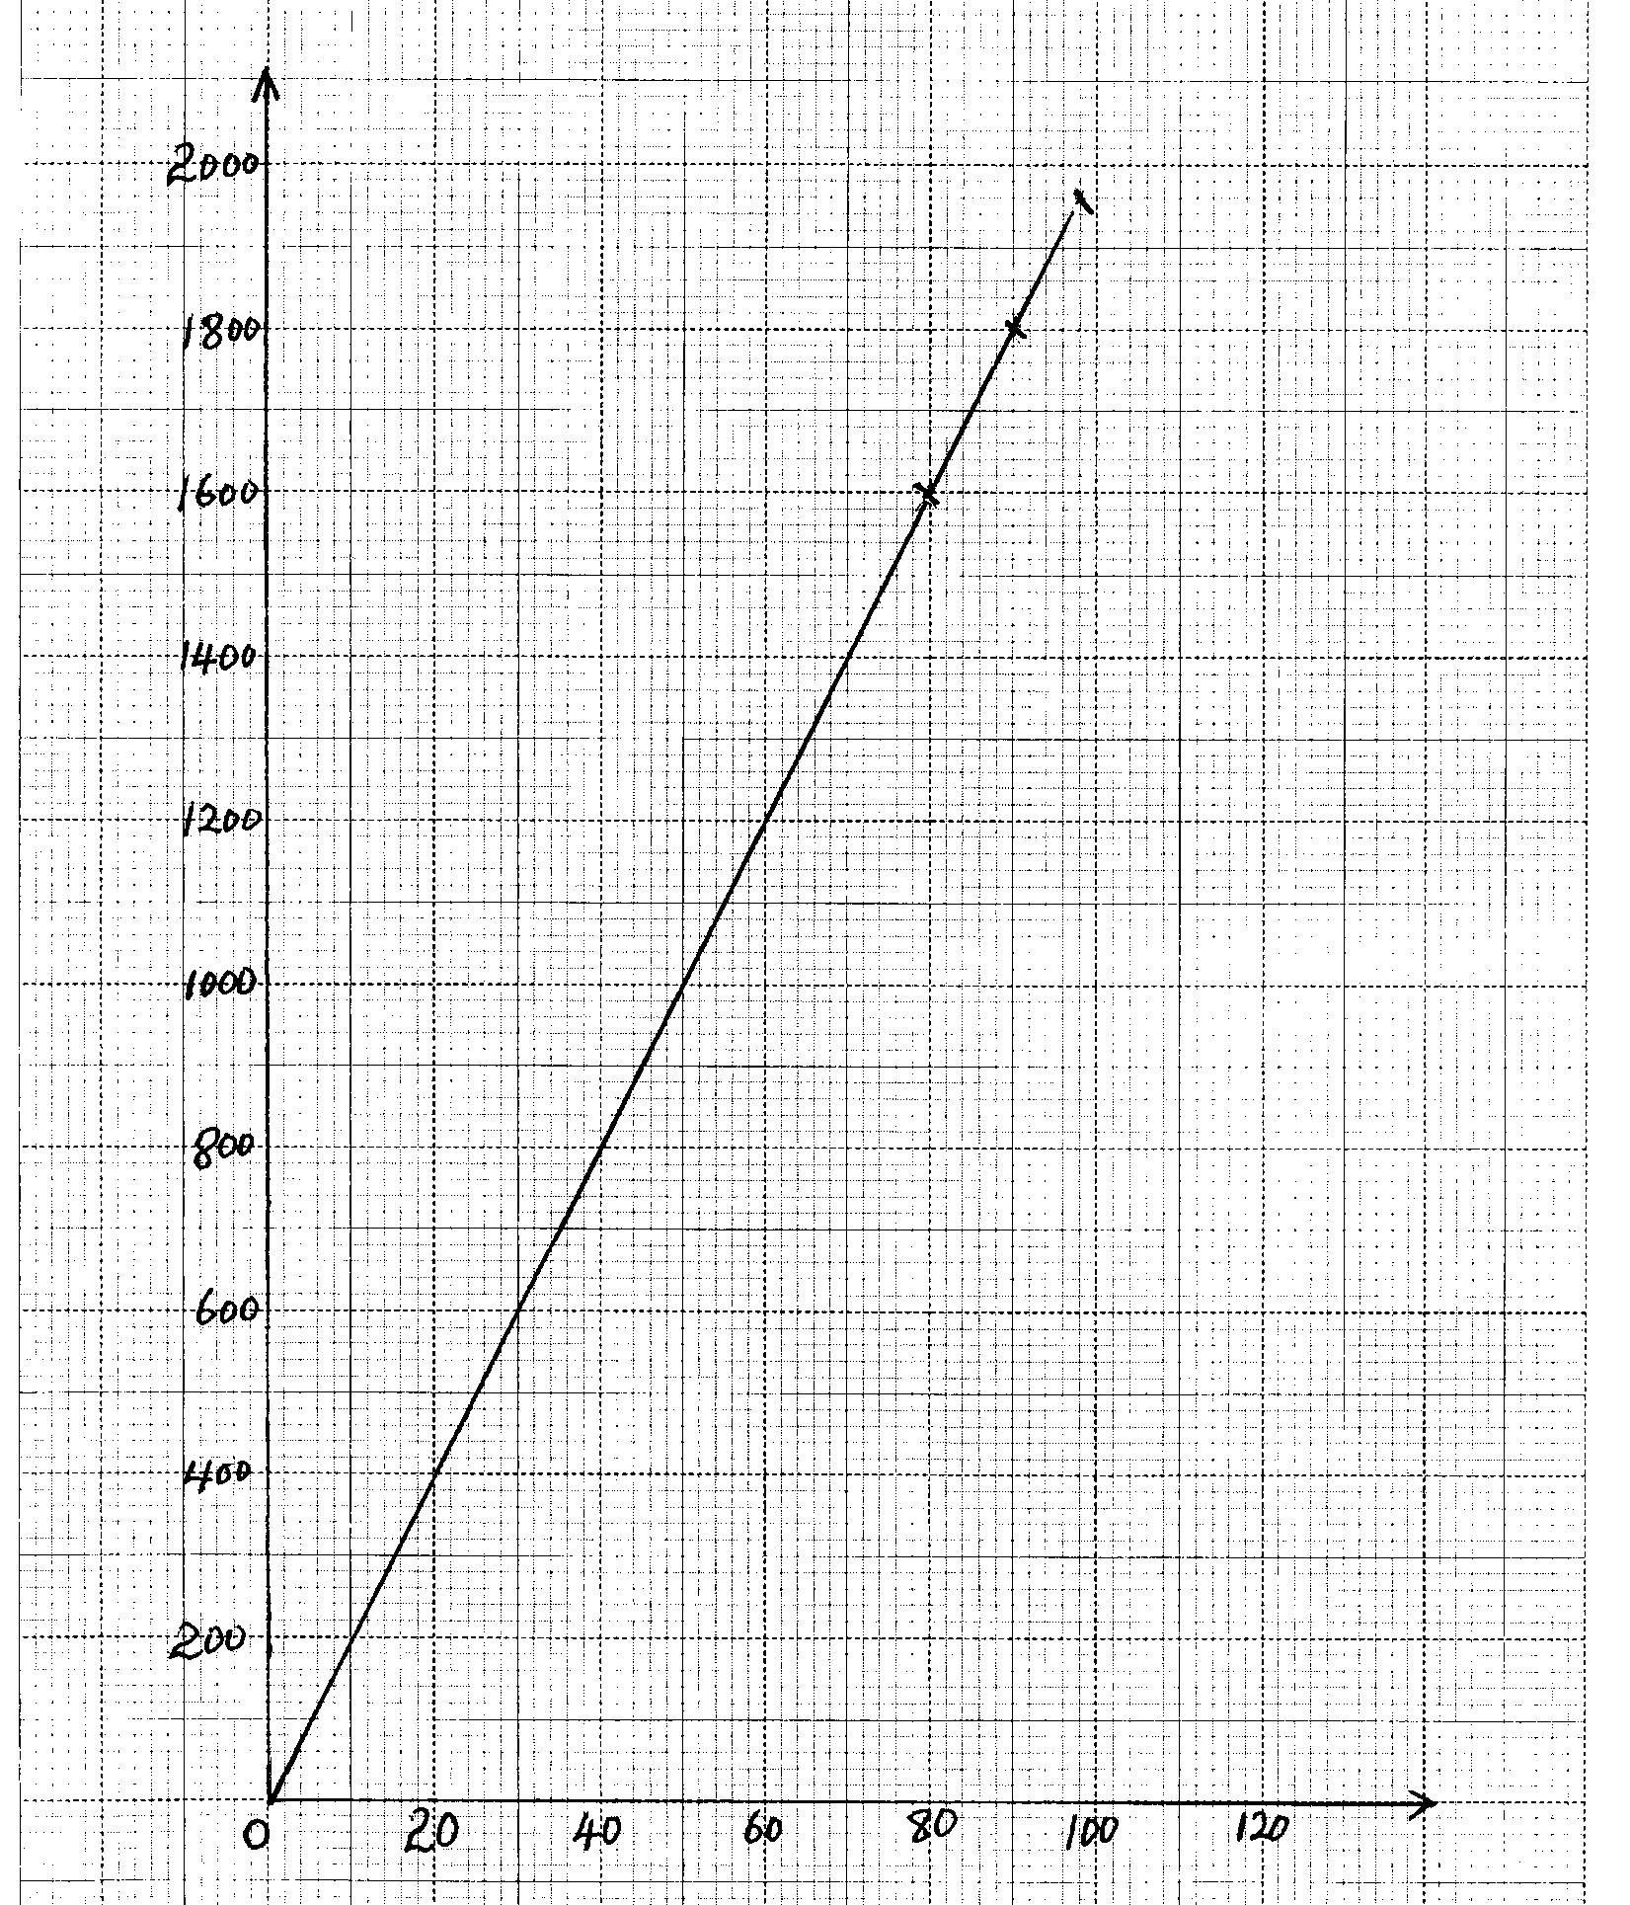
UV (cm²)
Axes
Scales
Plotting
Label
(u + v) cm

