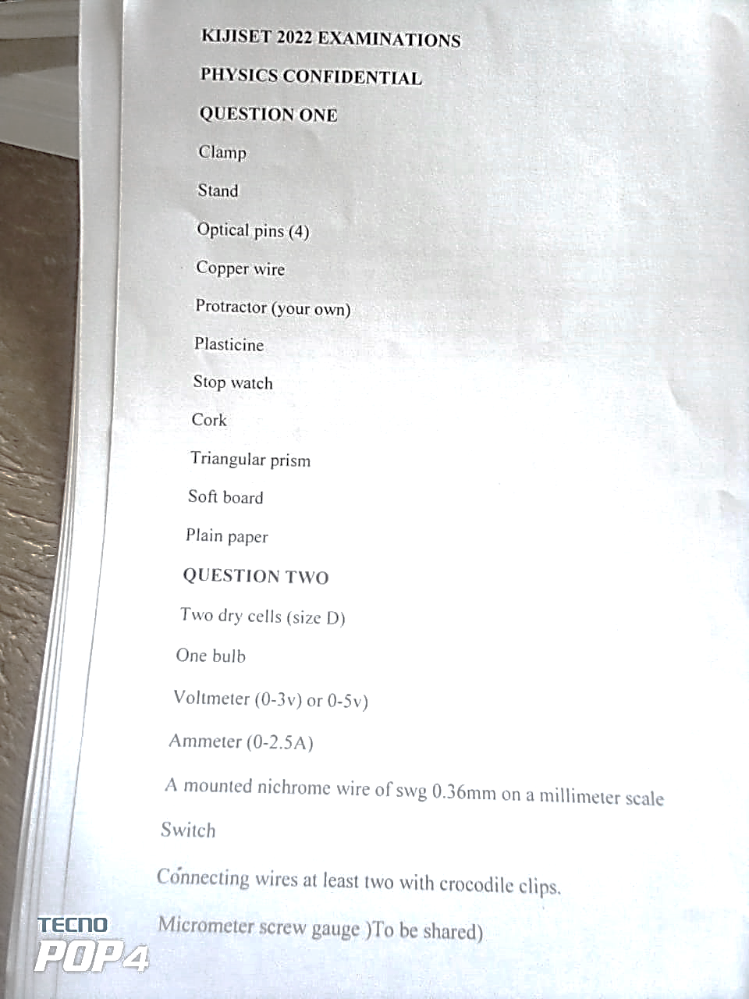

**KIJISET JOINT EXAMINATION FORM FOUR TERM II 2022**

**PHYSICS PAPER 3 PRACTICAL CONFIDENTIAL**

**QUESTION ONE**