NAME: …………………………………………………….. SCHOOL……………............

ADM NO:………………………… DATE:……………….. SIGNATURE………….……

232/2
PHYSICS
THEORY
PAPER 2
FORM FOUR
TIME: 2 Hours

CATHOLIC DIOCESE OF KAKAMEGA EVALUATION TEST.
AUG/SEPT EXAM 2022,

Instructions to candidates
- Write your name, index number, school and stream in the spaces provided above.
- Sign and write the date of examination in the spaces provided above.
- Answer ALL the questions in the spaces provided in the question paper
- Marks are given for clear record of the observations actually made, their suitability, accuracy and the use made of them.
- Candidates are advised to record their observations as soon as they are made
- Silent non-programmable electronic calculators may be used.

For Examiners use only

SECTION | QUESTIONS | MAX. SCORE | CANDIDATE’S SCORE
A | 1-13 | 25
B | 14 | 13
 | 15 | 09
 | 16 | 07
 | 17 | 14
 | 18 | 12
TOTAL SCORE |  | 80

This paper consists of 10 printed pages.
Candidates should check the question paper to ensure that all pages are printed as indicated and no questions are missing

SECTION A (25 marks)
Answer all the questions in this section in the spaces provided.
1 The figure shows the path of light after striking two mirrors at an angle.
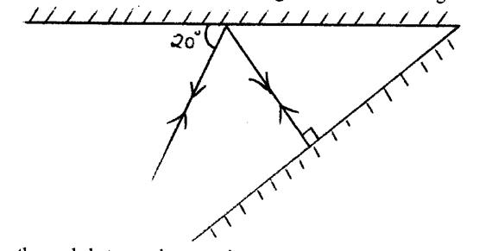

Determine the angle between the two mirrors. (1 mark)

2 In a textile industry, the machines experience electrostatic forces at certain points. Suggest one method of reducing these forces. (1mark)

3 A positively charged rod is brought near the cap of a leaf electroscope. The cap is then earthed momentarily by touching with the finger. Finally, the rod is withdrawn. The electroscope is found to be negatively charged. Explain how this charge is acquired. (2 marks)

4 (a) The figure shows a conductor carrying current placed within the magnetic field of two magnets.

Complete the diagram by showing the field pattern and the direction of force F that acts on the conductor. (2 marks)
(b) State the reason why soft iron is used as a core of the coil of an electric bell.
(1 mark)

5 The figure shows wave fronts in a ripple tank approaching a shallow region in the tank.
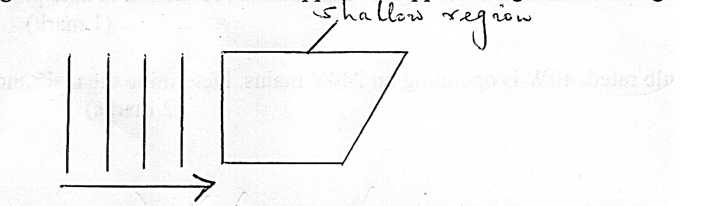

Complete the diagram to show the wave fronts as they pass over the shallow region and after leaving the region. (2 marks)
6 State one advantage of a lead-acid accumulator over a nickel-iron accumulator.
(1 mark)

7 Four bars of metal W, X, Y and Z are tested for magnetism. X attracts both W and Y but not
Z. Z does not attract W, X or Y. W and Y sometimes attract one another and sometimes
repel one another. State the conclusion you can draw about:
(a) Bar W (1 mark)

(b) Bar X (1 mark)

8 An observer watching a fireworks display sees the light from an explosion and hears the sound 4 seconds later. Determine how far the explosion was from the observer. (Speed of sound in air 330m/s). (3marks)

9 An object placed 15cm from a convex lens forms an upright image which is magnified two times. Determine the focal length of the lens. (2 marks)

10 (a) The figure shows light travelling from a less dense medium to a more dense medium.

Show the direction of the refracted ray. (1 mark)
(b) State any one condition necessary for total internal reflection to take place.
(1 mark)

11 An electric bulb rated, 40W is operating on 240V mains. Determine the resistance of its filament. (2 marks)

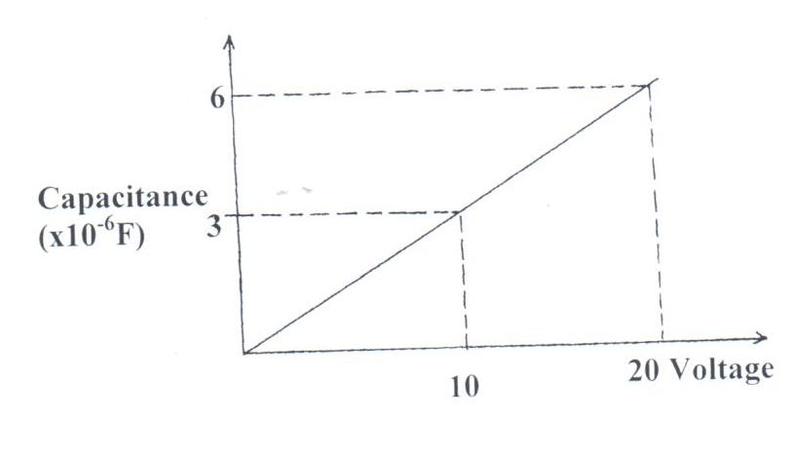
12 The graph shows the variation of capacitance of a capacitor with voltage supplied across it.

Fig. 6

Use the graph to determine the quantity of charge stored in the capacitor. (3marks)

13 The box contains names of seven parts of electromagnetic spectrum.
Radio waves | Microwaves | Infra-red | Visible light | Ultra violet | X-rays | Gamma rays
State the order in which they have been written. (1mark)

SECTION B (55 marks)
Answer all the questions in this section in the spaces provided.
14 (a) P-type and n-type semiconductors are made from a pure semiconductor by a process known as “doping”
(i) State what is meant by doping. (1 mark)

(ii) Explain how the doping produces an n-type semiconductor.
(2 marks)

(b) Sketch a circuit diagram that can be used to investigate p-n junction diode characteristics. (2marks)

(c) The figure below shows an electric circuit.
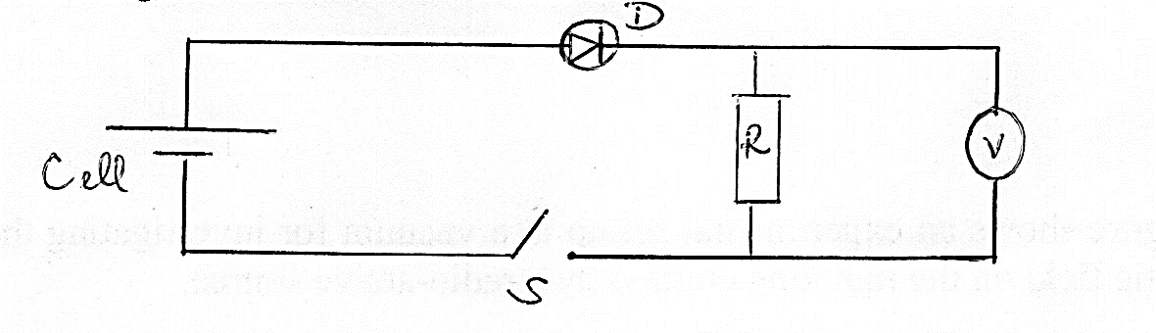

When the switch, S is closed, the voltmeter shows a reading. When the cell terminals are reversed, the voltmeter reading is zero. Explain these observations. (2 marks)

(d) Study the figure and use it to answer questions that follow.
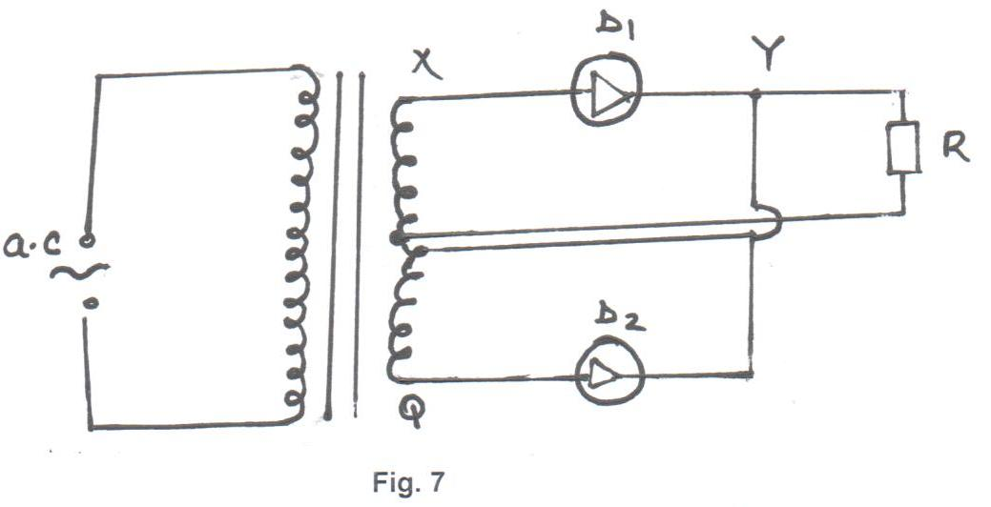
z
- Briefly explain how the circuit works to produce a rectified alternating current. (3marks)

(ii) Draw on the diagram to show the position of the capacitor. (1mark)

(iii) State the function of the capacitor in the circuit. (1mark)

(iv) Sketch the graph of the output as seen on a CRO screen. (1mark)

15 (a) A radioactive isotope showed a count rate of 82 counts per second initially. After a time of 210 seconds, the count rate dropped to 19 counts per second. The average background count remained constant at 10 counts per second. Determine the half-life of the material. (2 marks)

(b) The figure shows an experimental set up in a vacuum for investigating the effect of a magnetic field on the radiation emitted by a radio-active source.

N
A

B

C

S

The background radiation at the place is 5 counts per minute. The detectors are placed a positions A, B and C respectively. Results obtained are shown in the table below.
Positions | A | B | C
Counts / min | 480 | 5 | 400
Use the table to explain which of the three types of radiations are emitted from the source. (2marks)

(c) The figure shows a diffusion cloud chamber used for detecting radiations from a radioactive source.
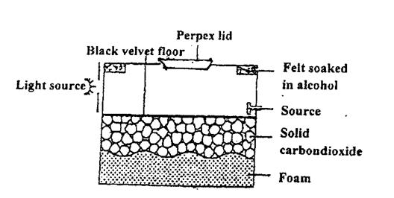

- Explain how the chamber works when a radioactive particle is introduced at the source. (2 marks)

(ii) State the purpose of solid carbon (IV) oxide. (1 mark)

(iii) State one advantage of the cloud chamber over a G.M tube as a detector of radioactive emissions. (1 mark)

(d) State one use of radio activity in medicine. (1mark)

16 (a) A photocell has a cathode made of caesium metal when a monochromatic radiation is shone on the cathode photoelectrons are emitted. A graph of kinetic energy against frequency is drawn as shown in the figure.
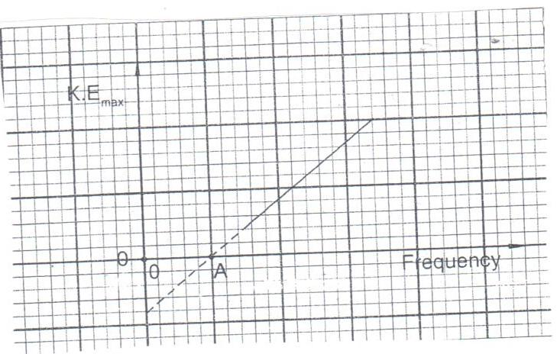

Use the graph to answer the questions below.
- State the unit of the slope. (1mark)

- State the physical quantity represented by point A. (1mark)

- Lithium metal has a higher work function than caesium. On the same axes, sketch the graph of lithium. (1mark)

- State what the term monochromatic means. (1mark)

(b) The maximum Kinetic energy of the electrons emitted from a metallic surface is 1.6 x 10⁻¹⁹J when the incident radiation is 7.5 x 10¹⁴Hz. Determine the minimum frequency of radiation for which electrons will be emitted. (Planck’s constant = 6.6 x 10⁻³⁴Js) (3marks)

17 (a) The figure shows the features of a cathode ray oscilloscope.
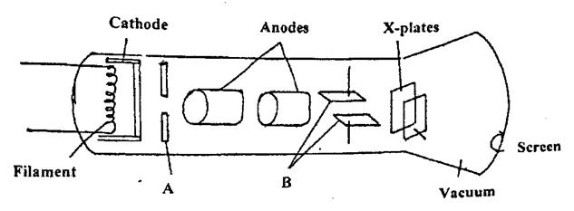

(i) Name the parts A and B. State role played each of the parts A and B. (2 marks)
A
B
(ii) Explain how electrons are produced. (2 marks)

(iii) State one factor considered when choosing the material for the cathode. (1 mark)

(b) The figure shows the trace on the screen of an a.c signal connected to the y-plates of a C.R.O with the time base on.
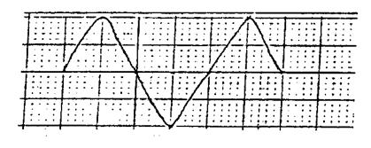

Given that the time base control is 100ms/div and the y-gain is at120V/division, determine:
(i) the frequency of the a.c signal (2 marks)

(ii) the peak voltage of the input signal (2 marks)

(c) The figure shows the features of an X-ray tube.
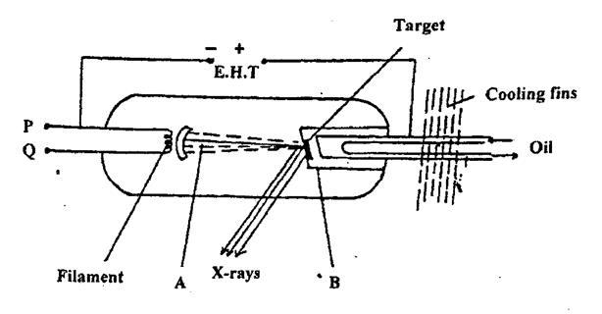

(i) Name the parts labelled A and B. (2 marks)

A
B
(ii) Explain how a change in the potential across PQ changes the intensity of the X-rays produced in the tube. (2 marks)

(iii) State the property of lead which makes it suitable for use as a shielding material. (1 mark)

18. (a) State Lenz’s law of electromagnetic induction. (1 mark)

(b) The figure shows a coil and a magnet being removed from the coil.
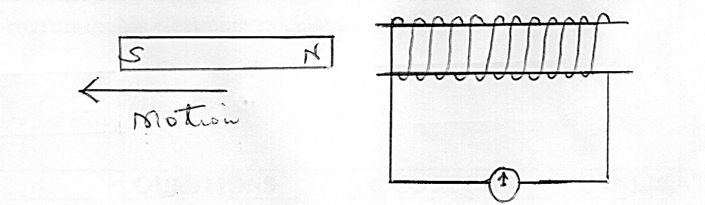

Indicate the direction of flow of current on the coil. (1 mark)
(c) The primary coil of a transformer has 1200 turns and the secondary coil has 60 turns. The transformer is connected to a 240V a.c source. Determine:
(i) the output voltage (3 marks)

(ii) the output current when the primary coil has a current of 0.5A. (Assume there is no energy loses) (2 marks)

(d) One of the primary ways in which power is lost in transformers is through eddy currents. State how eddy currents can be minimized. (1 mark)

(e) Give a reason why appliances which draw current from a ring’s main circuit have a third cable connected to the earth. (1mark)

(f) Determine the cost of using an electric iron rated 1500W, for a total of 30 hours given that the cost of electricity per kWh is Ksh 8. (3 marks)

