DECEMBER EXAM
232/2 PHYSICS PAPER 2 MARKING SCHEME 2021
TIME: 2 HOURS

SECTION A
- - Secondary cells are renewed/re-charged whereas primary cells are not; 1
  - Secondary cells generate higher electromotive force than primary cells; any
- Earth’s North – South direction 1
- Negatively charged
- Few –ve charges are attracted at the cap; More –ve charges are attracted to the cap inducing positive charge on leaf and plate hence more divergence.;
- Mag = v ;
u
= 45 ; 1
30
= 1.5
But hi = mag1 hi = 1.5
ho 10

hi = 15cm
hi = 0.15m; 1
Card board
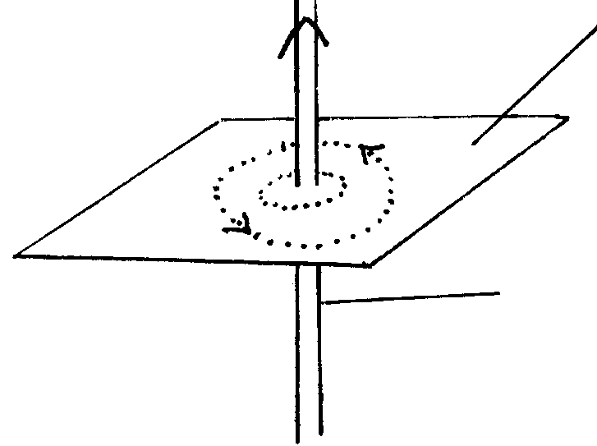
Arrow shown on the conductor;
1
Figure 2
Conductor
- - doping tetravalent element with trivalent element; 1
  - During the bonding there is a deficit of electron – hole 1
- 1/25 + 1/(2 +3) 1 = 1/25 + 1/51
1/C = 1 + 5/25
1/C = 6/25
= 4.167µF; 1
9. Np = Vp; 1
Ns Vs
Ns = 480 x 9; = 18; 1
240
10. - (infra-red) Photography; 1
- Heat sensors ( thermocouple detectors, bolo meter and heat seeking missiles ); 1
- cooking
- heating
- (to warm) green houses ( any 2)
11. P = VI
I = P/V
= 3x 100 + 10x40 + 8x601
240 240 240
= 1.25 + 1.667 + 2.0
= 4.917 A 1
Suitable fuse in circuit = 5 A fuse; 1
12. - Virtual; 1
- Upright; 1
- Diminished 1 Any 2
13. Sin i = 4;
Sin r 3

Sin 30 = 4;
Sin r 3

¾ x 0.5 = Sin r
r = 22.02°

SECTION B
14 a) Shape ; 1
Same wavelength; 1
λ
λ
b) - Constant phase difference / same C frequency ; 1
- Approximately same amplitude1
c) i) V = fλ
λ = v/f 1
= 334/256
= 1.305m 1
ii) - Temperature ; 1 Any two correct
- Direction of wind1
- Humidity
15. a) i) Emission of electrons from a surface when irradiated with radiation of sufficient
frequency; 1
ii) (I) Workability of set up 1
Labelling 1
Electroscope
Zinc Plate
U.V light

- Irradiate the Zinc plate with uv light ; Electrons are ejected and hence leaf diverge reduces.
  - Nature of emission is thus electrons
b) i) - Work function of metal ;
- Freq. of radiation ; 1

ii) h = grad x e; 1
h = Grad; xe
Extract;
Subst ;
Ans;

Ø = extract;
h = ( 3.6 – 0); x -1.6 x 10⁻¹⁹; 1
(14 – 5.2) x 10¹⁴
h = 6.545 x 10⁻³⁴; 1

ø = y – intercepts ;
e

ø = -2.1 x -1.6 x 10⁻¹⁹

= 3.36 x 10⁻¹⁹ J 1

16. a) – Both axes labelled with appropriate units; 1
- Simple and uniform scale; 1
- Correctly plotted point ½ mark each maximum of 4 points2
-straight line with positive gradient passing through at least 3 correctly plotted points1
TOTAL =5MKS

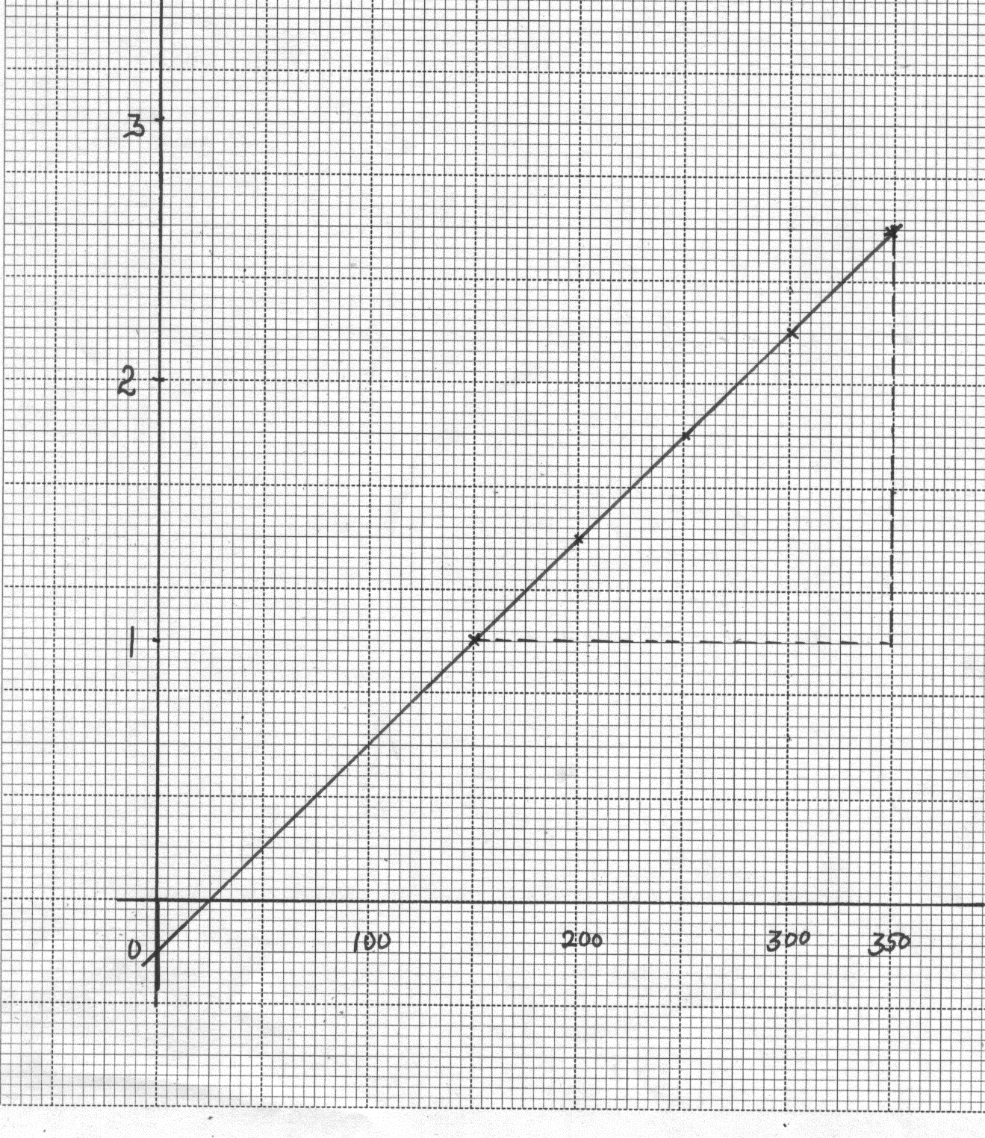
Resistance = gradient
= 2.60 – 1.00
(350 – 150) x 10⁻³
= 8.0 ± 0.2 Ω
Voltage(V)
Current(mA)

- Resistance = slope of Graph ;
= 2.2 – 1.4
0.3 – 0.2
= 8Ω;
17. a) i) 3200x ½ x ½ x ½x ½ = 400; 1
:half life = 40/4 hrs
= 10hrs:

ii) NO half – lifes = 30/10 or 3 half lives ; 1

No. undecayed = ½ x ½ x ½ x 4.0x 10²³

= 0.5x10²³
= 5.0x 10²² atoms 1
No decayed = ( 4.0 - 0.5) x 10²³
= 3.5 x 10²³ 1
- m = 238; 1
n = 92; 1
- i) They condense on air ions caused by radiations at low temperature 1
ii) - Piston is moved down suddenly making air to expand suddenly
too and thus causing cooling 1at low temperature vapour is saturated radiation ionizes airy and ionized air act as nuclei on which the vapour condenses forming tracks,
18. a) i)
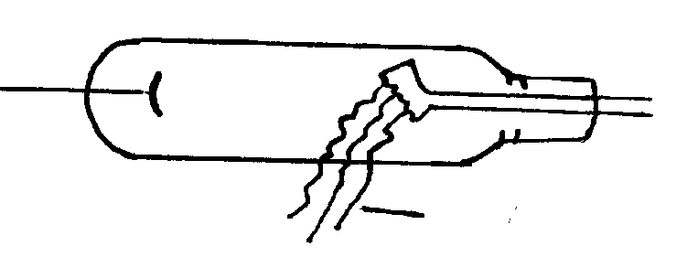
X - ray
ii) A- Copper anode; conduct heat away from target;

B- Tungsten or molybdenum ( or hard target); stops fast moving electronic
in a short time;
- Concave focusing cathode;
  - Focus electrons onto target B;
b) - Cathode is heated electrically to emits electrons; 1
- E.H.T between anode and cathode accelerate electrons to very high speed; 1
- Fast moving electrons bombard hard target and x – rays are produced; 1
c) i) - Increase accelerating potential; 1
- Increase cathode current; 1

- Electrical energy ; heat energy K.e x-rays Heat1
(filament cathode)
Any two correct
- To minimize possible loss of electron energy by collision with air particles; 1

