**Name …………………………………………....ADM NO………CLASS……..**

**Candidate’s signature …………………………… Date…………………**

**232/2**

**PHYSICS**

**PAPER 2**

**TIME: 2 HOURS**

***Instructions to candidates***

* *Write your name and index number in the spaces provided.*
* *This paper has two sections,* ***A*** *and* ***B***
* *Answer* ***all*** *questions in Section* ***A*** *and Section* ***B*** *in the spaces provided.*
* *All work must clearly be shown.*
* *Mathematical tables and non-programmable calculators* ***may*** *be used.*

***For Examiner’s Use Only***

|  |  |  |  |
| --- | --- | --- | --- |
| ***SECTION*** | ***QUESTION*** | ***MAX MARKS*** | ***CANDIDATE’S SCORE*** |
| ***A*** | *1 – 11* | *25* |  |
| ***B*** | *12* | *12* |  |
| *13* | *11* |  |
| *14* | *10* |  |
| *15* | *11* |  |
| *16* | *11* |  |
| ***TOTAL SCORE*** |  | ***80*** |  |

1. Figure 1 shows two plane mirrors AB and BC inclined at an angle of 100o. A ray of light is incident on mirror AB at an angle500. Complete the diagram to show the path of the ray on reflection from mirror BC. 3mks

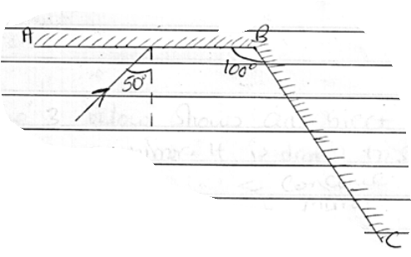

1. The chart below shows an arrangement of different parts of the electromagnetic spectrum.

|  |  |  |  |  |  |  |
| --- | --- | --- | --- | --- | --- | --- |
| Radio wave | **A** | **B** | Visible light | **C** | **D** | **E** |

1. Name the radiation representedby**A**. (1mk)
2. Name one detector of radiation **C** (1mk)
3. A lady holds a large concave mirror of focal length 1m, 80cm from her face. State one characteristic of her image in the mirror. (1mk)

4.The figure **below** shows a ray of light incident on a face of semicircular prism.

Determine the refractive index of the glass prism. (3marks)

42o

5.An electric bulb rated 40W is operated on240V mains. Determine the resistance of its filament. (3marks)

6. The diagram below shows a conductor in a magnetic field.

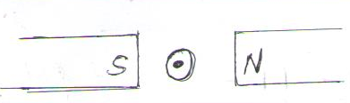

Indicate on the diagram the direction of motion. (1mark)

7.Figure 5 below shows a simple transformer connected to a 12v a.c source and an a.c voltmeter.



Determine the reading on the voltmeter. (2 marks)

The number of turns in primary cell is 10while in the secondary it is 5.

8.It is observed that when a charged body is brought near the cup of a positively charged

electroscope, the divergence of the leaf increases. State the type of charge on the

body(1mark)

9. Waves pass from deep water to shallow water and refraction occurs.

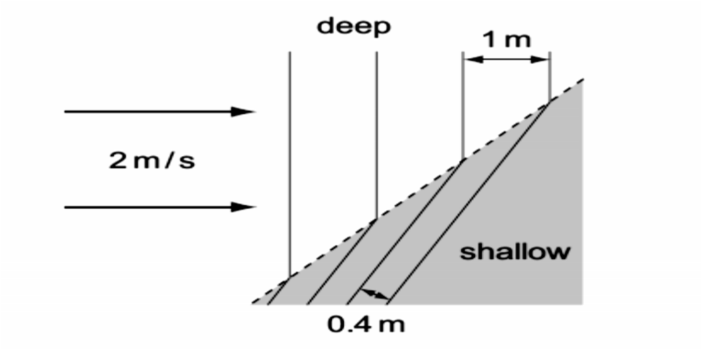

Calculate the speed of the waves after refraction occurs (2 marks)

10.An echo sounder of a ship transmits sound waves to the depth of the sea and receives the echo after 2.4 seconds. If the speed of sound in water is 1600ms−1, determine the depth of the sea. (3 marks)

11.The diagram in the figure 5.0 below shows an object O placed in front of a converging lens.

F

Using ray diagram determine the position of the image. (3 marks)

**SECTION B( 55MARKS)**

12. (a) In an experiment to determine the internal resistance of a cell, the following circuit was used.

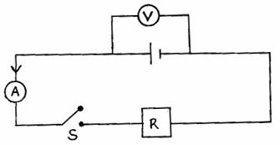

It was noted that when S is open, the voltmeter reads 1.5V and when S is closed the voltmeter reads 1.3V and ammeter reads 0.2A.

(i) What is the e.m.f of the cell. (1mark)

(ii) Determine the lost voltage. (1mark)

(iii) Find the value of R. (2marks)

(iv) Find the internal resistance of the cell. (2marks)

1. Study the circuit **below** and answer the questions that follow.

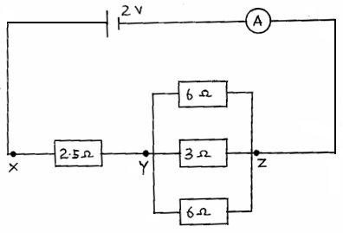

(i) Determine the effective resistance of the circuit. (2marks)

(ii) Find the ammeter reading. (2marks)

(iii) Find the p.d between X and Y. (2marks)

13. (a) The image formed by a convex lens is erect. On Figure 10 below, draw the object andusing ray diagram, locate and draw the erect image. (3mks)

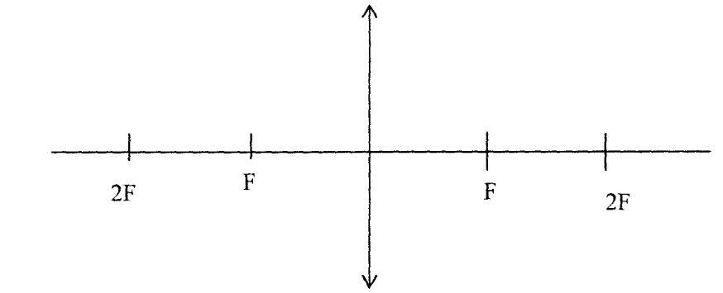 **Figure 10**

(b) 5Apart from being erect, state two other characteristics of the image. (2mks)

(c) In an experiment to determine the focal length of a converging lens using lens

formula, several values of image distance corresponding to value of objectdistanceU were determined and a graph of magnification m against image distance

v,plotted as shown in **Figure 11** below

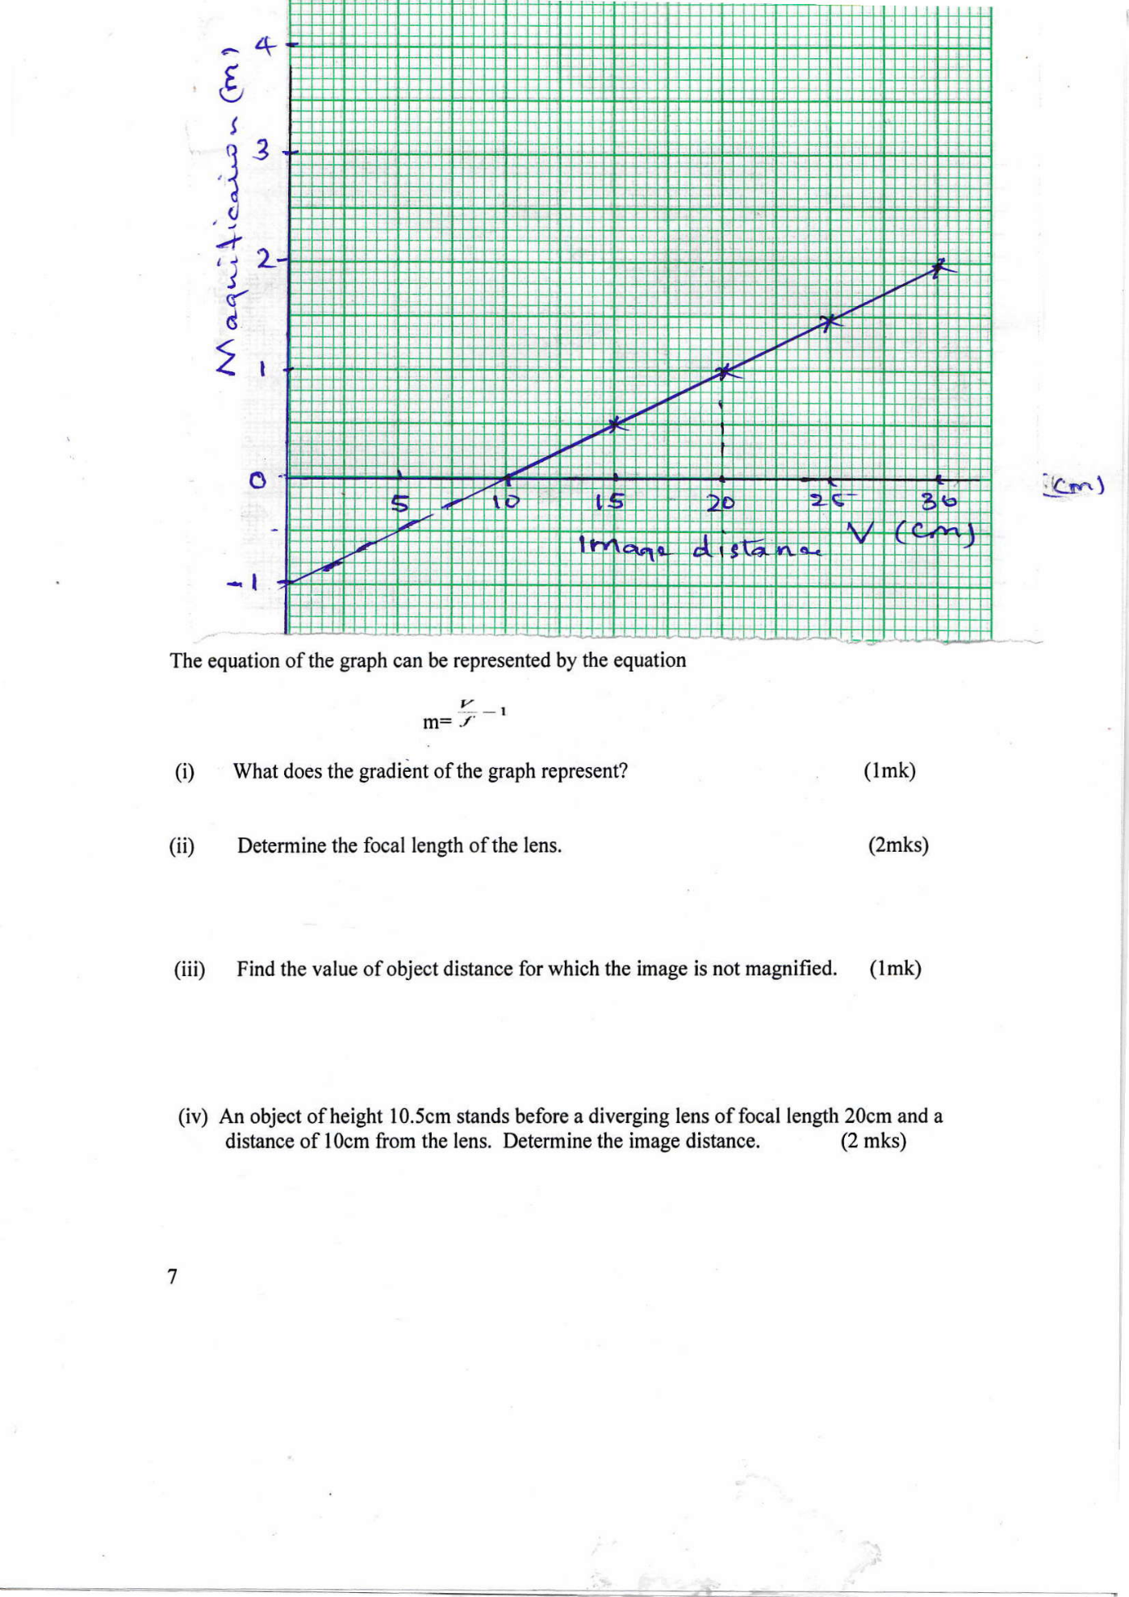

The equation of the graph can be represented by the equation

m=

(i) What does the gradient of the graph represent? (1mk)

(ii) Determine the focal length of the lens. (2mks)

(iii) Find the value of object distance for which the image is not magnified. (1mk)

(iv) An object of height 10.5cm stands before a diverging lens of focal length 20cm and a

distance of 10cm from the lens. Determine the image distance. (2 mks)

14. (a) The refractive index of glass is 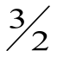and that of water is 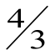. Calculate the refractive index of glass with respect to water. (2 mks)

1. The figure below shows a ray of light incident at an angle of 35.6 at point D

on the first face of a glass prism ABC. The refractive index of the prism

is 1.6.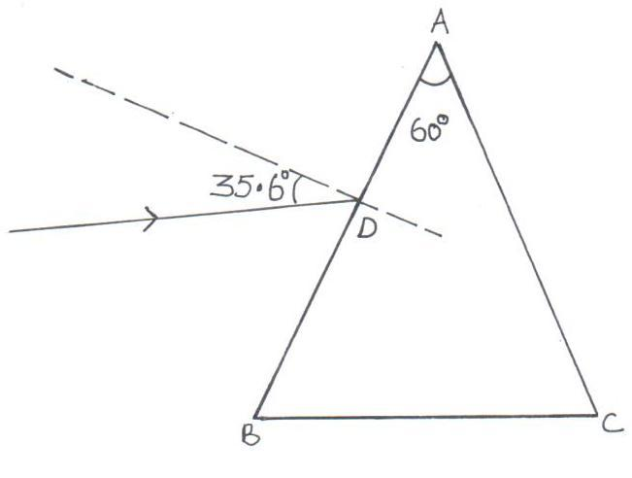

1. Determine the angle of refraction at point D. (2 mks)
2. Find the angle of incidence of the refracted ray on the face AC to 1 decimal point. (2 mks)
3. Complete the ray diagram to show the emergent ray from the face AC. (2 mks)
4. State **two** conditions necessary for total internal reflection to occur. (2 mks)

15.a) A student stands some distance from a high wall and claps his hands

1. What two measurements would need to be made in order to determine the speed of sound? (2mks)
2. Describe how you would make use of these measurements (2mks)
3. The speed of sound in air is 330m/s. How far from the wall would you stand? Choose an answer from the following distances 10m, 200m,500m. Give reasons why you did not choose each of the other two distance.(2mks)

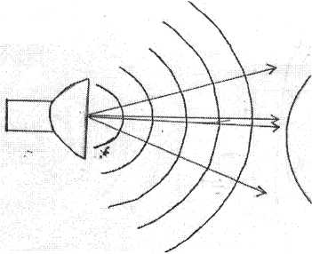b) The balloon filled with carbon dioxide can act like a lens and focus sound from a loud speaker. On to the microphone, Figure 6 show waves produced by loud speaker moving toward the balloon.

1. Complete the diagram to show what happens to the sound waves when they have passed through the balloon and moves towards the microphone. (2mks)
2. The loud speaker is now moved toward the balloon. This results in less sound at the microphone. Explain why there is less sound at the microphone (1mk)
3. The frequency of the sound emitted by the loud speaker is 1020Hz. Calculate the wavelength of the sound wave in air where its velocity is 340m/s (2mks)

16.(a) Figure 9 below shows two circuits close to each other.

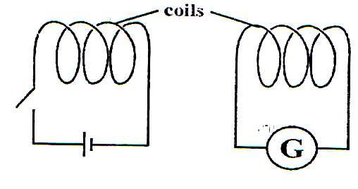

Fig 9

When the switch is closed, the galvanometer shows a reading and then returns to zero. When the switch is then opened, the galvanometer shows a reading in the opposite direction and then returns to zero. Explain these observations. (2 Marks)

(b) Explain how energy losses in a transformer are reduced by having:

(i) A soft-iron core. (2 Marks)

(ii) A laminated core (2 Marks)

(c) An ideal transformer has 2000 turns in the primary circuit and 200 turns in the secondary circuit. When primary circuit is connected to a 400V a.c. source the power delivered to a resistor in the secondary circuit is found to be 800W.

Determine the current in

1. The secondary circuit(3 Marks)

(ii) The primary circuit (3 Marks)