CATHOLIC DIOCESE OF KAKAMEGA EVALUATION TEST.
AUG/SEPT EXAM 2022.

132/1 PHYSICS PAPER 1 MARKING SCHEME

1 A micrometer screw gauge with a zero error –0.02mm was used to measure the diameter of a marble whose actual radius is 2.17mm. Determine the reading expected and hence draw the scale seen on the gauge (Pitch = 0.5mm). (2 marks)
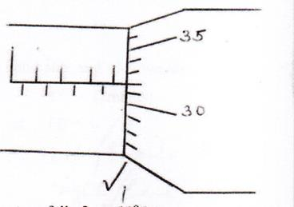
d = 2 x r
= 2 x 2 .17
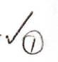
= 4.34mm
Scale reading = Actual diameter – zero error
= 4.34 – 0.02
= 4.32mm

2 Explain the variation of density of water when its temperature falls from 10ºC to freezing point. (2 marks)
  - It contracts/reduce in volume upto 4⁰C where its density in maximum.
  - From 4⁰C to 0⁰C its volume increase thus the density reduces.
3 The figure below shows two identical thermometers A and B placed near and at equal distances on either sides of a hot metal plate painted black on the side A and silvery on side B.

Black

Silvery

B
A
Hot metal plate

State and explain the observation made on the reading of the thermometers after some minutes. (2 marks)
- Thermometer A shows a higher reading
- Black surface are good emitters of radiant heat.

4 A body is acted upon by a force of I0N towards the right hand side and 6N towards the left hand side. Determine the resultant force. (2marks)

6N 10N Resultant force = 10-6
4N = 4N towards the right hand side

5 The figure below a uniform wooden plank of length 4m and weight 10N. The plank is held at equilibrium by a weight of 40N placed at one end as shown.
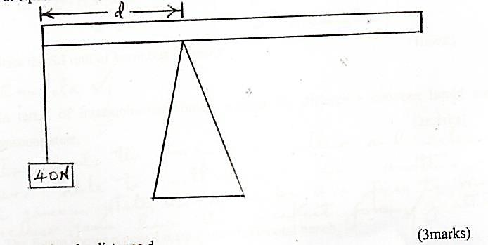

Determine the distance, d. (3marks)
Taking moments about the pivot
Sum of clockwise moments = same of anticlockwise moments ₁
F₁ d₁ = F₂ d₂
40 x d = 10 x ( 2-d) ₁
40d = 20 – 10d
40d + 10d = 20
50d = 20
d = $\frac{20}{50}=0.4m$
6 The figure shows a non-viscous fluid that is not compressible moving through a pipe of varied cross-sectional area.
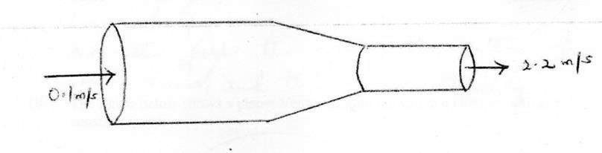

If the area of the narrower region is 0.05m², determine the diameter of the wider region. (3marks)

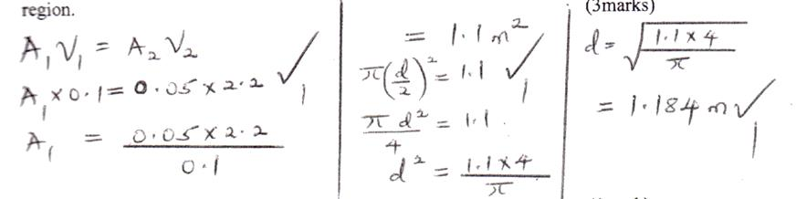

7 State the S.I unit of luminous intensity. (1mark)
- Candela ₁
8 In terms of intermolecular forces, explain the difference between liquid and gaseous state.
(2marks)
- In liquids the forces are smaller and molecules are able to roll ₁ over one another while in gaseous state, the molecules are free to move because gases have the weakest forces ₁ of attraction.
9 The figure shows a vessel resting on a horizontal bench.
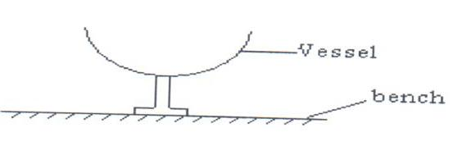
State and explain the effect on the stability of the vessel when it is filled with water. (2marks)
- Leaward ₁
- As water fills the versel, the centre of gravity rises ₁and this lowers stability
10 The figure below shows a planet Venus orbiting the sun in a circular orbit at constant speed.

₁
Venus

Sun

(i) State what provides the centripetal force. (1 mark)
- Gravitational force of attraction between the sum and versus

(ii) Indicate the direction of centripetal force on the planet. (1 mark)

11 On the axes below, sketch displacement time graph for an accelerating body. (1mark)

Displacement
(m) ₁

Time (s)

12 The figure shows a capillary tube dipped in water.
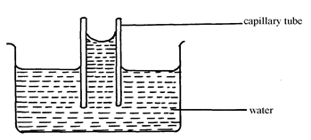
State two differences that will be observed when water is replaced with mercury in the set up above. (2 marks)
- Memory level inside the capillary tube is below the level outside ₁
- Has a convex meniscus ₁
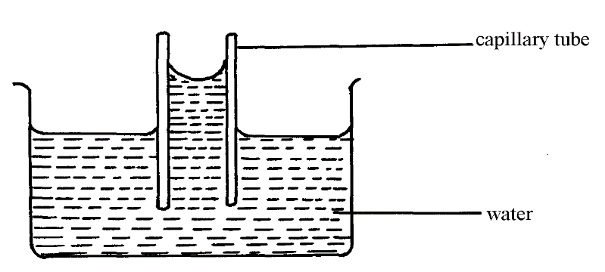
13 Water is known to boil at 100⁰C. A student heated some water and noticed that it boiled at 101⁰C. State two possible reasons for this observation. (2 marks)
- Presence of impurities ₁
- Increase in pressure ₁

SECTION B (55 marks)
Answer all the questions in this section in the spaces provided.

15 (a) State Archmedes’ principle. (1mark)
- When a body/object is partially or wholly immersed in a fluid, it experiences an up thrust equal to the weight of the fluid displaced. ₁
(b) The figure shows a hydrometer.
B

A

(i) State the reason why lead shots are fixed at the bottom of hydrometer. (1 mark)
- To keep the hydrometer upright ₁
(ii) State the letter in the figure which represents a greater density. (1 mark)
A ₁

(c) An ordinary hydrometer of mass 30g floats with 4cm of its stem out of the water. The area of the cross – section of the stem is 0.90 cm². Taking density of water= 1.0g/ cm³.
Determine the:
(i) mass of the water displaced. (1mark)
    - 30g ₁

(ii) Volume of water displaced. (1mark)
V = $\frac{m}{p}$ = $\frac{30}{1}$ = 30cm³ ₁

(iii) Volume of stem above water. (2marks)
V = 0.90x4
= 3.6cm³ ₁
(iv) Total volume of the hydrometer. (2marks)
30+3.6= 33.6cm³ ₁
(v) Length of stem above the surface when it floats in a liquid of relative
density 1.5. (2marks)
V=$\frac{m}{p}$ = $\frac{30}{1.5}$ = 20cm³
Volume of stem above = 33.6-20 = 13.6cm³
Length of stem above liquid = $\frac{13.6}{0.9}$ = 15.11cm³ ₁

(e) A balloon is filled with a gas which is lighter than air. It is observed to rise in air up to a certain height. State a reason why the balloon stops rising.
- mark)
- When the sum of upthrust and air resistance balance with the weight of the gas and
the balloon fabric ₁
(f) The figure shows a bucket of water.
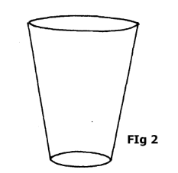

Explain why manufacturers prefer the shape shown above as a container for holding liquids such as water. (2marks)
- The pressure at the base is reduced ₁
- This is because pressure in fluids is directly proportional to the depth of the fluid. ₁

16 (a) The figure shows a block hanging at rest from a ceiling by a piece of rope.
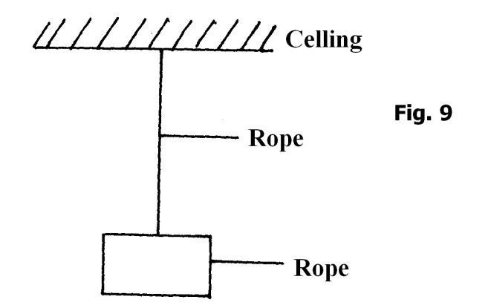
Block
Use the figure to answer question 16 (a) and (b)
- Both gravitational force and tensional force act on the system. State a reason
for the presence of each force:
(I) Gravitational force. ( 1mark)
- It has mass ₁
(II) Tensional force (1mark)
- Since the rope is stretched ₁
(ii) Air resistance and normal reaction are absent (do not act on the system). State a reason for each.
(I) Air resistance. (1 mark)
- Since the block is not moving relative to the surrounding / block is stationary
block at rest
(II) Normal reaction (1mark)
- Block is not supported by any surface ₁
(b) The figure shows a brick resting on an incline plane at an angle θ to the horizontal. The weight W and the frictional force, F_{r} are shown.
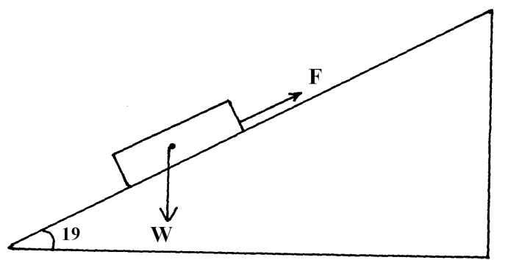
(i) On the same diagram show with an arrow one other force acting on the block and name the force. (1mark)
- Normal reaction – correct direction ₁
(ii) A runway for an airport is designed such that the lowest acceleration rate for the plane is 3m/s². The take off speed for the plane is 65m/s. Determine the minimum length for the runway. (2 marks)
V² = u² + 2as
65² = 0² + (2x3x5) ₁
65² = 65
S = 704.2m ₁
(c) A motor cyclist wears a helmet lined on the inside with sponge. Explain how this
minimizes injuries to the motorists head when involved in an accident. (2 marks)
- This is to increase time for collision ₁
- This reduces the rate of change of momentum hence the impulsive force is reduced. ₁
17 (a)The figure below shows masses A, B and C placed at different points on a rotating table. 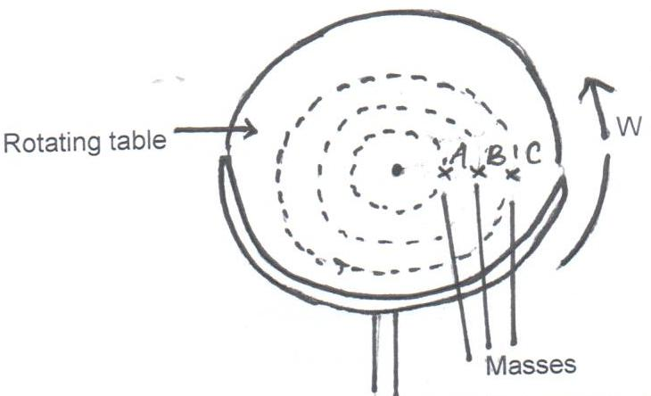

The angular velocity ω, of the table can be varied.
- State two factors that determine whether a particular mass slides off the table or not. (2marks)
- Roughness/smoothness of surface
- Radius of path
- Angular velocity/speed (any two)
- It is found that the masses slide off at angular velocities ω_{A}, ω_{B} and ω_{C} respectively. Arrange the values of ω_{A}, ω_{B} and ω_{C} in decreasing order. (1mark)
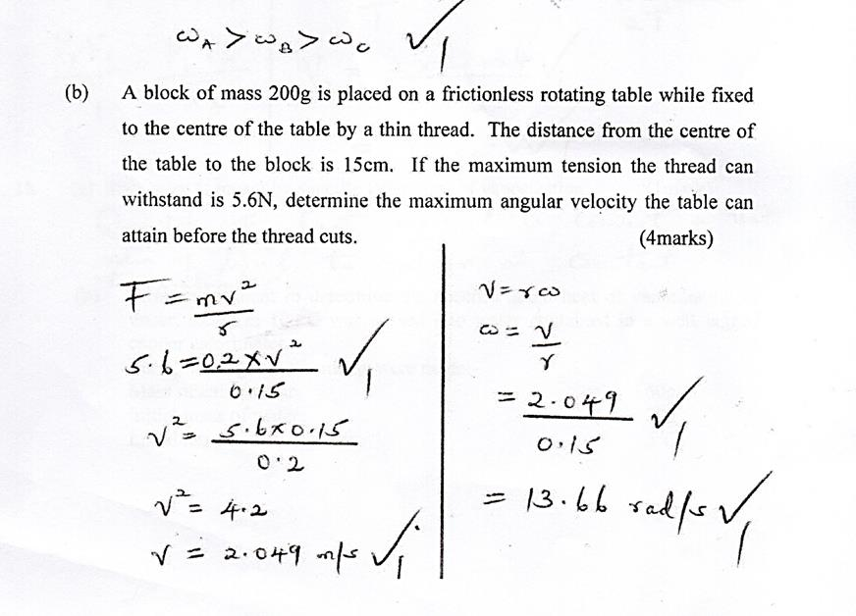

(c) State pressure law of an ideal gas. (1 mark)
- pressure of a fixed mass of a gas is directly proportional to its absolute temperature
provided volume is kept constant ₁
(d) When the temperature of a gas in a closed container is raised, the pressure of the gas increases. Explain how the molecules of the gas cause the increase in pressure. (2 marks)
- when a gas is heated molecules gain kinetic energy and move faster. If the volume of the container is constant, this increases the rate of Collins’s of the molecules with the walls of the container. The rate of change of momentum per unit area pressure increases.

(e) State one assumption for the experiments carried out to verify the gas laws.
(1 mark)
- Size of the molecules is negligible ₁
- Intermolecular forces are negligible (any one)

(f) A constant mass of hydrogen gas occupies a volume of 4.0 cm³ at a pressure of $2.4×{10}^{5}Pa$ and temperature of 15⁰C. Determine its volume at a pressure of $1.6×{10}^{5}Pa$ when the temperature is doubled. (3 marks)
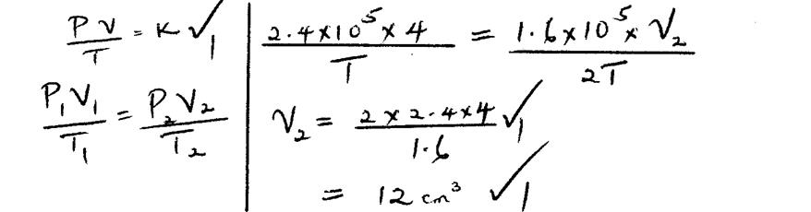

18 (a) State what is meant by specific latent heat of vaporization. (1mark)
- Quantity of heat required to convert a unit mass of liquid to vapour at constant temperature.

(b) In an experiment to determine the specific latent heat of vaporization of water, steam at 100⁰C was passed into water contained in a well lagged copper calorimeter.
The following measurements were made:-
Mass of calorimeter = 50g
Initial mass of water = 70g
Initial temperature of water = 5⁰C

Final mass of water + Calorimeter + condensed steam = 123g
Final temperature of mixture = 30⁰C
Specific heat capacity of water = 4200JKg⁻¹k⁻¹
Specific heat capacity of copper = 390 JKg⁻¹k⁻¹

- Determine the:-
- Mass of condensed steam (2marks)
= 123 – (70 + 50) ₁ = 3g ₁
= 123 – 120

- Heat gained by water and calorimeter. (2marks)
Total heat gained = 487.5 + 7350 ₁= 7837.5J
Heat gained by water = MC θ
= 0.07 x 4200 x 25= 7350J
Heat gained by calorimeter = 0.05 x 390 x 25 = 487.5J ₁

(ii) Given that L is the specific latent of heat of vaporization of steam:
- Write an expression for the heat given out by steam. (1mark)
0.003L + 882 = 7837.5
0.003L = 6955.5
Heat lost by steam = mL + MCA
= 0.003L + (0.003L + (0.003 x 4200 x 70)
= 0.003L + 882

- Determine the value of L. (2marks)
L = $\frac{6955.5}{0.003}$ = 2318500Jkg⁻¹ ₁

(c) The figure shows two similar containers with equal amounts of methylated spirit at room temperature. A draught is blown over container A and their temperatures taken after sometime.
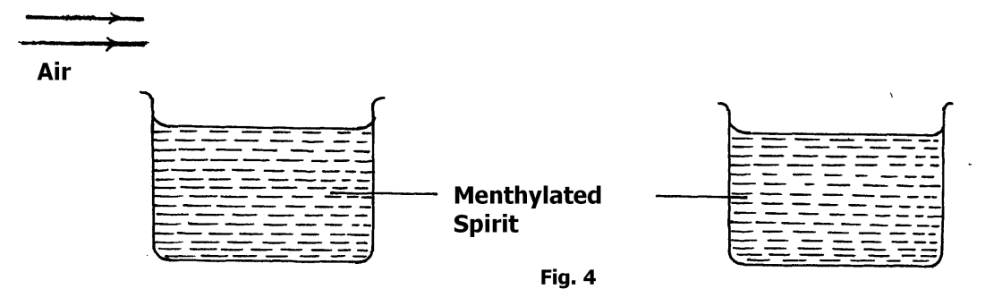
Container B
Container A

State and explain one that will have a lower temperature. (2marks)
- Container A ₁
- The rate of evaporation is increased / ₁more latent heat is drawn in A than in B.

19 (a) Two gear-wheels have 80 teeth and 20 teeth and they lock with each other. They are fastened on axles of equal diameter such that equal weight of 150N attached to the string around the axle will just raise 450N on the other axles.
Determine:
- the mechanical advantage. (2marks)
M.A. = $\frac{L}{E}$ = $\frac{450}{150 }$ ₁= 3 ₁

- the velocity ratio. (2marks)
V.R = $\frac{No. of teeth driven gear }{No. of teeth on drawing gear}$ = $\frac{80}{20}$

= 4
- The efficiency of this machine. (2marks)
M = $\frac{M.A}{V.R}$ X 100%

$\frac{3}{4}$ X 100%

= 75%

(b) State any one possible way of increasing velocity ratio of wheel and axle. (1mark)
V.R = $\frac{R}{r}$ (Radius of wheel)
(Radius of the axle)
- Increase the radius of wheel (R)
- Reduce the radius of the axle(r) (any one)
(c) A Loudspeaker is a transducer. Explain. (1mark)
- converts electrical energy to sound energy ₁

