DECEMBER EXAM 2021
232/1 PHYSICS PAPER 1 MARKING SCHEME

SECTION A (25MKS)
- Main scale reading 10.6
Vernier scale 0.08 +
10.68;
-
Zero error + 0.03
10.65cm;
- Weight of water = mg
= ρ x v x g
= 1000 x 25 x 10 x 10
10000 100
= 2.5N;
Weight of container = 250 x 10
1000
= 2.5N
Total downward force = 2.5 + 2.5 = 5.0 N;
Total upward force = 5N;
3.

Clockwise;

Heat
Convection current set is in anticlockwise direction setting wheel to rotate in opposite
direction;
4.
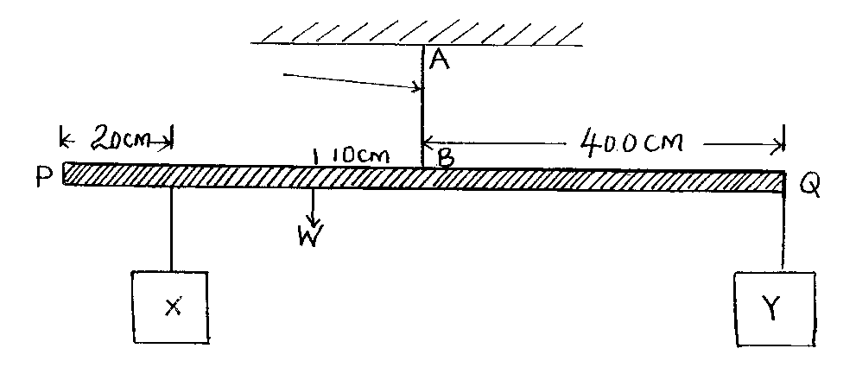
String
(X x 0.4) + (3 x 0.1); = (150 x 0.4 x 10);
1000
0.4x + 0.3 = 1.5 x 0.4
X = 0.75N
- Downward force = upward forces ( tension on AB);
0.75 + 3.0 + .5 = Tension
Tension.
Tension AB = 5.25N;
- Moment before collision = moment after collision.
200 x 90 x 1000 + 600 x 110 x 1000 = 800v;; Formula substitution
3600 3600

= 29.167m/s;
- Spring constant = F
e
= 1.2 x 100 = 60 N/m;
2
- Weight = 3 x 120;
100
= 3.6N;
- At Y, the radius r is minimum and hence the centripetal force is maximum;
- As the bucket gets filled, the centre of gravity is raised and so the stability reduces; 1 mk for both pts.

- T max = mv² + mg
r

= 8 x 6² + 8 x 10 Formula for both
2

= 224N; Ans
T min = mv² – mg
r
= 8 x 6² - 8 x 10
2
= 64N; Ans
- Steam already contains latent heat; (of vaporization) ; which water doesn’t have ;

SECTION B (55 MARKS)
- a) The volume of a fixed mass of a gas is directly proportional to its temperature at
constant pressure;
b)
Diagram ;
Labelling;
(at least 5);
Heat
Capillary tube
Stirrer
Beaker
Water bath
Thermometer
mm scale
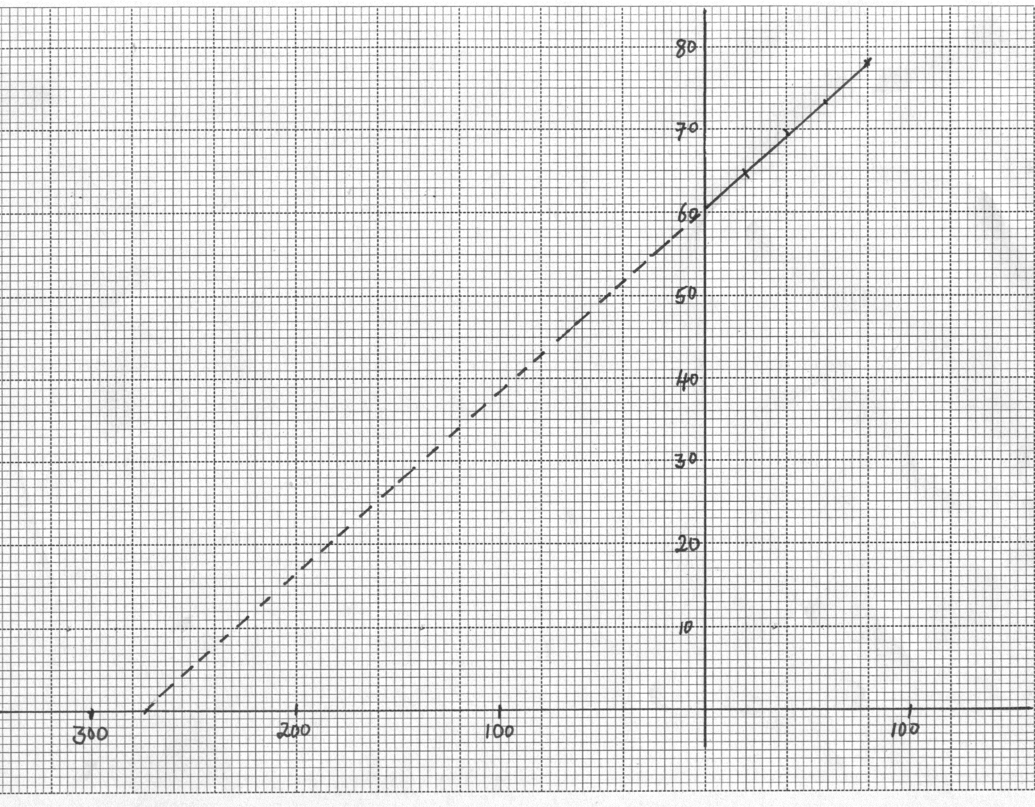
AXES
SCALE
PLOTTING
LINE
Temp ⁰C
Volume / Length (cm)
Continued line
Dotted line
(c) (i) – Both axes labelled with appropriate units; 1
- Simple and uniform scale; 1
- Correctly plotted point ½ mark each maximum of 4 points2
-straight line with positive gradient passing through at least 3 correctly plotted points1
c) ii) I 60cm ± 0.5;
II -268 ± 2° C;
TOTAL =5MKS

- a) i)
Shape of graph
At least 2 peaks
14

V (m/s)

Time (s)
    - h = u² ;
g
Distance = 2 x 14²; + 2 x 11²;
10 10
= 39.2 + 24.2
= 63.4m
b) i) Period T = 1; = 0.01s
100
Time AB = 5 x 0.01 sec
Dist = 1.5 m
100
∴vel in AB = 0.015; = 0.3m/s
0.05;
Time CD = 5 x 0.01 or 0.05s
Distance = 3.2 m or 0.032m
100
Av. Speed CD = 0.032 = 0.64m/s
0.05
- a = v - u; formular
t

a = 0.64 – 0.3;
14 x 0.01; Sub time at
= 2.429m/s ²; ans
- a) i) Have negligible temperature range in liquid state ;
ii) Wind blows out vapour creating room for more evaporation to occur;
b) i) Effect of density on rate of diffusion:
ii) I Hydrogen being of lower density diffuse faster inwards than air
diffuse outwards;
II Hydrogen more concentrated inside diffuses faster out;
iii) - Concentration of the hydrogen gas:
- Presence of moving air / wind / draught:
c) i) - Between A and B heat is translated to rise temperature with time; 1
- Between B and C heat is used to break bond between the solid
molecules to change state / latent heat;
  - Between C and D heat is used to raise temperature of liquid ;
- Q = mL_{f}
12.5 = 250 L_{F}; 1
1000
L_{f} = 50J Kg⁻¹; 1
16. a) A floating body displaces its own weight of the fluid in which it floats1
- Volume of acid displaced = mass of hydrometer
density
= 25
1.18
= 21.186 cm³1
Vol. hydrometer immersed = Vol of acid displaced 1
= 21.186 cm³
Vol. of part hydrometer = (3 x 0.5) cm3
above acid
= 1.5 cm³1
Total volume = 1.5 + 21.186
= 22.686 cm³1
c) i) - Hole B 1
- Speed is lower at wider end making pressure to be higher, hence it
leaks more; 1
2r
V_{A} X A_{A} = V_{B} x A_{B}
V_{A} = A_{B} = π x (2r) ² x 100% 1
V_{B} A_{A} π x r²
= 400% decrease 1
d) When all the particles passing through a given point or cross – section areas have the same velocity and trace the same path, the flow is streamline whereas when all the particles passing through a given point or cross – section area have differing velocities and trace differing paths, the flow is turbulent 1
17. a) i) The sum of kinetic energy and potential energy is always constant. ; 1
ii) 75p; 1 = 210 x 10 x 20; 1
100 1.2 x 60
P = 777.8 W; 1
b) i)

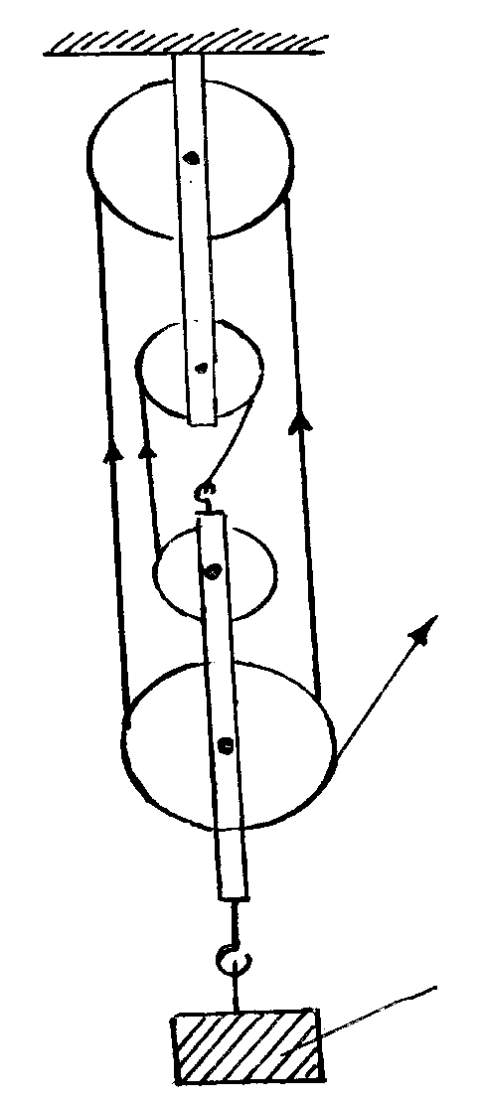
Effort
- Correct diagram ; 1
- Correct position of Effort and Load ;1
Load
As the load reduces, the ration of load to weight of the lower pulleys (and frictional force) reduces hence reduced M.A; 1
ii) Efficiency = M.A x 100%; 1
V.R

