Name ……………………………………………………………………Index No…………………………….
Candidate’s Signature ………………………………………………Date……………………………………...

232/2
PHYSICS
PAPER 1
(THEORY)

DECEMBER EXAM
2021
TIME: 2 HOURS
Instructions to candidates
- Write your name, index number, school and stream in the spaces provided above.
- Sign and write the date of examination in the spaces provided above.
- Answer ALL the questions in the spaces provided in the question paper
- Marks are given for clear record of the observations actually made, their suitability, accuracy and the use made of them.
- Candidates are advised to record their observations as soon as they are made
- Silent non-programmable electronic calculators may be used.

For Examiner’s Use Only
SECTION | QUESTION | MAX. SCORE | CANDIDATE’S SCORE
I | 1-12 | 25
II | 13 | 10
 | 14 | 14
 | 15 | 12
 | 16 | 11
 | 17 | 08
TOTAL SCORE |  | 80

This paper consists of 14 printed pages.
Candidates should check the question paper to ensure that all pages are printed as indicated and no questions are missing

SECTION A (25 MARKS)
1. The figure 1 below shows a scale of a part of a vernier callipers. If the instrument has
a zero error of positive 0.03, state the correct reading (2mks)
Fig.1
………………………………………………………………………………………………………………………………………………………………………………………………………………………………………………………………………………………………………
2. The figure 2 below shows a beaker of height 10 cm and cross – sectional area 25cm²
filled with water then inverted over water held in a trough.
Fig.2
water
trough
beaker
The beaker weighs 250g when empty. Determine the amount of force F required to
hold the beaker at the position shown. (Take acceleration due to gravity g = 10ms⁻² or 10 N/kg, density of water = 1000 Kg/m³) (3mks)
…………………………………………………………………………………………………………………………………………………………………………………………………………………………………………………………………………………………………………………………………………………………………………………………………………
3. The figure 3 below shows a paddle wheel made of light material. Show on the diagram
the direction of its rotation when heat is applied at one end of the container as shown.
Give a reason for your answer. (2mks)
paddle
Water bath
Fig. 3
Heat
water

……………………………………………………………………………………………………………………………………………………………………………………………………
Below is figure 4 showing a system in equilibrium with a metre rule held horizontally.
Use it to answer questions 4 and 5.
Fig.4
Mass 150g
string
4. PQ is a uniform rule of length 1.0m and weighs 3.0N. Determine the weight of block X.
(3mks)

5. Determine the tension in the string AB (2mks)
…………………………………………………………………………………………………………………………………………………………………………………………………………………………………………………………………………………………………………………………………………………………………………………………………………
6. A cyclist of mass 200kg and traveling at 90km/h is involved in a head on collision with
a car of mass 600 kg traveling at 110km/h. The cyclist is thrown onto the bonnet of the
car which continued to move after impact in the original direction .Find their velocity after impact. (3mks)
…………………………………………………………………………………………………………………………………………………………………………………………………………………………………………………………………………………………………………………………………………………………………………………………………………
A light spring fixed at one end extends by 2.0cm when a weight of 120g is suspended from the free end. Use this information to answer question 7 and 8.
7. Determine its spring constant. (1mk)
………………………………………………………………………………………………………………………………………………………………………………………………………………………………………………………………………………………………………
8. Three such springs are arranged in a manner shown in figure 5 below and used to support
a load. If each extends by 2.0cm, determine the weight of the load. (2mks)
Fig.5

9. An aerial view of a car of mass m moving along a curved part of the road with constant
speed is depicted in figure 6 below.
Fig.6
Explain the fact that the car is more likely to slide at Y than at X if the speed is not
adjusted. (1mk)
……………………………………………………………………………………………………………………………………………………………………………………………………
10. A water bucket taking the shape of a sliced off inverted pyramid with a circular base is being filled with water. Explain how its stability varies. (1mk) ………………………………………………………………………………………………… ………………………………………………………………………………………………… ………………………………………………………………………………………………… …………………………………………………………………………………………………
11. An object of mass 8 kg is whirled in a vertical circle of radius 2.0m with a constant
speed of 6 m/s. Determine the maximum and minimum tension in the string (3mks)
…………………………………………………………………………………………………………………………………………………………………………………………………………………………………………………………………………………………………………………………………………………………………………………………………………

12. A burn from steam is more severe than one from water boiling at the same temperature.
Give reasons. (2mks)
………………………………………………………………………………………………………………………………………………………………………………………………………………………………………………………………………………………………………………………………………………………………………………………………………… SECTION B (55 MARKS)
13. a) State Charles’ law for an ideal gas. (1mk)
…………………………………………………………………………………………………………………………………………………………………………………………………………………………………………………………………………………………………………………………………………………………………………………………………………
b) Draw a setup of apparatus that can be used to verify Charles’s law. (2mks)

c) In a similar experiment a student recorded the readings below.
Temp (°C) | 20 | 40 | 60 | 80 | 100
Length of air column (cm) | 64.5 | 69 | 73.3 | 77.5 | 82
i) Plot a graph of volume against temperature. (5mks)
ii) Use the graph to obtain values for
- Volume trapped by air at 0°C. ( 1mk)

- Temperature at which the volume of the trapped air would become zero (1mk)

14. A ball is thrown vertically upwards with a velocity of 14ms⁻¹. It falls and bounces back with a velocity of 11 ms⁻¹.
a) i) Represent this information on a velocity – time graph (until it strikes the
ground twice) (2mks)
Velocity (m/s)

0
Time(s)
ii) Determine the total distance covered until the ball strikes the ground twice. (Assume the ball is thrown from the ground level) (4mks)

b) A tape attached to a moving trolley is run through a ticker timer. Figure 7 below shows
a section of the tape after running.
Fig.7
If the frequency of the timer is 100Hz determine the;
(i) Average velocity at intervals AB and CD (4mks)

(ii) Average acceleration of the trolley (4mks)

15. a) i) Suggest a reason why some solids change their state directly to gas. (1mk)
……………………………………………………………………………………………………………………………………………………………………………………………………
(ii) Presence of wind enhances rate of evaporation of a liquid. Explain how this is achieved. (1mk)
……………………………………………………………………………………………………………………………………………………………………………………………………
b) The set up in figure 8 below shows some observations made by a form two student in
their school laboratory during a physics class. In fig 8(a) bubbles were coming out of
water when hydrogen gas was allowed to flow over the porous pot whereas, fig 8(b)
shows water having risen through the tube.
Fig.8(a) Fig. 8(b)
(i) State what the lesson was investigating. (1mk)
…………………………………………………………………………………………………
(ii) Briefly explain each observation made in:
I Fig 8(a) (1mk)
……………………………………………………………………………………………………………………………………………………………………………………………………
II Fig 8(b) (1mk)
……………………………………………………………………………………………………………………………………………………………………………………………………

(iii) Name two factors that would affect the observation made in the experiment set up,
in figure 8, above. (2mks)
……………………………………………………………………………………………………………………………………………………………………………………………………
(c) A 250 g sample of a solid was heated steadily in a lagged colorimeter of negligible mass.
The observations were represented in a graph as shown below.
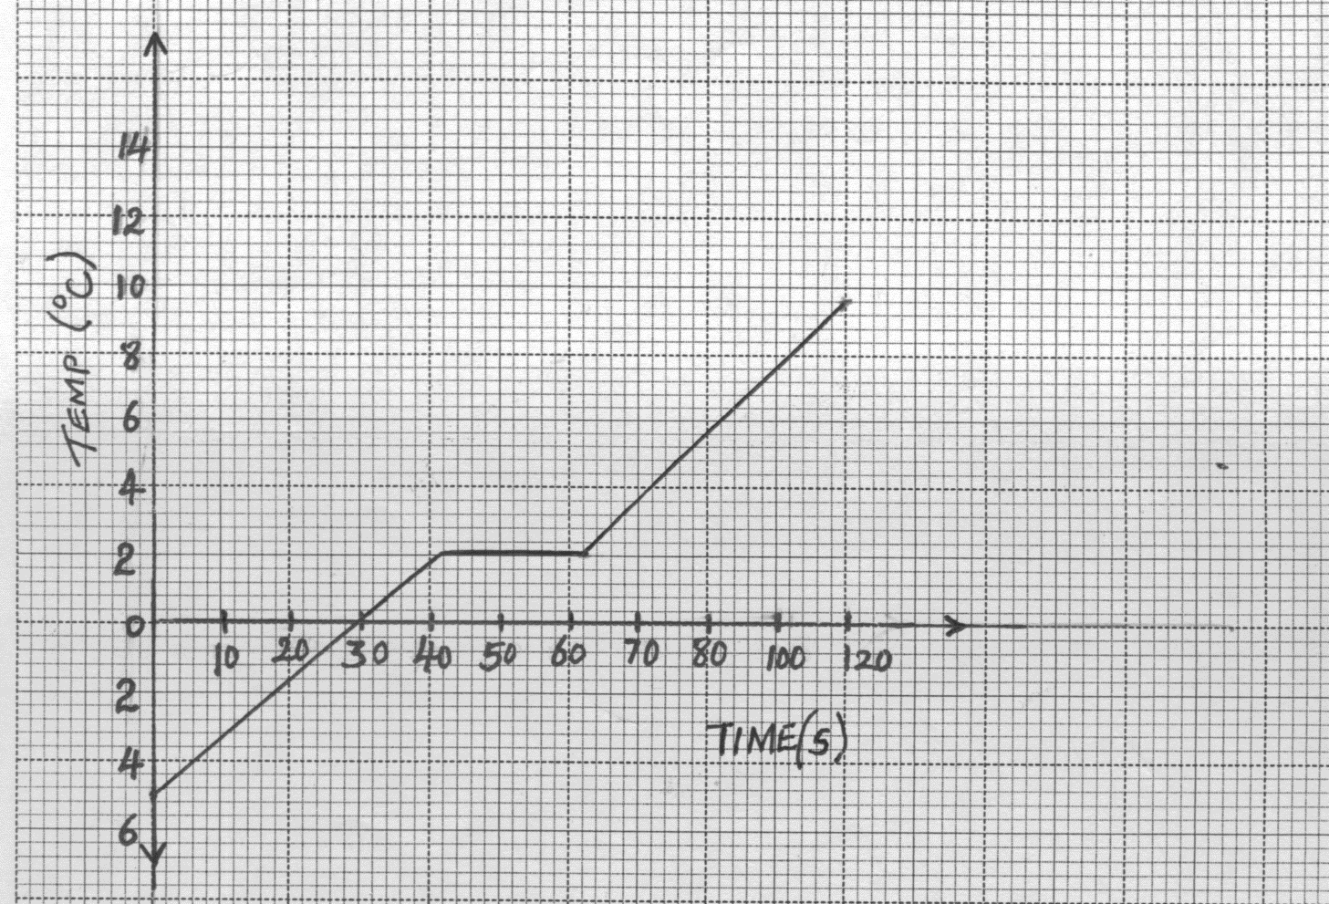
B C
Time (s)
Temp (ºC)
A
-

-

-
D
(i) Explain the shape of the graph. (3mks)
…………………………………………………………………………………………………………………………………………………………………………………………………………………………………………………………………………………………………………………………………………………………………………………………………………

(ii) The solid requires 12.5J of energy to change its state. Determine its specific latent
heat of fusion. (2mks)
……………………………………………………………………………………………………………………………………………………………………………………………………
……………………………………………………………………………………………………………………………………………………………………………………………………
16. a) State the law of flotation. (1mk)
……………………………………………………………………………………………………………………………………………………………………………………………………
b) A hydrometer of mass 25g floats in an acid of density 1.18 g/cm³ with 3.0cm of its
stem above the acid. If the cross- section area of the stem is 0.5cm², determine its
total volume. (4mks)

c) Water flows in a pipe of varying diameter as shown in figure 9 below.
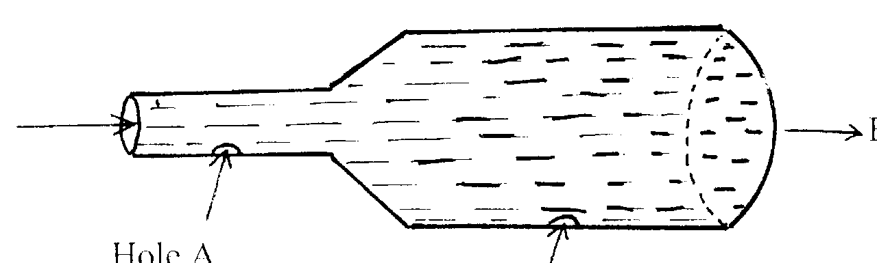
Hole A
Hole B
Fig.9
Flow of water

(i) Two perforations are developed with time at points A and B as shown. If the holes are of same dimensions, suggest with a reason which hole leaks more. (2mks)
…………………………………………………………………………………………………………………………………………………………………………………………………………………………………………………………………………………………………………………………………………………………………………………………………………
(ii) If the diameter of the larger end of the pipe in figure 9 above is twice that of its smaller end, find the percentage decrease in speed as the water flows from narrow to wider end. (3mks)
…………………………………………………………………………………………………………………………………………………………………………………………………………………………………………………………………………………………………………………………………………………………………………………………………………

(d) Distinguish between streamline and turbulent flow. (1mk)
…………………………………………………………………………………………………………………………………………………………………………………………………………………………………………………………………………………………………………………………………………………………………………………………………………
17 a) i) State the law of conservation of energy in terms of kinetic energy and potential
energy. (1mk)
……………………………………………………………………………………………………………………………………………………………………………………………………
(ii) 210 litres of water is pumped through a height of 20m in 1.2 minutes. Determine the power rating of the pump if it is 75% efficient. (3mks)
…………………………………………………………………………………………………………………………………………………………………………………………………………………………………………………………………………………………………………………………………………………………………………………………………………

(b) i) Draw a pulley system of velocity ratio 5 and having a total of 4 pulleys and
explain why its efficiency reduces as the size of the load reduces. (3mks)

(ii) State the relationship between M.A., V.R and efficiency of a machine. (1mk)
……………………………………………………………………………………………………………………………………………………………………………………………………

