Name _________________________________________ Index No__________________________
School ________________________________________ Candidate’s Signature ______________
Date ______________________________
232/3
PHYSICS PRACTICAL
PAPER 3

AUGUST/SEPTEMBER - 2022
TIME: 2 ½ hours

ARISE AND SHINE TRIAL EXAMINATIONS
Kenya Certificate of Secondary Education (KCSE)

INSTRUCTIONS TO CANDIDATES
- Write your name and index number in the spaces provided above
- Answer ALL the questions in the spaces provided.
- You are supposed to spend the first 15 minutes of the 2 ½ hours allowed for this paper reading the whole paper carefully before commencing your work.
- Marks are given for a clear record of the observations actually made, their suitability, accuracy and the use made of them.
- Candidates are advised to record their observations as soon as they are made.
- KNEC MATHEMATICAL TABLES AND NON PROGRAMMABLE SILENT CALCULATORS MAY BE USED.
For Examiners’ Use Only
Question 1 | Part A |  |  | Part B |  | Part C |  |  |  |  | TOTAL
 | ii | iii | vi | iv | v | i | ii | iii | iv | v
Maximum score | ½ | 5 | 1 | 3 | ½ | 1 | 4 | 3 | 1 | 1 | 20
Candidate’s score
Question 2 | PART A |  |  | PART B |  |  |  |  | PART C |  | TOTAL
 | i | ii | iii | a | b(i) | b(ii) | b(iii) | b(iv) | (ii) | (iii)
Maximum score | 1 | 1 | 1 | 1 | 4 | 4 | 2 | 1 | 3 | 2 | 20
Candidate’s score

QUESTION 1
Part A
You are provided with the following apparatus.

- Helical spring with pointer.
- One clamp, one stand and one boss
- A stop watch
- One 50g mass
- Two 100g masses

Proceed as follows:
- Suspend the spring vertically alongside a clamped metre rule as shown in the diagram so that the pointer slide along the millimeter scale of the metre rule as shown in the figure below.
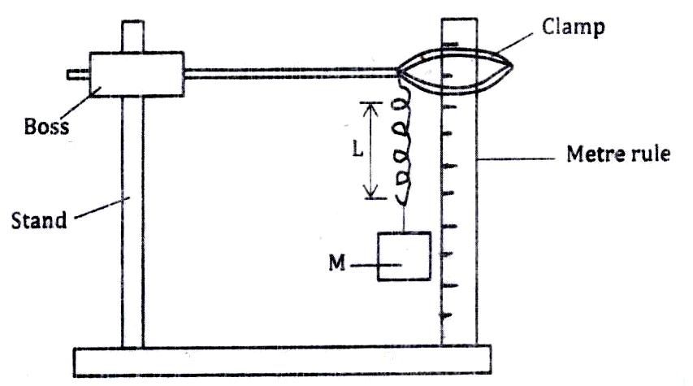

- Measure the length L_{o} of the unloaded spring. (½ mark)

Lo - ……………………………………….

- Attach a mass of 100g on the spring and measure the new length L of the spring. Record this in the table. (5 marks)

Table
Mass (g) | Weight… (N) | L (M) | Е = (L – L₀) (M) | K = $\frac{w}{e}$ $\left(\frac{N}{M}\right)$
100
150
200
- Calculate the change in length е = (L-L_{o})m due to the mass of 100g and record in the table.

- Repeat the procedure in (i) - (iv) for mass of 150g and 200g.

- Calculate the value of K given:
K = $\frac{w(N)}{e(M)}$ and find the average value of K.
K Average = (1 mark)

PART B
- Using the same set up as in Part A above, attach the 100g on the spring and support it to stop oscillating.

- Pull the mass through a small distance vertically downwards and release it to make vertical oscillations and record the time for 10 oscillations and determine the periodic time(s).

- Hence complete the table to get T²(S²) and the value of K = $\frac{39.49 x M(Kg)}{T^{2}\left(S^{2}\right)}$ where
M = mass used and T² (S²) is its periodic time (T) squared.

- Table (3/marks)
Mass m(kg) | Time for 10 oscillations t(s) | T (s)  T = $\left(\frac{t}{10}\right)$ | T² (S²) | $\frac{39.49 x M(Kg)}{T^{2}\left(S^{2}\right)}$
1.00
1.50
2.00
- Find the average value of K (½ mark)

PART C
You are provided with the following:

- A meter rule
- Complete stand
- One 50g mass and a 100g mass
- Three pieces of thread 30cm each.
- Some water in a beaker
- Liquid L in a beaker
- Tissue paper.

Proceed with the experiment as follows:

- Balance the meter rule on the stand and record the reading at this point.
Balance point = ………………………………………………………………(1 mark)
(For the rest of the experiment, the balancing thread must be placed at this position)

- Set up the apparatus as shown in the figure 4 below: Use the thread provided to hang the masses such that the positions of the support can be adjusted.
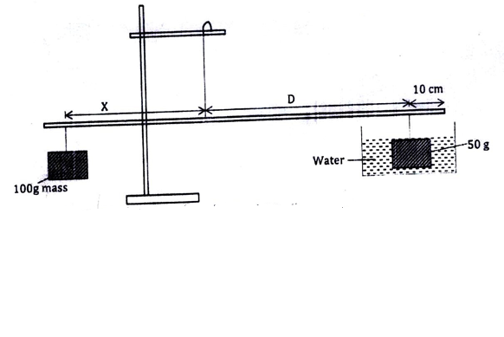
The balance point is attained by adjusting the position of the 100g mass. Note that the distance X and D are measured from the supporting string and the 50g mass is fully submerged in water.

Record the values of
X = ………………………………………………………………………………… (1 mark)
D = ………………………………………………………………………………… (1 mark)
Apply the principle of moments to determine the weight W₁ of the 50g mass in water and hence determine the upthrust U_{w} in water. (2 marks)

W1 = ……………………………………………………………………………………………………………………………………………..
Uw = ………………………………………………………………………………………………………………………………………………

Remove the 50g mass from the water and dry it using the tissue paper.

- .Now changing distance D obtained in (ii) balance the metre rule when the 50g mass is fully immersed in the liquid. Record the new value of the distance X.
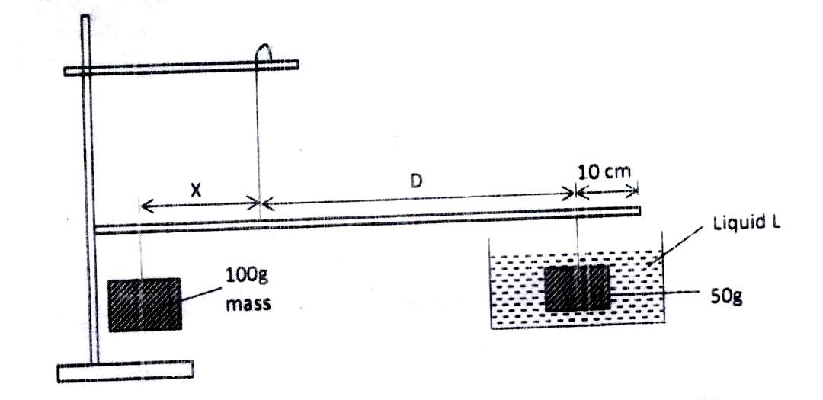

X = …………………………………………………………………………………… (1 mark)
Apply the principle of moments to determine W₂ of the 50g mass in the liquid L and hence determine the upthrust U_{L} in the liquid. (2 marks)

W₂ = ……………………………………………………………………………………………..

UL = ……………………………………………………………………………………………………………………………………………..
- Determine the relative density R.D of the liquid L given that: (1 mark)

R.D = $\frac{UL}{Uw }$

- Find the density of liquid L in Kg/m³ (1 mark)

QUESTION 2

You are provided with the following apparatus

- Two dry cells and a cell holder
- A voltmeter
- An ammeter (0-1A)
- Potentiometer P
- A bulb and bulb holder
- 7 connecting wires
- 4 crocodile clips
- A switch S

PART A
Set up the circuit as shown below.
Ensure the switch is off.
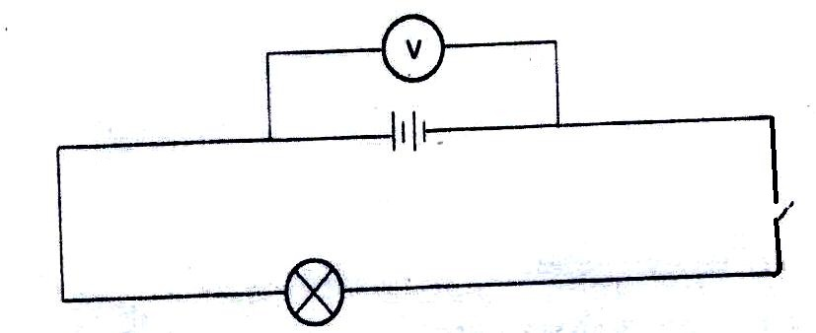

- Record the reading of the voltmeter when the switch is open (1 mark)

V₁ ………………………………………………………………………………………………….

- Close the switch and record the voltmeter reading. (1 mark)
V2 …………………………………………………………………………………………………………………………………………………..

- Explain the differences in the value of V₂ and V₁ (1 mark)
………………………………………………………………………………………………………………………………………………………………………………………………………………………………………………………………………………………………………………………..

PART B
- Set up the circuit as shown below.
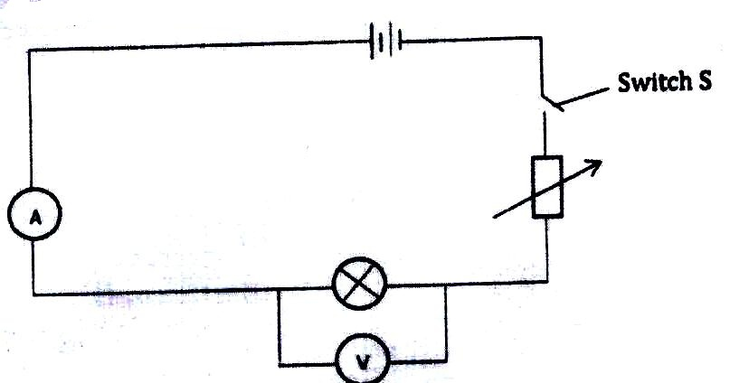
P

Close the switch S and adjust the potentiometer P till the bulb lights brightest. Record the ammeter and voltmeter reading.
I …………………………………………………………………………………………(½ mark)
V ………………………………………………………………………………………..(½ mark)

- (i) By adjusting the potentiometer P obtain the corresponding ammeter readings of the values of voltmeter readings given in the table. (4 marks)

Volts (V) | 1.5 | 1.4 | 1.2 | 1.0 | 0.8 | 0.6 | 0.4 | 0.2
Current I (A)

- Plot a graph of voltage against current. (4 marks)

- Determine the resistance of the bulb when voltage is 0.9v. (2 marks)

- Explain the nature of the curve in the graph. (1 mark)
……………………………………………………………………………………………………………………………………………………………………………………………………………………………………………………………………………………………………………………………....
PART C

You are provided with the following:

- A lens holder
- Convex lens
- A white screen
- A metre rule
- A candle

Proceed as follows:
- Set up the apparatus as shown in Figure 4

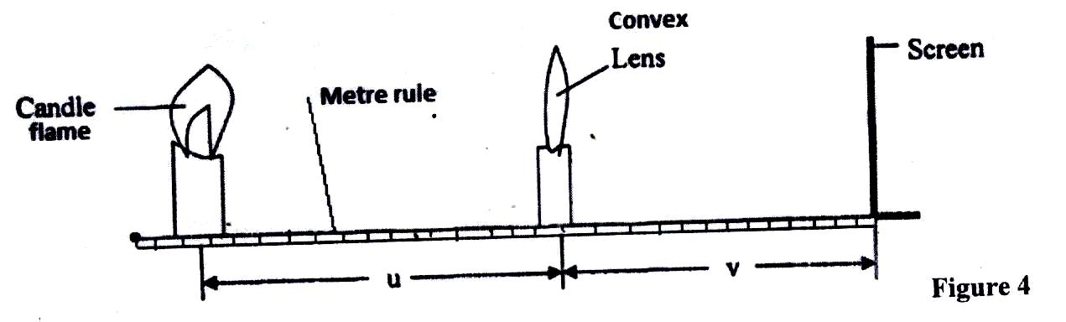

- Starting with u=30 cm, adjust the position of the screen to obtain a sharp image of the candle flame. Record the value of v in Table 3.

Repeat the procedure for u-50 cm. Complete Table 3 (3marks)

u (cm | v(cm) | m = $\frac{v}{u}$
30
50
Table 3

- Given that the focal length f of the lens satisfies the equation f = $\frac{v}{m+1}$, determine the average value of the focal length, f. (2 marks)

