PHYSICS - PAPER 3 - MARKING SCHEME
AUGUST/SEPTEMBER – 2022

ARISE AND SHINE TRIAL 1 EXAMINATION 2022
PART A
- You are provided with the following apparatus:
- Helical spring with pointer
- One clamp, one stand and one boss
- A stop watch
- One 50g mass
- Two 100g masses

Proceed as follows;
- Suspend the spring vertically alongside a clamped metre rule as shown in the diagram so that the pointer slide along the millimeter scale of the metre rule as shown in the figure below.
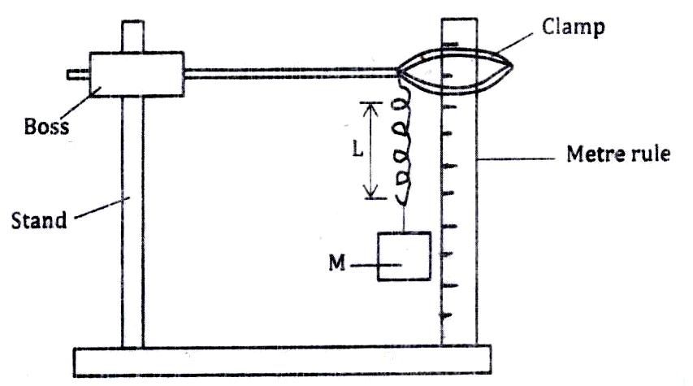
- Measure the length L of the unloaded spring.
L₀ = 40.8cm (At least 1d.p) (use student values. Any length within the metre rule)

- Attach a mass of 100g on the spring and measure the new length L of the spring. Record this in the table. (5 marks)
Table
Mass (Kgl | Weight (N) | L(M) ± 0.020 | ɵ = (L – L₀) (M) | K = $\frac{w}{e}$ $\left(\frac{N}{M}\right)$
100 | 1.0 | 0.478 | 0.07 | 14.29
150 | 1.5 | 0.409 | 0.139 | 10.79
200 | 2.0 | 0.338 | 0.21 | 9.524
All correct ½ mark. Each 1mark All correct ½ mark All correct 1 mark

- Calculate the change in length ɵ = (L – L0)m due to the mass of 100g and record in the table.
- Repeat the procedure in i – iv for mass of 150g and 200g.
- Calculate the value of K given: (1 mark)
K = $\frac{w}{e}$ $\left(\frac{N}{M}\right) and find the average value of K.$
K average = $\frac{14.29 + 10.79 + 9.524 }{3}$ - principle of averaging ✔½
= 11.53 - Evaluation ✔½
(ignore units)
PART B
- Using the same set up in part A above, attach the 100g on the spring and support it to stop oscillating.
- Pull the mass through a small distance vertically downwards and release it to make vertical oscillations and record the time for 10 oscillations and determine the periodic time(s).
- Hence complete the table to get T²(S²) and the value of K = $\frac{39.49 x M(Kg) }{T2(S2)}$ where M = mass used and T²(S²) is its periodic time T squared.
Table (3 marks)
Mass in (kg) | Time for 10 oscillations t(s)  2 d.p | T(s)  T =(t/10) ±0.2  Exact | T² (S²)  4S + | 39.49 X M(Kg)/T² (S²)  4S+
0.10 | 6.80 | 0.680 | 0.4624 | 8.54
0.15 | 8.42 | 0.842 | 0.7090 | 8.355
0.20 | 10.03 | 1.003 | 1.006 | 7.851
Each ½mark All correct ½ mark. All correct ½ mark All correct ½ mark
(v). Find the average value of K. (½ mark)
K = 8.54 + 8.355 + 7.851
= 8.249 Kgs¯² ✔½

PART C
You are provided with the following:
- A metre rule
- Complete stand
- One 50g mass and a 100g mass
- Three pieces of thread 30cm each
- Some water in a beaker
- Liquid L in a beaker
- Tissue paper

Proceed with the experiment as follows:
- Balance the meter rule on the stand and record the reading at this point.
Balance point = 50.0 ± 0.1cm ✔1 1 d.p
(For the rest of the experiment, the balancing thread must be placed at this position)

- Set up the apparatus as shown in the figure 4 below;
Use the thread provided to hang the masses such that the positions of the support can be adjusted.
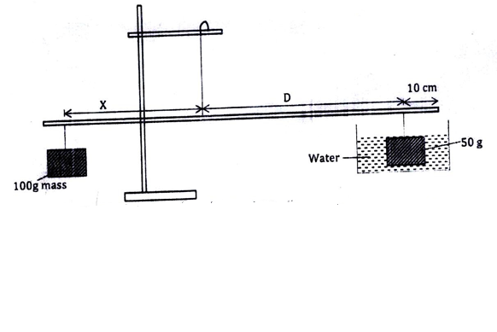
The balance point is attained by adjusting the position of the 100g mass. Note that the distance X and D are measured from the supporting string and the 50g mass is fully submerged in water.

Record the values of X and D.
X =17.5 ± 1.0cm ✔1 1 d.p is a must
D = 40.0 ± 1.0cm✔1 1 d.p is a must
Apply the principle of moments to determine the weight W₁ of the 50g mass in water and hence determine the upthrust U_{w} in water.
1 x 175 = w₁x40 ✔½
W₁ = 0.4375n ✔½ Use student value
U_{w} = 0.5 – 0.4375 = 0.0625N ✔1
Remove the 50g mass from the water and dry it using the tissue paper

- Now balance the metre rule when the 50g mass is fully immersed in the liquid L. Record the value of the distance X
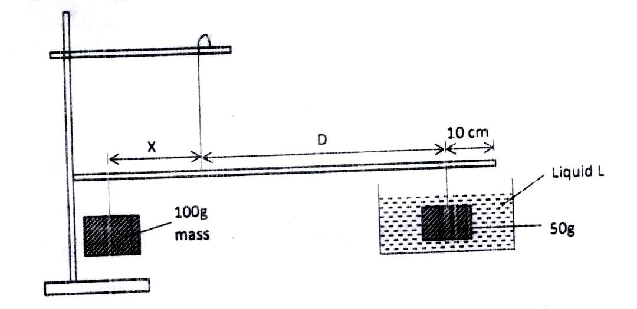
X = 18.3 ± 1.0cm ✔1 1 d.p is a must

Apply the principle of moments to determine W₂ of the 50g mass in the liquid L and hence determine the upthrust U1 in the liquid.
W₂ = 0.4575✔½ W₂ X 40 = 1.0 X 18.3
U_{L} = 0.5 - 0.4575 = 0.0425N✔1
- Determine the relative destiny R.D of the liquid L given that:
R.D = $\frac{UL}{Uw}$ = $\frac{0.0425}{0.0625}$ = 0.68✔1
- Find the density of liquid L in Kg/m³
ℓL = 0.68 X 1000
= 680Kg/m³✔1

QUESTION 2
You are provided with the following apparatus.
- Two dry cells and a cell holder
- A voltmeter
- An ammeter (0-1A)
- Potentiometer P
- A bulb and bulb holder
- 7 connecting wires
- 4 crocodile clips
- A switch S

PART A
Set up the circuit as shown below.
Ensure the switch is off.
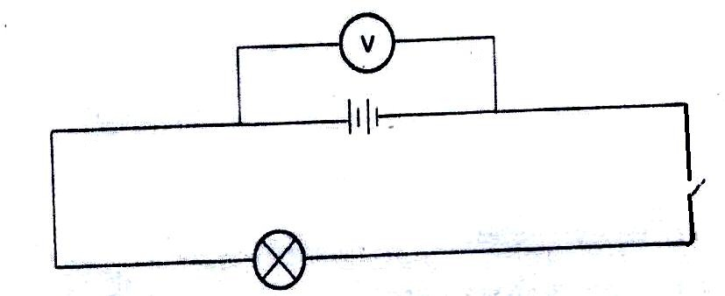
Record the reading of the voltmeter when the switch is open.
3.0V ± 0.2 1 d.p ✔1
2.7V ± 0.2 1 d.p✔1
Explain the differences in the value of V₂ and V₁
Voltage is lost due to internal resistanceS ✔1

PART B
Set up the circuit as shown below:
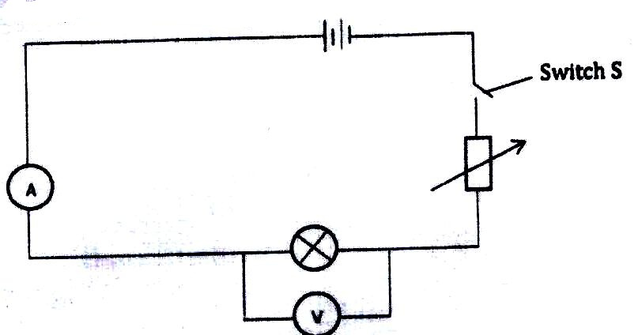

Close the switch S and adjust the potentiometer P till the bulb lights brightest. Record the ammeter and voltmeter reading.
I 0.23A ± 0.02 (2 d.p) ✔1
V 2.1 ± 0.2 (1 d.p) ✔1

By adjusting the potentiometer P, obtain the corresponding readings of the values of voltmeter readings given in the table. (4 marks)
Volts (V) | 1.5 | 1.4 | 1.2 | 1.0 | 0.8 | 0.6 | 0.4 | 0.2
Current I (A) | 0.20 | 0.19 | 0.17 | 0.16 | 0.15 | 0.13 | 0.12 | 0.10
2 d.p (each ½ mark)
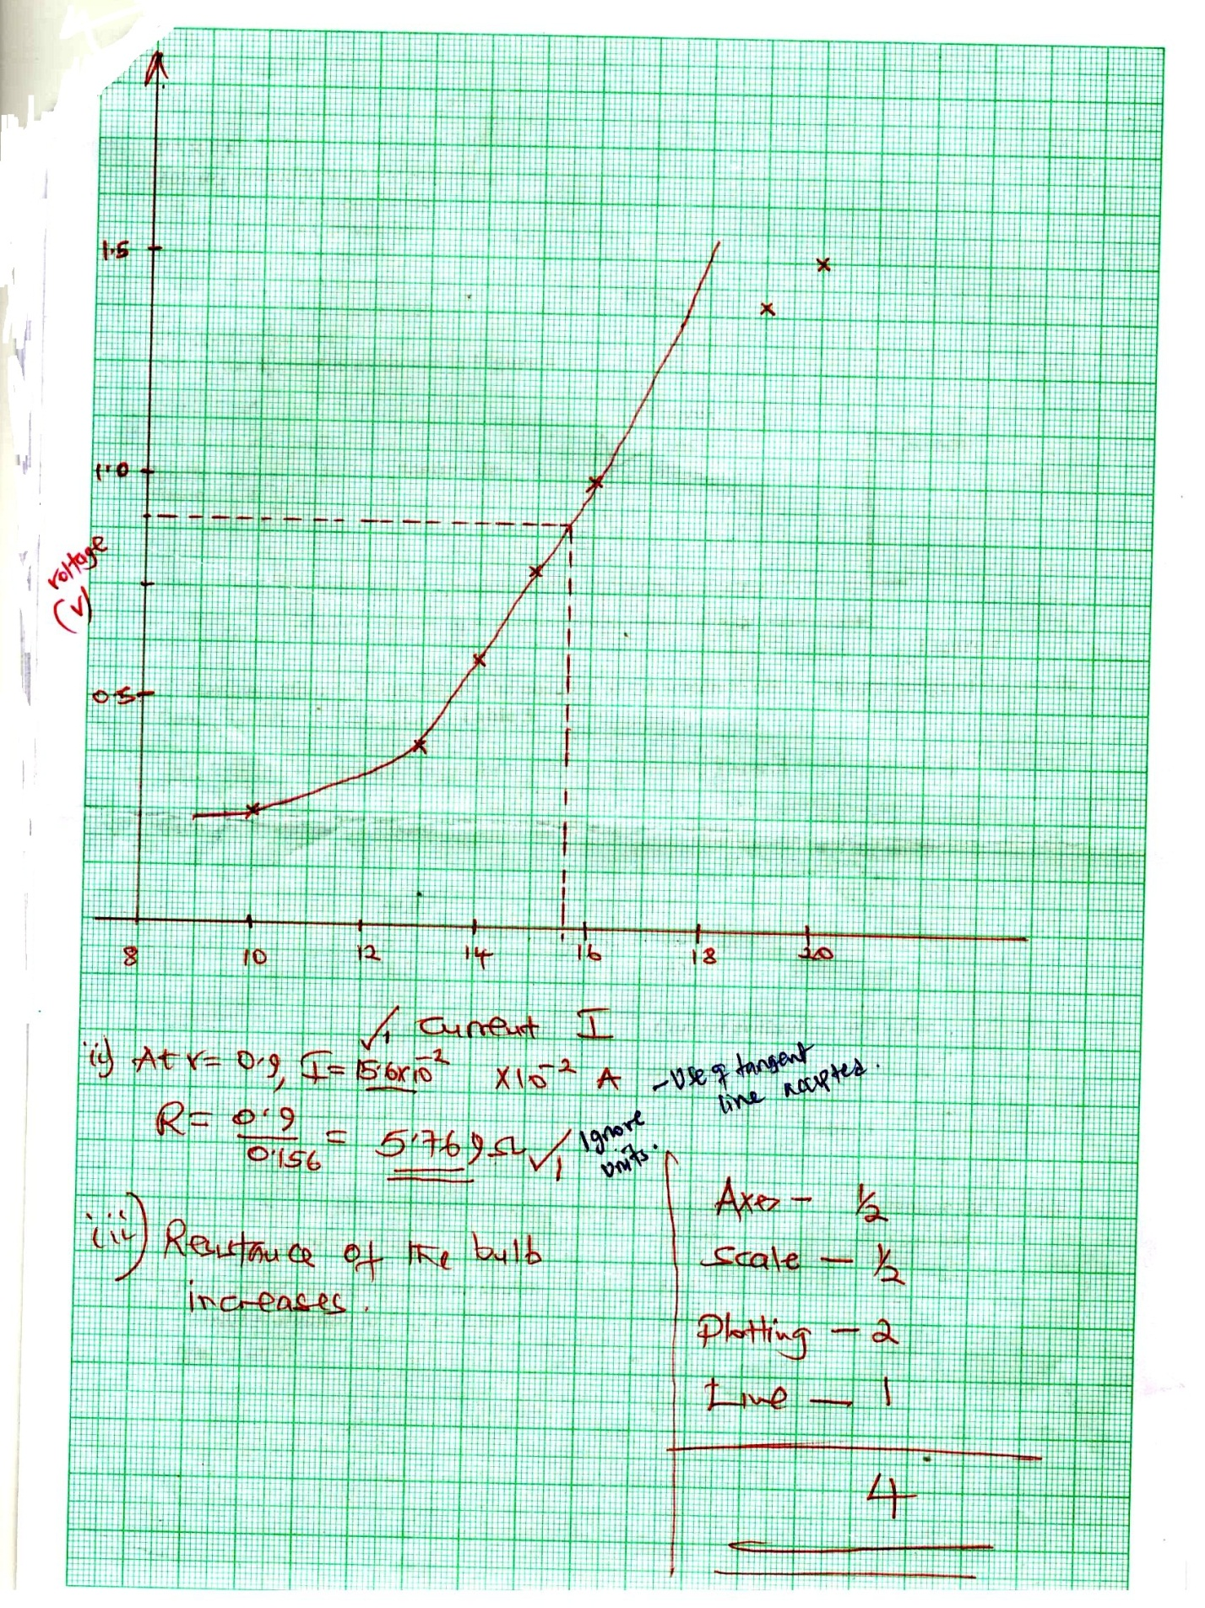

PART C
You are provided with the following:
- A lens holder
- Convex lens
- A candle
- A screen
- A metre rule

Proceed as follows:
Set up the apparatus as shown in Figure 4
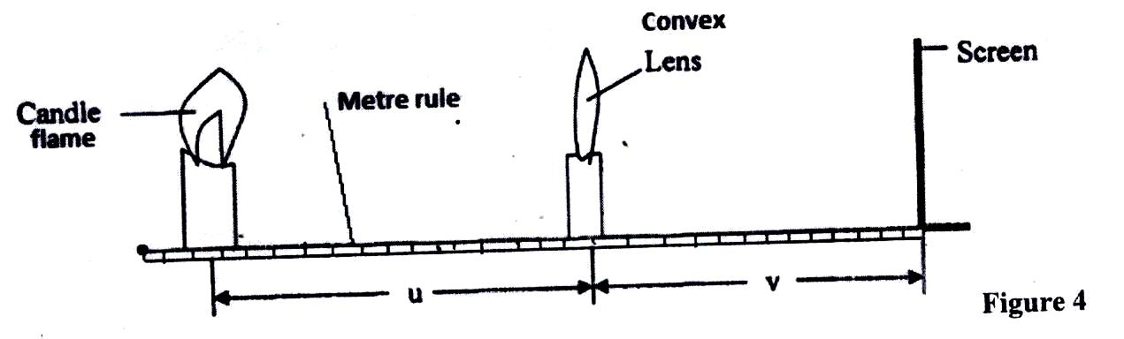
Starting with u =30cm, adjust the position of the screen to obtain a sharp image of the candle flame. Record the value of v in Table 3.

Repeat the procedure in (g) for u = 30cm. Complete Table 3. (3 marks)
u(cm) | v(cm) | m = $\frac{v}{u}$
30 | 30.0 | 1
50 | 21.5 | 0.43
 | 1 d.p ± 2.0 @1 mark | Correct evaluation to 4 s.f or exact - all 1 mark
Table 3
Given that the focal length f of the lens satisfies the equation f = $\frac{v}{m+1}$, determine the average value of the focal length, f.
- Principle of averaging must be shown ✔1 1 mark
- Correct evaluation to 4 s.f of exact. ✔1 1 mark
- Ignore units

