NAME:…………………………………………INDEX NO. …………………ADM NO….................

232/2 Signature: ……………………..… Date: ………………………

PHYSICS
PAPER 2

August 2022
TIME: 2 HRS.

ARISE AND SHINE TRIAL 1 EXAMINATION -2022
Kenya Certificate of Secondary Education (K.C.S.E)

Instructions to candidates:

- Write your Name and Index Number in the spaces provided above.
- Sign and write the date of examination in the spaces provided above.
- This paper consists of two sections; A and B.
- Answer ALL the questions in Section A and B in the spaces provided.
- All workings must be clearly shown.
- Non-programmable silent electronic calculators and KNEC Mathematical tables
may be used.

FOR EXAMINER’S USE ONLY:

SECTION | QUESTION | MAXIMUM SCORE | STUDENT’S SCORE
A | 1 - 12 | 25
B | 13 | 13
 | 14 | 10
 | 15 | 12
 | 16 | 9
 | 17 | 11
TOTAL SCORE |  | 80

SECTION A (25 MARKS)

Answer all the questions in this section in the spaces provided.

1. The figure 1 below shows a ray of Light incident on the surface of one plane mirror.

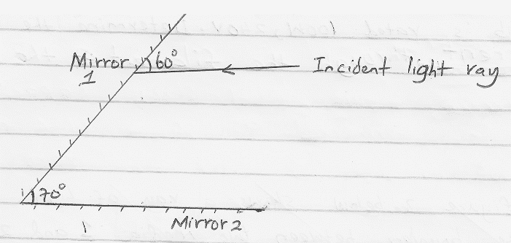
Sketch the path of the ray on the diagram after striking mirror 2 indicating all the angles.(2 marks)

2. An observer watching a fireworks displays sees the light from an explosion and hears the sound 4 seconds later. How far was the explosion from the observer (speed of sound in air =330m/s. (2 marks)

………………………………………………………………………………………………………………………………………………………………………………………………………………………………………………………………………………………………………………………………………………
……………………………………………………………………………………………………………..

3. In the circuit diagram shown in figure 2 below the lamps are identical and the cells are also identical.
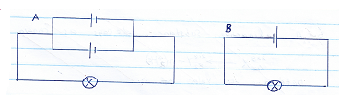
State with a reason in which circuit the lamp will be lit for a longer period. (2 marks)
…………………………………………………………………………………………………………………………………………………………………………………………………………………………………………………………………………

4. A bulb is rated 100W, 240V. Determine the amount current through the filament of the bulb.
(2 marks)
………………………………………………………………………………………………………………………………………………………………………………………………………………………………………………………………………………………………………………………………………………
5. A negatively charged rod is brought near the cap of a leaf electroscope. The cap is then earthed momentarily by touching with the finger. Finally the rod is withdrawn. State the final charge on the electroscope. Explain your answer. (3 marks)

………………………………………………………………………………………………………………………………………………………………………………………………………………………………………………………………………………………………………………………………………………

6. Figure below show a wire carrying current whose direction is out of the paper. The paper is placed in a magnetic field. .

N

S

(a). Indicate on the figure the direction of the forced F, acting on the wire. (1 mark)
………………………………………………………………………………………………………………………………………………………………………………………………………………………………

(b). State what would be observed on the wire if the direction of the current is reversed (i.e. into the paper). (1 mark)
………………………………………………………………………………………………………………………………………………………………………………………………………………………………
………………………………………………………………………………………………………………

7. The figure 4 below shows a device x connected in series with a resistor of resistance R, the voltage across x is 0.14v. .
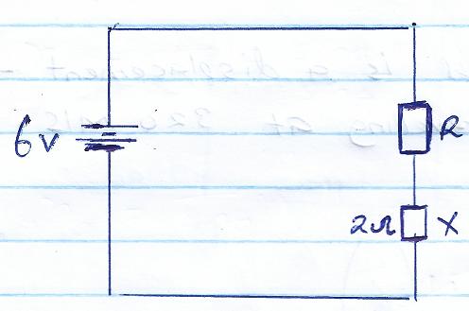
Calculate the value of resistance R. (3 marks)
………………………………………………………………………………………………………………………………………………………………………………………………………………………………………………………………………………………………………………………………………………………………………………………………………………………………………………………………………………………………………………………………………………………………………………………………………………………………………………………………………………………………
- The Table below shows the type of radiation detection method and uses of electromagnetic radiations. Complete the table. (1 mark)
Type of radiation | Detection | Use
 | Blackened thermometer | warming

- An object O is placed in front of a convex mirror as shown in the diagram below.

Complete the diagram to show the position of the image I. (3 marks)
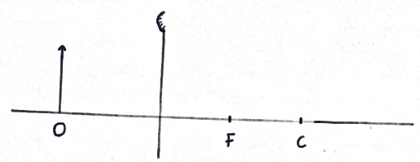

10. The sketch shown below is a displacement-time graph of a wave travelling at 320m/s.
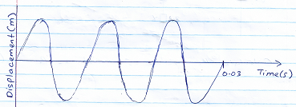
Determine the wavelength of the wave. (3 marks)
………………………………………………………………………………………………………………………………………………………………………………………………………………………………………………………………………………………………………………………………………………………………………………………………………………………………………………………………………………………………………………………………………………………………………………………………………………………………………………………………………………………………
11. Give a reason why repulsion in magnetism is the surest way of testing polarity. (1 mark)
………………………………………………………………………………………………………………………………………………………………………………………………………………………………
- The diagram below shows plane waves moving from shallow to deep end of a pond.
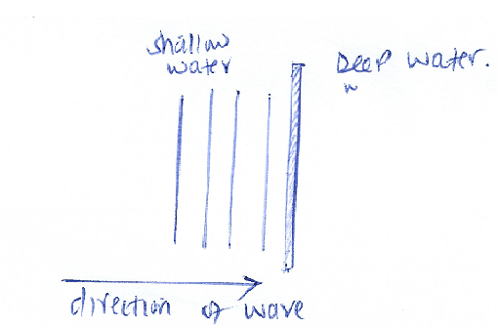
Complete the diagram to show the waves on the deep end. (1 mark)
………………………………………………………………………………………………………………………………………………………………………………………………………………………………
SECTION B (55 MARKS)
Answer all questions in this section

- (a). Figure 4 below shows a modern mains appliances
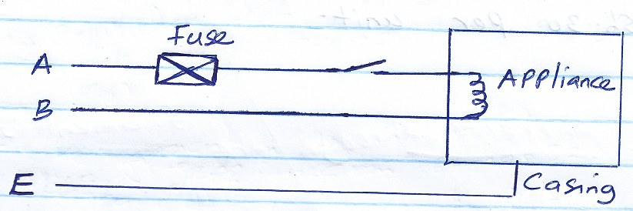
(i). Name wire A and B (2 marks)
A ………………………………………………………………………
B ………………………………………………………………………
(ii). State the purpose of Lead E (1 mark)
………………………………………………………………………………………………………………………………………………………………………………………………………………………………
(iii). State the function of the fuse in the circuit. (1 mark)
………………………………………………………………………………………………………………………………………………………………………………………………………………………………
(b). A heater is marked 3kW, 240V. The fuses available are marked 10A, 13A and 20A. Which fuse is most suitable? 2 marks)
………………………………………………………………………………………………………………………………………………………………………………………………………………………………
………………………………………………………………………………………………………………………………………………………………………………………………………………………………
(c). Give a reason why power is transmitted at high voltage. (1 mark)
………………………………………………………………………………………………………………………………………………………………………………………………………………………………

(d). A 2kW electric heater is used for 10 hrs. Calculate the cost of electricity if it costs sh.30 per unit.
(3 marks).
………………………………………………………………………………………………………………………………………………………………………………………………………………………………
………………………………………………………………………………………………………………………………………………………………………………………………………………………………
(e). A step down transformer has 600 turns in the primary coil. The input voltage is 120V while the output voltage is 24V. Determine the number of turns in the secondary oil. (2 marks)
………………………………………………………………………………………………………………………………………………………………………………………………………………………………
………………………………………………………………………………………………………………………………………………………………………………………………………………………………
(f). State how energy lost through eddy currents is minimized in a transformer. (1 mark)
………………………………………………………………………………………………………………………………………………………………………………………………………………………………
- (a).State Snell’s law. (1 mark)
………………………………………………………………………………………………………………………………………………………………………………………………………………………………
(b). A ray of light travelling from water to glass makes an angle of incident of 30º as shown below.
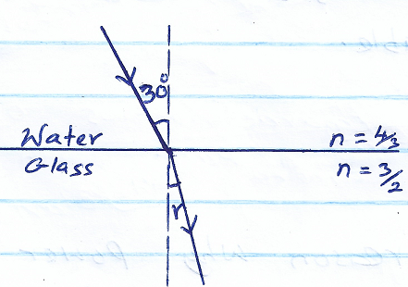

Determine the angle of refraction in the glass. (3 marks)
(Refractive index of water = ⁴/₅ and Refractive index of glass = ³/₂)
………………………………………………………………………………………………………………………………………………………………………………………………………………………………
…………………………………………………………………………………………………………………………………………………………………………………………………………………………
(c). State the necessary and sufficient conditions for total internal reflection to occur. (2 marks)
………………………………………………………………………………………………………………………………………………………………………………………………………………………………………………………………………………………………………………………………………
(d). The figure below shows a ray of Light incident on an isosceles triangle of right angle.
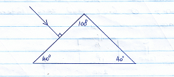

Complete the diagram to show how the ray travels through the Prism. Take the critical angle of the glass prism to be 39º. (2 marks)

(e). State two advantages of optical fibre when used in communication over ordinary copper wires.
(2 marks)
…………………………………………………………………………………………………………………………………………………………………………………………………………………………
15. (a). Define work function (1 mark)
…………………………………………………………………………………………………………………………………………………………………………………………………………………………
(b). Name two factors that affect photoelectric effect. (2 marks)
…………………………………………………………………………………………………………………………………………………………………………………………………………………………

(c).The threshold frequency of sodium is 5.6 x 10¹⁴Hz. Planks constant 6.63 x 10⁻³⁴Js. Find
(i). Work function of sodium. (2 marks)
……………………………………………………………………………………………………………
……………………………………………………………………………………………………………..
(d). A certain metal is illuminated with radiation of different frequencies and corresponding stopping potential determined. The graph below shows how the stopping potential vary with frequency. (Electronic charge, e = 1.6 x 10⁻¹⁹c)
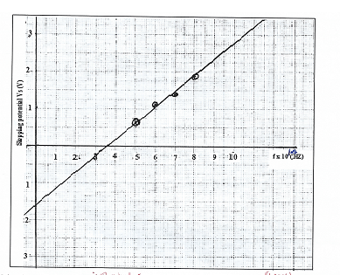
Using the graph determining
(i). Threshold frequency. (1 mark)
………………………………………………………………………………………………………………………………………………………………………………………………………………………………………………………………………………………………………………………………………

(ii).Planks constant. (3 marks)
………………………………………………………………………………………………………………………………………………………………………………………………………………………………………………………………………………………………………………………………………
………………………………………………………………………………………………………………………………………………………………………………………………………………………………………………………………………………………………………………………………………

(iii). Work function of the metal. (3 marks)
…………………………………………………………………………………………………………………………………………………………………………………………………………………………

16. (a).Distinguish between nuclear fusion and nuclear fission. (1 mark)

…………………………………………………………………………………………………………………………………………………………………………………………………………………………
(b). The equation below represents a nuclear reaction
${}_{84}^{218}{Po ⇢{}_{85}^{218}A+ {}_{q}^{p}y}$

(i). Determine the values of P and q. (2 marks)
……………………………………………………………………………………………………………
…………………………………………………………………………………………………………………………………………………………………………………………………………………………
……………………………………………………………………………………………………………

(c). The figure below represents diffusion of various radiations from a radioactive source S placed in an electric field between two plates X and Y (1 mark)
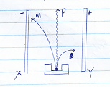

Identify the radiations marked with letters M and P. (2 marks)
M ......................................................................................................................................................

P …………………………………………………………………………………………………..

(d). Given that 5g of cobalt-60 is kept in a laboratory and it has a half-life of 5 years. Determine the mass that will have decayed after 15 years. (3 marks)
……………………………………………………………………………………………………………
…………………………………………………………………………………………………………………………………………………………………………………………………………………………
……………………………………………………………………………………………………………
17. The figure below represent the important parts of an x-ray tube used in an industry
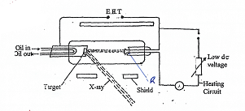
(a). Name the part labelled R. (1 mark)
……………………………………………………………………………………………………………
(b). Name a suitable material used for the target, give reason for your answer. (2 marks)
…………………………………………………………………………………………………………………………………………………………………………………………………………………………
(c). State the reason why R is concaved in shape. (1 mark)
…………………………………………………………………………………………………………………………………………………………………………………………………………………………
(d). Explain how x-rays are produced in the x-ray tube. (3 marks)
………………………………………………………………………………………………………………………………………………………………………………………………………………………………………………………………………………………………………………………………………

(e). Explain why the x-ray tube should be evacuated. (1 mark)
………………………………………………………………………………………………………………………………………………………………………………………………………………………………………………………………………………………………………………………………………
(f). The shields are usually made from lead metal.
Explain why lead is the preferred material for shield. (1 mark)
………………………………………………………………………………………………………………………………………………………………………………………………………………………………………………………………………………………………………………………………………
(g). Explain the effect on the x-rays produced when:
(i). The magnitude of the extra-high tension. Voltage is increased. (1 mark)
…………………………………………………………………………………………………………………………………………………………………………………………………………………………
(ii). The ammeter reading is increased. (1 mark)
…………………………………………………………………………………………………………………………………………………………………………………………………………………………

