MARKING SCHEME

232/2
PHYSICS PAPER 2
AUGUST 2022

ARISE AND SHINE TRIAL 1 EXAM
AUGUST 2022

Section A
1.
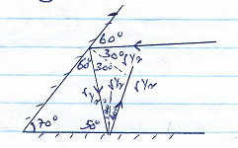
2. v = ^{d}/_{t}
d = 330 x 4 $√$¹
d = 1320cm $√$¹
3. Circuit A $√$¹
Current drawn from each cell is less than in$√$¹ B. (1mk)
OR Internal resistance in circuit A is less than in circuit B.
4. P = IV
I = $\frac{P}{V}$
= $\frac{100}{240}$
= 0.4167A $√$¹

5. Positive charge.$√$¹
When the negatively charged rod is brought close to the cap, negative charges on the cap are repelled$√$¹ to the leaf and plate. On earthing the negative charges on the leaf and plate flow to the earth$√$¹ leaving electroscope positively charged.

6. (a). F $√$¹

(b). The wire will be deflected to the left. $√$¹

7. V = IR
0.14 = I x 2$Ω$
I = 0.07A $√$¹
Voltage across R = 6 – 0.14
= 5.86V
5.86 = 0.07 x R $√$¹
R = 83.71$Ω√$¹
8.
Type of radiation | Detection | Use
Infrared radiation$√$¹ | Blackened thermometer | warming

9.
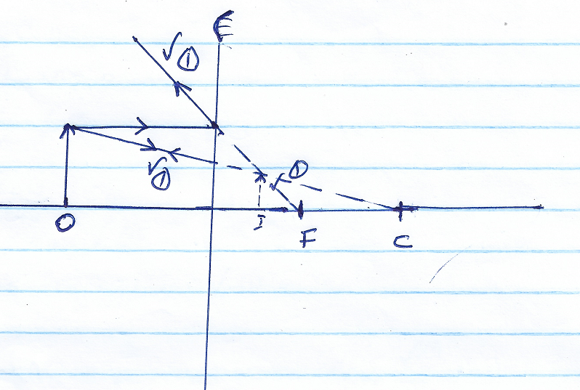
10. Period, T = $\frac{0.03}{3}$
= 0.015 $√$¹
$δ$=$\frac{1}{4}$
= $\frac{1}{0.01}$
= 100Hz $√$¹
V = $δ⋋$
$⋋$=$\frac{320}{100}$
$⋋$= 3.2m$√$¹
11. Repulsion only occurs between the likes poles. $√$¹
12.
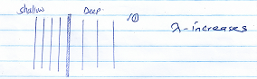
13. (a).(i). A-live wire $√$¹
B- Neutral wire $√$¹
(ii) Provides a safe route for the current in case the live wire touches the casing of the appliance. $√$¹
(iii). Safeguard appliance from damage incase excess current flows in the circuit. $√$¹
(b). P = 3kW,v=240v
I =$\frac{P}{V}$ $√$¹
I = $\frac{3000}{240}$
= 12.5A$√$¹
13A is suitable $√$¹
(c). To minimise power loss. $√$¹
(d). Number of units = 2kw x 10hrs
= 20kWh $√$¹
Cost = 20 x 30 $√$1
= sh. 600 $√$¹
(e) . $\frac{N}{NP}$=$\frac{Vs}{Vp}$ $√$¹
$\frac{Ns}{600}$= $\frac{24}{120}$
NS = $\frac{600 x 24}{120}$ $√$¹
Ns = 120 turns $√$¹
(f). Laminating the core/using a laminated core. $√$¹
14. (a). The ratio of sine of angle of incidence to the sine of angle of refraction is a constant for a given pair of media $√$¹
(b). _{w}n_{g} = _{w}n_{a} _{a}n_{g}
$\frac{3}{4}$x$\frac{3}{2}$ = $\frac{9}{8}√$¹
$\frac{\sin{i}}{\sin{r}}$= n
$\frac{9}{8}$ = $\frac{{\sin{30}}^{o}}{\sin{r}}$ $√$¹
sin r = $\frac{8}{9}$ x sin 30º
r = 26.4º
OR
n₁ sin $θ$ = n = sin$θ$₂ $√$¹
$\frac{4}{3}$ sin 30º =$\frac{3}{2}$ sin $θ$₂ $√$¹
sin $θ_{2}$= $\frac{2}{3}$x $\frac{4}{3}$sin 30º
$θ_{2}$= 26.4º
r = 26.4º$√$1
(c).(i). Angle of incidence in the dense medium must be greater than the critical angle.
(ii). Light must be travelling from denser to a rare medium $.√$¹
d)
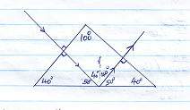
e). - Lighter and thinner
- Higher carrying capacity
15. (a), Minimum amount of energy required to dislodge an electron from a meal surface. $√$¹
(b). - Intensity of the radiation
- Energy of the radiation/frequency
- Type of metals
(Any two @ 1mk
c). (i). W_{o} = hf_{o}
= 6.63 x 10⁻³⁴ x 5.6 x 10¹⁴ $√$¹
= 3.713 x 10^{-19J}$√$¹

(ii). hf = wo + K.E $√$¹
8.6 x 10¹⁴ x 6.63 x 10⁻³⁴ = 3.718 x 10⁻¹⁹ + K.E $√$¹
5.702 x 10⁻¹⁹ = 3.713 x 10⁻¹⁹ + K.E
$∴$K.E = 5.702 x 10⁻¹⁹ – 3.713 x 10⁻¹⁹
= 1.989 x 10⁻¹⁹J $√$¹

(d). (i) f_{o} = (3.6$±$ 0.1) x 10¹⁴Hz (x-intercept)

(ii).$\frac{h}{e}$ = gradient $√$¹
Slope = $\frac{1.5-0}{{\left\{7-3.6\right\} x 10}^{14}}$
$= \frac{1.5}{{3.4 x 10}^{14}}$
= 4.412 x 10⁻¹⁵
$∴$ $\frac{h}{{1.6 x 10}^{-19}}$ = 4.412 x 10-15
h = 4.412 x 10-15 x 1.6 x 10-19 $√$¹
= 7.059 x 10⁻³⁴Js $√$1

(iii).
Wo = hf_{o} $√$¹
= 7.059 x 10⁻³⁴ x 3.6 x 10¹⁴
= 2.541 x 10⁻¹⁹J $√$¹
16. (a). Nuclear fission is the splitting of nucleus of radioactive element to release energy while nuclear fusion is the combination of two light nuclei leading to release of energy

(b). (i). 218 = 218 + P
P = 0 $√$¹
84 = 85 + Q $√$1
Q = -1

(ii). Beta Particle $√$¹
(c) M –Alpha particle $√$¹
P – Gamma rays/radiation $√$¹
(d). 5$→$ 2.5$→$ 1.25$→$ 0.625g $√$¹
No. of half lifes$\frac{15}{5}$ = =3 $√$¹
Mass remaining = 0.625g $√$¹
Mass decayed = 5 - 0.625
= 4.375g $√$1
OR
N = N_{o}(¹/₂)^{T}/t/₁/₂
N = 5(¹/₂)¹⁵/₅ $√$¹
= 5 x ¹/₈
N = 0.625 $√$¹
Mass delayed
= 5-0.625
= 4.375g $√$1

17. (a). R – Concave focusing cathode/cathode$√$¹
(b). Tungsten/molybdenum $√$1– It has a high melting point hence can withstand high temperature/hence cannot melt due to high temperature.
(c). To concentrate/focus $√$¹ electron beam onto the target.
(d). When current flows through the filament in the cathode, the cathode is heated and electrons are produce by thermionic Emission$√$¹. The produced electrons are accelerated by the anode towards the target where they are suddenly stopped by the target and their kinetic$√$¹ energy is transformed into x-rays and heat.
e). To remove air molecules $√$1 so that the electrons do not cost some of their kinetic energy through collision
(f). has high density/ it has ability to absorb most of the x-rays.
(e). (i). Harder/more penetrating $√$¹ x –rays are produced.
(ii). Intensity of x – rays produced $√$¹ increases.

