Name: …………………………………………………………Index No. …………….……………
School: ……………………………………………. Candidate’s Sign. …………..........................
ADM.NO: ……………………………………… Date: ……………............................................

PHYSICS THEORY
PAPER 1
232/1

AUGUST/SEPTEMBER - 2022
TIME: 2 HOURS

ARISE AND SHINE TRIAL EXAMINATION
Kenya Certificate of Secondary Education (KCSE)

INSTRUCTIONS TO THE CANDIDATES:
- Write your name and index number in the spaces provided above.
- Write the date of the examination and your SIGNATURE in the spaces provided above.
- This paper consists of TWO sections; A and B.
- Answer ALL the questions both in section A and B in the spaces provided below each question.
- ALL workings MUST be clearly shown.
- Non-programmable silent electronic calculators may be used.
- This paper consists of 11 printed pages.
- Candidates should check the question paper to ascertain that all the pages are printed as indicated and that no questions are missing.

For Examiners’ Use Only
SECTION | QUESTION | MAXIMUM SCORE | CANDIDATE’S SCORE
A | 1-12 | 25
B | 13 | 11
 | 14 | 11
 | 15 | 12
 | 16 | 10
 | 17 | 11
 | TOTAL | 80
SECTION A (25 MARKS)
Answer All Questions In This Section In The Spaces Provided

- Figure 1 shows part of the scales of a micrometer screw gauge when it is completely closed.
Find the zero error of this micrometer screw gauge. (1 mark)
……………………………………………………………………………………………………………………………………………………………………....................................................................................................................................................................
- A barometer reads 760mmHg at sea level. Find it’s reading at an altitude of 2500m above sea level. (Density of mercury = 13600kgm⁻³ and density of air 1.25kgm⁻³) (3 marks)
……………………………………………………………………………………………………………………………………………………………………………………………………………………………………………………………………………………………………………………………………………………………………………………………………………………………………………………………………………………………………………………………………………………………………………………………………………………………………………………………………………………………………………………………………………………………………………………………………………….………..
- Figure 4 shows a velocity-time graph of a small metal sphere falling through water in a tall jar.
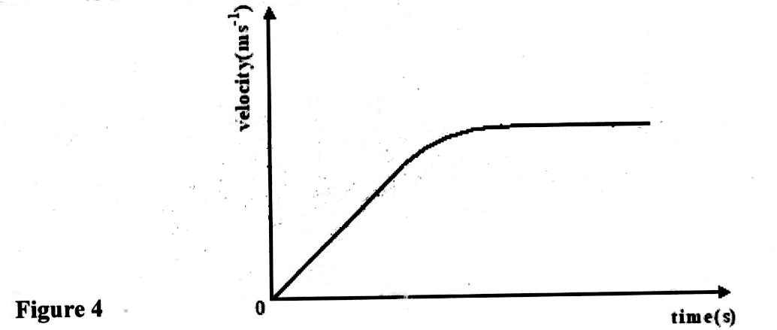

On the same axes, draw a velocity-time graph for the same metal sphere falling through air. (1 mark)

- Figure 5 shows the tension, T on a pendulum bob suspended from a support.
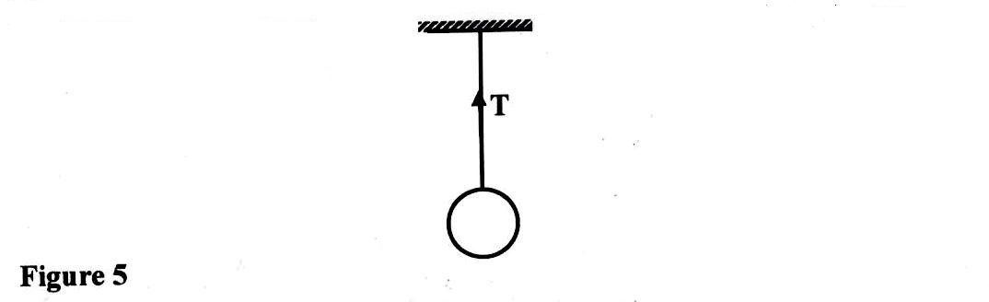
Indicate on the diagram the other force acting on the pendulum bob. (1 mark)

- A stone and a feather are dropped from rest from a building 20m tall. If they reach the ground at the same time,

- State the condition under which they fall. (1 mark)
…………………………………………………………………………………………………….
- Find the velocity with which they reach the ground. (take g = 10m/s²) (2 marks)
……………………………………………………………………………………………………………………………………………………………………………………………………………………………………………………………………………………………………………………………………………………………………………………………………………………
……………………………………………………………………………………………………
- Define a radian as applied in circular motion. (1 mark)
…………………………………………………………………………………………………………………………………………………………………………………………………………
- The figure below shows a thermometer used by a doctor to determine the temperature of a patient. Why is it difficult to work with this thermometer? (2 marks)
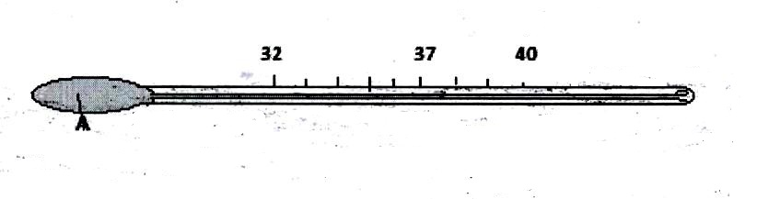

- A glass block is suspended from a spring balance and held inside a beaker without touching the beaker. Water is added gradually into the beaker. The figure below shows the variation of the upthrust on the block with depth of water in the beaker.
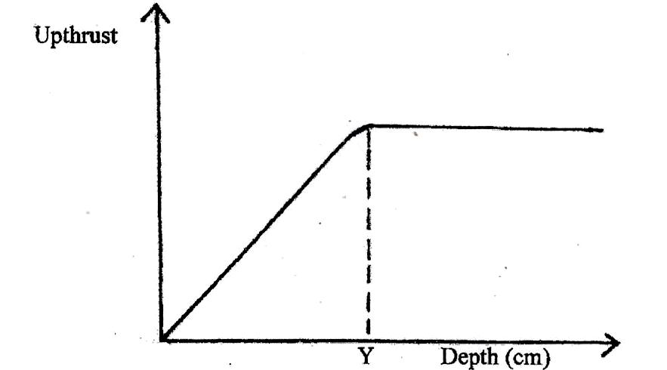

State the reasons for the observation at Y (2 marks)
……………………………………………………………………………………………… ……………………………………………………………………………………………….
- Which branch of Physics deals with kinetic energy within matter? (1 mark)
……………………………………………………………………………………………………
- The figure 2 below shows a beaker containing water placed on a flat bench. State and explain the changes in stability of the beaker when the water freezes to ice. (2 marks)
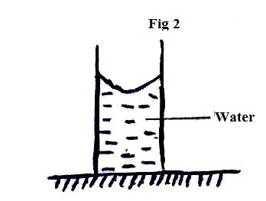
………………………………………………………………………………………………………………………………………………………………………………………………………………………………………………………………………………………………………………………………………………………………………………………………………………………………………………………………………………………
- Figure 5 is a simple diagram of a vacuum flask with an enlarged view of the part of it in the circle. Use it to answer question (a) and (b).
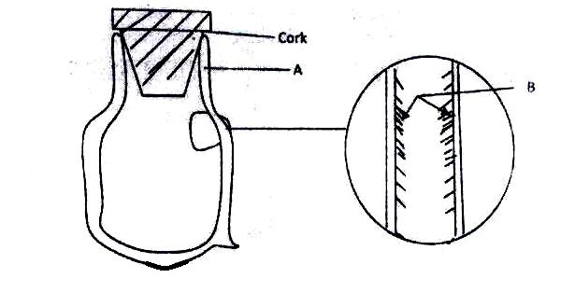
- Name the material in A and B.

A: …………………………………………………………………………………… (1 mark)

B: …………………………………………………………………………………… (1 mark)

- What type of energy losses are minimized or prevented by the parts A and B?

A: ……………………………………………………………………………………. (1 mark)

B: ……………………………………………………………………………………. (1 mark)
- (a) State Newton's Third Law of Motion (1 mark)
…………………………………………………………………………………………………………………………………………………………………………………………………………
(b) A car of mass 900kg is initially moving at 20m/s. Calculate the force required to bring the car to rest over a distance of 15m. (3 marks)

SECTION B – 55 MARKS
Answer All the Questions

- (a) A body of mass 20Kg hangs 4m and swings through a vertical height of 0.9m as shown in the figure below.
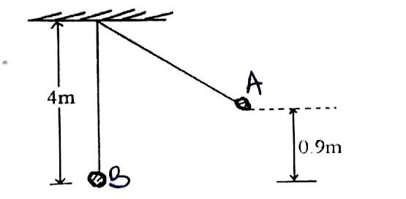
Determine;
- The potential energy at position, A (2 marks)

- The speed of the body when passing through the lowest point, B (2 marks)

(b) A Crane lifts a load of 2000kg through a vertical distance of 3.0m in 6 seconds.
Determine the:

- Work done by the crane. (Take g= 10N/Kg) (2 marks)

- Power developed by the crane. (2 marks)

- Efficiency of the crane given that it is operated by an electric motor rated 12.5kW (3 marks)

- (a) Figure 9 shows a suspended copper solid immersed in a fluid.
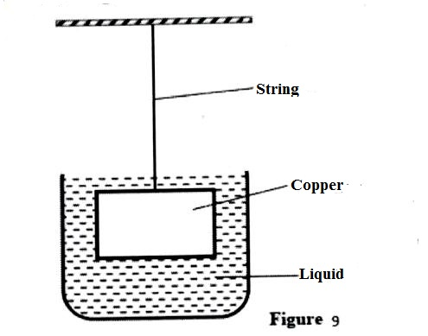
Explain what will happen to the tension in the string if a liquid of higher density is used. (2 marks)
………………………………………………………………………………………………………………………………………………………………………………………………
(b) Figure 10 below shows a ball fully immersed in water and held with a string attached at the bottom.
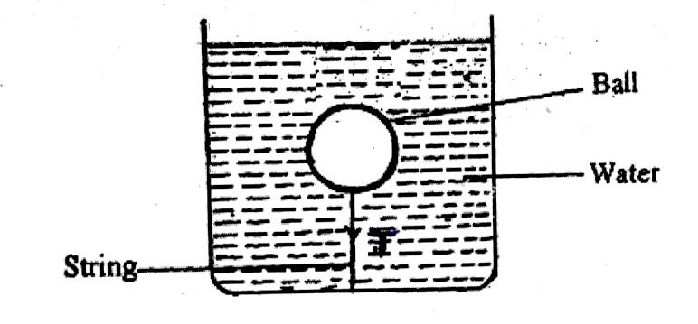
- If the mass of the ball is 0.5kg, calculate the weight of the ball. (1 mark)

- The volume of the water displaced by the immersed ball is 8.0 x 10⁻⁴ m³. Calculate the up thrust on the ball. (ꝭ water = 1000 kg m⁻³) (3 marks)

- Determine the tension T on the string (2 marks)

(c) An object weighs 5.0N in air, 3.0N when fully immersed in water and 4.0N when fully immersed in a certain liquid. Determine the density of the liquid. (3 marks)

- a) Define the term ‘heat capacity’ (1 mark)
…………………………………………………………………………………………………………………………………………………………………………………………………………
- A block of metal of mass 150g at 100⁰C is dropped into a well lagged calorimeter of mass 215g and specific heat capacity of 400J/Kg/K containing 100g of water at 25°C. The temperature of the resulting mixture is 34°C (Specific heat capacity water is 4200J/Kg/K).Determine;

- Heat gained by calorimeter. (2 marks)

- Heat gained by water. (3 marks)

- Specific heat capacity of the metal block (3 marks)

- A copper block of mass 500g is electrically heated with a heater rated 5W.The heater is on for 8 minutes. Calculate the temperature rise in the block. (Specific heat capacity of copper is 460J/Kg/K) (3 marks)

- a) A car negotiating a corner at a constant speed is said have a change of momentum. Explain this observation. (1 mark)
………………………………………………………………………………………………………………………………………………………………………………………………………………………………………………………………………………………………………………
- Figure 15 shows the overview of a turn table on which glass blocks A and B are placed at different radii from the centre along a straight line. The radius r1 is 50cm while that of r2 is 120cm. The mass of A is 300g that of B is 900g.
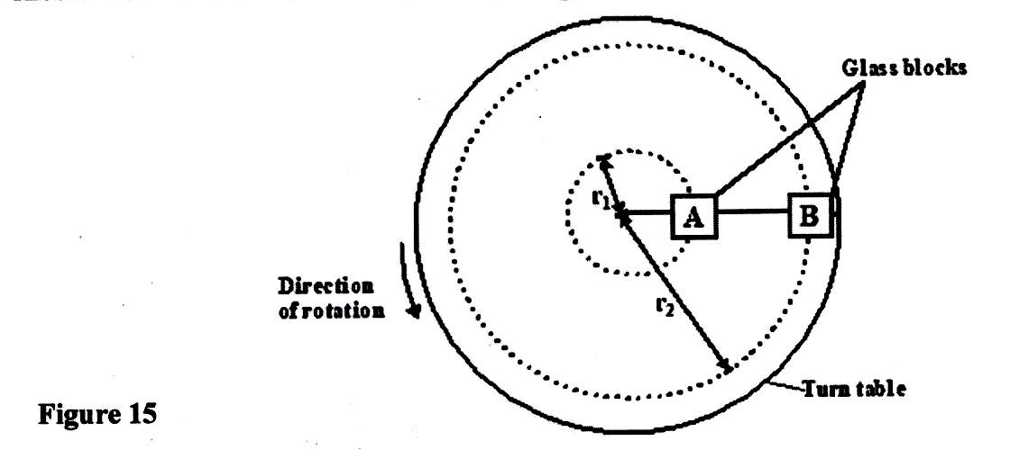

Both blocks maintain the same straight line as the turn table moves in uniform circular motion. Block A has a linear velocity of 40ms⁻¹.

- Determine the:
- Centripetal force on block A. (3 marks)

- Linear velocity of block B. (3 marks)

- (i) State which block is likely to slide off the turn table. (1 mark)
………………………………………………………………………………………………...
- Explain your answer in (II) (i) above. (2 marks)
……………………………………………………………………………………………………………………………………………………………………………………………………………………………………………………………………………………………….
- (a) Figure 8 shows a sealed glass syringe that contains smoke particles suspended in air.
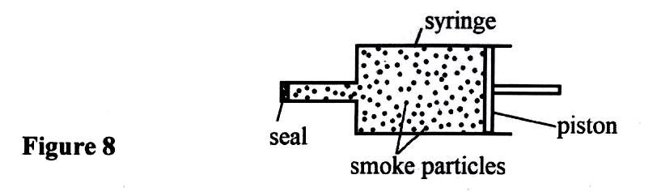

- Explain why the smoke particles are suspended in the air and do not settle to the bottom. (2 marks)
………………………………………………………………………………………………………………………………………………………………………………………………………………………………………………………………………………………………………………
- The air in the syringe is at a pressure of 2.0 x 10⁵ Nm⁻². The piston is slowly moved into the syringe until the volume of the air is reduced from 80 cm³ to 25 cm³.
- State why the piston must be moved slowly. (1 mark)
…………………………………………………………………………………………………….
…………………………………………………………………………………………………….
- Calculate the final pressure of the air in the syringe. (3 marks)

- State what is meant by an ideal gas. (1 mark)
…………………………………………………………………………………………………….
…………………………………………………………………………………………………….
- The pressure acting in a gas in a container was changed steadily while the temperature of the gas was maintained constant. The value of volume, V, of the gas was measured for various values of pressure. The graph in the figure A shows the relation between the pressure. P₁ and the reciprocal of volume, I/V.
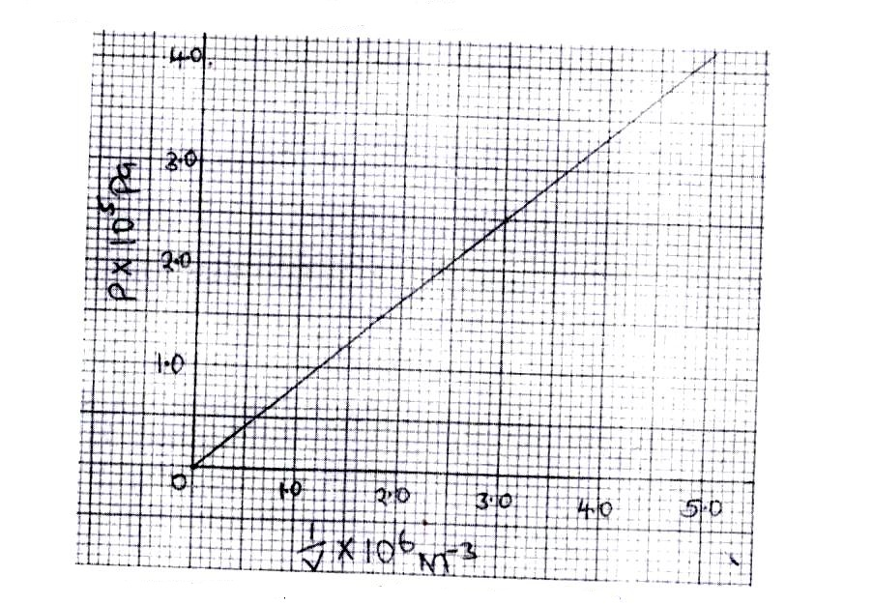

- Given that the relation between the pressure P and the volume V of the gas is given by PV=k, where k is a constant use the graph to determine the value of k. (3 marks)

- What physical quantity does k represent? (1 mark)
………………………………………………………………………………………………….

